MEDITERRANEAN JOURNAL OF CHEMISTRY

Graphical Abstract

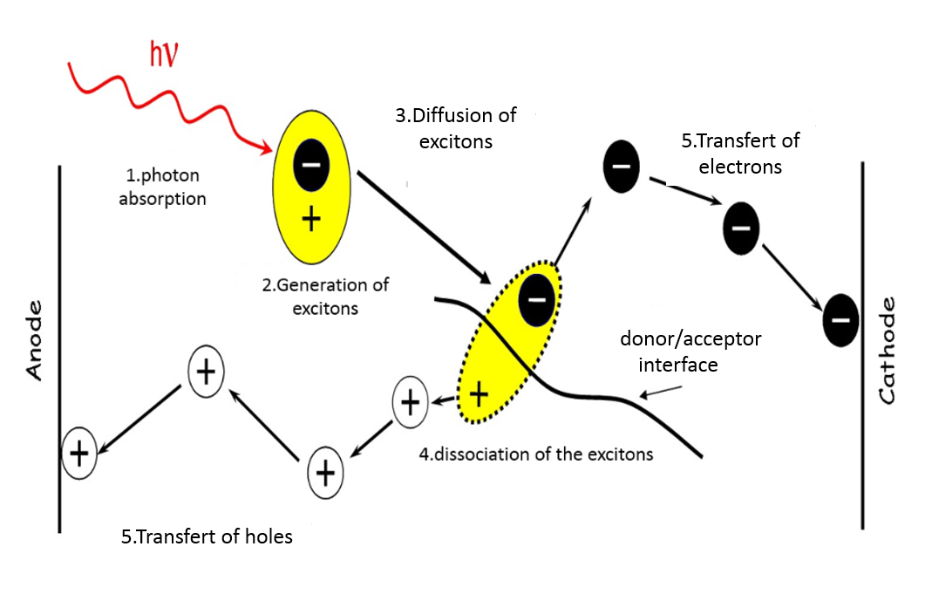

The 5 stages of the photovoltaic conversion in the organic semiconductors

