**Figure captions**

**Figure 1:** crystal structure diamond

**Figure 2:** crystal structure wϋrtzite

**Figure 3:** Examples of small molecules combined commonly used in the organic photovoltaic cells

**Figure 4:** The 5 stages of the photovoltaic conversion in the organic semiconductors

**Figure 5:** schematic diagram of the evolution of molecular orbitals (levels) with increasing polyene size



**Fig. 1.**

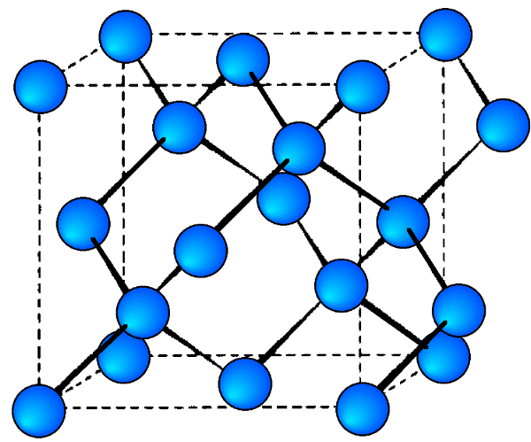

**Fig. 2.**

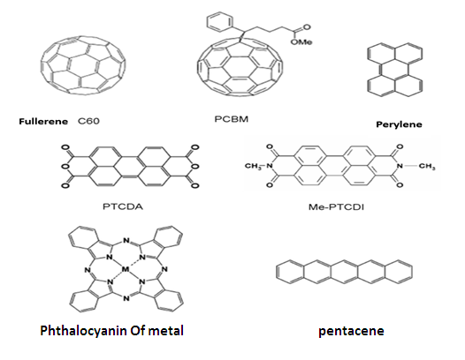

**Fig. 3.**

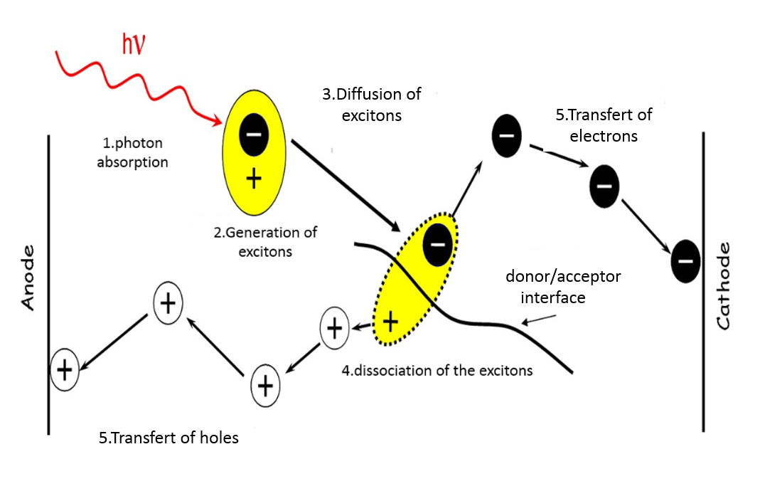

**Fig. 4.**

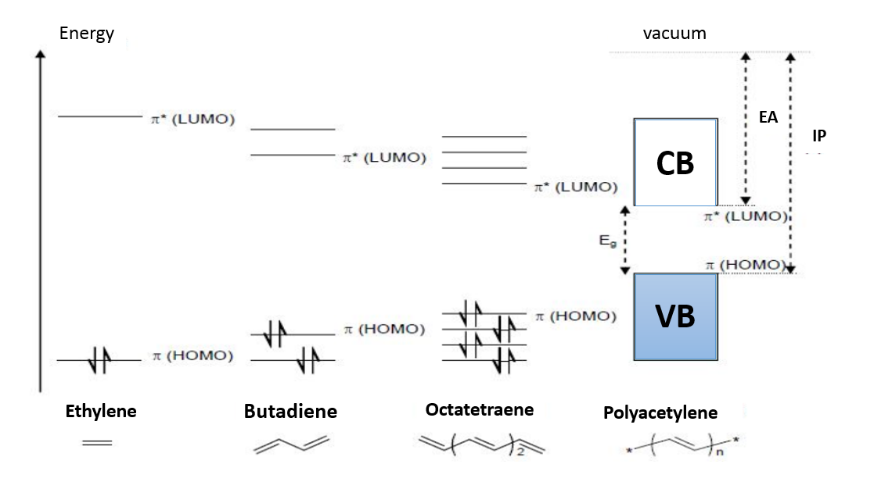

**Fig. 5.**