**EVALUATION QUALITY OF SOIL SAMPLES OF THE TANGIER LANDFILL: GENERAL CHARACTERIZATION**

Ikram Chaera,b, Asmae El Cadia, Jamal Briguib, Khadija Ziata, Mohamed Khaddora*

*a Laboratory of physico-chemical materials, natural substances and environment, Departement of Chemistry, Faculty of Sciences and Technology, Abdelmale Essaâdi University, Tangier, Morocco*

*bLaboratory of Materials and Valorization of Resources, Departement of Chemistry, Faculty of Sciences and Technology, Abdelmale Essaâdi University, Tangier, Morocco*

*E-mail du correspondant : [mohamedkhaddor@yahoo.fr](mailto:mohamedkhaddor@yahoo.fr)

**Abstract**

In recent decades, landfill sites have been a potential source of contamination, which can have a negative impact on the environment due to the accumulation of heavy metals and processed organic products. In the Tangier landfill, the different wastes types are without any prior treatment and any protection of the soil. This behavior constitutes a risk factor for contamination of soil and groundwater. Between the waste and soil, many physico-chemical and biological reactions occur. The objective of this work effort is to derive a global and in-depth characterization of the organic and mineral matter of the soil samples from Tangier landfill. The study of organic matter (OM) in soils helps to understand the evolution of soil contamination. Eight samples of soil have studied using a range of chemical and physical analytical methods. FT-IR spectroscopy and X-ray diffraction analyses have used to investigate the nature of organic matter. The analysis of heavy metals in the soil showed that the presence of Pb, Cd, As, Cr and Zn significant quantities whose it is mainly due to industrial waste.

Keywords: wastes, Organic matter, X-ray diffraction, heavy metals.

**1. Introduction**

The increase in industries and population growth in the world, have led to a huge growth of contaminating waste, which must managed well to avoid the transfer of environmental pollution [1]. Implementing landfill solid waste without any prior treatment and without any protection of the soil in landfill sites constitutes a risk factor of contamination of soil surface and groundwater. Landfill is the most common way of storing waste around the world. This practice leads to the gaseous emissions and liquid leachates that are produced after waste decomposition and rainwater percolation [1,2,3]. Their composition varies considerably, depending on the origin and nature of the disposed waste, the landfill geographic location and the climate conditions [2,4]. There are different types of pollution, in particular chemical, physical, radioactive and biological pollution. This study aims to provide baseline data on the chemical and metal pollution contained in the soil in northern Moroccan city (Tangier). Large quantities of heavy metals (in solid forms) have buried during storage of municipal or industrial waste. The purpose of this study is to investigate mainly the organic parameters and the total concentrations (mg/kg dry matter) of metals Zn, Cr, Pb, Cd, and As to assess and quantify the organic and metallic pollution, and learn about how urban and industrial activities may generate this pollution. Moreover, MEB, X-ray diffraction and spectroscopic analyses (FT-IR, UV-visible) have used to investigate the organic and the inorganic matter nature of the soils. For FT-IR analysis, we focused on the absorption bands in the region of 400–1000 cm-1 in order to obtain detailed information of organic matter nature of soils.

**2. Materials and methods**

**2.1. Sites**

The landfill of Tangier city is uncontrolled and open, it located southeast of the town 5 km from the center of city on the road (RN2) into Tetouan, and it extends on a flat 20 ha. It has put into operation in the early 1970 on land belonging to the private domain of the State. The landfill is located on hills surrounded by the valleys of the bottom Moghogha and GhirBoudra south and those bottoms MlalehKhandak and BouHajjar of east.

The quantity of waste has closely linked to population ratio and the production of waste.

**2.2. Soil samples**

Eight samples have collected from the surface layer of soil (0-20 cm) from landfill uncontrolled of tangier. These samples obtained from the landfill have manually sorted to remove metal, plastic, glass, and stone. Residual samples were ground and sieved particles smaller than 2mm in diameter have used for analyses.

**2.3. Soil analysis**

Soil pH was measured in water, and also in 0.1 M KCl (soil/solution ratio 1/2.5), using a glass electrode The organic matter (OM) content was determined by the loss on ignition of the dry mass at 550 °C, and the total nitrogen (Nt)––by the Kjeldahl method. The organic carbon content (Ct) has determined using TOC/TNb2100S (Tangier, morocco) Analytik jena analyzer.

The contents of heavy metals (Zn, Cr, Pb, Cd, and As) in the sediments were determined by Atomic- plasma emission Spectroscopy ICP AES (Ultima 2 – JobinYvon) in (CNRST) national center of scientific research. The obtained results have expressed in mg/kg. In this work, the choice of these metals takes in consideration those most dangerous and most frequently met in the soil. Moreover, these metals have usually used in the industrial.

**2.4. UV–Vis spectroscopy of soil samples**

One gram of each soil sample has weighted into a 250 ml polyethylene flask and extracted with 50 ml of 0.5M NaOH by shaking for 2 h. After, the flask was leaving overnight. Next day the suspension has centrifuged at 3000 rpm for 25 min and the absorbance (A) of the supernatant has measured at λ=280 nm (A280) and 664 nm (A664) [5]. The following absorbance ratios indicating the degree of humification were calculated: Q2/6 =A280/A664, Q2/4 = A280/A472. The Q2/4 reflects the proportion between the lignins and other materials at the beginning of humification, and the content of materials at the beginning of transformation. The Q2/6 denotes the relation between non-humified and strongly humified material. The Q4/6 is often called the humification index and is the most often calculated ratio. Typical values of the Q4/6 ratio for humified material are usually <5 [6,7].

**2.5. FT-IR spectroscopy**

Pellets have prepared by mixing 1 mg of each freeze-dried sample with 100 mg of KBr so that the mixture became homogeneous. Infrared spectra have recorded on these pellets with JASCO Corp., FT/IR-410 spectrometer over the 4000–400 cm-1 range.

**2.6. X-ray diffraction**

For X-ray diffraction analysis, samples ground into powder were suspended in deionized, distilled water then smeared on glass slides, air-dried, and analyzed with Diffractometer system=XPERT-PRO (Operator: C.N.R.S.T, morocco) using Cu as a node Material and generator settings of 40 mA, 45 kV.

**3. Results**

**3.1. Physico-chemical analyze**

**Table 1:** Some physico-chemical parameters of the landfill Tangier soil samples

|  |  |  |  |  |  |  |  |  |  |  |  |
| --- | --- | --- | --- | --- | --- | --- | --- | --- | --- | --- | --- |
| **Samples** | **Dry**  **Matter**  **%** | **pH eau** | **OM %** | **EC ms/cm** | **CaCO3%** | | **COT%** | **NOT%** | **Size fractions** | | |
| **total** | **active** |  |  | **clay** | **silty** | **sandy** |
| **P1** | 96,86 | 7,40 | 3 | 5,91 | 29,50 | 14,20 | 1,76 | 0,19 | 20 | 60 | 20 |
| **P2** | 96,40 | 7,77 | 0,17 | 4,81 | 28,40 | 11,75 | 0,10 | 0,01 | 35 | 45 | 20 |
| **P3** | 90,80 | 7,51 | 7 | 3,94 | 25,20 | 9,12 | 2,83 | 0,19 | 18 | 47 | 35 |
| **P4** | 96,70 | 7,65 | 3,57 | 3,77 | 26,40 | 10,35 | 4,96 | 0,38 | 22 | 38 | 40 |
| **P5** | 88 | 7,60 | 12,41 | 0 ,13 | 15,90 | 3,25 | 7,50 | 0,27 | 35 | 40 | 25 |
| **P6** | 95,40 | 8 | 24 | 3,65 | 17,30 | 5,30 | 14,94 | 0,73 | 18 | 52 | 30 |
| **P7** | 99 | 9,07 | 5,40 | 3,33 | 24 | 8,50 | 4,02 | 0,30 | 10 | 50 | 40 |
| **P8** | 63,75 | 7,50 | 12, 30 | 3,97 | 25,50 | 10,75 | 10,06 | 0,50 | 29 | 52 | 19 |

The Table 1 shows the main physical and chemical characteristics, measurement of electrical conductivity (EC) of the soil is a property that has become one of the methods of measuring soil salinity [8]. For our samples, it has a high conductivity indicating that it is salty; EC values ​​are varied between 0.1282 ms/cm and 5,91 ms/cm. These values ​​are relatively high to EC cultivated soil [9] and similar to household waste compost values [7,9].

The pH is around neutral except P6 and P7 which is basic, so the medium is neutral-basic. Theoretically, at atmospheric pressure, the pH of the soil solutions increases with the presence of excess carbonate [10] and the presence of limestone in a soil, causes an increase of the total organic matter content. The most of the values ​​are highly calcareous varied between 15.90 and 29.50% (According to International Norm: NF ISO 10693).

For organic matter, the percentage varies from one site to another (from 0.172% to 24%). The organic matter in landfill soils comes from several types of waste fermentable (degraded compounds, cardboard paper …) and other easily degradable compounds (such as plastics which are important sources of organic matter). Indeed, the organic material content is the parameter that has a very good correlation with the retention power of the organic and metal pollutants by the soil [11].

The C/N ratio does not exceed 15 in most samples except P5, P6 and P8, the maximum value (27.77) is observed in the P5 and similar to household waste compost values [12,13]. Landfill soil samples are poor in nitrogen (varies between 0.01 and 0.73%).

All of the physical and chemical properties of the soil have closely related to structure and texture. Soil particles are classified according to their diameter: sands (from 2mm to 50μm), silts (50μm to 2μm) and clays (<2μm). The distribution of these different particles makes it possible to determine the texture of the soils regardless of the nature and composition of these minerals.

Particle size fractionation have used regularly to measure the structural stability of a soil for studying the organic matter associated with stable aggregates. The granulometry study shows that the samples of soils rather coarse, with a predominantly silty texture) (Table 1). This study are realized by two modes (vertical vibration sieving and laser granulometry

According to their mineral quality, the silts do not stabilize the soil structure, unlike silts. This distribution indicates, according to the triangle of textures [14], that the soil of the landfill of Tangier is unstable.

**3.2. Heavy metals**

The results of heavy metals analyses of the superficial landfill soil samples shown in Table 2.Heavy metals are among the principal polluting agents of the soil environment. The more part of them are generally associated to the suspended matter or to the sediments, in particular those of the surface layer because it is where the phenomena of adsorption are most active. They could have two possible origins: natural origin by partial degradation of the rocks or an industrial origin related to the human activity [15,16]. The concentrations of heavy metals in the landfill of Tangier exceeding those authorized in landfill soil in other landfills [17], these high values ​​of heavy metals in soils can attributed to the nature and waste composition. Metal pollution of buried waste is a long-term problem; the metals have distributed in the soil in various forms.

The five heavy metals cited in the study: Pb, Cd, As, Cr, and Zn. The results show in the different samples vary from 1,286 at 4,414mg / kg for cadmium; and from 4.47 at 7.30 mg / kg Arsenic; and from 85.72 at 340.84 mg / kg for Chrome ; and from 44.44 to298.36 mg / kg for lead; and from 488.9 to 16117.7 mg / kg for zinc.

Pb is toxic and is one of the least mobile metallic elements in the soil. It found commonly in household waste in developing countries because its use as a component of cells [18].

The middle concentration are beyond the AFNOR norm NF U 44-041[19] except P1 (Table 2), but below than that of other landfills in the world. The cadmium can generated by batteries but also plastics, glass and metals [18]. The total middle the Cd is higher than the AFNOR norm. Among the studied of heavy metals, the zinc concentrations has very high levels in landfill soils than that in natural soils (5 to 127 times higher in landfills than in natural soils [20]. The concentration of zinc in our study far exceeds the thresholds recommended by the AFNOR norm (300 mg / kg). Thus, the middle concentration of Cr detected in the 0-20 cm depth is higher than that found by CCME [21]; it is very small compared to the AFNOR norm. The high concentration of Cr can be explained by its anthropogenic in solid waste [22,23]. The concentration of As is very low compared than that found by CCME [21] and to than other landfill (Table 2). The presence of heavy metals in the discharge is not uniform. This is due not only to the heterogeneity of the waste but also to non-uniform degradation of this waste.

**Table 2:** Heavy metal content expressed in (mg / kg) of the Tangier landfill and other landfills; comparison with values given by AFNOR and CCME.

|  |  |  |  |  |  |  |
| --- | --- | --- | --- | --- | --- | --- |
| Landfill |  | As | Cd | Cr | Pb | Zn |
| Tangier Morocoo | P1 | 3,175 | 7,302 | 85,716 | 44,445 | 488,899 |
| P3 | 1,855 | 5,964 | 119,278 | 106,02 | 975,431 |
| P4 | 1,676 | 4,469 | 119,827 | 135,189 | 657,79 |
| P5 | 1,286 | 4,716 | 340,836 | 151,983 | 16117,702 |
| P6 | 2,548 | 5,096 | 129,94 | 185,993 | 13834,81 |
| P7 | 4,414 | 5,885 | 107,106 | 298,366 | 3078,697 |
| P8 | 1,536 | 6,145 | 92,17 | 156,177 | 1461,918 |
| Ahfir-Saidia(Morocoo) [23] | | 33,96 | - | 75,74 | 656,46 | 62,87 |
| Akouédo Abidjan [1] | | - | 1 - 11,5 | 27,7 - 125 | 10,3 - 1500 | 18,6 - 1163,7 |
| Al Ain (Emirats Arabes Unis) [1] | | - | 0,043 | 19,1 | 13,7 | 117 |
| Mal (NewJersey) [1] | | - | 0,55-4,6 | 6-1260 | - | 13,2-1008 |
| France [19] | | - | 2 | 150 | 100 | 300 |
| Canada [21] | | 12 | 1,4 | 64 | 70 | 200 |
| India [23] | | 51,7 | - | 127,9 | 206,4 | 122,3 |

**3.3. FTIR spectra**

The FTIR spectra of all seven samples were very similar in terms of the position of principal absorption bands and shoulders (figure 1). Fine bands located at 3697, 3650 and 3619 cm-1corresponding to stretching vibration of the OH group of the Si-O-H respectively kaolinite and silicates [24, 25]

All of the spectra have characterized by strong bands at around 3403cm-1 for O-H groups of alcohols, phenols and organic acids. 1636 cm-1 mainly for C=C stretching vibration of aromatic rings. The bands at 1433cm-1 and 874 cm-1 for C=O asymmetric stretching, O-H deformation and C-O-H deformation of carboxyl groups. The bands at 1102.1, 1162.8 and 921 cm-1 can be attributed to C–O stretching of carbohydrates, polysaccharides, acids, esters and ethers Amide III, acid or aliphatic alcools, deformation of C-O and O-H the carboxylic groups, compounds organo-sulfurs -C-O-C particularly, Si-O-C grouping [26]. The bands at 1433 cm−1 and 874 cm−1 are similar to the results of pure calcite spectra (calcium carbonate CaCO3) [26]. The Two sharp bands at about 2922 cm-1and 2854 cm-1 due to aliphatic C-H group stretching, this band are more noticeable on P3.

The band at 695 cm-1is associated with the deformation of the Si-O bonds of the Kaolinit, and the band (a shoulder in some cases) at 1799 cm-1 is attributed to the C=O stretching vibration of COOH, ketones, aldehydes and esters, this band very intense in P7 spectra.

Finally, in all spectra, a peak was detected at 1080–1030 cm-1and ascribed to the C–O stretching of polysaccharides and/or to Si–O vibrations of silicate impurities( is more intense for the samples P5et P8).Thus, the peaks between 520 and 470 cm-1are due to para-di-substituted aromatic groups [27].

Although the FTIR spectra seemed very similar, differences across the spectra were apparent in terms of the relative intensity of some bands, depending on the landfill depths position.



**Figure 1:** The FT-IR spectra of the soil of the eight different points of the Tangier landfill

**3.4. X-ray diffraction**

The X-ray diffraction is an analytical technique based on the X-ray diffraction on the material (This technique defines micro mineral phases and polycrystalline materialsà. X-Ray Diffraction (XRD) has performed to determine the mineralogical composition of the six soil samples (P1, P3, P4, P5, P7 and P8), (Figure 2).

Shows the proportion of quartz and calcite (the peaks located at 4,26 Å and 3,34 Å) contained in almost all the diffraction patterns of soil landfill samples.

Soil samples are composed in addition to quartz and calcite, kaolinite [Al2Si2O5 (OH) 4], Halite and muscovite, vanadian K(Al,V)2 (Si, Al)4O10 (OH) 2] for P1, of kaolinite [Al2Si2O5 (OH) 4] for P8, hematite (Fe2O3) for P7 . These results are confirmed by SEM analyzes.



**Figure 2:** X-ray diffraction patterns of eight samples landfill soil samples at different position

**3.5. Electronic scanning microscope analyze (SEM)**

Figure 3 shows the photograph taken at SEM with an EDS spectrum of Tangier landfill (P3). SEM results show that they mainly consist of quartz and numerous alloys based on Si, Ca, Fe, Al, Zn, Mg ...

The two images in the figure 4 have demonstrated the existence of intra-granular porosity (rough surfaces and cracks) which are all factors leading to overestimation of the actual surface area of ​​the landfill soil.

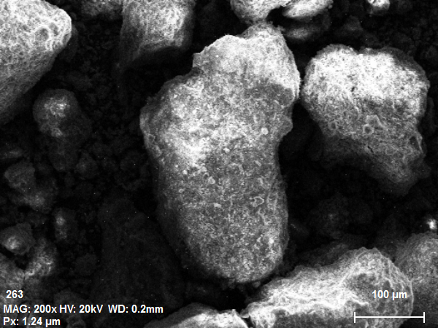

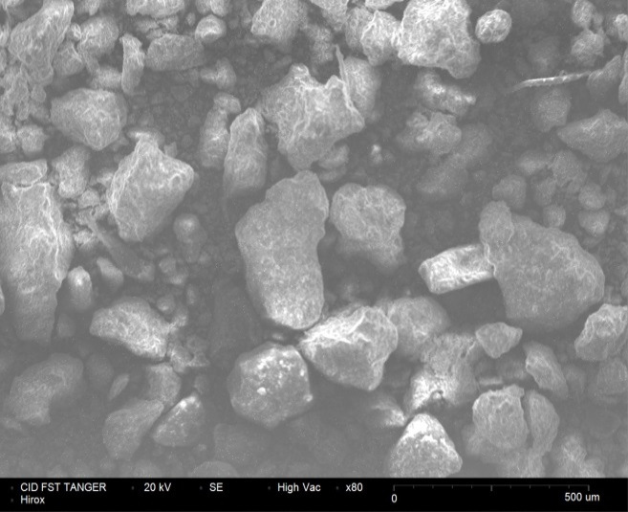



|  |  |
| --- | --- |
| **Eléments** | **[%]** |
| **Oxygène**  **silicium**  **carbone**  **aluminium**  **calcium**  **fer**  **magnésium**  **soufre**  **plomb**  **cuivre**  **zinc** | **13.80**  **15.29**  **8.14**  **4.53**  **2.55**  **1.36**  **0.77**  **0.10**  **0.05**  **0.09**  **0.15** |
|  | |

**Figure 3:** Shows the photograph taken at SEM with an EDS spectrum of Tangier landfill (P3)

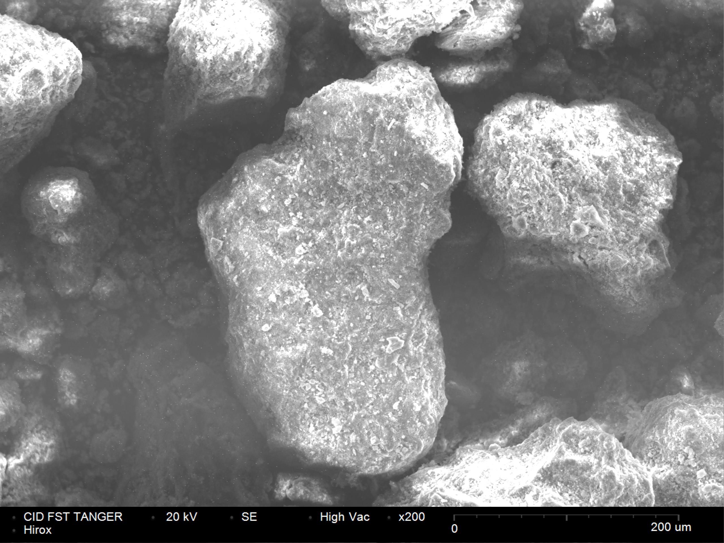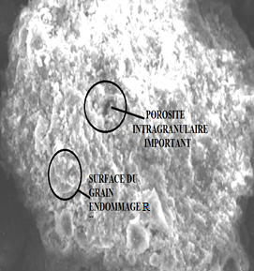

Figure 4: Picture SEM of P3 grain Tangier landfill, fraction <80 μm

Figure 4: Picture SEM of P3 grain Tangier landfill, fraction <80 μm

**3.6. UV - visible spectroscopy**

Many authors have used UV-Visible spectroscopy to characterize the degree of humification and stability of organic matter. According to the work of Swift, Kononova, Chen et al and Stevenson [28, 29, 30, 31] Q4/Q6 are used as an index of humification. In the same principle, Zbytniewski & Buszewski [7] identified three main areas within the spectra of alkaline extracts compost or soil.

**Table 3:** Q465/665 and Q280/665 ratios of landfill soil samples at different position.

|  |  |  |
| --- | --- | --- |
| **Samples** | **Q465/665** | **Q 280/665** |
| **P1** | **10,20** | **48,78** |
| **P2** | **12,10** | **20,35** |
| **P3** | **9,90** | **21,50** |
| **P4** | **6,74** | **14,40** |
| **P5** | **4,26** | **38,77** |
| **P6** | **4,87** | **8,32** |
| **P7** | **11,14** | **36,92** |
| **P8** | **8,25** | **69,84** |

The region between 460 and 480 nm correspond to the organic matter at beginning of humification and the absorbance 600-670 nm correspond to highly humified matter and condensed with aromatic groups.

These ratios were calculated for 8 samples of the soil and the results are expressed in Table 3.

Decreases reports Q2/Q6 and Q4/Q6 indicate increased strongly humified organic matter in the soil and reflect a high degree of aromatic condensation and indicate a higher level of organic material humification [31,32] These results indicate that the landfill soil samples are in early humification (characterized by a large amount of fulvic acid and a low molecular weight[33].

**4. Conclusion**

This work brings to understanding the different components with soil in landfill.

The organic material content is the parameter that has a very good correlation with the retention power of the organic and metal pollutants by the soil,

Our soil is very rich with limestone (moderately and strongly calcareous) and the C / N ratio does not exceed 15 in most samples.

Thus, the medium concentrations of heavy metals observed are higher than the standard reference values and other landfill of polluted soils, especially Zinc, whose origin is probably anthropogenic (industrial waste).

For Spectroscopic (infrared and UV-visible) analysis the results indicates that these soils are high molecular weight organic compounds (humic substances).

Finally, analyzes of SEM showed the presence of intragranular porosities in grains. Moreover, the landfill Soil samples are composed to quartz and calcite the many mineral composite.

**Références**

1**-** I.K. Kouame, D.L. Gone, I. Savane, E. A. Kouassi, K. Koffi, M. Goula, B.T.A. Diallo,Mobilité relative des métaux lourds issus de la décharge d’Akouédo et risque de contamination de la nappe du Continental Terminal (Abidjan - Côte d’Ivoire). *Afrique Science.,* **2006,**02(1), 39 – 56

2- A. Tahiri, A Richel., J. Destain, P. Druart, P. Thonart, M. Ongena,Comprehensive comparison of the chemical and structural characterization of landfill leachate and leonardite humic fractions*. Analytical and bioanalytical chemistry.,* **2016**, 408,1917-1928.

3-V. Vilar, E. Rocha, F. Mota, A. Fonseca, I. Saraiva, R. Boaventura**.** *Treatment of a sanitary landfill leachate using combined solar photo-Fenton and biological immobilized biomass reactor at a pilot scale. Water Res*., **2011**, 45, 2647–58.

4- S. Renou, J.G. Givaudan, S. Poulaina, F. Dirassouyan, P. Moulin. Landfill leachate treatment: review and opportunity. *J Hazard Mater.,* **2008**, *150,* 468–93.

5-B. Sapek, A Sapek. Determination of optical properties in weakly humified samples. In: H. Dziadowiec, S.S Gonet. (Eds.),The Study of Soil Organic Matter–– the Methodical Guide. *Warszawa*, Poland., **1999**.

6- E. Gieguzynska , A.  Kocmit  and  D Golebiowska. Studies on humic acids in eroded soils of. western Pomerania. In: Humic Substances in Ecosystems., **1998,** 3, 35-41

7- Zbytniewski. R, Buszewski B. Characterization of natural organic matter (NOM) derived from sewage sludge compost. Part 2: multivariate techniques in the study of compost maturation*. Bioresour. Technol.,* **2005**, 96, 479–484.

8- M. D. Zaafour, *Impact des décharges sauvages sur les Zones Humides de la région d’El-Tarf.* Annaba., **2012**,166.

9- I. Jemai, S.B. Guirat, N. B. Aissa, N. Jedidi, T. Gallali, Effet de l’amendement par fumier de ferme et par compost d’ordures ménagères sur la restauration d’un sol argileux de plaine sous climat semi-aride tunisien Etude et gestion des sols., **2011**, 271 - 285.

10­- M. Giroux, P. Audesse, Comparaison de deux méthodes de détermination des teneurs en carbone organique, en azote total et du rapport C/N de divers amendements organiques et engrais de ferme*. Agrosol.,* **2004**,15, 107-110.

11- F. Letacon. *La* présence de calcaire dans le sol. Influence sur le comportement de l'Epicéa commun (Picea exce/sa Link.) et du Pin noir d'Autriche (Pinus Nigra nigricans Host.). *Ann. Sei. Forest.,* **1978,** *35*, 165-174.

12- S. Sadaka, A. El-Taweel. Effects of aeration and C:N ratio on household waste composting in Egypt. Compost Science & Utiliza tion., **2003**, 11 (1), 36-40.

13- T. Eggen, O. Vethe. Stability indices for different composts. Compost Science and Utilization., **2001**, 9(2), 19-36.

14- **G.** Monnier, P. Stengel.Rôle des propriétés d'origine texturale dans les processus d'organisation structurales des sols.. *Science du Sol, Bulletin de l'A.F.E.S .,* **1976,** *0*2,131-138.

15- A.J.M Baker, R.R. Brooks**.** Terrestrial bigber plants wbicb fiyperaccumuiate metallic elements - a review of their distribution, ecology and pbytochemistry. *Biorecovery.,* **1989**,  *0*1, 81-126.

16- D.Chabert. *Pollution d’un milieu lagunaire parles métaux lourds.* Vie marine., **1980**, 02,145.

1**7-** I. Chaer. A, El Cadi, A. L. Fakih, M. Khaddor, J. Brigui. . *Détermination du degré de contamination du site de la décharge, non contrôlée, de la ville de Tanger par quelques métaux lourds . J. Mater. Environ. Sci.,* **2016**, *7 (2),* 541-546.

18- M.M. Mokhtaria, B.B. Eddine, D. Larbi, H. Azzedine, L Rabah. *Caractérisation de la décharge publique de la ville de Tiaret et son impact sur la qualité des eaux souterraines.*Courrier du Savoir., **2007**, 08, 93-99.

19- AFNOR (Association française de normalisation). Qualité des sols. *Recueil de normes françaises. 3e***.,** **1996,** 534.

20- C. Aulin, I. Neretnieks, A Material balance for an Industrial Landfill. In Proceeding Sardinia, 5th International Waste Management and Landfill Symposium. Cagliari Italy., **1997**, 173-180.

21- CCME. Interim Canadian environmental quality criteria for contaminated sites, Winnipeg ., **1999.**

22- C.H. Jung, T. Matsuto, N. Tanaka .J. *Flow analysisof metals in a municipal solid waste management system. Waste Manage.,* **2006**, 26, 1337-1348.

23- F. Nhari, M. Sbaa, J. L. Vasel, M. Fekhaoui, M. El Morhit. Contamination des sols d'une décharge non contrôlée par les métaux lourds : cas de la décharge Ahfir- Saidia (Maroc oriental). *J. Mater. Environ. Sci.,* **2014,** 05, 1477-1484.

24-G. Haberhauer, M.H. Gerzabek. FTIR-spectroscopy of soils — characterization of soil dynamic processes.*Trends Appl. Spectrosc*., **2001**, 03, 103–109.

25- M. Tatzber, M. Stemmer, H. Spiegel, C. Katzlberger, G. Haberhauer, M.H. Gerzabek**.** An alternative method to measure carbonate in soils by FT-IR spectroscopy. *Environ. Chem. Lett*. **2007**, 05, 9-12.

26­­- G. Haberhauer, M.H. Gerzabek. FTIR-spectroscopy of soils -characterization of soil dynamic processes. *Trends Appl. Spectrosc.,* **2001**, 03, 103–109.

27- M. Koriko, S. Tcheguni, K. E. Koledzi, D. D. Bafai, E. Zonvidey, G. Tchangbdji, A. K Kili et M. Hafdi. Extractions et caractérisations physico-chimiques des substances humiques naturelles des sols et du compost . *Int. J. Biol. Chem. Sci,****.* 2013**,7(3) ,1405-1415.

28- R. S. Swift. Organic matter characterization.*In:* Methods of Soil Analysis, Part 3: Chemical Methods. D. L. Sparks, et al. (eds.). SSSA Book Series No. 5, SSSA and ASA, Madison, WI., **1996**, 1011-1069.

29**-** M. M. Kononova.Soil organic matter, *Pergamon, New York*., **1966,** 544.

30-Y. Chen, N. Senesi, M. Schnitzer.Information provided on humic substances by E4/E6 ratios*. Soil Science Society of America Journa*l., **1977,** 41, 352–358.

31- F.J. Stevenson.Humus chemistry, Genesis, Composition, Reactions John Wiley and Sons, Inc., Second Edition, New York., **1994**, 350

**32-** M. Domeizel, A. Khalil & P. Prudent. UV spectroscopy: a tool for monitoring humification and for proposing an index of the maturity of compost. Bioresource Technology. *Bioresource Technology.,* **2004**, 94,177-184.

33**- S**. Amir.Contribution à la valorisation de boues de stations d'épuration par compostage, devenir des micropolluants métalliques et organiques et bilan humique du compost, Thèse de doctorat, Université Cadi Ayyad, Faculté des Sciences Semlalia., **2005,** 341.