**Kinetic and Thermodynamic Study of Adsorption of Copper Ion**

**on Moroccan Clay**

**H. Essebaai, I. Ismi, A. Lebkiri, S. Marzak and E. H. Rifi**

*Laboratory of Organic Synthesis and Extraction Processes, Department of Chemistry, Faculty of Sciences,*

*University Ibn Tofail, BP 133 Kénitra 14000. Morocco*

**Abstract**

The adsorption properties of cuprous ions on the crude clay from a synthetic aqueous solution have been studied. The characterization of the studied clay was carried out by X-ray diffraction (XRD), X-ray fluorescence Infrared spectroscopy (IR) and Scanning electron microscope(SEM/EDS). The modeling of the adsorption kinetics of copper onto the clay used has shown that the adsorption process follows a second-order kinetic law. Isothermal modeling of adsorption is better represented by the model of Freundlich. The values of the two factors RL (separation factors of Langmuir) and n (Freundlich constant) gives a favorable adsorption indication. Finally thermodynamic study has shown that copper adsorption process on the crude clay is endothermic (ΔH°>0) and spontaneous (ΔG°<0).

***Keywords***

Adsorption, Thermodynamic, Clay, Copper, Characterization

**1. Introduction**

Contamination of various water resources by heavy metals has become a major concern in recent years, due to the adverse effects of these metals on the ecosystem and human life [1].

Various methods were used to remove metal ions from contaminated water, such as precipitation [2], the ion exchange [3], a process linked to the membrane [4,5], the liquid-liquid extraction [6,7]. However, these methods present several disadvantages (low performance efficiency, the need to use expensive chemicals in certain methods, as well as disposal problem accompaniment).

Adsorption is considered a better art according to its simplicity and high performance characteristics even for a small amount of metal ions. Adsorption has recently attracted considerable interest due to cheaper and materials available in abundance such as sugarcane bagasse [8], sugar beet pulp [9] and based on phosphate materials [10-12] or other biosorbent [13] which are used for the removal and recovery of metal ions.

Heretofore, many studies have focused on clay materials which have a high potential for adsorption of heavy metals due to a number of characteristics, for example the chemical and physical stability [14], the high specific surface [15] and cationic exchange capacity [16,17].

The objective of this work is to determine the performance of adsorption of copper ions on natural clay which requires mathematical modeling of the experimental results of the kinetic study, the study of adsorption isotherms and the thermodynamic study.

**2. Material and Methods**

**2.1. Adsorbent material**

The material used in this work is a clay that is taken from the Berrechid region (Morocco) .

The study area is located 16 km northwest of the city of Benhmed, it is accessed from Casablanca

first by the Berrechid road, then the main road N°13 linking Berrechid to Benhmed.

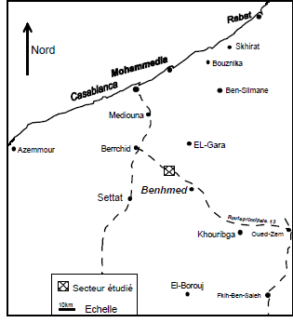

**Fig.1:** geological setting of the sampling area.

This material was mostly milled and sieved and the acquisition of the average diameter of 0.112 mm.

**2.2. Preparation of metallic solutions**

Copper metal solutions are prepared by dissolving salt of hydrated copper sulfate (CuSO4 5H2O) in distilled water. The pH of the solution is adjusted with sulfuric acid (H2SO4) and sodium hydroxide (NaOH) using a type of pH meter .

**2.3. Technique of adsorption**

The extraction of metal cations Cu2+ by the the natural clay was conducted by contacting 100 ml of the metal solution of a concentration and a pH known, with a known mass of clay into beakers of 250 ml at a temperature of 20°C. Then the system is stirred until equilibrium. Samples were carried out in the aqueous solution. Each sample was diluted adequately with distilled water and analyzed using flame atomic absorption spectrometry. The spectrometer used was Varian AA Spectrometer 220 types.

**3. Results and discussion.**

**3.1. Clay characterization**

**3.1.1. X-ray fluorescence spectroscopic analysis**

The chemical composition of the clay was determined by X-ray fluorescence type "Axios", with wavelength dispersion 1kW, method of preparation Pastille (PROT-ELE03-v01).

**Table 1:** Chemical composition of the raw clay(%).

|  |  |
| --- | --- |
| ***Composition*** | ***Content (%)*** |
| ***SiO2***  ***Al2O3***  ***Fe2O3***  ***CaO***  ***MgO***  ***K2O***  ***Na2O***  ***TiO2***  ***P2O3***  ***P.A.F*** | *50,5*  *23,6*  *5,57*  *3,4*  *2.35*  *2.22*  *1.3*  *0,65*  *11,2*  *9.93* |

The chemical analysis showed that the main constituents of raw clay are silica,alumina and iron oxides (Table1 ). The excess of SiO2 is due to the presence of quartz, as shown by XRD.

**3.1.2. X-Ray Diffraction**

A mineral analysis of the clay was performed by X-ray diffraction (XRD) powder using a Philips Analytical Diffractometer type functioning at wavelength Kα of copper (λ = 1,5405A°). The Identification of various crystalline phases was carried out by referring to the database and using a data processing software PANalytical X'Pert Pro Highscore Plus**.**



**Fig. 1.** XRD spectra of the examined clay

The diffractogram of clay studied shows that the clay is composed of kaolinite with a 38.7%, Muscovite with a 22.2%, Illite with a14.8%, Halloysite with a 12% and Quartz with a 12.3%.

Quantification of argillaceous phases was carried out by the method of Reitveld (filtering), the quality of the refinement has been confirmed by reliabilité factors Rp 15% , Rwp 20% and Chi = 1.76.

**3.1.3. Infrared spectroscopy**

Infrared transmission spectra (IR) were recorded on a FFT / IR-4600typeA spectrometer, spectra were recorded between 4000-400 cm-1 .

The groups may be incorporated into the clay structure studied were revealed using the Fourier transform spectrometry model FT/IR-4600 type A. The spectrum obtained is shown in Fig (2).



**Fig. 2.** Infrared spectrum of the examined clay

The infrared spectrum of the clay Moroccan shows absorption bands associated with the following bonds:

- The band that lies between 3200-3700 cm-1 show a peak at 3626cm-1 is the elongation vibration of the hydroxyl group -OH linked to the constitution water.

- The band between 1300-1700 cm-1 has peaks at 1644 and 1433 cm-1 corresponds to deformation vibrations of the -OH bond due to water molecules adsorbed between the layers.

- The presence of the Si-O: They are characterized by an absorption band between 900-1200 cm-1. Infrared spectra confirmed the presence of silica compounds.

- We also note a wide band located towards the 795 cm-1 and 776 cm-1 attributed probably to the deformation vibrations of Fe-Fe-OH. That to 518 cm-1 435 cm-1 are assigned respectively to the deformation vibration of Si-O-Al and Si-O-Si.

Based on the bibliographic data [18-20] we can only confirm the results previously obtained by XRD.

**3.1.4. Scanning electron microscope**

A scanning electron microscope (SEM) equipped with an X-ray energy dispersion spectrometer (EDS) was used to characterize the morphology of clay particles and to perform point elemental analysis .

SEM images recorded before and after adsorption of copper ions on raw clay are presented in Fig. 3.

(a)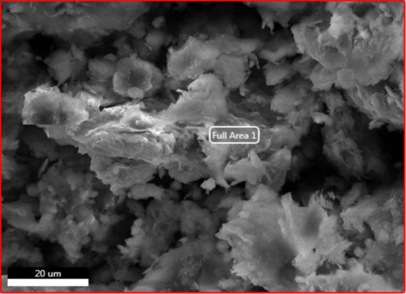(b)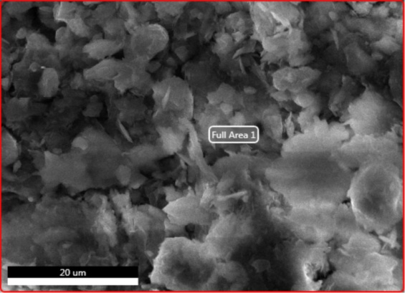

**Fig.3.** SEM images recorded before (a) and after (b) adsorption process

of copper ions on raw clay.

The enlarged images produced by SEM at 2000 times magnification show that the studied material micrograph of the samples (Fig.3 a and b), present generally a granular structure illustrate some tiny particles as well as particles of a somewhat larger size indicating crystallinity. When comparing the micrograph of the raw sample and after adsorption, there is a little difference. Raw sample (a) is more heterogeneous with more open porosity.

EDS (fig.4) elemental analysis over a number of selected crystals showed that they are composed of Si, Al, O, Ca, Mg and Fe the biggest constituent composition it is oxygen average of 47.2% by weight and 23.3% Si is a component of the clay.

(a)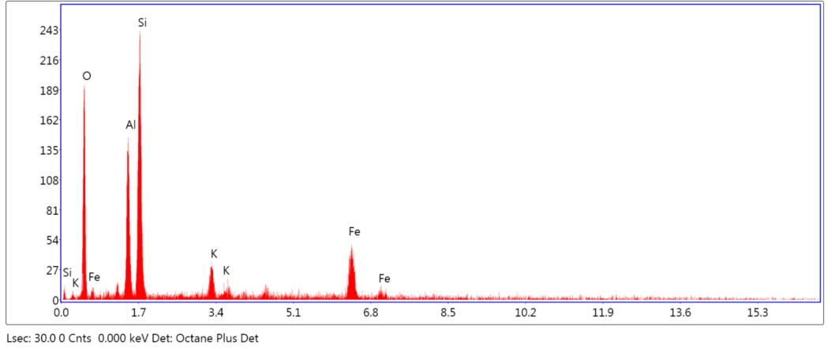

(b)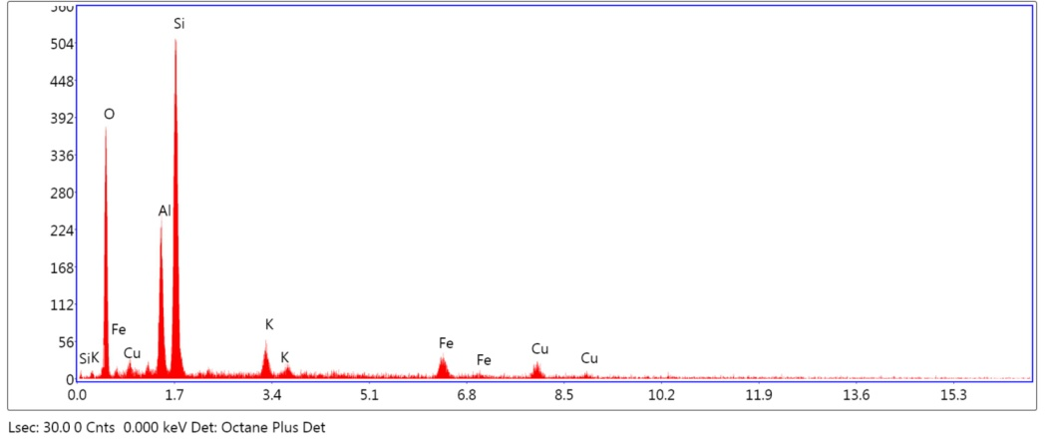

**Fig.4 :** EDS elemental analysis recorded raw clay

The spectrum of the natural clay sample EDX (Fig. 4.a) shows the absence of the characteristic peak of copper. On the other hand, on the clay spectrum after adsorption, there are two peaks of copper. This means that the copper has been inserted into the clay matrix, which explains the compacted clay surface morphology observed after adsorption of the copper ions (Fig.4.b). This result indicates that the copper ions were adsorbed on the clay surface.

**3.2. Adsorption study**

**3.2.1. Effect of contact time**

To study the effect of contact time on the adsorption of copper by crude clay Moroccan, a mass of 0.5 g of clay was put into contact with 100 ml of a copper solution.

The mixture is stirred for 140 minutes. Then we followed the variation of the amount of copper adsorbed (mg/g) versus contact time for various initial concentrations of copper up of 10, 25 , 50 to 100 mg/L and at a constant temperature and pH (T=20 °C and pH=5.5).

The amount of the solute absorbed per mass unit of the adsorbent is given by the following equation:

$$q_{t}=\left(C_{o}-C_{t}\right).\frac{V}{m}$$

With:

qt: Adsorption capacity (mg.g-1).

Co: Initial concentration of the solute (mg.L-1).

Ct: Instantaneous concentration of the solute (mg.L-1).

m: Mass of adsorbent (g).

V: Volume of the solution (L).

The curves representing the variation of the adsorption capacity of the copper by the crude clay in function of time are shown in Fig (5)

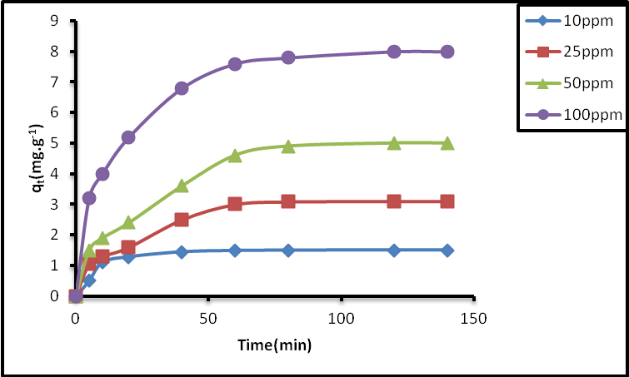

**Fig. 5.** Variation of the amount of copper absorbed by the clay as a function of time

From the curves shown in Fig.5, it is found that the amount of adsorption qt (mg of adsorbate per gram of adsorbent) increases with contact time in proportion as the copper concentration of the metal solution increases. The extraction equilibrium is reached after 40 min for a low concentration of copper (10 mg/L) while it reached after 80 minutes for a high concentrations of copper (25 and 100 mg/L).

**3.2.2. Effet of pH**

The effect of pH imposed on the solution of copper (II) known by an initial concentration of 10 mg.L-1 of the clay adsorption capacity was studied. The pH range varies from 3 to 7 and the amount of clay used is 0.5 g, the system is stirred for 120 minutes. The results obtained are illustrated in fig.6.

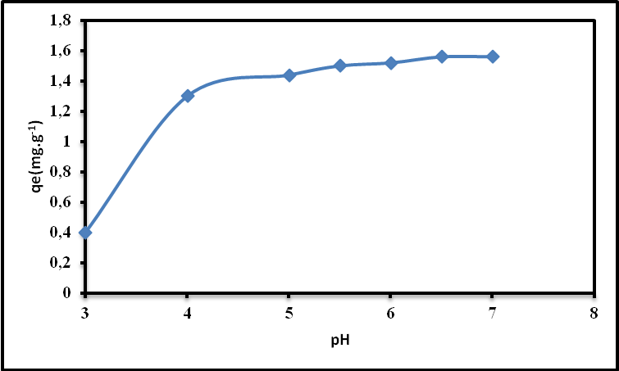

**Fig.6** : Evolution of the adsorption capacity of clay in Cu (II) as a function of pH.

(Vaq = 100ml, [Cu2+]i = 10mg.L-1, marg=0.5g, T=20°C ).

From the data of Fig (6), it is noted that the quantity of copper (II) fixed by the clay at equilibrium is all the more important as the pH imposed on the metal solution is high. Indeed, from pH = 3 to 5.5 the retention capacity of Cu (II) increases from 0.4 to 1.5 mg.g-1 . This result can be explained by the fact that, at low values of pHi, the surface of the adsorbent would also be surrounded by H+ ions, which would decrease the interaction of copper with the adsorbent. After that, theretention capacity increasing From 1.5 to 1.6 mg.g-1 for a pH values from 5.5 to 7 respectively. The same results were obtained using a natural clay (Cankırı bentonite) by Sevil Veli et al. [21].

**3.2.3. Effect of temperature**

The influence of temperature on the adsorption capacity of copper by the clay was studied in the range 20-60°C. The trials were performed on mixtures of 100 ml of the copper solution at the concentration of 10 mg/L, with a mass of 0.5g of clay Moroccan in a beakers of 250 ml and at pH=5,5. These mixtures are kept at constant agitation for duration of 120 minutes. The residual copper concentration was determined by atomic absorption spectrometry at flame. The results obtained are shown in Fig.7.

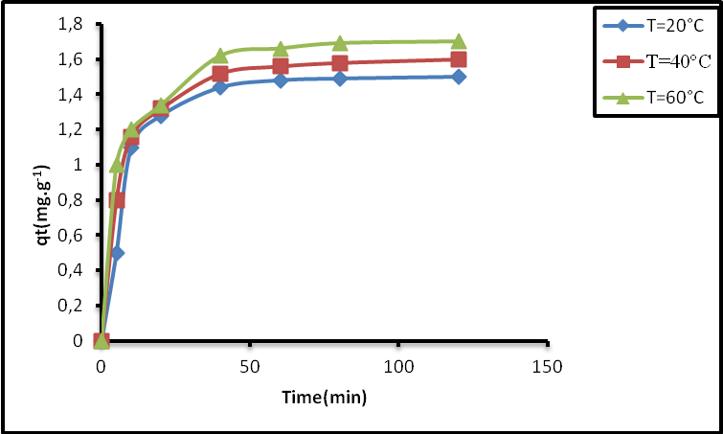

**Fig.7.**Effect of temperature on the adsorption of copper onto clay Moroccan versus time

(20°C, 40°C and 60°C)

From the results in Fig.7, we note that the heating slightly favors increasing the ion capacity of Cu2+ on clay. This result may be due to the increased mobility of copper ions which promotes their penetration into support. The same results were found by Francisco Arias and al.[22] adsorbing Zn2+ ion by a Kaolin clay.

**3.2.4. Kinetic study**

To describe the phenomenon of copper adsorption on Moroccan clay we applied four kinetic models: The first pseudo model, the pseudo second order model, the model of Elovich and intraparticular diffusion model.

**First order Lagergren model**

Lagergren showed that the adsorption rate of the solute onto the adsorbent is based on the adsorption capacity and followed by a first order equation [23]. The linear form of the first-order equation is given by the following equation:

$$ln \left(q_{e}-q_{t}\right)=ln \left(q_{e}\right)-k_{1}t$$

qe and qt are the amounts of Cu (II) adsorbed (mg/g) at the time of equilibrium and at any instant of time, t, respectively. k1 (L/min) is the rate constant of the first order of the adsorption reaction.

For each starting concentration, the curve log (qt-qe) as a function of time t (Fig.8) is a straight line indicating that the adsorption kinetics is first-order, from which the constant k1 is estimated. The first order constants are summarized in Table 2.

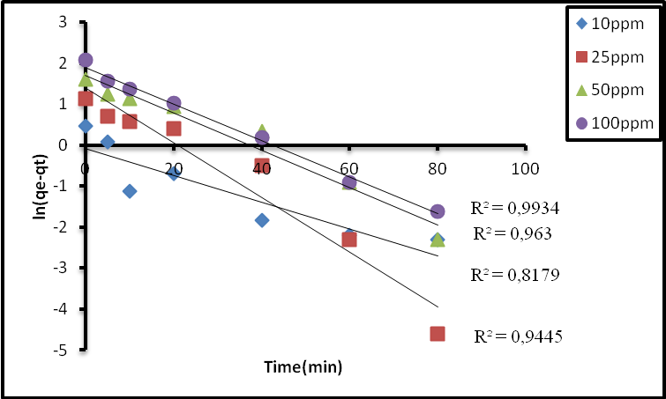

**Fig. 8.** Thefirst order kinetic model of adsorption of copper on the clay

at various concentrations

***Second-order kinetic model***

The term of the second order kinetic model was used to describe the kinetics of the adsorption process, the linear form of the equation is given by the following relationship:

with, k2 (g /mg.min) is the rate constant of the second order reaction [24].

In such circumstances, the curves of t /q versus t should give a linear relationship, which allows the calculation of qe and k2 from the slope. This model has the advantage of determining the adsorption capacity theoretically in order to compare the theoretical results with experimental.

The application of the kinetic model to experimental results is shown in Fig.9. and constants were summarized in Table 2.

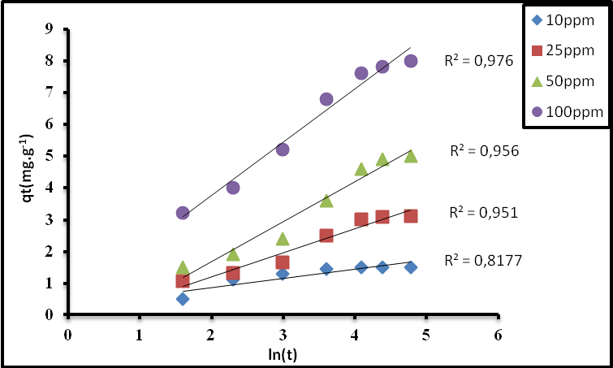

**Fig.9.** Second order kinetic model of adsorption of copper on the clay at various concentrations

These results show that the adsorption reaction is best described by the equation of the pseudo-second order for four concentrations of copper 10,25, 50 and 100 mg.L-1. Ineed, the correlation coefficients are closer to the unit, they exceed 0.98 and the value of the theoretical adsorption capacity (qe,theo=8.78) is almost equal to that experimental (qe,exp=8).

***Elovich kinetic model***

The model Elovich is one of the most used models to verify and describe the chemisorption during an adsorption [25]. This model is expressed in the following linear form:

$$q_{t}=\left(\frac{1}{β}\right)\ln\left(αβ\right)+\left(\frac{1}{β}\right)ln⁡(t)$$

With α (mg.g-1 .min-1) is the initial adsorption rate and β (g.mg-1) is the constant of desorption related to the extent of surface coverage and energy activation for the chemisorption.

The equation of Elovich was used to correlate our experimental data by plotting the curves qt = *f* (lnt) as shown in Fig.10. The values of the constants α, β and R2 are summarized in Table 2.

According to the data of Table 2 reveals that the correlation coefficients of the three lines obtained are higher than 0.81, which is in agreement with a chemisorptions process type of adsorption of copper onto the clay Moroccan.

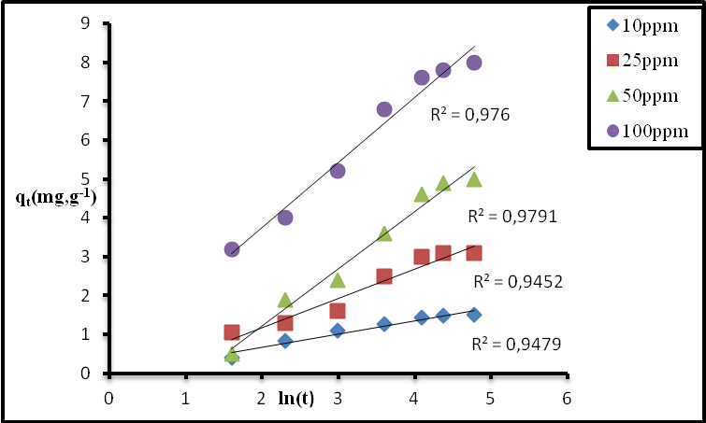

**Fig.10.** Elovich kinetic models for the adsorption of copper on the clay at different concentrations.

***Intraparticular Diffusion model***

The diffusion mechanism was further analyzed by the equation of the intraparticular diffusion rate, expressed in equation [26]:

$$q_{t }=k_{d}.t^{1/2}+C$$

Where Kd is the intraparticular diffusion rate constant (mg/g.min) and C is the intercept at the origin. The constant Kd was obtained from the slope of the qt curve with respect to t ½. The intraparticle diffusion is the only rate-determining step if the plot is linear and passes through the origin. The application of this model to the experimental results is shown in fig.11. and the values of the parameters are given in the table 2. As indicated by the presence of the intercept C ≠ 0 shows that the traces do not pass through the origin. The presence of the boundary layer effect (C) showed that there's a sorption of cuprous cations on the clay surface indicating that the internal diffusion is not the only rate limiting step of adsorption.

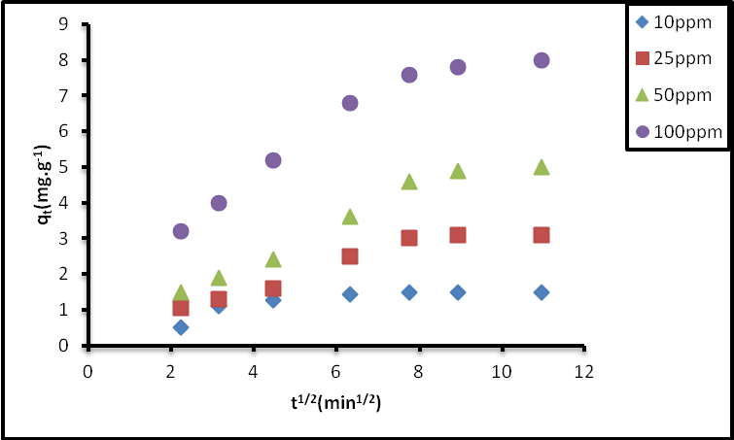

**Fig.11.** Curves illustrating the model Intraparticular diffusion for the adsorption of copper

on clay at different concentrations of copper.

**Table 2.** Parameters of kinetic models

| **[Cu2+] (mg/L)** | **Pseudo-first ordre** | | | **pseudo-second ordre** | | | **Elovich** | | | **Intra-particular Diffusion** | | |
| --- | --- | --- | --- | --- | --- | --- | --- | --- | --- | --- | --- | --- |
| **k1** | **qe** | **R2** | **k 2** | **qe** | **R2** | **β** | **α** | **R2** | **Kd** | **C** | **R2** |
| **10** | 0.026 | 0.61 | 0.8179 | 0.1 | 1.59 | 0.9967 | 0.59 | 0,78 | 0.817 | 0.092 | 0.675 | 0.653 |
| **25** | 0.035 | 2.01 | 0.9445 | 0.016 | 3.61 | 0.9873 | 0.79 | 0.64 | 0.951 | 0.269 | 0.544 | 0.914 |
| **50** | 0.035 | 3.6 | 0.963 | 0.007 | 5.98 | 0.9842 | 1.32 | 0.5 | 0.956 | 0.4536 | 0.575 | 0.945 |
| **100** | 0.9934 | 0.0448 | 0.9934 | 0.013 | 8.78 | 0.9985 | 3.5 | 2.17 | 0.976 | 0.588 | 2.404 | 0.914 |

***3.3. Isotherms Adsorption***

Adsorption isotherms are based on the equilibrium distribution of solute between the two phases involved in the process, namely the solid and the solution. The result obtained from the adsorption isotherm of cuprous cations on Moroccan clay is shown in Fig.12.

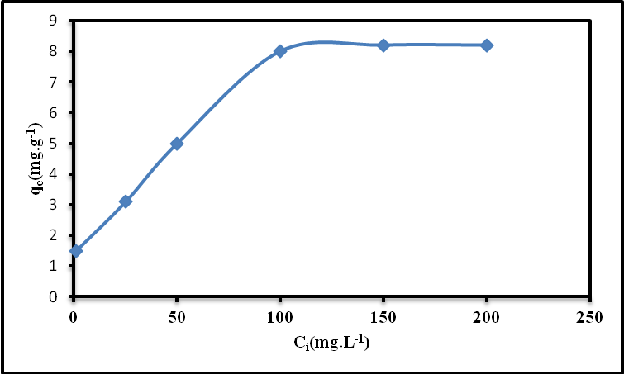

**Fig. 12.** Adsorption isotherms of copper on clay

To describe the behavior of copper during the adsorption process, the isotherm obtained in the present study was adjusted by the following models: Langmuir, Freundlich and Dubinin-Radushkevich.

***Freundlich Isotherm***

The Freundlich model [27], which gives an indication of the heterogeneity at the surface of the adsorbent, has been applied to measure the adsorption capacity. The linear form of the Freundlich equation can be written in logarithmic form according to the following relation:

$$\ln{qₑ}= ln K_{F}+ \frac{1}{n}ln Cₑ$$

KF and n are Freundlich constants related to the adsorption capacity and the adsorption intensity.

The experimental results obtained for the different concentrations of copper studied were modeled by the Langmuir equation and represented in fig.13. The values of the parameters of this isotherm are given in Table 3.

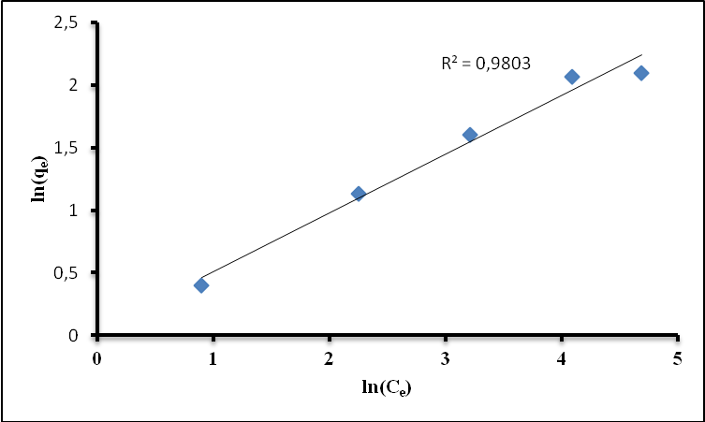

**Fig.13.** Adsorption isotherms of copper on the clay according to the Freundlich model

From the data in Table 3, the value of the Freundlich constant 1/n is less than 1 which indicates that the adsorption of the Cu2+ cations on the Moroccan clay is favorable according to this model. The value of the correlation coefficient is very close to unity (R²=0.98), showing that the experimental results are better correlated by the Freundlich equation.

***Isotherm of Langmuir***

The Langmuir model makes it possible to determine if a monolayer is adsorbed and if there is no interaction between the adsorbed molecules. The Langmuir equation is valid for only one monolayer adsorbed with a well defined number of uniform and identically energetic adsorption sites. The linear form of the Langmuir isothermal equation can be expressed as follows [28]:

$$\frac{1}{q_{e}}=(\frac{1}{K_{L}{.q}_{max}})\frac{1}{C_{e}}+\frac{1}{q_{max}}$$

With:

qe: quantity of substance adsorbed on 1 g of clay,

qm: amount required to cover the entire surface with a monolayer of the adsorbed substance (mg.g-1)

Ce: concentration of copper in solution at equilibrium (mg.L-1),

KL: adsorption energy constant.

The constants qm and KL can be determined from the slope of the line obtained from the representation of 1/qe in function 1/Ce.

Fig.14. shows the application of the Langmuir equation to the experimental results. The values of the parameters of this model are given in Table 3.

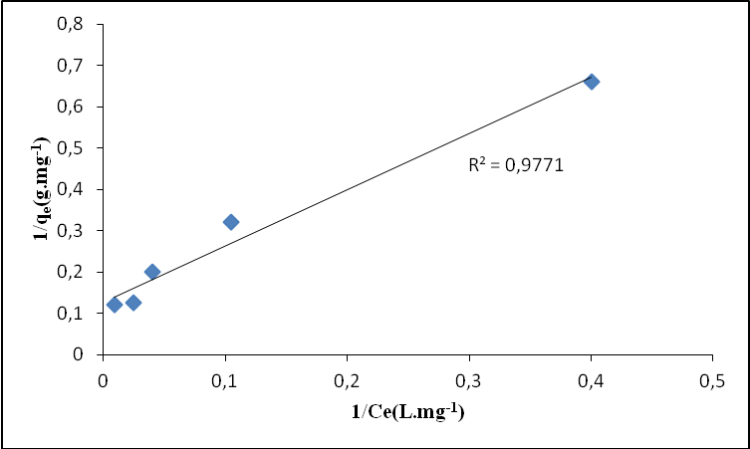

**Fig.14.**  Adsorption isotherms of copper on the clay according to the Langmuir model

An essential characteristic of the Langmuir isotherm can be expressed in terms of an adimensional separation factor (RL) [29], defined as follows:

$$R_{L}=\frac{1}{{1+K}_{L}C_{i}}$$

With:

Co: initial concentration of copper (mg.L-1).

The adsorption is said to be favorable if 0<RL<1 and unfavorable if RL>1.

Fig.15. illustrates the evolution of the separation parameter RL as a function of the initial concentration of copper. The estimated values of RL are less than unity (RL <0.3), showing a favorable adsorption of copper on the Moroccan clay according to the Langmuir model, which confirms the results obtained from the Freundlich model.

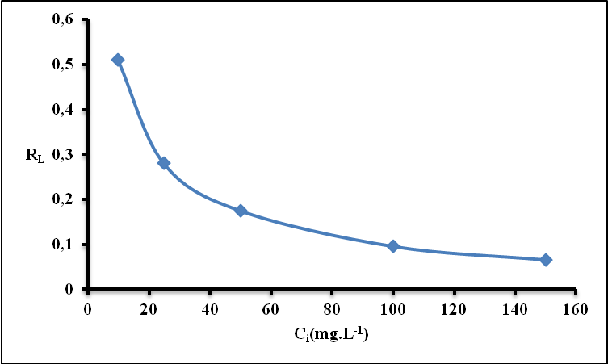

**Figure.15.** Evolution of the separation factor RL as a function of the initial concentration of copper

***Isotherm of Dubinin-Redushkevich***

The Dubinin-Redushkevich isotherm (D-R) [30] is applied to determine the nature of the adsorption mechanism based on potential theory assuming that the surface of the adsorbent is heterogeneous. The linear form of the Dubinin Redushkevich equation (D-R) is expressed as:

$${lnq}_{e}=\ln\left(q_{s}\right)-(Bε^{2})$$

With qs (mol.g-1) is the theoretical monolayer saturation capacity of the adsorbent and ε is the Polanyi potential

Since R is the gas constant (8.314 J.mol-1.K-1) and T is the absolute temperature (K).

The isothermal constants of qs and B are obtained from the ordinate and the slope of the curve of lnqe= *f* (ε2) respectively.

Fig.16. shows the application of the Dubinin-Redushkevich model to the experimental results. The parameters of this model are grouped in Table 6.

Based on the correlation coefficient value (R² = 0.684), it is found that the D-R isotherm did not provide a good fit. Consequently, the adsorption of Cu2+ ions by Moroccan clay is well described by the Freundlich model, which indicates that the adsorption is carried out in a multilayer.

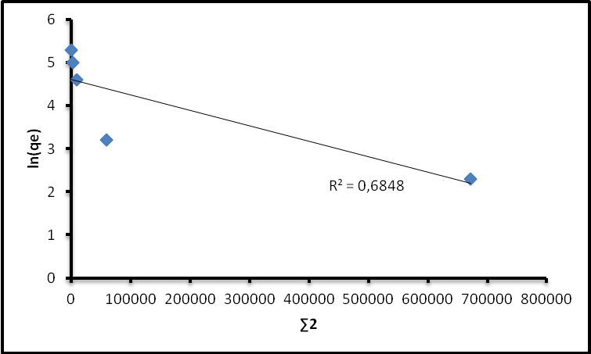

**Fig.16.** Adsorption isotherms of copper on the clay according to model of Dubinin-Redushkevich

**Table 3.** Constant adsorption isotherms of copper on clay

|  |  |  |
| --- | --- | --- |
| **Langmuir parameters** | **qm (mg. g-1)** | 7.83 |
| **KL (L. mg-1)** | 0.009 |
| **R²** | 0.977 |
| **Freundlich parameters** | **KF** | 0.47 |
| **n** | 1.93 |
| **R²** | 0.999 |
| **D-R parameters** | **qs (mol. g-1)** | 12.55 |
| **B.10-6(mol2.kJ-2)** | 4 |
| **R2** | 0.684 |

***3.4. Thermodynamic study of copper adsorption***

Thermodynamic parameters such as Gibbs free energy (ΔG°), standard enthalpy (ΔH°) and standard entropy

(ΔS°) were calculated using the following equations [31,32]:

$$k_{c}=\frac{C_{a}}{C_{e}}$$

$$∆G°=RTlnK_{c}$$

$$∆G°=∆H°-T∆S°$$

Kc is the equilibrium constant, Ca is the concentration at equilibrium in phase adsorbent (mg/L) and Ce is the equilibrium concentration in solution (mg/L). ΔH ° and ΔS ° were obtained from the slope and the ordinate at the origin of G as a function of T.

From the straight line obtained in Fig.17, it was possible to deduce the various parameters grouped in Table 4. The enthalpy values of free ΔG ° are negative, indicating the feasibility and spontaneity of adsorption of copper on Moroccan clay, whereas the negative value of ΔS ° shows that there is a decrease of Disorder in the solid/solute interface solution system during the adsorption process. The obtained value of ΔH° is positive indicating that the adsorption of copper on the Moroccan clay is endothermic.

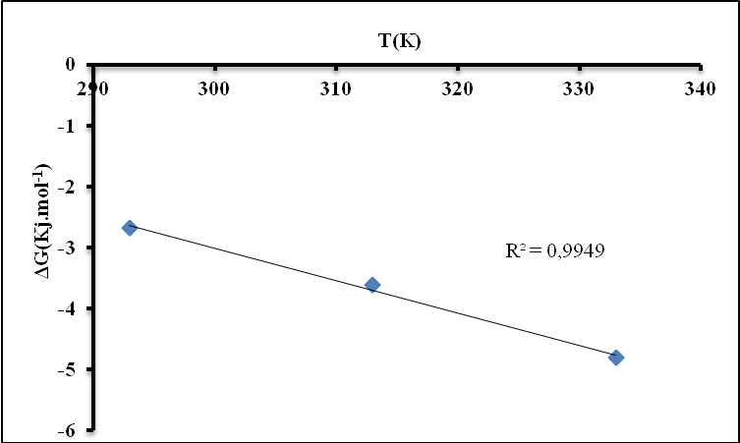

**Fig.17.** Determination of thermodynamic parameters

**Table 4.** Thermodynamic parameters of Cu (II) adsorption on clay

|  |  |  |  |
| --- | --- | --- | --- |
| **Temperature (K)** | **ΔG° (kJ/mol)** | **ΔH° (kJ/mole)** | **ΔS°(KJ/mol.K)** |
| **293** | -2.676 |  |  |
| **313** | -3.607 | 12.941 | 0.0531 |
| **333** | -4.802 |  |  |

**Conclusions**

The removal of copper ions from a synthetic aqueous solution by natural clay was studied. The results show that:

- The kinetic study indicates that the adsorption of copper ions is more or less a two-step process: rapid adsorption of the copper metal ion on the external surface followed by an intraparticular diffusion of the adsorbent which has to confirmed by intraparticular diffusion model, and also the process of adsorption of copper follows the pseudo-second order kinetic model.

- The Freundlich isotherm is the most applicable with respect to the Langmuir isotherm to describe the adsorption of copper on the clay. The values of the RL (RL<1) constants in Langmuir isotherms and the constant 1/n (1/n<1) of Freundlich give a favorable indication of adsorption.

- Thermodynamic parameters are determined at three different temperatures and it has been found that the adsorption process is endothermic due to ΔH° positive and the free energy values of Gibbs ΔG° have been found to be negative, indicating the Feasibility and spontaneity of adsorption.

**References**

1. Azzam Eid M.S., Eshaq Gh., Rabie A.M., Bakr A.A. , Abd-Elaal Ali A., El Metwally A.E., Tawfik Salah M., *Intern. J. Biolog. Macrom.*, 2016, 89, 507-517.

2. Fu F., Wang Q., J. Environ. Manag., 2011, 92, 407-418.

3. Hamdaoui [O.](http://www.sciencedirect.com/science/article/pii/S0304389408005414), [*J. Hazard. Mater.*](http://www.sciencedirect.com/science/journal/03043894),2009, 161, 737-746.

4. [Qdais](https://scholar.google.fr/citations?user=4v1AmYQAAAAJ&hl=fr&oi=sra) HA., [Moussa](https://scholar.google.fr/citations?user=_kV9Q6cAAAAJ&hl=fr&oi=sra) H., *Desalin. J.*, 2004, 164, 105-110.

5. [Irani](https://scholar.google.fr/citations?user=57ZlLDgAAAAJ&hl=fr&oi=sra) M., Keshtkar AR, Mousavian MA. [*Chem. Engin. J.*,2011, 175, 251-259.](javascript:void(0))

6. [Rodrigues](http://www.sciencedirect.com/science/article/pii/S1383586608001457) G. D., [Hespanhol da Silva](http://www.sciencedirect.com/science/article/pii/S1383586608001457) D. C, [Mendes da Silva](http://www.sciencedirect.com/science/article/pii/S1383586608001457) L. H,  [Paggioli](http://www.sciencedirect.com/science/article/pii/S1383586608001457) F. j,  [Minim](http://www.sciencedirect.com/science/article/pii/S1383586608001457) L. A, [Reis Coimbra](http://www.sciencedirect.com/science/article/pii/S1383586608001457) J. S., [*Separ. Purif. Techn.*](http://www.sciencedirect.com/science/journal/13835866)*,2008,* 62 (3), 687-693.

7. [Hoogerstraete](http://pubs.acs.org/author/Hoogerstraete%2C+Tom+Vander) T. V, [Onghena](http://pubs.acs.org/author/Onghena%2C+Bieke) B., [Binnemans](http://pubs.acs.org/author/Binnemans%2C+Koen) K.[,](http://pubs.acs.org/doi/abs/10.1021/jz4005366?journalCode=jpclcd#cor1) J. Phys. Chem. Lett.,2014, 4(10), 1659-1663.

8. Elanza S., Lebkiri A., Marzak S., Rifi E. H., Lebkiri A., Satif C., *J. Mater. Environ. Sci*.,2014, 5, 1591-1598.

9. [Aksu](http://www.sciencedirect.com/science/article/pii/S1359511305001285) Z., [Alper İşoğlu](http://www.sciencedirect.com/science/article/pii/S1359511305001285) I., [*Pro. Biochem.*](http://www.sciencedirect.com/science/journal/13595113), 2005, 40(9), 3031-3044.

10. Chafki L., Ismi I., Elaidi H., Hatim Z., Lebkiri A., Rifi E. H., *Inter. J. Sci. Eng. Res.*, 2015,6 (1) , 678-684.

11. Elaidi H., Ismi I., Chafki L., Rifi E. H., Lebkiri A., Hatim Z. , *Inter. J. Sci. Eng. Res.*,2014, 5(11), 441-444.

12. Chafki L., Ismi I.,  Elaidi H., Hatim Z., Lebkiri A., Rifi E. H., *Chem. Pro. Engin. Res.*,2014, 29, 15-23.

13. Farooq U., Kozinski J. A., Ain Khan M., Athar M., *Biores. Technol.,2010,* 101, 5043-5053.

14. Kanti Sen T., Gomez D., *Desalin. J.*,2011, 267, 286-294.

15. Veli S., Alyuz B., *J. Hazard. Mater.*,2007, 149, 226-233.

16. [Sdiri A.,](https://www.sciencedirect.com/science/article/pii/S0169131716301016#!) [Khairy](https://www.sciencedirect.com/science/article/pii/S0169131716301016#!) M., [Bouaziz](https://www.sciencedirect.com/science/article/pii/S0169131716301016#!) S., [El-Safty](https://www.sciencedirect.com/science/article/pii/S0169131716301016#!) S., [Applied Clay Science](https://www.sciencedirect.com/science/journal/01691317) , 2016,126, 89-97.

17. SenGupta S., Bhattacharyya K.G., *J. Coll. Interf. Sci.,2006,* 295, 21-32.

18. Gionis V., Kacande G. H., Kastritis I. D., Chryssikos G. D., *Americ. Mineral.*, 91 (2006) 1125-1133.

19. Suárez M., García-Romero E., *Appli. Cl. Scie.*, 31 (2006) 154-163.

20. Blanco C., Gonzalez F., Pesquera C., Benito I., Mendioroz S., Pakhares J. A., *Spectros. Lett.*, 22 (1989) 659-673.

21. S. Veli, B. Alyuz, J. Hazard. Mater.,2007, vol.149, pp. 226-233.

22. [Arias](http://www.sciencedirect.com/science/article/pii/S0927775709004026) F., [Kanti Sen](http://www.sciencedirect.com/science/article/pii/S0927775709004026) T., [*Coll. Surf. A: Physic. Engin. Asp.*](http://www.sciencedirect.com/science/journal/09277757),  [348 (1-3](http://www.sciencedirect.com/science/journal/09277757/348/1)) (2009)100-108.

23. Lagergren S., *Kung. Sven. Vetenskapsakad. Handl.*, 24 (1898) 1-39.

24. Ho Y-S., Ofomaja A. E., *J. Hazard. Mater. B*, 129 (2006) 137-142.

25. Turner N. H., *J. Catal*., 36 (1975) 262-265.

26. Mezenner N. Y., Bensaadi Z., Lagha H., Bensmaili A., *Larhy. J.*, 11 (2012) 7-16.

27. Freundlich H., *Zeitsch. Physic. Chem.,* 57 (1907) 385-471.

28. Langmuir I., *J. Ameri. Chem. Socie.,* 38 (1916) 2221-2295.

29. Fang G-Z., Tan J., Yan X-P., *Anal. Chem*., 77 (2005) 1734-1739.

30. Dubinin M.M., Radushkevich L.V., *Proc. Acad. Sci. USSR Phys. Chem. Sect*.,1947, 55, 331-337.

31. [Yeddou Mezenner](http://www.sciencedirect.com/science/article/pii/S1385894708003768) N.,  [Bensmaili](http://www.sciencedirect.com/science/article/pii/S1385894708003768) A., [*Chem. Engin. J.*](http://www.sciencedirect.com/science/journal/13858947), 2009,[147 (2-3](http://www.sciencedirect.com/science/journal/13858947/147/2" \o "Go to table of contents for this volume/issue)), 87-96.

32. [Kul](http://www.sciencedirect.com/science/article/pii/S0304389410003158) A. R, [Koyuncu](http://www.sciencedirect.com/science/article/pii/S0304389410003158) H., [*J. Hazard. Mater.*](http://www.sciencedirect.com/science/journal/03043894), 2010,[179 (1-3](http://www.sciencedirect.com/science/journal/03043894/179/1)), 332-339.