Synthesis, Characterization And Biological Evaluation Of Benzimidazole - Dihydroartemisinin Hybrids As Potential Dual Acting Antimalarial Agents.

*Ukpe AJIMA¹, Johnson O. ONAH¹ and Noel N. Wannang²
¹ Department of Pharmaceutical and Medicinal Chemistry, Faculty of Pharmaceutical Sciences, University of Jos, PMB 2084, Jos, Nigeria.
Department of Pharmacology and Toxicology, Faculty of Pharmaceutical Sciences, University of Jos, PMB 2084, Jos, Nigeria.

*Corresponding author
Email: descar84@yahoo.com
Telephone number: +2347031284923

Supporting Information

UV SPECTRUM OF 5-BICAD
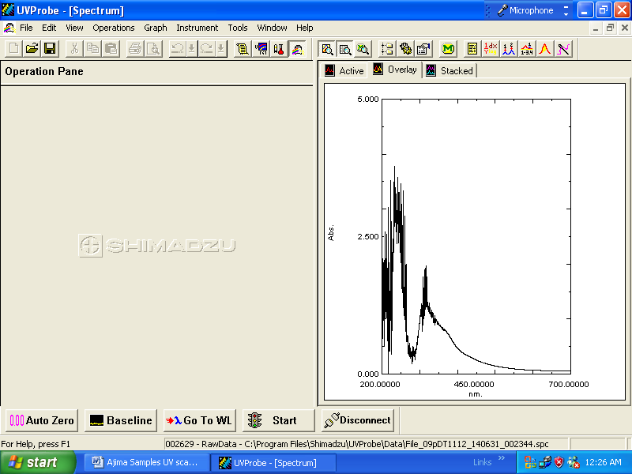

UV SPECTRUM OF 10β-(2-Bromoethoxy) Dihydroartemisinin

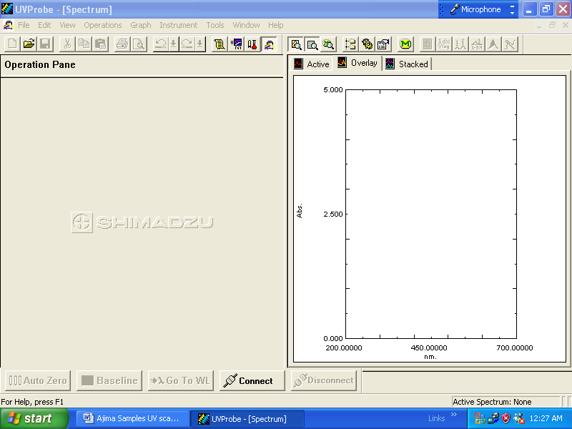

UV SPECTRUM OF MEBC
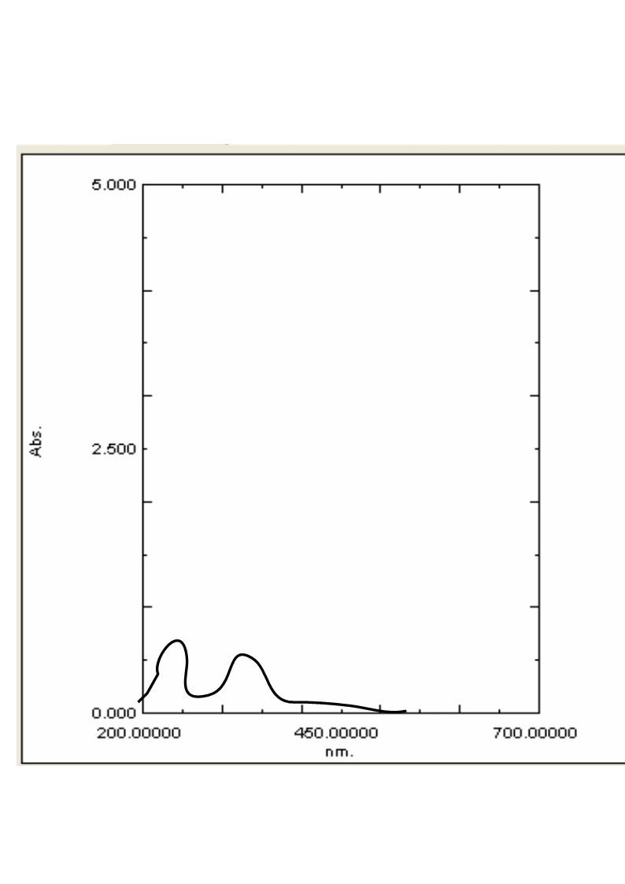

FTIR SPECTRUM OF 5-BICAD CONJUGATE

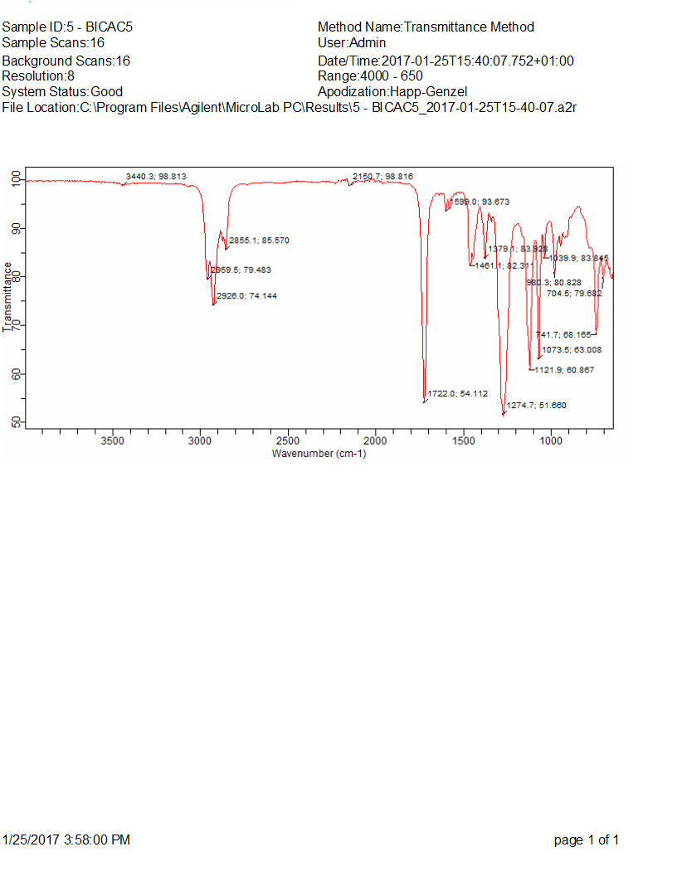

FTIR SPECTRUM OF 10β-(2-Bromoethoxy) Dihydroartemisinin
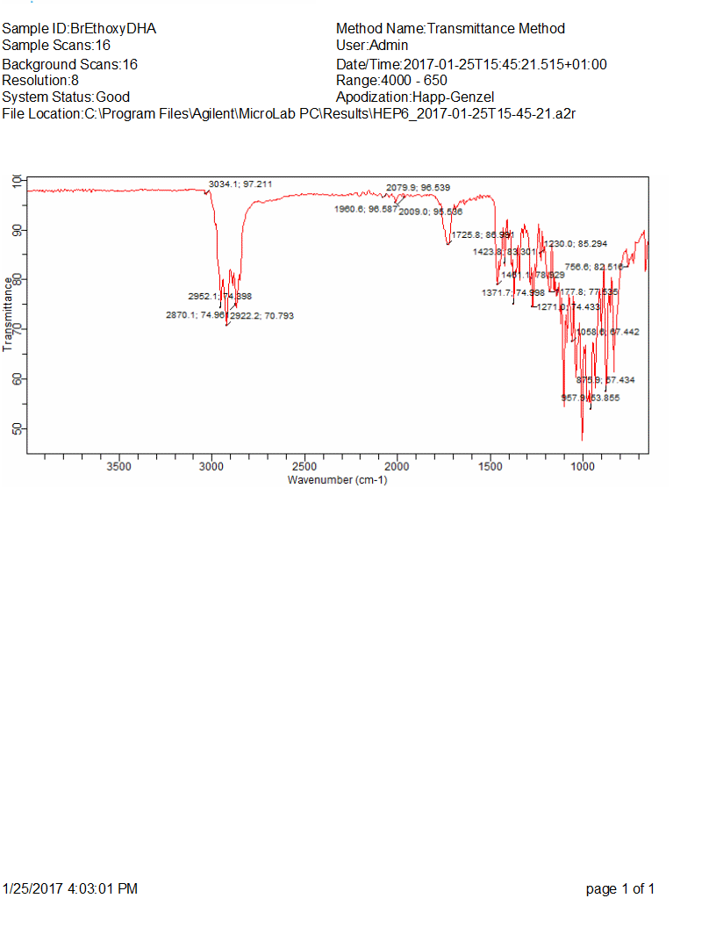

FTIR SPECTRUM OF MEBC CONJUGATE

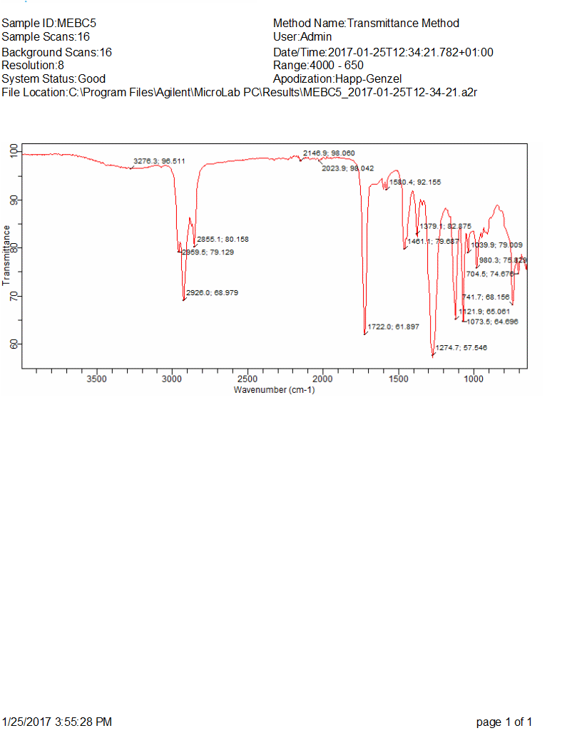

LCMS CHROMATOGRAM AND SPECTRUM FOR 5-BICAD

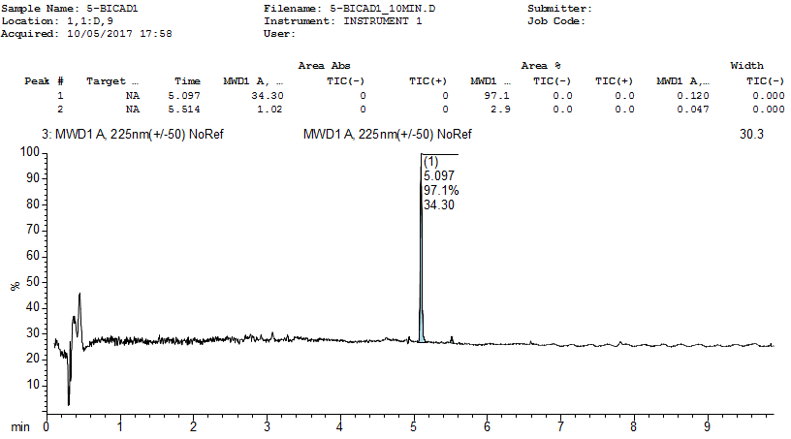

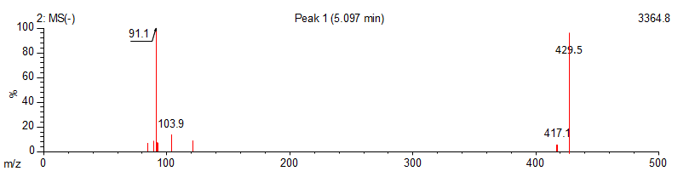

LCMS CHROMATOGRAM AND SPECTRUM FOR 10β-(2-Bromoethoxy) Dihydroartemisinin
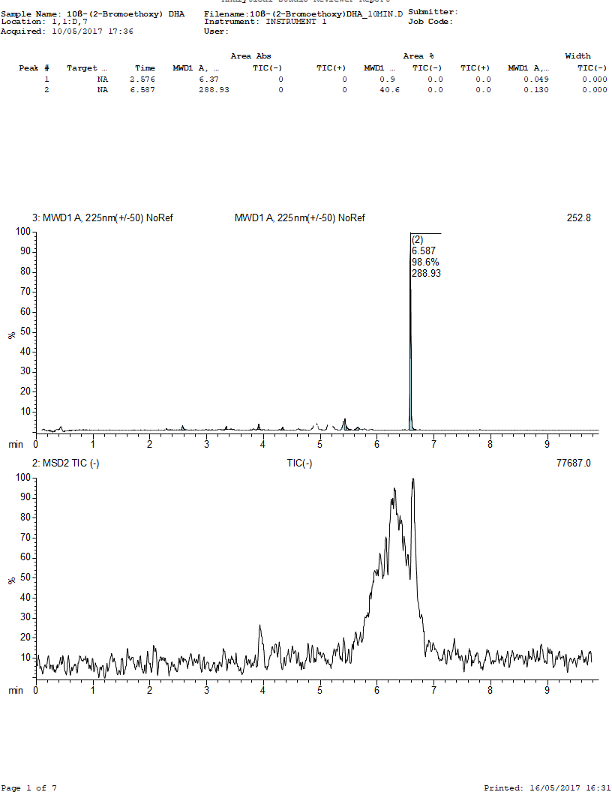
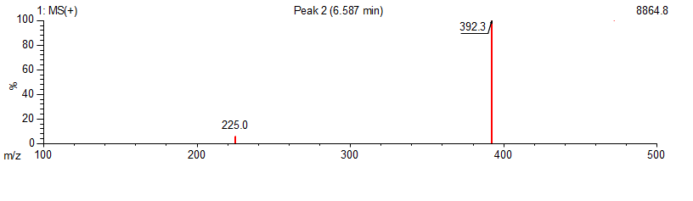

LCMS CHROMATOGRAM AND SPECTRUM FOR MEBC

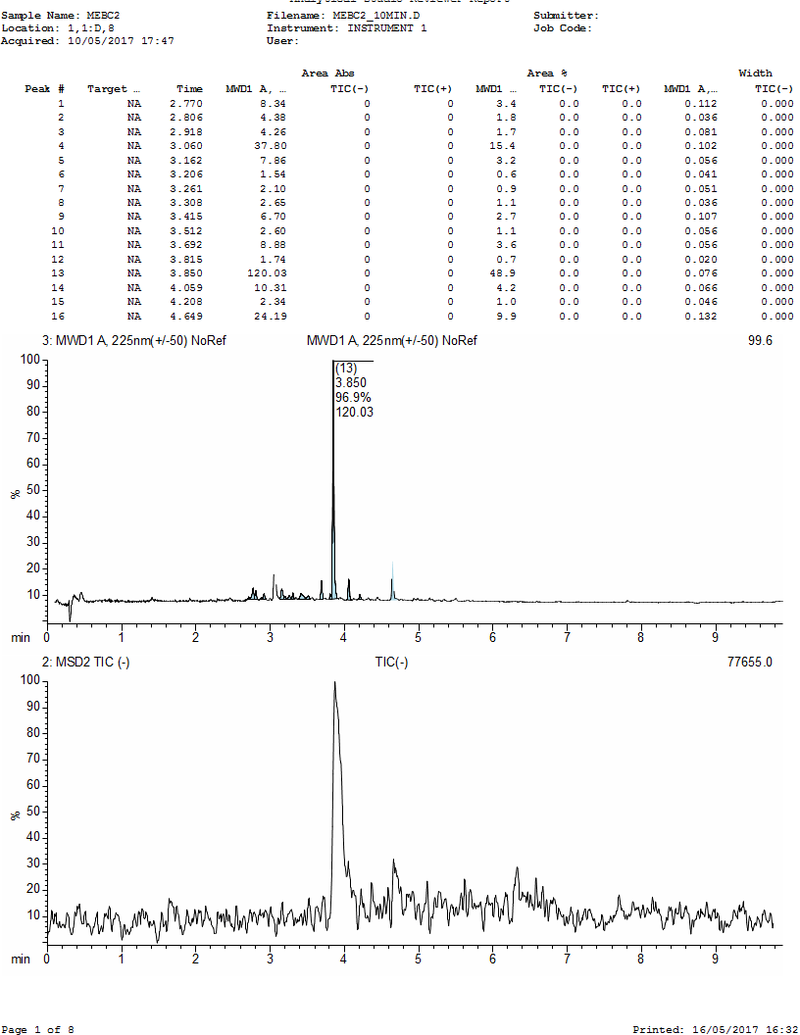
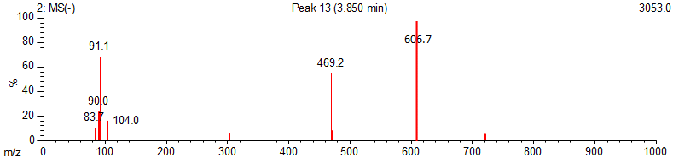
1H NMR SPECTRUM OF 5-BICAD

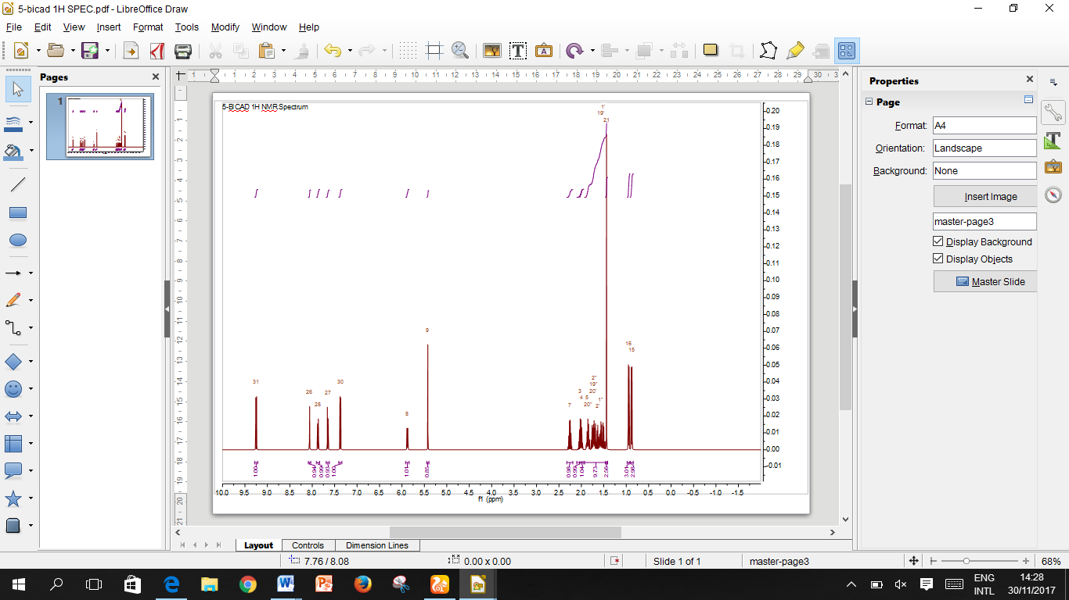
13C NMR SPECTRUM OF 5-BICAD
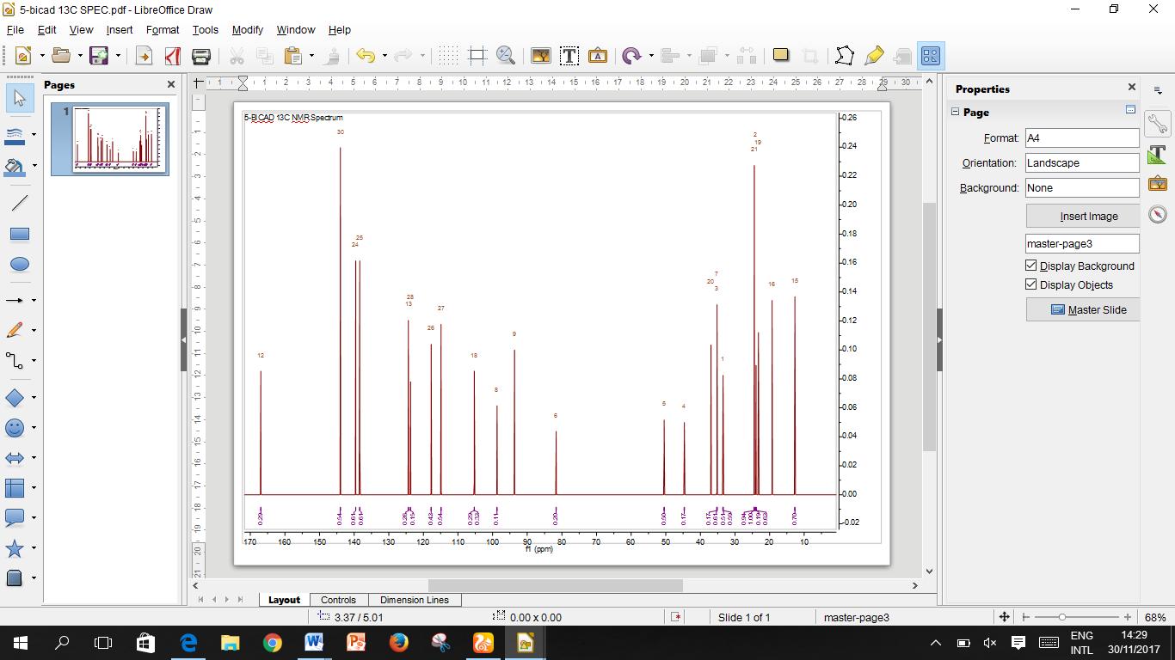
1H NMR SPECTRUM OF 10β-(2-Bromoethoxy) Dihydroartemisinin

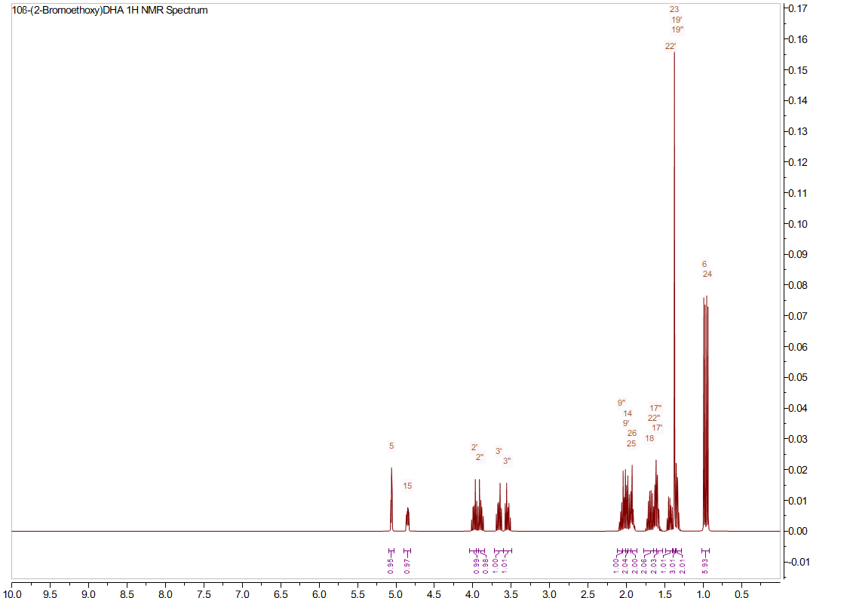

13C NMR SPECTRUM OF 10β-(2-Bromoethoxy) Dihydroartemisinin
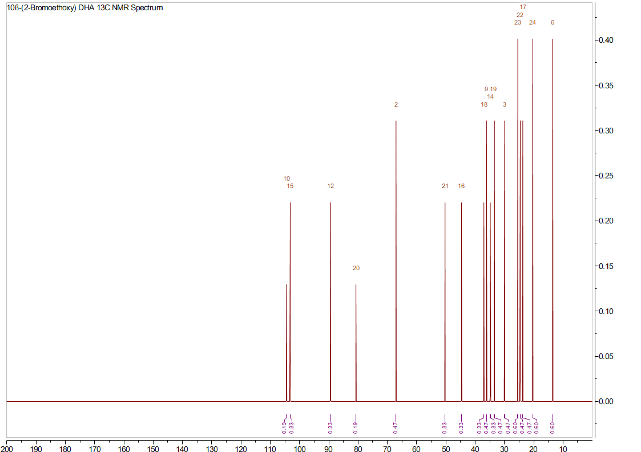

1H NMR SPECTRUM OF MEBC

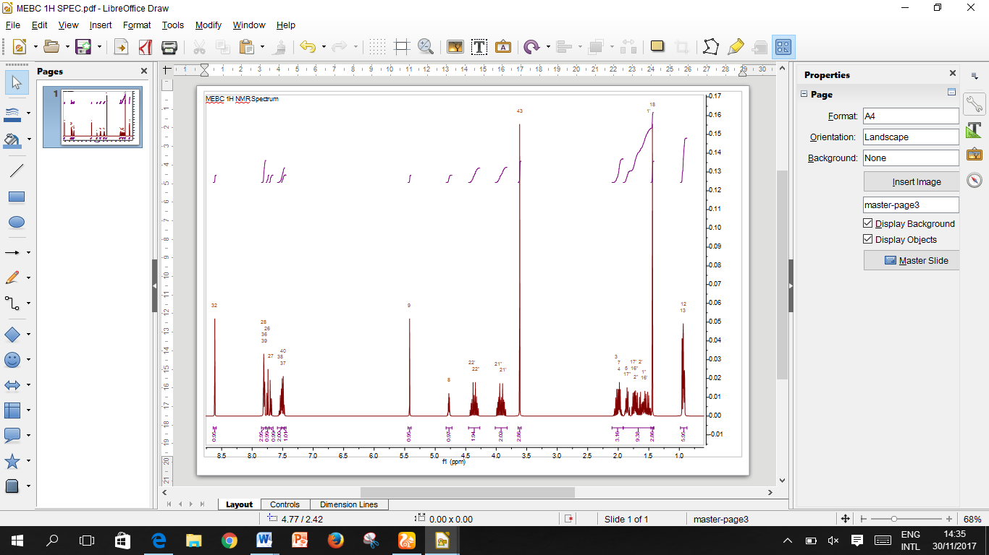
13C NMR SPECTRUM OF MEBC
