Vibrational study, thermal behavior of (NH₃C₆H₄COOH)₃H₂P₃O₁₀.3H₂O and crystallographic characterization of a new triphosphate
(NH₃C₆H₄COOH)₃H₂P₃O₁₀ fertilizer type NP

M. Belhabra¹*, I. Fahim¹, A. Atibi^{1,2}, K. El Kababi^{1,2}, A. Ouasri³, S. Zerraf¹,
M. Tridane^{1,2} , M. Radid¹, and S. Belaaouad¹.

¹⁾ Laboratoire de Chimie Physique des Matériaux LCPM, Faculté des Sciences Ben M’sik, B. P. 7955.
Bd Cdt Driss El Harti. Université Hassan II de Casablanca. Maroc.
²⁾ Centre Régional des métiers d’éducation et de formation Casablanca Anfa, Bd Bir Anzarane Casablanca. Maroc.
³⁾ Centre Régional des métiers d’éducation et de formation Rabat. Maroc.

Abstract: Chemical synthesis methods, X-ray diffraction and IR spectrometry studies are reported for an organic triphosphate (NH₃C₆H₄COOH)₃H₂P₃O₁₀.3H₂O and its anhydrous new form NH₃C₆H₄COOH)₃H₂P₃O₁₀. The hydrate compound (NH₃C₆H₄COOH)₃H₂P₃O₁₀.3H₂O was synthetised by the ion-exchange resin method. The dehydration of (NH₃C₆H₄COOH)₃H₂P₃O₁₀.3H₂O leads at 130°C to (NH₃C₆H₄COOH)₃H₂P₃O₁₀ crystallizing in the triclinic system with space group $P\overset{}{1}$ (Z = 2) [a = 14.566(6) Å, b = 6.866 (1) Å, c = 6.445 (6)Å, α = 112.36 (3)°,
β = 94.51 (1)°, γ = 95.94(7)°, and V = 587.98 (1)Å³]. Merit’s figures are M (10) = 91.9 and F (10) = 55.6 (0.0032, 56). Its thermal behavior and kinetic study were studied by using thermal analyses TGA and DTA techniques between 25 and 600°C.

Keywords: Chemical synthesis, para-carboxyphenylammonium triphosphate, IR spectrometry, vibrational study, thermogravimetric and differential analyses (TGA–DTA), Kinetic, Ozawa, KAS

Introduction

The P-carboxyphenylamine (4-aminobenzoic acid) considered as a biological molecule, has an anticoagulant and antioxidant propreties. Existing naturally in foods, it is produced by essential symbiotic bacteria to metabolize constantly in the human body [1]. The active sites of several biological systems have kind of hydrogen bonding in hybrid compound [2]. Indeed, the crystal structures of 4-carboxyphenylammonium dihydrogen phosphate and
4-carboxyanilinium hydrogen sulphate compounds have been recently studied [3, 4]. Furtherer, the p-carboxyphenylammonium dihydrogenmono-phosphate monohydrate compound was found to be consisted of H₂PO₄⁻ anions, water molecules and p- HOOC-C₆H₄-NH₃⁺ cations [5]. In this structure, anions and cations are linked to each other through strong hydrogen bonds, formed by all H atoms covalently bonded to anions, nitrogen, carboxylic groups and water molecules. A three-dimensional complex network of hydrogen bonds ensures the cohesion of the ionic structure.
During a systematic investigation of triphosphates associated to organic matrixes, the triphosphate trihydrate of para carboxyphenylammonium (NH₃C₆H₄COOH)₃H₂P₃O₁₀.3H₂O was prepared by the method of ion-exchange resin [6] in our laboratory [7, 8]. The present study reports on the chemical preparation, XRD data, IR vibrational spectroscopy, thermal dehydration and decomposition by thermal analyses (TGA and DTA) of (NH₃C₆H₄COOH)₃H₂P₃O₁₀.3H₂O. The total thermal dehydration of this compound, leads to the corresponding anhydrous form, which is a new triphosphate of para carboxyphenylammonium (NH₃C₆H₄COOH)₃H₂P₃O₁₀. The kinetic parameters of dehydration have been studied for the title compound. Indeed, (NH₃C₆H₄COOH)₃H₂P₃O₁₀.3H₂O and (NH₃C₆H₄COOH)₃H₂P₃O₁₀ are binary organic fertilizers type NP (nitrogen and phosphorus) second generation and corrosion inhibitors [9-11]. The two triphosphates associated to para carboxyphenylammonium reported in the present work are stable in the normal conditions of temperature and hygrometry.

Experimental

Synthesis (NH₃C₆H₄COOH)₃H₂P₃O₁₀.3H₂O
Single crystals of (NH₃C₆H₄COOH)₃H₂P₃O₁₀.3H₂O were prepared by slowly adding dilute cyclotriphosphoric acid, H₅P₃O₁₀, to an aqueous solution of para carboxyphenylammonium, NH₂C₆H₄COOH according to the following chemical reaction :
H₅P₃O₁₀ + 3NH₂C₆H₄COOH + 3H₂O (NH₃C₆H₄COOH)₃H₂P₃O₁₀.3H₂O
The so-obtained solution was then slowly evaporated at room temperature until large prisms of (NH₃C₆H₄COOH)₃H₂P₃O₁₀.3H₂O were obtained. The triphosphoric acid, H₅P₃O₁₀, used in this reaction was prepared from an aqueous solution of Na₅P₃O₁₀ passed through an ion-exchange resin ‘Amberlite IR120’ [6]. (NH₃C₆H₄COOH)₃H₂P₃O₁₀.3H₂O is stable in the normal conditions of temperature and hygrometry. (NH₃C₆H₄COOH)₃H₂P₃O₁₀.3H₂O was also obtained using the same method, by the hydrolysis of P₃O₉³⁻ ion in aqueous solution. (NH₃C₆H₄COOH)₃H₂P₃O₁₀
The product resulting from the total thermal dehydration of (NH₃C₆H₄COOH)₃H₂P₃O₁₀.3H₂O, at 130°C, is a new anhydrous triphosphate of para carboxyphenylammonium (NH₃C₆H₄COOH)₃H₂P₃O₁₀. The reaction is the following:
(NH₃C₆H₄COOH)₃H₂P₃O₁₀.3H₂O (NH₃C₆H₄COOH)₃H₂P₃O₁₀ + 3H₂O
(NH₃C₆H₄COOH)₃H₂P₃O₁₀ is stable in the normal conditions of temperature and hygrometry.
With additional increase in temperature, (NH₃C₆H₄COOH)₃H₂P₃O₁₀ is decomposed by evolving NH₃ followed by CO₂.

Data Collection and Reduction
X-ray diffraction. Powder diffraction patterns for the two title compounds were collected with a SIEMENS D 5000 diffractometer using Cu Kα1 radiation (λ = 1.5406 Å). The experimental 2θ range was from 5 to 60° (2θ) with a step size of 0.01° and a counting time of 30 s per step. The program of graphic tool for powder diffraction named.
WinPLOTR was used to determine the observed diffraction peak positions for (NH₃C₆H₄COOH)₃H₂P₃O₁₀.3H₂O and (NH₃C₆H₄COOH)₃H₂P₃O₁₀. The unit-cell parameters of (NH₃C₆H₄COOH)₃H₂P₃O₁₀ were calculated by means of the computer program Dicvol [12].
Thermal behavior. Coupled TGA-DTA thermal analyses were performed using the multimodule 92 Setaram Analyzer operating from room temperature up to 1400°C, in a platinum crucible, at various heating rates from 1 to 15°C/min.
Infrared spectrometry. The infrared spectra of the powdered samples of (NH₃C₆H₄COOH)₃H₂P₃O₁₀.3H₂O and (NH₃C₆H₄COOH)₃H₂P₃O₁₀ were recorded in the range 4000-400 cm⁻¹ with a Perkin-Elmer IR 983G spectrophotometer, using samples dispersed in spectroscopically pure KBr pellets.

Results and Discussion

A. Crystallographic Characterization

(NH₃C₆H₄COOH)₃H₂P₃O₁₀.3H₂O
(NH₃C₆H₄COOH)₃H₂P₃O₁₀.3H₂O studied elswhere [7,8] crystallizes in the triclinic system with space group $P\overset{}{1}$ (Z = 2) [a = 9.844(1) Å, b = 13.086(4) Å, c = 13.320(2) Å; α = 107.12(2)°, β = 106.08(1)°, α = 97.87(2)°, and V = 1530(1) Å³].

(NH₃C₆H₄COOH)₃H₂P₃O₁₀
(NH₃C₆H₄COOH)₃H₂P₃O₁₀ crystallizes in the triclinic system with space group $P\overset{}{1}$(Z = 2). Its unit-cell dimensions are: a = 14.566(6) Å, b = 6.866 (1)Å, c = 6.445 (6)Å, α = 112.36 (3)°, β = 94.51 (1)°, γ = 95.94(7)°, and V = 587.98 (1) Å³. Merit’s figures are M(10) = 91.9, and F (10) = 55.6(0.0032, 56).

B. Vibrational study

1. Vibrations analysis of H₂P₃O₁₀³⁻
The anion dihydrogenotriphosphate (H₂P₃O₁₀)³⁻ supposed to be of symmetry group C₁, has 39 internal vibration modes [Γ_{int} =3 9A’ (IR, Ra)]. According to this hypothesis, the anionic modes of (H₂P₃O₁₀)³⁻ free are all active in Raman and Infrared thus should appear in the form of simple bands.
In the structure of (NH₃C₆H₄COOH)₃H₂P₃O₁₀.3H₂O), space group $P\overset{}{1}$ (Group of factors Ci) [13], (H₂P₃O₁₀)³⁻ The anions have a C₁ site symmetry. this implies that all anionic internal modes (Table 1) generally remain infrared and Raman assets in the crystal site group. theoretically, the presence of two units per unit of formula (Z = 2) doubles the number of cationic and anionic modes with Ag and Au symmetry in the group of factors Ci. In the crystal being centro-symmetric (C_{i} group factor), only Au insensitive augs are active in infrared. All modes of vibration are theoretically active in infrared and Raman. These anionic modes correspond mainly to the vibrations of the PO₄³⁻ and P-O-P.

Table 1. Correlation table (C₁--->Ci) for the internal vibrational modes of (H₂P₃O₁₀)³⁻.

Point group : C1 | Site group : C1 | Factor group : Ci
39 A‘(Ra, IR) | 39 A‘(Ra, IR) | 39 Ag (Ra)  39 Au (IR)

2. Vibrations analysis of 4-carboxyphenyl ammonium
The free 4-carboxyphenyl ammonium cation is assumed to be of C_{s} symmetry point group, and then has 48 internal vibrational modes described as: Γ_{int} = 32A’ (IR, Ra) + 16 A’ (IR, Ra). According to this assumption, the cationic modes are all Raman and Infrared active and should appear as single bands. In the structure of (NH₃C₆H₄COOH)₃H₂P₃O₁₀.3H₂O compound, of $P\overset{}{1}$space group (Ci factor group) [13], 4-carboxyphenyl ammonium cations have C₁ site symmetry. This implies that all cationic internal modes (table 2) remain usually infrared and Raman actives in the site group of the crystal. The presence of two motifs per formula unit (Z = 2) doubles theoretically the number of cationic modes having A_{g} and A_{u} symmetry in the factor group Ci. It is concluded that all vibrational modes are theoretically Infrared and Raman active. Due to the centro symmetry of the crystal, only the ungerade modes A_{u} are Infrared active for the cations.

Table 2. Correlation table (C₁---> Ci) for the internal vibrational modes of (NH₃C₆H₄COOH)⁺.

Point group : C1 | Site group : C1 | Factor group : Ci
32A‘ (Ra, IR)  16 A“ (Ra, IR) | 32 A‘(Ra, IR)  16 A‘(Ra, IR) | 48 Ag (Ra)  48 Au (IR)

The mainly important cationic vibration bands correspond principally to the vibrations of amino NH₃⁺, carboxyl groups and benzene ring. It is to note that the distribution of the internal vibrations modes for benzene group by developing the normal coordinate analysis has been carried out [14]. In its free state, the NH₃⁺ cation has C_{3v} symmetry with a pyramidal geometry; the corresponding normal vibrational modes are described as: non degenerative modes [ν₁(A₁), ν₁(A₁)], and doubly degenerated [ν₃(E) and ν₄(E)], which all active as well as in Raman and In Infrared. In the 4-carboxyphenyl ammonium cation of C_{s} symmetry, all NH₃⁺ modes become non degenerative, with A’ and A” symmetry as indicated above, and remain usually Infrared and Raman active. The COOH has 9 internal vibrations modes given by 3m-3, where m is the number of atoms in the group. These modes correspond to: O-H stretching, C-O stretching, C=O Stretching, in-plane-rocking, in-plane bending of C-O, in-plane bending of C=O, in-plane-bending of OH, out-of-plane wagging, and out-of-plane torsion.

3. Infrared Spectra of hydrate and anhydrous compounds
The infrared spectra of (NH₃C₆H₄COOH)₃H₂P₃O₁₀.3H₂O and (NH₃C₆H₄COOH)₃H₂P₃O₁₀ compounds, recorded the range 4000–400 cm⁻¹, are given in Figure 1a and 1b. These compounds are consisted of NH₃⁺ groups, COOH, parsubstituted benzene ring, H₂P₃O₁₀, and 3H₂O in the case of hydrate compound.
* NH₃⁺ vibrations: Generally, the antisymmetric and symmetric stretching modes of the NH₃⁺ group appear in the spectral region of 3200-2800 cm⁻¹ spectral region; whereas the antisymmetric and symmetric deformations appear in the 1660-1610 cm⁻¹ and 1550-1480 cm⁻¹ regions, respectively. In the Infrared spectrum of the anhydrous compound, the ν_{as} (NH₃⁺) stretching is observed as a medium band at 3230 cm⁻¹. The ν_{s} (NH₃⁺) stretching modes give a weak and broad band at 2880 cm⁻¹ in the case of the anhydrous compound and a medium band at 2887 cm⁻¹ for the hydrate compound. The remaining bands corresponding to wagging w(NH₃⁺), twisting t((NH₃⁺) and rooking ρ (NH₃⁺) bending vibrations are assigned as indicated in the table 3.
* Carboxyl groups vibrations: Studying vibrational spectra of benzoic acid, Antony et al. [15] assigned C=O, C-O stretching modes; C-O, C=O in-plane bending, OH stretching, rocking mode, torsion mode and wagging mode to band appearing respectively at 1745 cm⁻¹, 1050 cm⁻¹, 594 cm⁻¹, 1804 cm⁻¹, 3785 cm⁻¹, 554 cm⁻¹, 594 cm⁻¹ and 441 cm⁻¹. Florio et al. [16] observed C=O stretching at 1752 cm⁻¹, C-O stretching at 1347 cm⁻¹, C-O in-plane bending at 628 cm⁻¹, OH stretch at 3785 cm⁻¹, rocking mode at 628 cm⁻¹, and wagging mode at 160 cm⁻¹. In present study, the assignement of bands corresponding to the different COOH vibrations is shown in Table 3.

* Para substituted benzene ring vibrations : the C-H stretching modes of benzene ring are generally expected in the 3115-3005 cm⁻¹ [17, 18]. The β(C-H) “in-plane” and δ(C-H) “out-plane” bending vibrations are located in the range 1250-1000 cm⁻¹ and 900-690 cm⁻¹, respectively [17, 18] . For the studied compounds, the β(C-H) and δ(C-H) of the benzene ring are observed in the expected ranges as indicated in the table 3. The C=C and C-C benzene ring stretching modes occur in the 1650-1430 cm⁻¹ and 1400-1300 cm⁻¹, regions respectively
[17, 18]. For the two compounds, these modes are assigned to the corresponding bands as illustrated in the table 3. Finally, the C-N stretching and the ring breathing modes were identified for the studied compounds, and given in the table 3.
* H₂P₃O₁₀³⁻ vibrations: The assignment of bands due to the fundamental modes, of valence and bending, of P₃O₁₀⁵⁻ anions are presented in Table 3 for both triphosphates. The frequencies of the P₃O₁₀⁵⁻ anion are assigned on the basis of the characteristic vibrations of the P–O–P bridge, PO₂ and PO₃ groups. Since the P–O bond in the PO₂ and PO₃ group is weaker than that in the
P–O–P Bridge, the vibrational frequencies of PO₂ and PO₃ are expected to be higher than those for P–O–P. The bands due to the symmetric and antisymmetric stretching frequencies of PO₂ and PO₃ in P₃O₁₀⁵⁻ are generally observed in the region 1190–1010 cm⁻¹ [19, 20]. The bands observed in the domain 970–840 cm⁻¹ are attributed to the antisymmetric and symmetric POP stretching modes. The bands due to δ(OPO), δ (PO₂), δ (PO₃) and δ (POP) are also identified in Table 3, which contains the IR frequencies and the vibrational modes corresponding to Rb₃H₂P₃O₁₀.1,5H₂O, para-carboxyphenylammonium NH₂C₆H₄COOH, compared with those of (NH₃C₆H₄COOH)₃H₂P₃O₁₀.3H₂O and (NH₃C₆H₄COOH)₃H₂P₃O₁₀. The IR frequencies of the P₃O₁₀⁵⁻ anions observed in the two triphosphates associated to para carboxyphenylammonium, (NH₃C₆H₄COOH)₃H₂P₃O₁₀.3H₂O and (NH₃C₆H₄COOH)₃H₂P₃O₁₀, are the same as those observed in the triphosphate associated to rubidium Rb₃H₂P₃O₁₀.1,5H₂O [19].
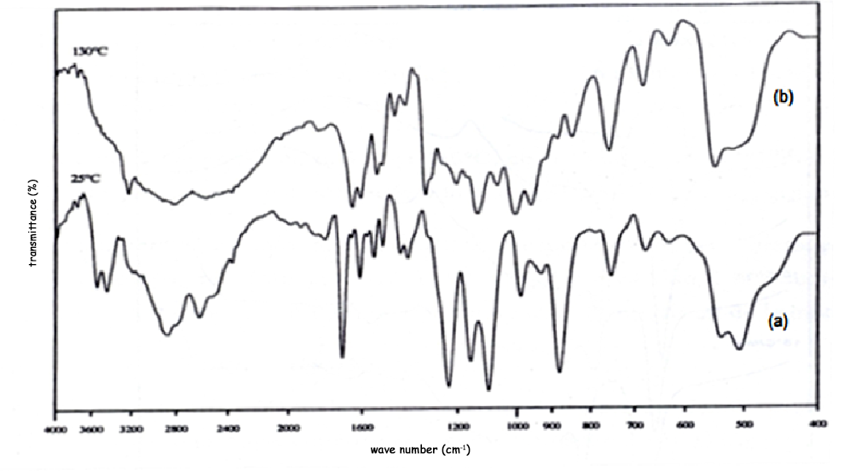
Figure 1: IR spectra of the phosphates: (a) (NH₃C₆H₄COOH)₃H₂P₃O₁₀.3H₂O and (b) (NH₃C₆H₄COOH)₃H₂P₃O₁₀

Table 3: Characterization of (NH₃C₆H₄COOH)₃H₂P₃O₁₀.3H₂O and (NH₃C₆H₄COOH)₃H₂P₃O₁₀ by IR vibration spectrometry [7, 8]
Rb₃H₂P₃O₁₀.  1,5H₂O | NH₂C₆H₄COOH | (NH₃C₆H₄COOH)₃H₂P₃O₁₀.3H₂O | (NH₃C₆H₄COO)₃H₂P₃O₁₀. | Vibrational modes
3553 |  | 3545 |  | ν (OH)  ν_{as} (NH₃⁺)  ν_{as} (NH₃⁺)
3428 | 3466 | 3449 |  | ν (OH)  ν_{as} (NH₃⁺)  ν_{as} (NH₃⁺)
 | 3367 |  |  | ν (OH)  ν_{as} (NH₃⁺)  ν_{as} (NH₃⁺)
 | 3233 |  | 3230 | ν (OH)  ν_{as} (NH₃⁺)  ν_{as} (NH₃⁺)
 | 3065 |  |  | ν (OH) + ν (C-H)
 | 2980 | 2885 | 2880 | ν_{s} (NH₃⁺)
 |  |  |  | Non fundamental modes
2730 |  |  | 2780 | Non fundamental modes
 | 2678 | 2614 | 2577 | Non fundamental modes
2350 | 2552 |  | 2390 | Non fundamental modes
 |  |  | 2036 | Non fundamental modes
 | 1912 |  |  | β C=O in-plane
 |  |  | 1846 | β C=O in-plane
1770 |  |  |  | δ (OH)/ν C=O  δ_{as} NH₃⁺/ ν C=C/ ν C=O  δ_{s} NH₃⁺/ ν C=C  δ_{s}NH₃⁺/νC=C  ν C=C  ν C-N/ β(OH)  ν C-N / β(OH)
 | 1673 | 1698
 | 1632
 | 1602 | 1614 | 1600
 | 1580 | 1578 | 1561
 | 1532 | 1550 | 1539
 |  | 1510 | 1516
 | 1441 | 1431 | 1468
 | 1420 | 1403 | 1424
ν C-C/ ν C-N/ ν C-O

ν C-O/ β(C-H)/ β(P-OH)

β(C-H)/ ν (P=O)
β(C-H)/ ρ (NH₃⁺)
β(C-H)/ ρ (NH₃⁺)
β(C-H)
β(C-H) /ν C-O

w(NH₃⁺)/ν PO₂
ν PO₃
δ (C-H)
ν P-O-P/ Ring breathing
t (NH₃⁺)/ δ (C-H)

δ (C-H)
 | 1321 | 1317 | 1341
 | 1293
1233 |  | 1237
1203
1191 | 1180 |  | 1200
 |  | 1156
1126 | 1131 |  | 1130
1101 |  | 1096
 | 1075 |  | 1060
1032
1000 | 970 | 997 | 1000
 | 920 | 934 | 953
 | 899 | 883 | 890
 | 843 |  | 845
 | 773 | 761 | 756
714 | 709 | 727
684 |  | 686 | 678
 | 618 | 637 |  | v C=O  ρ CO₂ /ν PO₄  δ PO₂
 | 555 | 542 | 540 | v C=O  ρ CO₂ /ν PO₄  δ PO₂
 | 498 | 511 |  | v C=O  ρ CO₂ /ν PO₄  δ PO₂

C) Study of the thermal behavior of (NH₄)₃P₃O₉
To facilitate the thermal behavior study of (NH₃C₆H₄COOH)₃H₂P₃O₁₀.3H₂O, we firstly studied the decomposition of (NH₄)₃P₃O_{9,} which was prepared by the method of ion-exchange resin [6], and characterized crystallographically by M. Bagieu-Beucher in 1976 [20] . It crystallizes in the monoclinic system with space group P2₁/n (Z = 4) (C_{2h}⁵), and parametres: a = 11,515 Å, b = 12,206 Å, c = 7.699 Å, β = 101.63 °. The structure of (NH₄)₃P₃O₉ was resolved using that of its isotype K₃P₃O₉ [20]. In this structure, the P₃O₉ cycle does not have proper symmetry. Its C₁ symmetry is approximately C_{3v}, where k⁺ cations or NH₄⁺ occupy three separate sites.
Indeed, we have prepared (NH₄)₃P₃O₉ by the exchange resin method and controlled its purity by X-ray diffraction, and then we examine the thermal behavior, between 25 and 1400°C (sample mass: 23 mg) using the coupled TG-DTA analyses with a heating rate of 1°C/min. TGA, DTA and DTG curves (figures 2 and 3) show two distinct steps. The first step between 180°C and 450°C corresponds to a loss in brutal mass 17.5%. This loss is the equivalent of three ammonia molecules per formula unit. The DTG curve indicates two distinct peaks, the first at 180 °C and the second at 295°C. But the elimination of the first molecule of NH₃ does not seem to be accompanied by a thermal effect. For the other two molecules of NH₃, the DTA curve indicates a peak, endothermic top temperature to 290°C, which is of asymmetrical profile. This confirms the existence of more than one type of site occupied by NH₄⁺ in the structure of (NH₄)₃P₃O₉. And explains the succeeding departure of 3 molecules of NH₃ because of distinct bond energies. At 450°C, after the departure of 3 ammonia molecules per formula unit and a thermal residue, 240 g/mol, destroyed (NH₄)₃P₃O₉ and leads to H₃P₃O₉. The reaction scheme is the following:
(NH₄)₃P₃O₉ 3NH₃ + H₃P₃O₉ (amorphous)

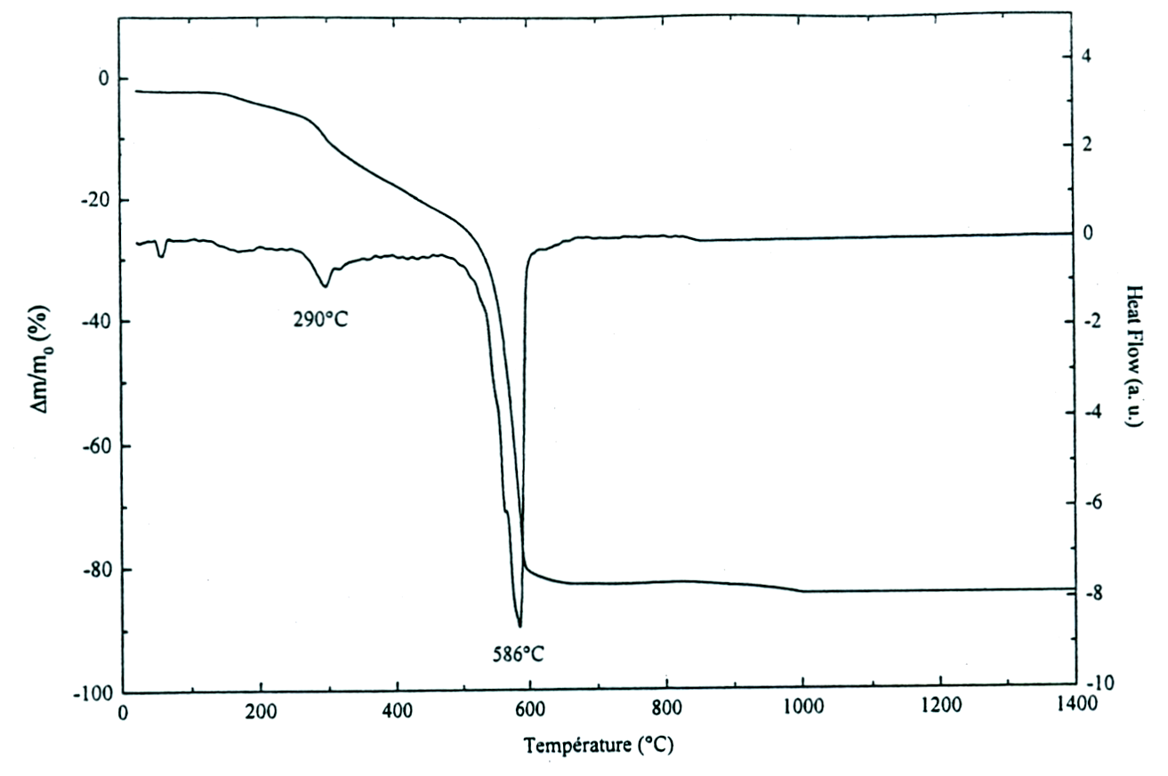
Figure 2: TGA-DTA thermograms of (NH₄)₃P₃O₉ (V = 1°C/min).
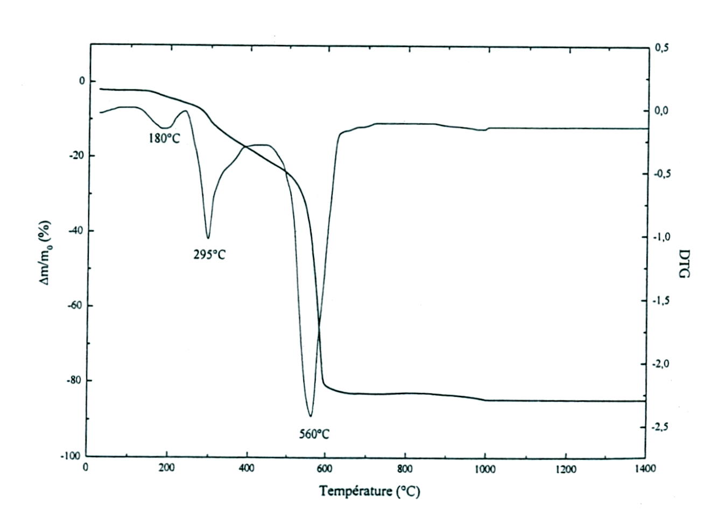
Figure 3: TG-DTG thermograms of (NH₄)₃P₃O₉ (V = 1°C/min).

The second stage, between 450°C and 650°C, corresponds to a weight loss of 64.5%, the equivalent of 2/3 of the weight of thermal residue H₃P₃O₉. This loss is accompanied by an intense and endothermic DTA peak at 586°C due to the decomposition of the acid H₃P₃O₉ amorphous entity which releases H₂O and P₂O₅ with a top speed at 560°C on the DTG curve. At 650°C, the reaction scheme is the following:

H₃P₃O₉ HPO₃ (amorphous) + H₂O + P₂O₅

Between 650°C and 1400°C, any mass loss was observed in the TGA thermogram, and any thermal effect was highlighted by the TGA-DTA thermograms (Figure 2).

D) Study of the thermal behavior of (NH₃C₆H₄COOH) ₃H₂P₃O₁₀.3H₂O
The study of the thermal behavior of tetra (4-carboxyphenyl ammonium) dihydrogenotriphosphate trihydrate (NH₃C₆H₄COOH)₃H₂P₃O₁₀.3H₂O, was performed by linear increase in temperature from 25 to 600°C using the TGA coupled on thermodifferential of powder samples of about 20 mg, at different heating rates : v = 1, 3, 6, 10 and 15°C/min under atmospheric pressure.
1) Thermogravimetric analysis
The TGA thermograms of (NH₃C₆H₄COOH)₃H₂P₃O₁₀.3H₂O, realized at different heating rates (Figure 4), have all the same look and show five separate mass loss steps. Careful examination of the thermogramms, carried out at low speed, indicates that the first step is not on that initially the water whereas the other four steps are related to entities from the decomposition of the organic matrix and the mineral matrix.
The TGA-DTA thermogram realized at a heating rate of 3°C / min (Figure 5) shows 5 mass loss steps:
- The first stage begins at 110°C and ends at 126°C. It appears to involve a single process of evolving water (mass loss calculated 7.47%, observed 7.5%). The DTG thermogram has a maximum loss of water at 118°C. Between 126 and 168°C, in the TGA thermogram there is no variation of mass.
- The second step starts at 168°C and ends at 188°C. It corresponds to a mass loss, relatively fast, about 7.01%. It is attributed to the loss of three molecules of ammonia for which the loss mass is theoretically calculated of 7.05%. The maximum loss is observed on the DTG thermogram at 179°C.
- The third stage, between 188 and 260°C, corresponding to a mass loss of 18.22% is assigned to 3 moles of CO₂ per formula unit (mass loss calculated 18.2%). Two loss maxima are reported on the DTG curve, during the third step, the first peak well pronounced at 197°C and a second peak doubtful to 214°C.
- The fourth step starts at 260 and ends at 310°C. It corresponds to a weight loss of 13.4% and could be attributed to the loss of gas from the decomposition of the residual heat. The maximum rate of loss is observed on the DTG thermogram at 280°C.
- The fifth stage, between 310 and 530°C, corresponding to a mass loss of 20.9%. This loss could be attributed to the combustion of the organic matrix.

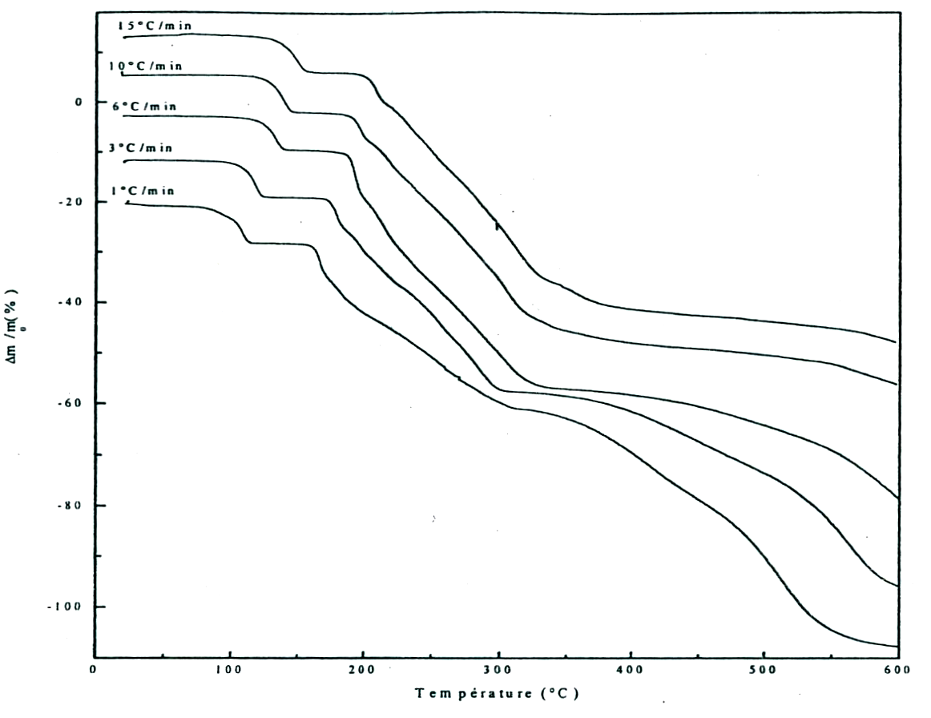
Figure 4: TGA thermograms of (NH₃C₆H₄COOH)₃H₂P₃O₁₀.3H₂O at different heating rates.

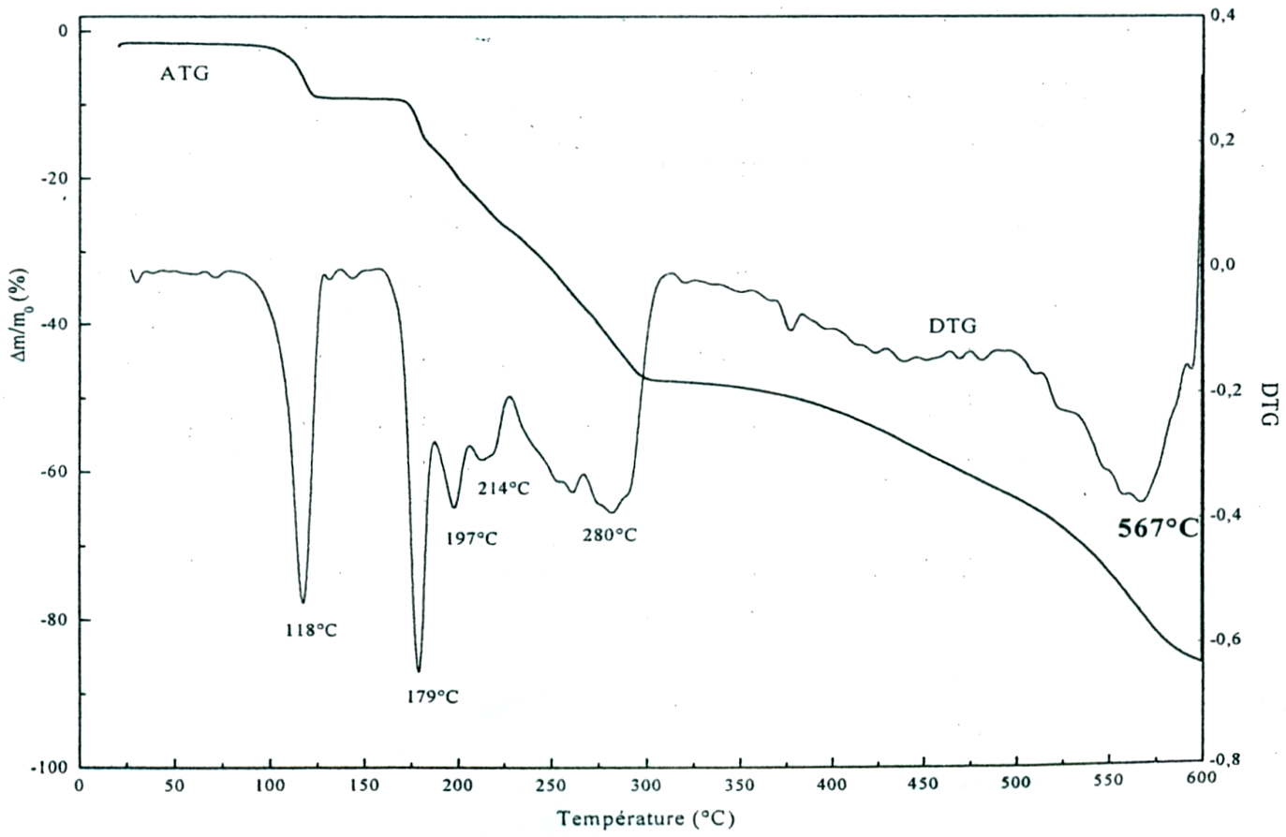
Figure 5: TG-DTG thermograms of (NH₃C₆H₄COOH)₃H₂P₃O₁₀.3H₂O at 3°C/min.

- The sixth stage, between 530 and 600°C, corresponding to a weight loss of 17%, is accompanied by a DTG peak at 567°C corresponding to the maximum speed of water H₂O and pentaoxide phosphorus P₂O₅ release from decomposition of the mineral matrix.
2) Differential thermal analysis
DTA thermograms made at different speeds and coupled with the thermogravimetric analysis are shown in Figure 6. The analysis of the thermogram corresponding to the heating rate 3°C/min (Figure 7) allows to highlight the following points :
The first phase, between 110 and 126°C, accompanied by an endothermic peak at 118°C which coincides with the maximum reported loss on the derivative curve at 118°C. This peak corresponds to the loss of 3 water molecules according to the following reaction scheme:
(NH₃C₆H₄COOH)₃H₂P₃O₁₀.3H₂O (NH₃C₆H₄COOH)₃H₂P₃O₁₀ + 3H₂O
An exothermic peak was observed at 147°C only for the weak heating rates for 1 and
3°C/min after the total removal of water. It corresponds to the crystallization of the corresponding anhydrous (NH₃C₆H₄COOH)₃H₂P₃O₁₀. This well crystallized phase was characterized by its IR spectrum (Figure 1).

- The second stage, between 168 and 188°C, is accompanied by two endothermic peaks at 174 and 180°C. The last peak at 180°C coincides with the maximum loss at 179°C. These two endothermic effects are attributed to the loss of three molecules of ammonia. The presence of two endothermic peaks may be interpreted on the basis of structural data of (NH₃C₆H₄COOH)₃H₂P₃O₁₀.3H₂O which indicates the presence of three types of nitrogen atoms. The first endothermic peak at 174°C, can be attributed to the departure of two moles of ammonia NH₃ (1) and NH₃ (3), the two nitrogen atoms having thermal agitation factors very close [2] 7, and the second at 180 ° C, the last remaining ammonia molecule NH₃ (2) (having a nitrogen atom of thermal agitation factor low [7]). The reaction scheme is as follows:
(NH₃C₆H₄COOH)₃H₂P₃O₁₀ (C₇H₅O₂)₃H₂P₃O₁₀ + 3NH₃
- The third stage, between 188 and 260°C, corresponding to the departure of 3 moles of CO₂, is accompanied by an endothermic peak at 197°C which coincides with the maximum loss rep orted on the DTG curve peak at 197°C. It is worth noticing that this third stage can be subdivided into two distinct stages. The first one is made between 188 and 210°C, the second between 210 and 260°C. In this case, the endothermic peak observed at 197°C would be the CO2 group the more weakly bonded to the organic chain
the endothermic peak observed at 197 ° C is related to the CO₂ group, more weakly bonded to the organic chain (CO₂ (7)), and it corresponds to the liberation of 6.06%, the CO₂ removed between (1/3) 188 and 210°C (18.02%). The second stage from 12.1% per formula unit; (2/3) of CO₂ corresponding to groups (CO₂ (14)) and (CO₂ (21)). Indeed, the structure of the compound shows that the C₆-C₇ distance is relatively longer, 1.498Å longer, longer than 1.498Å. The reaction scheme in this step is as follows:

(C₇H₅O₂)₃H₂P₃O₁₀ (C₆H₅)₃H₂P₃O₁₀ + 3 CO₂
The thermal residue obtained at the end of the third stage (C₆H₅)₃H₂P₃O₁₀ after loss successively of 3 H₂O, (2NH₃, 1NH₃) and 3 CO₂ per formula unit undergoes thermal degradation of organic matrices and / or mineral. The ATD Thermogram brings up an exothermic peak at around 300°C which could be attributed to an atomic reorganization. Indeed, the temperature of start of the exothermic effect coincides with the onset temperature of the 4th stage and the exothermic peak observed at 300°C corresponds to the temperature of the end of this step.
- The fifth stage, between 310 and 530°C, make appear an exothermic peak at the top temperature of 432°C which may be due to the burning of the residue of the organic matrix.
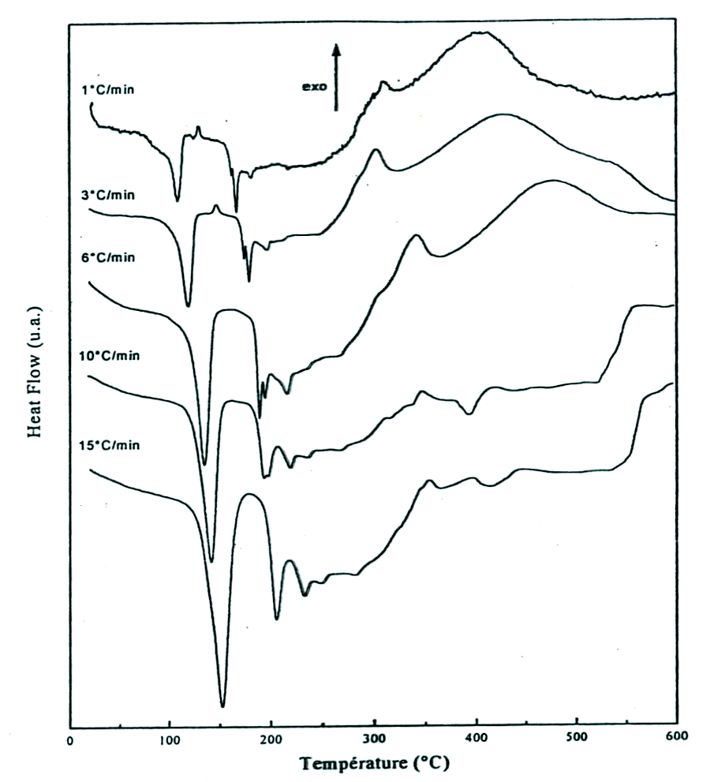
Figure 6: TGA thermograms of (NH₃C₆H₄COOH)₃H₂P₃O₁₀.3H₂O at different heating rates.
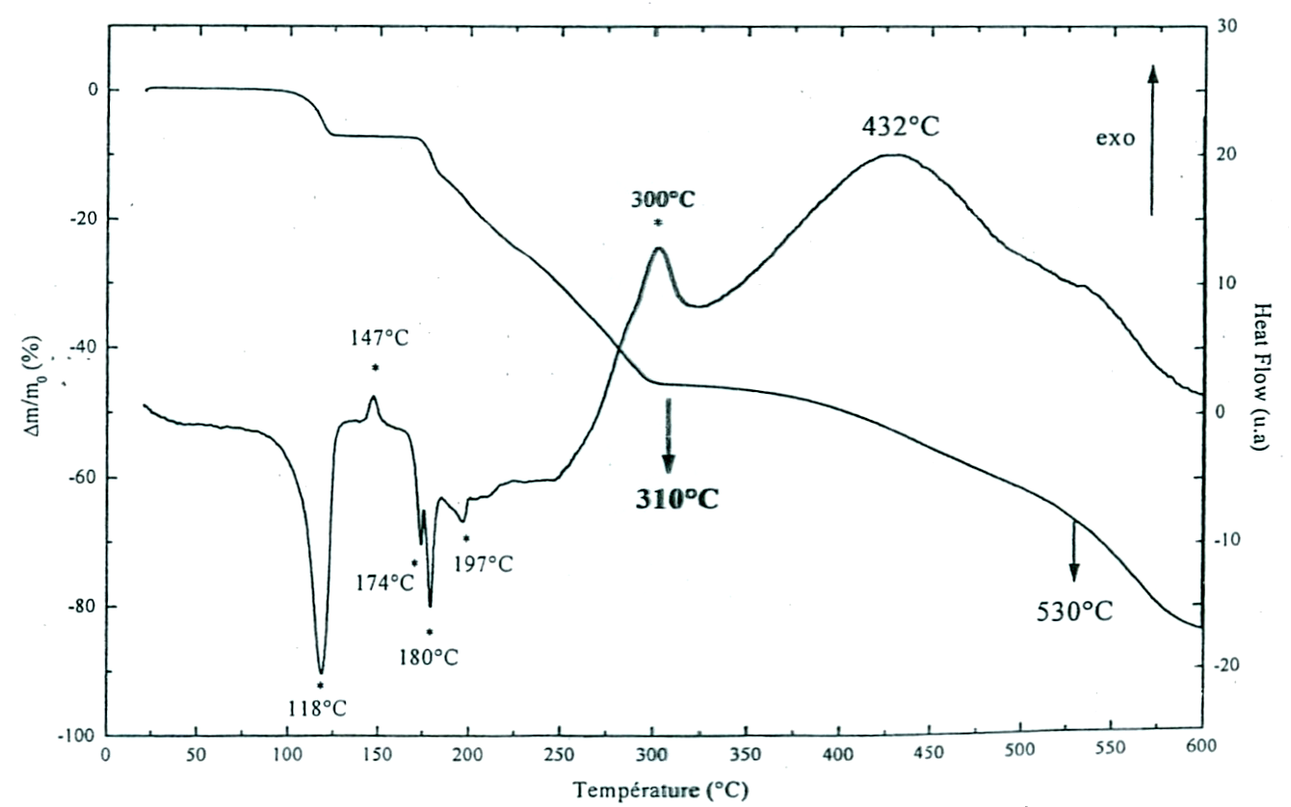
Figure 7: TGA-DTA thermograms of (NH₃C₆H₄COOH)₃H₂P₃O₁₀.3H₂O at 3°C/min.

3) Measurement of kinetic parameters
Estimation of the thermodynamic functions: Various equations of kinetic analyses are known [21-25]. Ozawa and KAS methods are selected in studying the kinetics of thermal dehydration of the title compound. So, water loss kinetic parameters were evaluated from the curves ln(v/T²m) = f(1/Tm) and ln(v) = f(1/Tm) (Figures 8 and 9), where (v) is the heating rate and Tm the sample temperature at the thermal effect maximum. The characteristic temperatures at maximum dehydration rates, Tm in °C, at different heating rates from the DTA curves of (NH₃C₆H₄COOH)₃H₂P₃O₁₀.3H₂O are gathered in table 4.
Table 4: Temperatures of endothermic peak summits on the DTA curves of (NH₃C₆H₄COOH)₃H₂P₃O₁₀.3H₂O
heating rates | 1°C/min | 3°C/min | 6°C/min | 10°C/min | 15°C/min
3 H₂O | 108 | 118 | 134 | 142 | 152 | Temperatures of endothermic peak summits (°C)
2 NH₃ | 161.4 | 174 | 189 | 193.4 | 206 | Temperatures of endothermic peak summits (°C)
1 NH₃ | 166.6 | 180 | 194 | 198 | 206 | Temperatures of endothermic peak summits (°C)
3 CO₂ | 181.6 | 197 | 216 | 219 | 233 | Temperatures of endothermic peak summits (°C)

From these temperatures, the apparent activation energies of dehydration were calculated for the (NH₃C₆H₄COOH)₃H₂P₃O₁₀.3H₂O. For the Kissinger-Akahira-Sunose (KAS) [22] method, the slope of the resulting straight line of the curve: ln(v/T²m) = f(1/Tm) (Figure 8), equals to :
-Ea/R, allows the apparent activation energy to be calculated (table 4). with reference to the Ozawa method, the slope of the resulting straight line on the curve: ln(v) = f(1/Tm) (Figure 9), equals to -1.0516E/R, allows also the apparent activation energy to be calculated by this second way (table 4). The equations used for the two methods are the following:

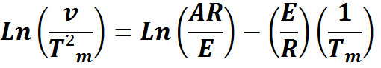
for KAS [22] (1)

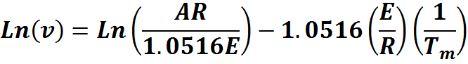
for OZAWA [23] (2)

The pre-exponential factor or Arrhenius constant (A) and the related thermodynamic functions can be calculated by using the activated complex theory (transition state) of Eyring [26-28]. The following general equation can be written [28] :
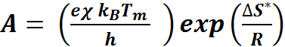
(3)
(3)

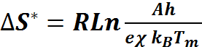
where e is the Neper number (e = 2.7183), χ is the transition factor, which is unity for the monomolecular reaction, k_{B} is the Boltzmann constant ( k_{B} = 1.3806 × 10-23 J K-1), h is Plank's constant ( h = 6.6261 × 10-34 J s), T_{m} is the peak temperature of the DTA curve, R is the gas constant ( R = 8.314 J K⁻¹ mol⁻¹) and ΔS* is the entropy change of transition state complex or entropy of activation. Thus, the entropy of activation may be calculated as follows: (4)

The enthalpy change of transition state complex or heat of activation (ΔH*) and Gibbs free energy of activation (ΔG*) of decomposition were calculated according to Eqs. (5) and (6), respectively:
ΔH* = E* − R T_{m} (5)
ΔG* = ΔH* − T_{m} ΔS* (6)

Where, E* is the activation energy E_{a} of both KAS [22] and Ozawa [23] methods. The values of the activation energy are gathered in (Table 5). Thermodynamic functions were calculated from Eqs. (4), (5) and (6) and summarized in (Table 6). The negative values of ΔS* from two methods for the dehydration step reveals that the activated state is less disordered compared to the initial state. These ΔS* values suggest a large number of degrees of freedom due to rotation which may be interpreted as a « slow » stage [28-30] in this step. The positive values of ΔG* at all studied methods are due to the fact that, the dehydration processes are not spontaneous. The positivity of ΔG* is controlled by a small activation entropy and a large positive activation enthalpy according to the Eq. 6. The endothermic peaks in DTA data agree well with the positive sign of the activation enthalpy (ΔH*). The estimated thermodynamic functions ΔS* and ΔG* (equation 6, table 6) from two methods are approximatively the same due to the same pre-exponential factor of about 10¹². While ΔH* (equation 5, table 6) exhibits, in all the cases, an independent behavior on the pre-exponential factor as seen from exhibiting nearly the same value.

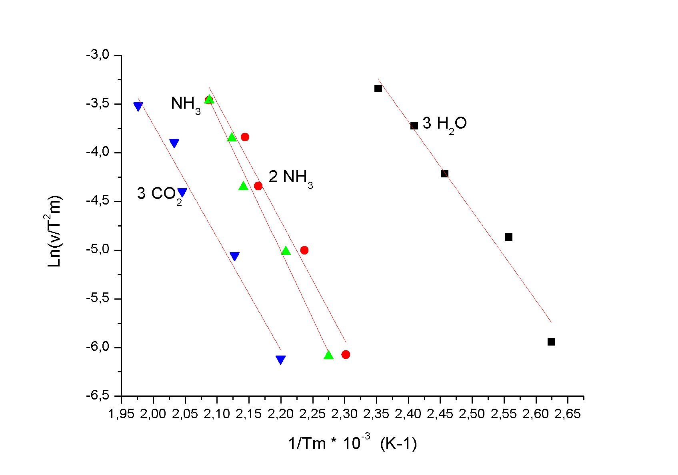
Figure 8: Straight Ln (v/T²m) = f(1/Tm) of (NH₃C₆H₄COOH)₃H₂P₃O₁₀.3H₂O
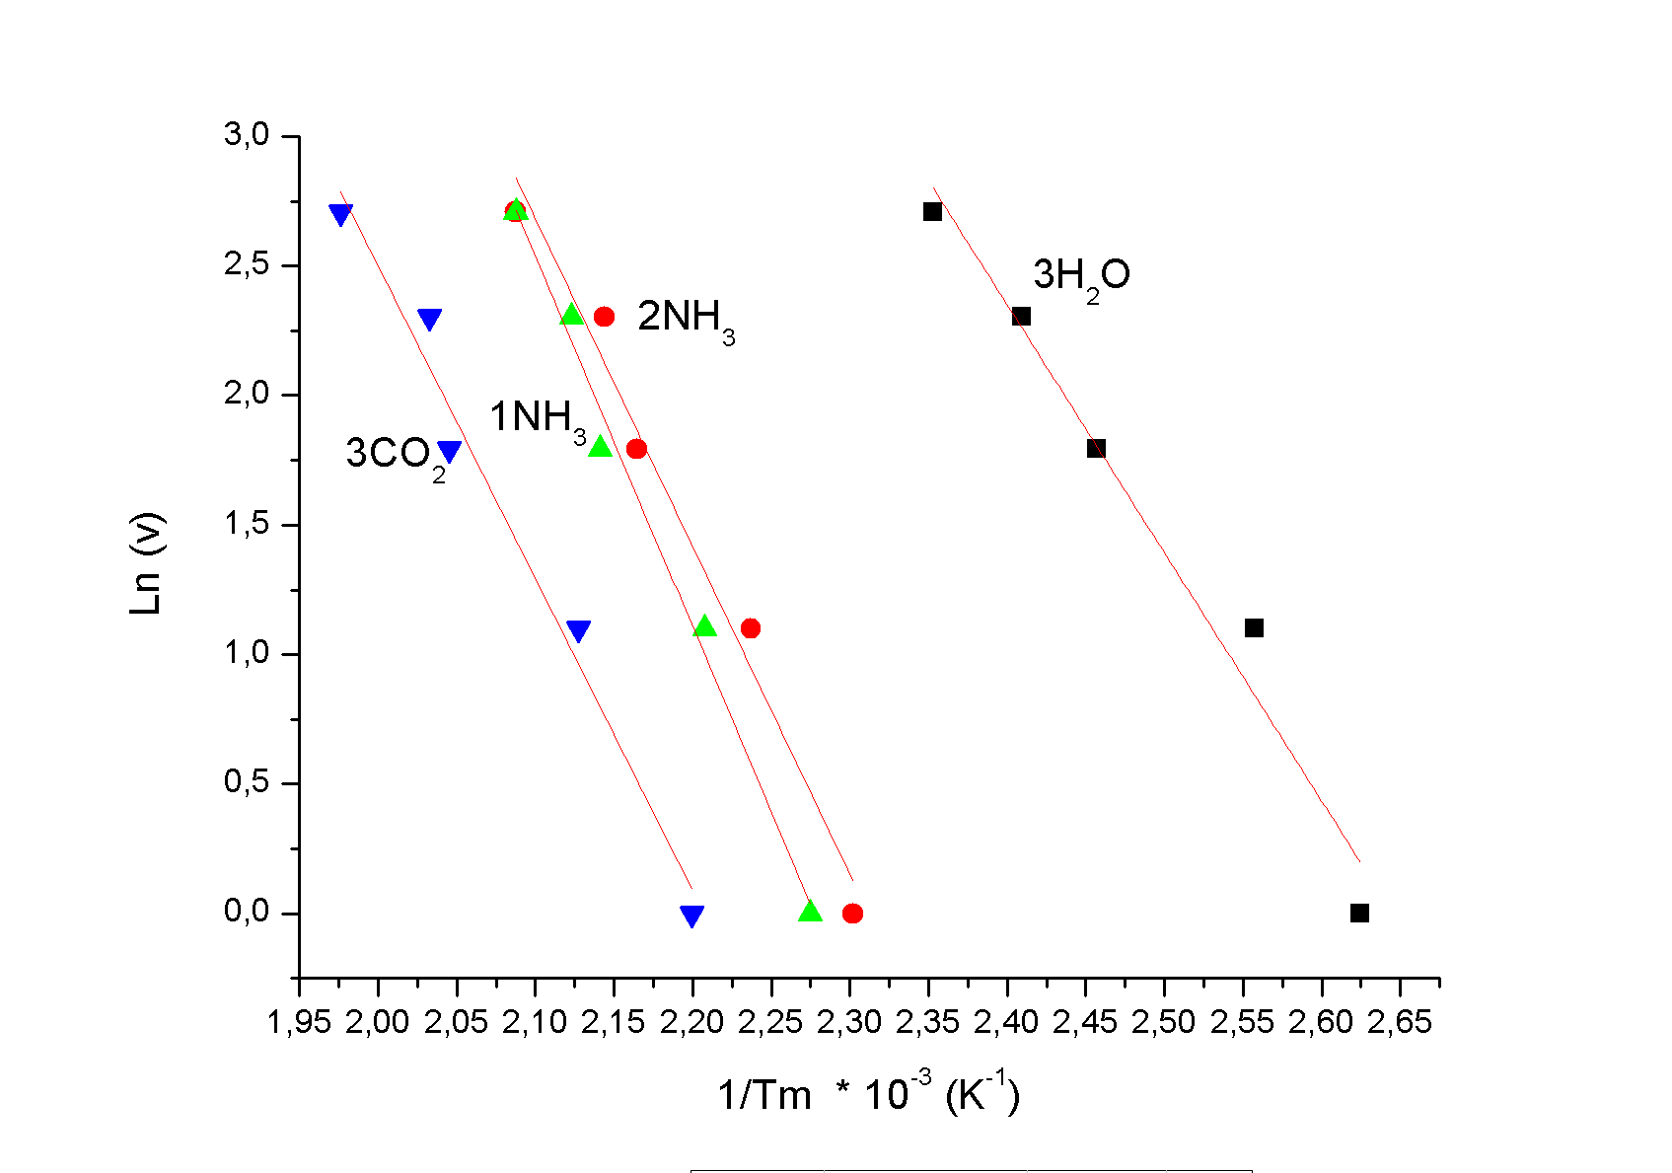
Figure 9: Straight Ln (v) = f(1/Tm) of (NH₃C₆H₄COOH)₃H₂P₃O₁₀.3H₂O.

Table 5: Activation energy values Ea, pre-exponential factor (A) and correlation coefficient (r²) calculated by ozawa and KAS methods for the dehydration of (NH₃C₆H₄COOH)₃H₂P₃O₁₀.3H₂O under atmospheric pressure.
 | OZAWA |  |  | K.A.S
Steps | Ea (kJ/mol) | A  (min⁻¹) | r² | Ea  (kJ/mol) | A  (min⁻¹) | r²
Step 1 (3H₂O) | 75.6954 | 2.3714×10¹² | 0.97 | 76.2636 | 8.3937×10¹¹ | 0.963
Step 2 (2NH₃) | 99.9956 | 7.8151×10¹² | 0.973 | 101.373 | 6.6787×10¹² | 0.97
Step 3(1NH₃) | 112.9685 | 4.3858×10¹² | 0.99 | 114.992 | 3.6930×10¹² | 0.99
Step 4 (3CO₂) | 92.9084 | 3.9084×10¹² | 0.971 | 96.1057 | 3.0864×10¹² | 0.97

Table 6: Values of ΔS≠, ΔH≠ and ΔG≠ for dehydration step of (NH₃C₆H₄COOH)₃H₂P₃O₁₀.3H₂O calculated according to ozawa and KAS equations.
 |  | OZAWA |  |  | K.A.S
Steps | ∆S  (J. K⁻¹.mol⁻¹) |  | ∆H  (kJ.mol⁻¹) | ∆G  (kJ.mol⁻¹) | ∆S  (J. K⁻¹.mol⁻¹) | ∆H  (kJ.mol⁻¹) | ∆G  (kJ.mol⁻¹)
Step 1 (3H₂O) | -19.2678 |  | 72.1619 | 80.3508 | -27.9027 | 72.7302 | 84.5888
Step 2 (2NH₃) | -10.3472 |  | 96.0132 | 100.969 | -11.4960 | 97.4661 | 102.869
Step 3(1NH₃) | -15.1501 |  | 108.98614 | 116.2431 | -16.5795 | 111.0096 | 118.9513
Step 4 (3CO₂) | -16.5641 |  | 91.0571 | 99.4386 | -18.5271 | 91.8983 | 101.273

Conclusion
The structural and thermal study of 4-carboxyphenyl dihydrogenotriphosphate ammonium trihydrate (NH₃C₆H₄COOH)₃H₂P₃O₁₀.3H₂O developped by X-ray diffraction, IR spectrometry vibration and TGA-DTA analyses coupled brings up the following results :
The reaction of phosphoric acid with aminobenzoic acid leads, due to the hydrolysis of P₃O₉³⁻ ion in aqueous solution or by using H₅P₃O₁₀, to a triphosphate with a formula (C₇H₈NO₂)₃H₂P₃O₁₀.3H₂O. The structural resolution shows the existence of ion channels H₂P₃O₁₀³⁻ linked together by hydrogen bonds. Organic cations, water molecules and phosphates chains are linked together by hydrogen bonds. A detailed vibrational study is reported for (NH₃C₆H₄COOH)₃H₂P₃O₁₀.3H₂O with all of its entities NH_{3,} C₆H₄COOH, H₂P₃O₁₀ and H₂O. The thermal analysis showed that the compound is stable between 25 and 90°C and has confirmed the number of water molecules per formula unit. This loss of water takes place in one step and leads to the crystallization of the anhydrous phase, (C₇H₈NO₂)₃H₂P₃O₁₀, which was characterized by its X-ray powder diffraction pattern and IR spectrum. This phase (C₇H₈NO₂)₃H₂P₃O₁₀ was found stable in a small temperature range, 150-160°C. We have shown that by raising the temperature, the anhydrous phase loses successively 3H₂O ((2) NH₃, (1) NH₃) and 3CO₂ per formula unit. For each of these entities released, the apparent activation energy was measured. These energies are respectively
73,4 kJ/mol for 1 NH₃ and 92,29 kJ/mol for 3CO₂. Between 260 and 300°C, the residual mass, (C₆H₅)₃H₂P₃O₁₀ undergoes a weight loss corresponding to a molar loss of 70 g/mol. This weight loss is accompanied by an atomic rearrangement which results on the DSC thermogram with a peak at 300°C. Beyond 300°C, there is degradation of the organic matrix and / or the mineral matrix. An exothermic peak at the top temperature at 432°C could be the combustion of the residue of the organic matrix.

References

[1] Akberova S.I(2002) Biol Bull Russian Acad Sci 29: 390-393
[2] Benali-Cherif N, Allouche F, Direm A, and Soudani K (2009) Acta Cryst E E65: 0064-0065
[3] Benali-Cherif N, Allouche F, Direm A, and Soudani K (2007) Acta Cryst E E63: 02272-02274
[4] N. Benali-Cherif, Allouche F, Direm A, and Soudani K (2007) Acta Cryst E E63: 02054-02056
[5] Benali-Cherif N, Abouimrane A, Sbai K, Merazig H, Cherouana A and Bendjeddou L (2002) Acta Cryst E E58:0160-0161
[6] Jouini A and Durif A (1983) C R Acad Sci 297 II:573-578,
[7] EL Kababi K (2000) Doctorat National. Faculté des Sciences Ben M’sik. Casablanca. Maroc
[8] El Kababi K, atibi A, Lamsatfi A, Zerraf S, Fahim I, Tridane M and Belaaouad S (2016) International Journal of Trend in Research and Development 3(3):302-305
[9] Tridane M (2006) Doctorat National. Faculté des Sciences Ben M’Sik. Casablanca. Maroc.
[10] Fahim I, Kheireddine A and Belaaouad (2013) S J Optoelec Adv Mat 15(5- 6):451 – 456
[11] Kheireddine A, Tridane M and Belaaouad S (2013) Mediterr J Chem 2(4):549-S69
[12] Boultif A and Louër D (2004) J Appl Cryst 37:724-731
[13] EL Kababi K (2016) Habilitation Universitaire. Faculté des Sciences Ben M’sik. Casablanca. Maroc
[14] Samsonowicz M, Hrynaszkiewicz T, Swislocka R, Lewandowski W (2005) Journal of Molecular Structure 744:345-352
[15] Antony J, Helden GV, Meijer G, Achmidt B (2005) J Chem Phys 123: 014305
[16] Florio M, Zwier TS, Sibert EL (2003) J Chem Phy 118: 4

[17] Muthuselvi Ch, Princy A. S and Pandiarajan S. S Asian (2017) J Applied Sc 10(4):159-169
[18] Abraham F, Jalbout, Zhen-Yi Jiang, Ouasri A, Jeghnou H, Rhandour A, Dhamelincourt, P. Dhamelincourt M. C, Mazzah A (2003) J Vibrational Spectroscopy 33:21-30
[19] Koval V, Nagornyi P (1990) J Appl chem. 62:2373
[20] Bagieu-Beucher M, Tordjman I, Durif A and Guitel J (1976) Acta Crystallogr B32:1427-1430
[21] Kissinger H. E (1957) Anal Chem 29:1702
[22] Akihira T, Sunose T (1971) Res Report Chiba Inst Technol (Sci. Technol.) 16 :22
[23] Ozawa T. A (1965) Bull Chem Soc Jpn 38:1881
[24] A. W. Coats, Redfern J. P (1964) Nature 201: 68
[25] Van Krevelns D. W, Hoftijzer P.J (1954) Trans I Chem E 32:5360
[26] Young D (1984) Decomposition of Solids, Academia Prague
[27] Rooney J, Eyring J (1995) J Mol Catal A Chemical L1:96
[28] Boonchom B (2008) J Chem Eng Data 53:1533
[29] Valaev L, Nedelchev N, Gyurova K, Zagorcheva M (2008) J Anal Appl Pyrol 81:253
[30] Noisong P, Danavirutai C, Boonchom T (2008) Solid State Sci 10:1598

