Graphical abstract



Dilute hydrochloric acid pretreatment (DHAP)

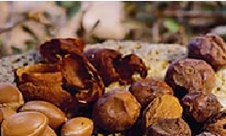

Dilute acid pretreatment optimization by response surface methodology

Minimum phenolic inhibitors



Dilute sulfuric acid pretreatment (DSAP)

Bioethanol production

Argane pulp (pericarp)

Maximum reducing sugars

Optimal Dilute sulfuric acid pretreatment

Argane pulp biomass was sucessfully pretreated using dilute acid process, which was optimized by response surface methodology, that improved the extraction of the maximum of fermentable sugars and minimum of fermentation inhibitors generation for the bioethanol production.