## Supplementary Information

**Synthesis of new analogs of 3-methyl-[1,2,4] triazolo [3,4-*a*] phthalazines *via* suzuki coupling and evaluation of their anticancer and antimicrobial activity**

**Gollapudi Ravi Kumar 1, 2, Chandra Mohan Kurmarayuni1**, **Manideepa Indupalli 3 and Hari Babu Bollikolla 1,\***

*aDepartment of Chemistry, Acharya Nagarjuna University, Nagarjuna Nagar-522510, Guntur, Andhra Pradesh, India*

*bDepartment of Chemistry Kakatiya Government College, Warangal-506001, Telangana, India.*

*cDepartment of Botany & Microbiology, Acharya Nagarjuna University, Nagarjuna Nagar-522510, Guntur, Andhra Pradesh, India*

**Spectra of synthesized compounds**

**1H NMR Spectra of Compound- 8a:**

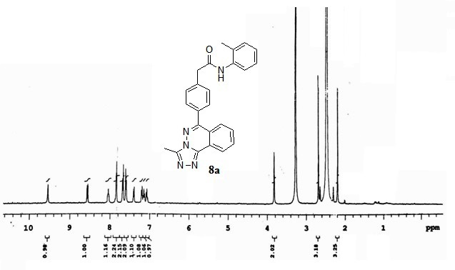

1H NMR (expansion )Spectra of Compound- 8a:

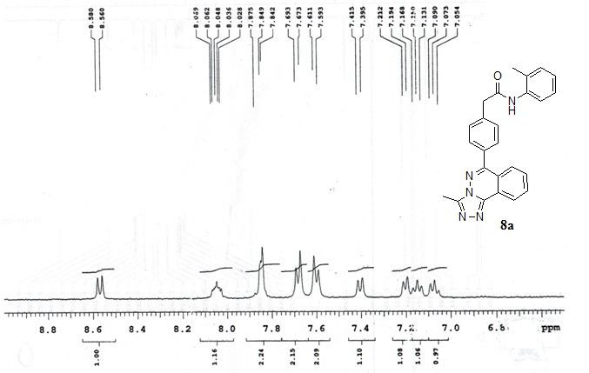

13C NMR Spectra of Compound - 8a:

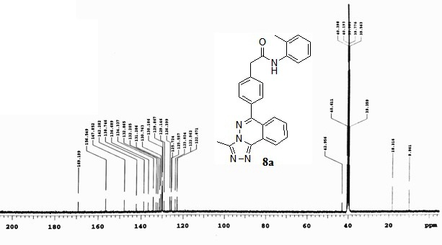

HRMS Spectra of Compound -8a

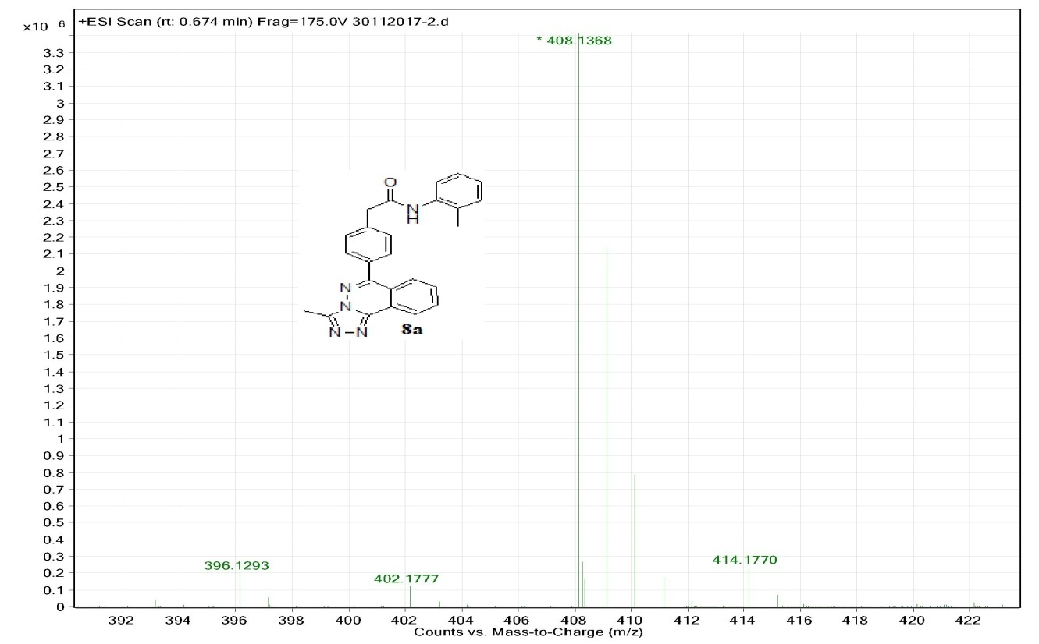

1H NMR Spectra of Compound- 8b:

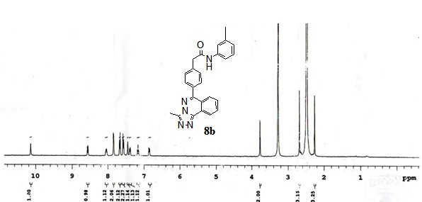

1H NMR Spectra of Compound- 8b(expansion):

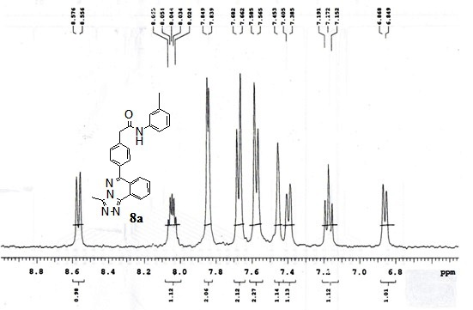

13 C NMR Spectra of Compound- 8b:

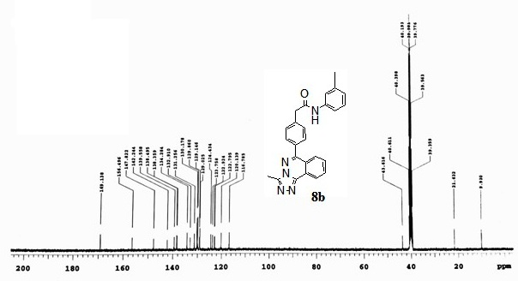

Compound 8b 13C NMR

HRMS Spectra of Compound -8b: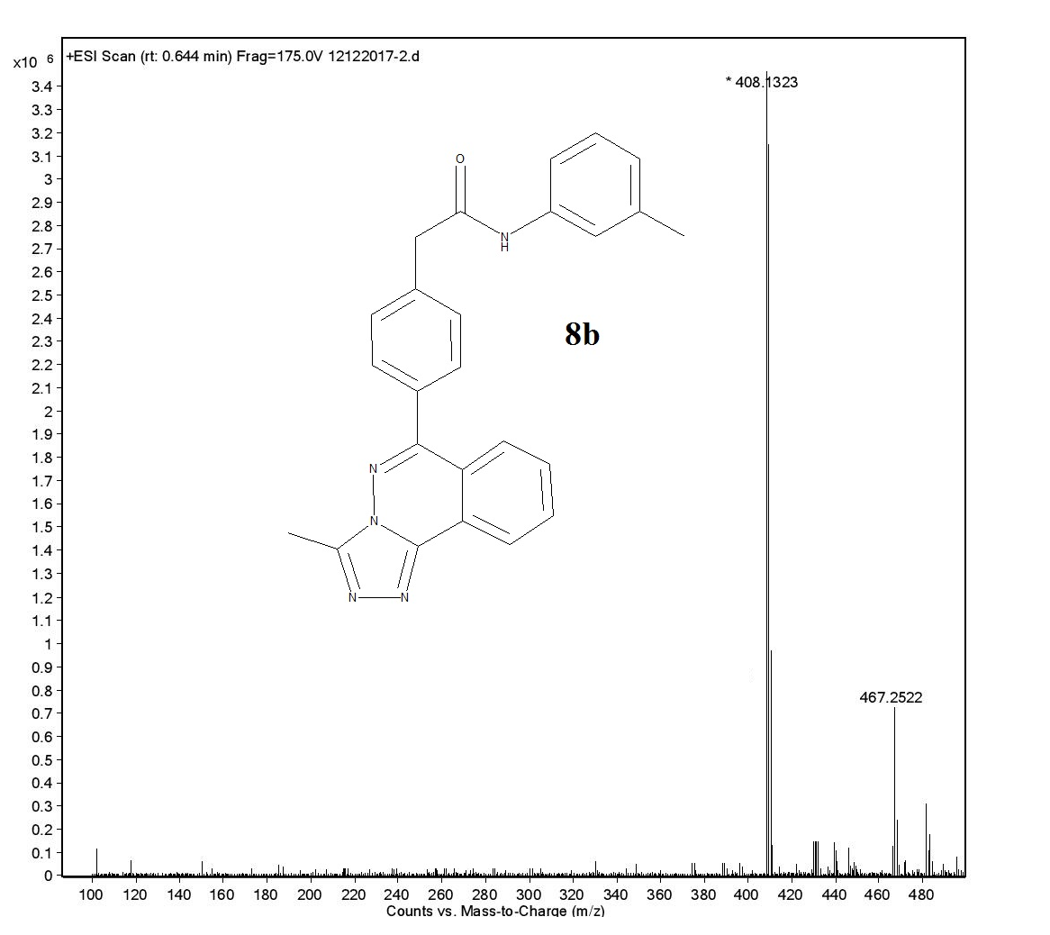

1H NMR Spectra of Compound- 8c:

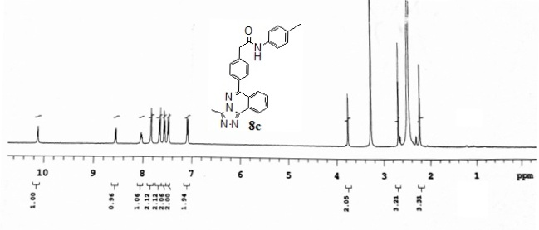

1H NMR Spectra of Compound- 8c (expansion):

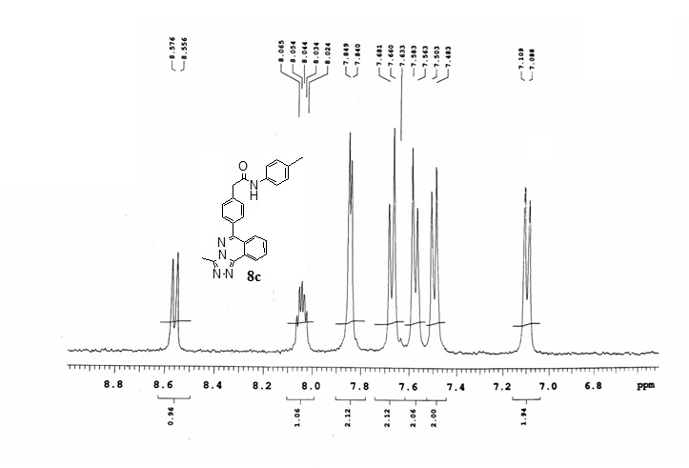

HRMS Spectra of Compound -8c:

COMPOUND 8C EXPANSION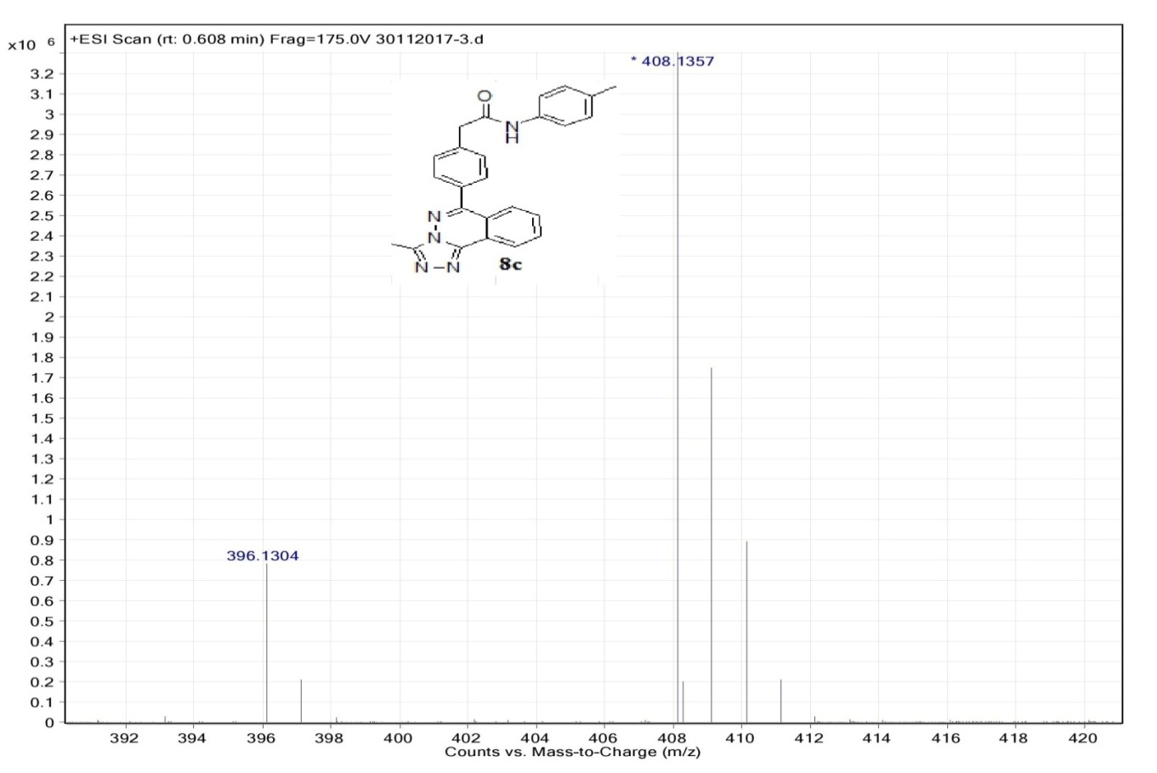

1H NMR Spectra of Compound- 8d:

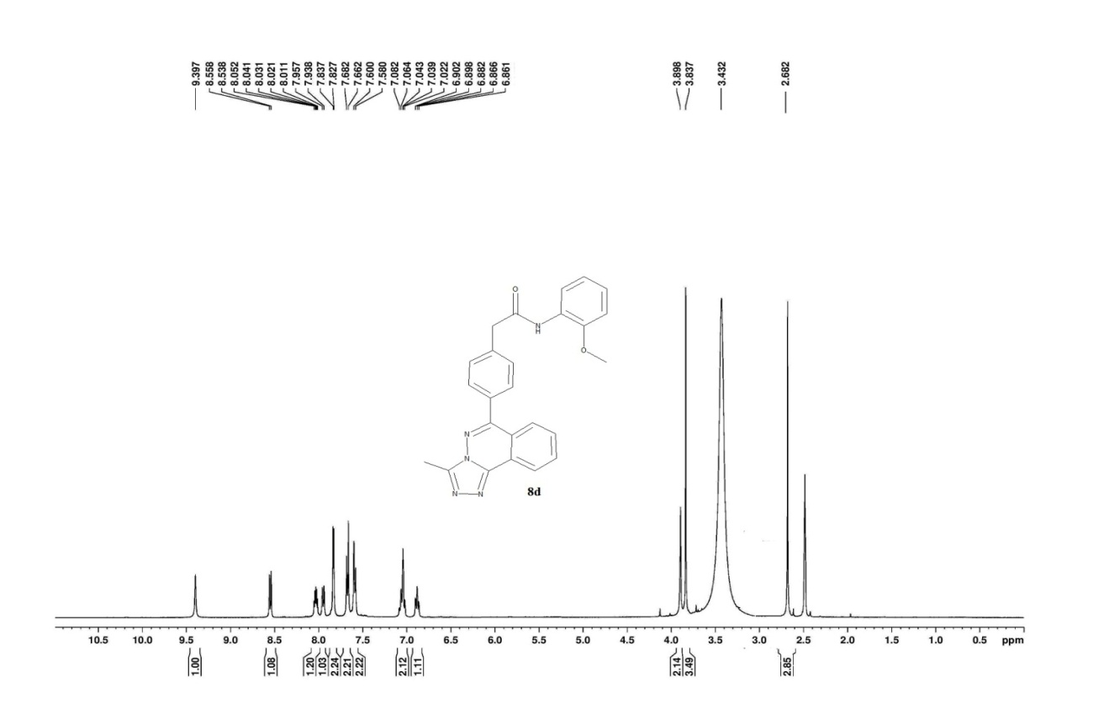

1H NMR Spectra of Compound- 8d (expansion):

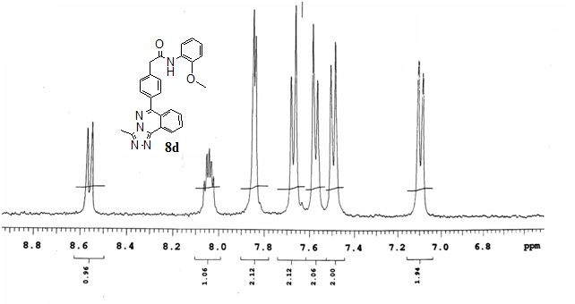

13 C NMR Spectra of Compound- 8d:

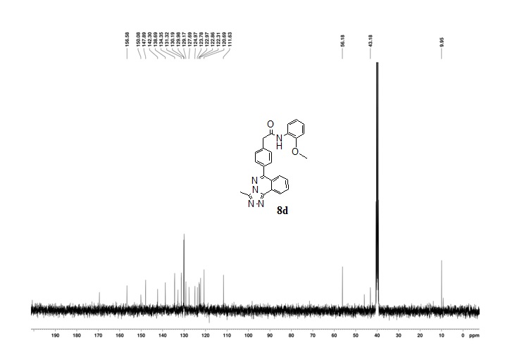

HRMS Spectra of Compound -8d:

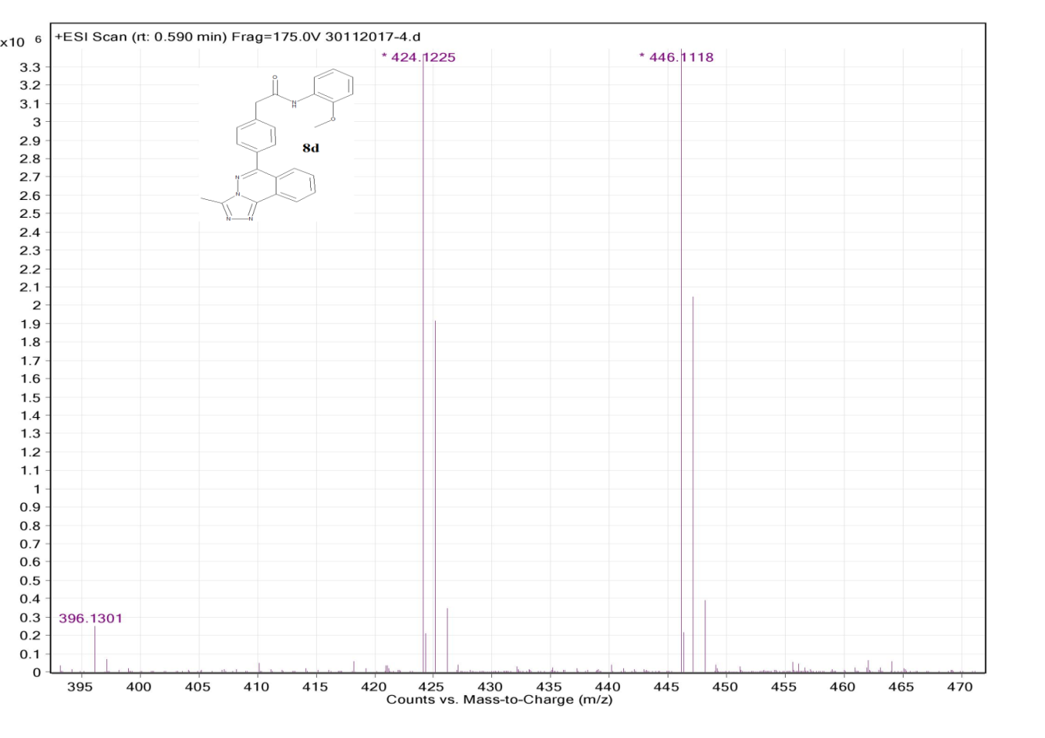

1H NMR Spectra of Compound- 8e:

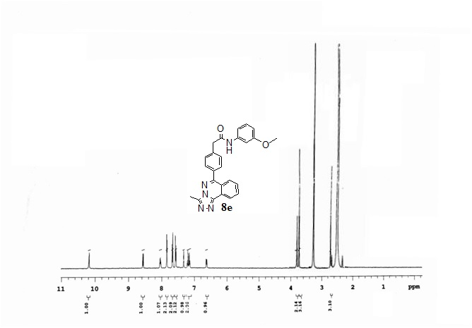

1H NMR Spectra of Compound- 8e (expansion):

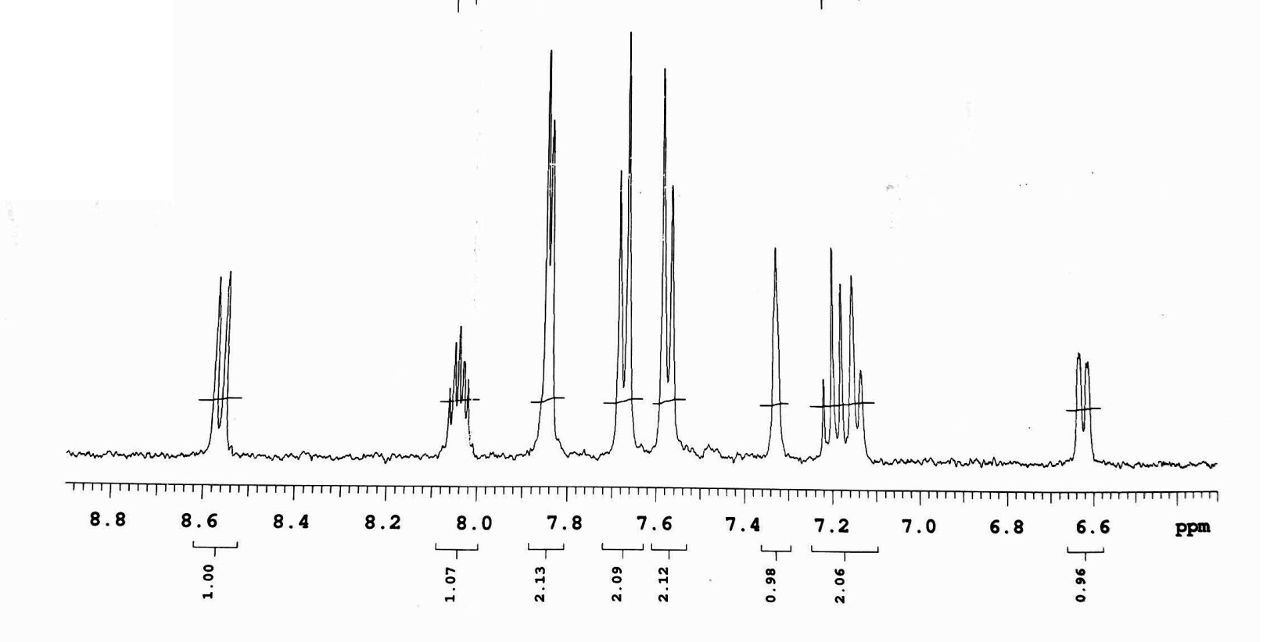

HRMS Spectra of Compound -8e:

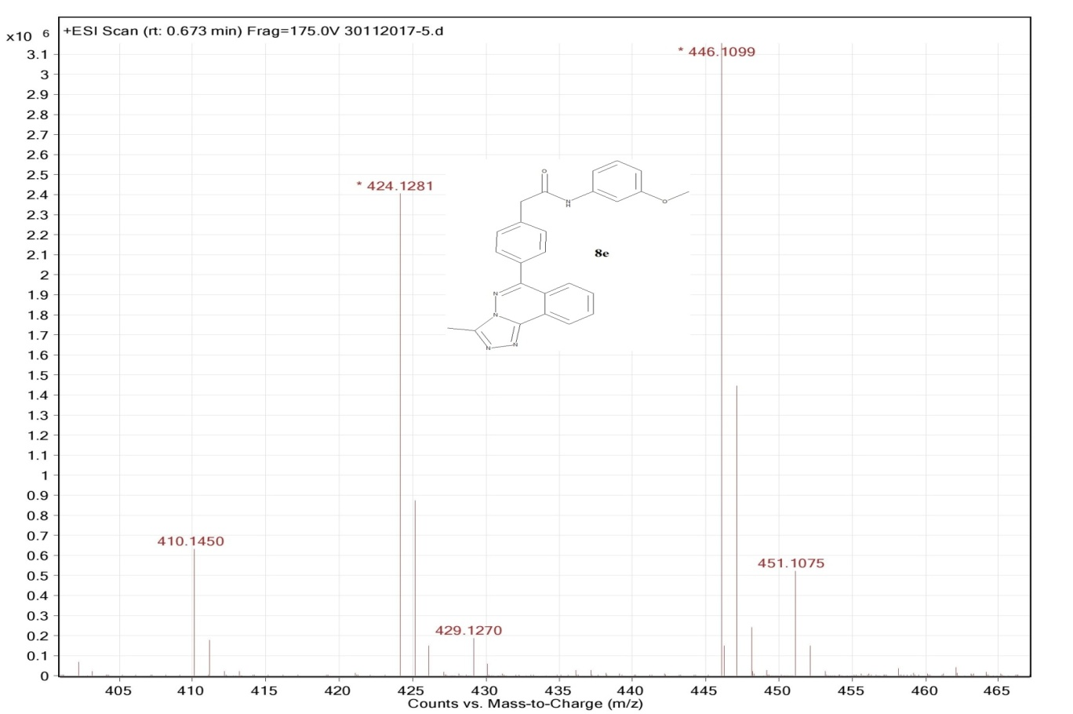

13 C NMR Spectra of Compound- 8e:

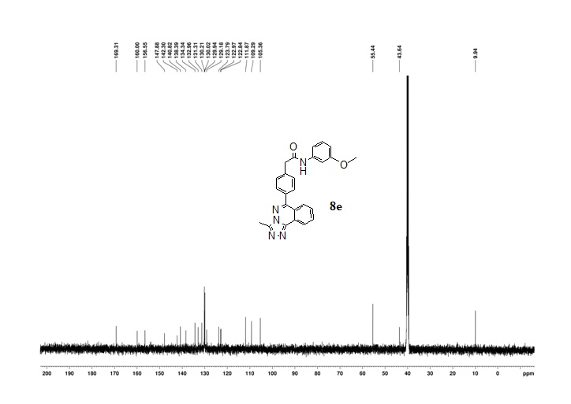

1H NMR Spectra of Compound- 8f:

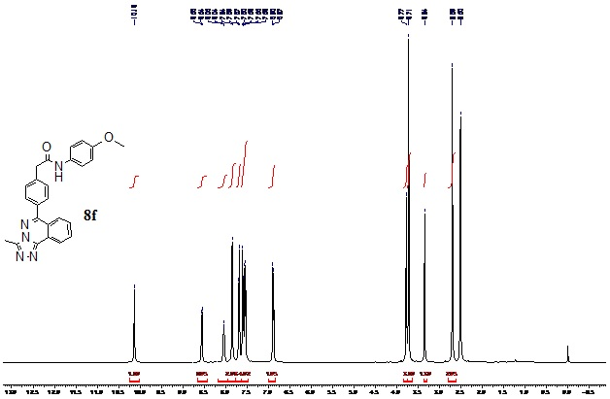

1H NMR Spectra of Compound- 8e (expansion):

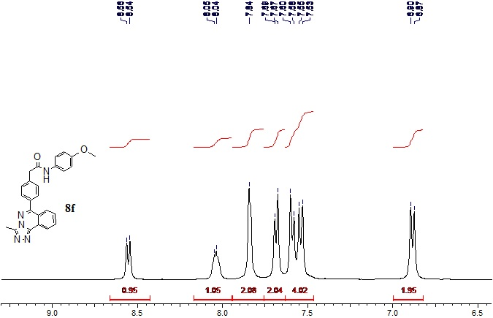

13 C NMR Spectra of Compound- 8f:

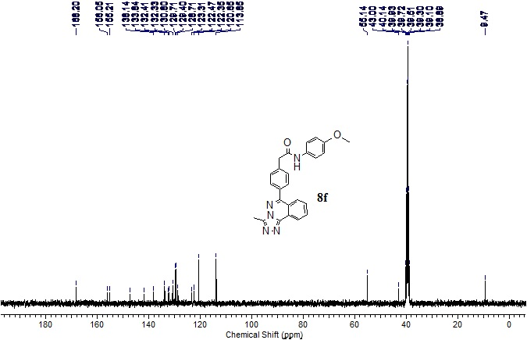

DEPT of compound 8f

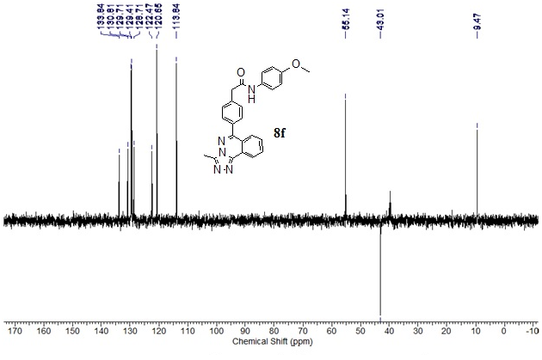

HRMS Spectra of Compound -8f:

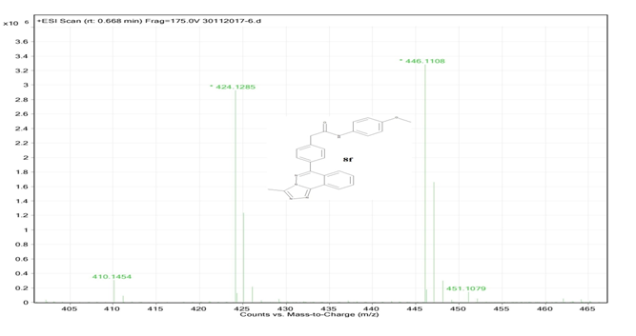

1H NMR Spectra of Compound- 8g:

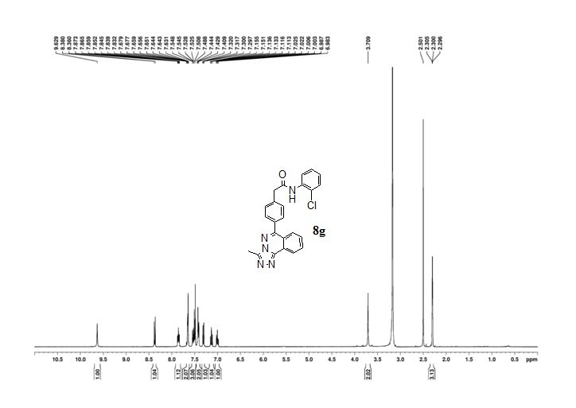

HRMS Spectra of Compound -8g:

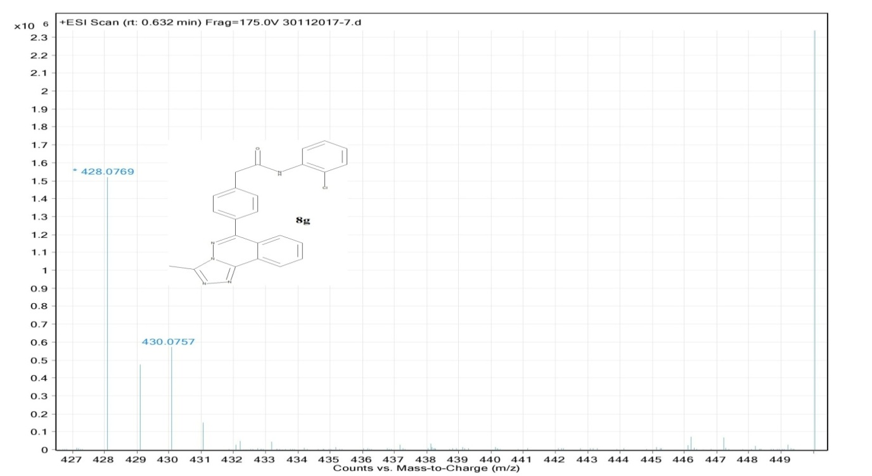

1H NMR Spectra of Compound- 8h:

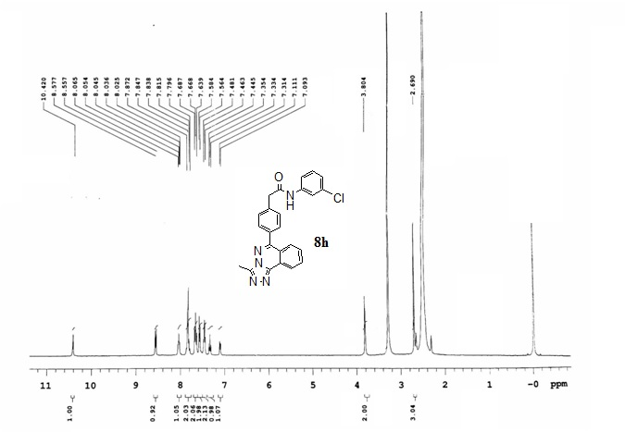

HRMS Spectra of Compound -8h:

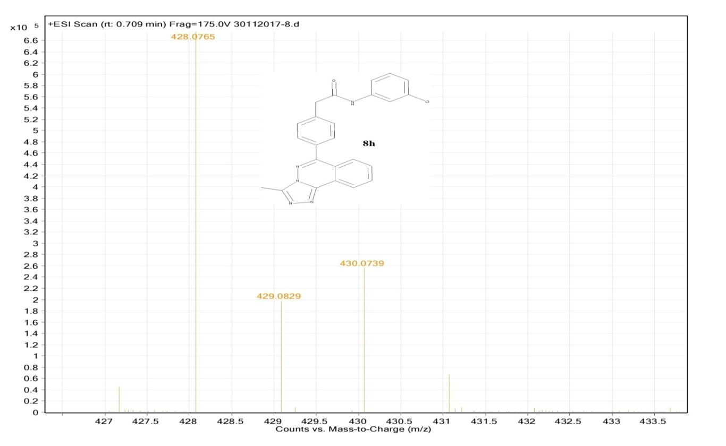

1H NMR Spectra of Compound- 8h:

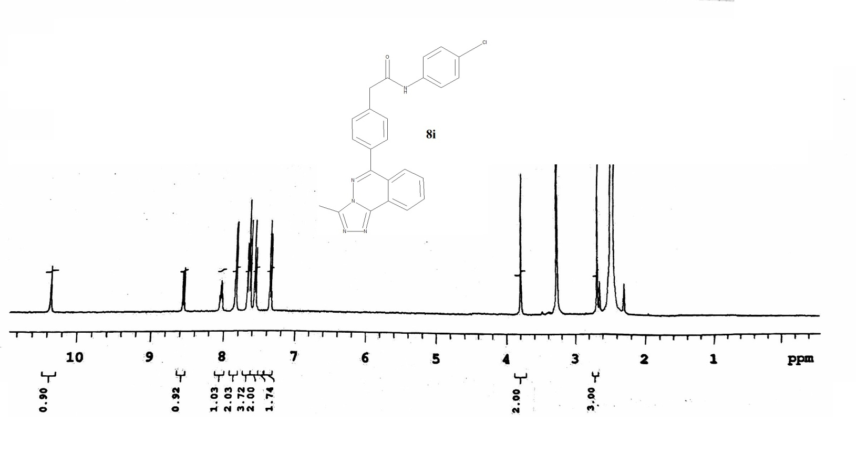

HRMS Spectra of Compound -8i:

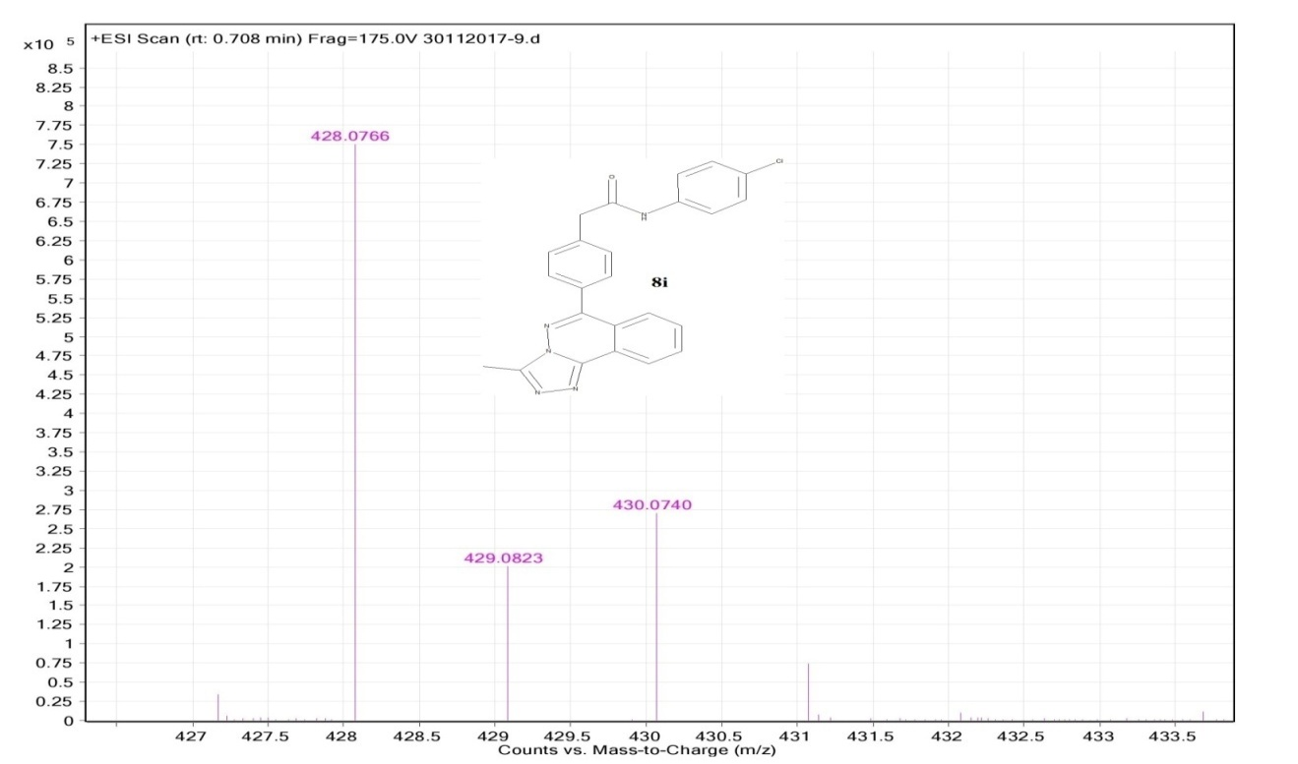

1H NMR Spectra of Compound-6:

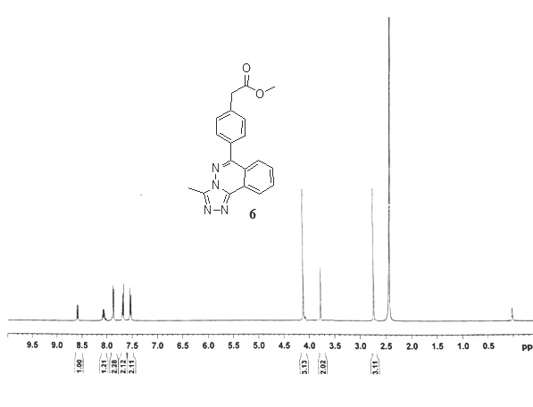

HRMS Spectra of Compound-6:

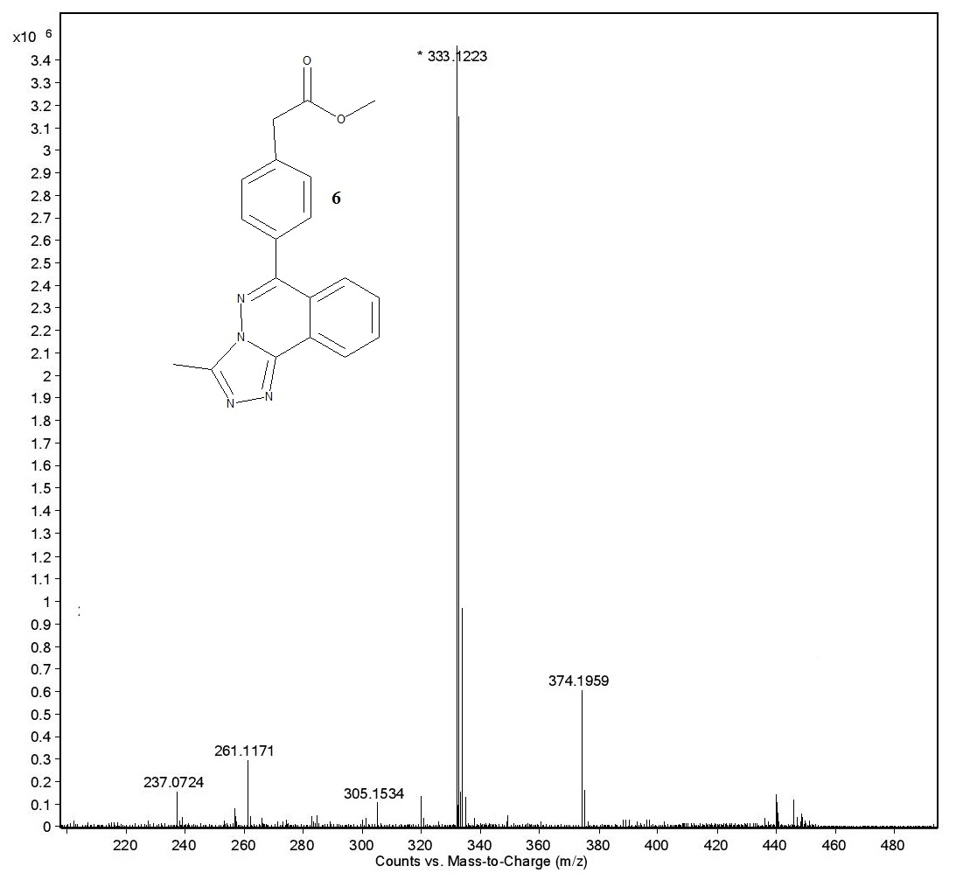

1H NMR Spectra of Compound- 7:

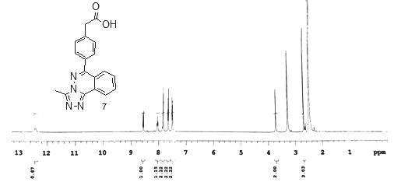

1H NMR Spectra of Compound- 7 (expansion):

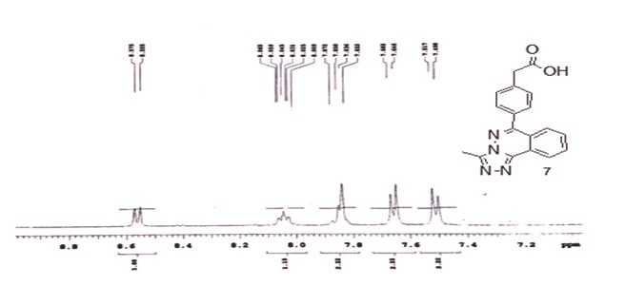

HRMS Spectra of Compound-7:

