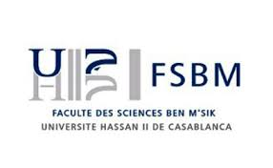
Prof Abdelaziz El Jazouli
Email: eljazouli_abdelaziz@yahoo.fr
Phone: +212 616848890
Casablanca, October 23rd, 2018.
To
Editor-in-Chief
Mediterranean Journal of Chemistry

Submission of manuscript

Dear Editor,
We would like to submit our manuscript entitled: “Synthesis, structural characterization and ionic conductivity of mixed alkali titanium phosphate glasses” to Mediterranean Journal of Chemistry.

In this work, Na_{3-x}Li_{x}CaTi(PO₄)₃ [10(3-x) mol. % Na₂O - 10x mol. % Li₂O - 20 mol. % CaO - 20 mol. % TiO₂ - 30 mol. % P₂O₅] (0 ≤ x ≤ 3) glasses were prepared by standard melt-quenching technique, and their structural and physical properties were characterized by thermal analysis, density measurements, Raman, and impedance spectroscopy.

This manuscript is the authors' original work and has not been published nor has been submitted simultaneously elsewhere. All authors have checked the manuscript and have agreed to the submission.

With my best regards,

Prof Abdelaziz El Jazouli

