New sulfonamide hybrids: synthesis, in vitro biological evaluation and docking study of some novel sulfonamide derivatives bearing carbamate/acyl-thiourea scaffolds
GRAPHICAL ABSTRACT

Figure 1: a) reported drugs contain sulfonamide prodrug as antimicrobial; b) general formula of our designed compounds.
Scheme1; syntheses of p-substituted sulfamoylphenylisothiocyanate2a-e
Scheme 2; syntheses of carbamates3a-e containing sulfonamide moiety
Scheme 3 .Fragmentation pattern of carbamate derivative 3c
Scheme 4 .Fragmentation pattern of carbamate derivative 3d
Scheme 5; the proposed mechanism for the formation of carbamates 3a-e

Scheme 6; synthesis of acetamides7a-e containing sulfonamide moiety
Scheme 7 .Fragmentation pattern of compound 7a

Scheme 8; the proposed mechanism for the synthesis of acyl thioureas7a-e

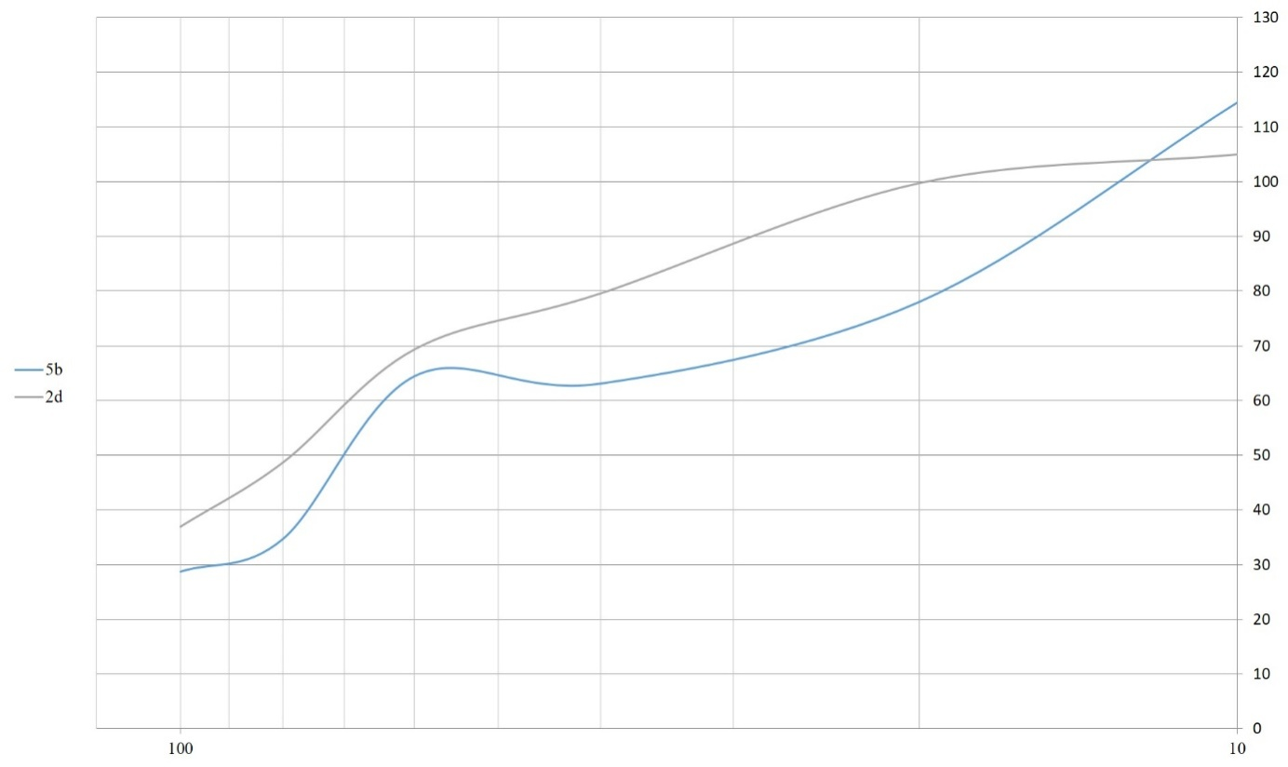
Figure 2: The minimum inhibitory concentration of 7b and 3d on Bacillus subtilis

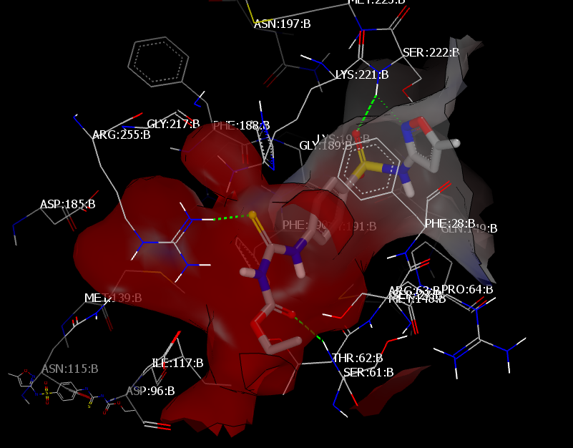
Figure 3: Visual representation for 3ddocked with PDB: 3TZF showing three HBs interaction
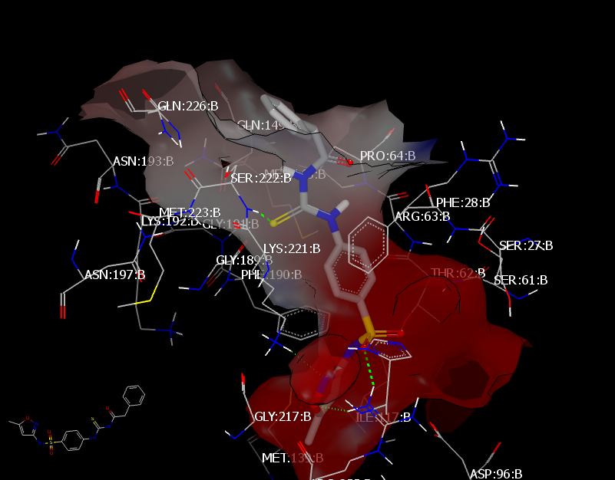
Figure 4: Visual representation for 7c docked with PDB: 3TZF showing Two HBs interaction towards the binding site
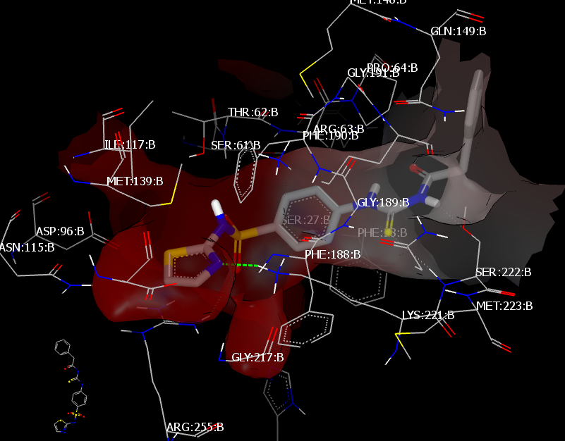
Figure 5: Visual representation for 7b docked with PDB: 3TZF showing HB interaction towards the binding site.
Figure 6: Quantum Homo and Lumo of prepared compounds
Comp. | HOMO |  | LUMO
3b
3b | 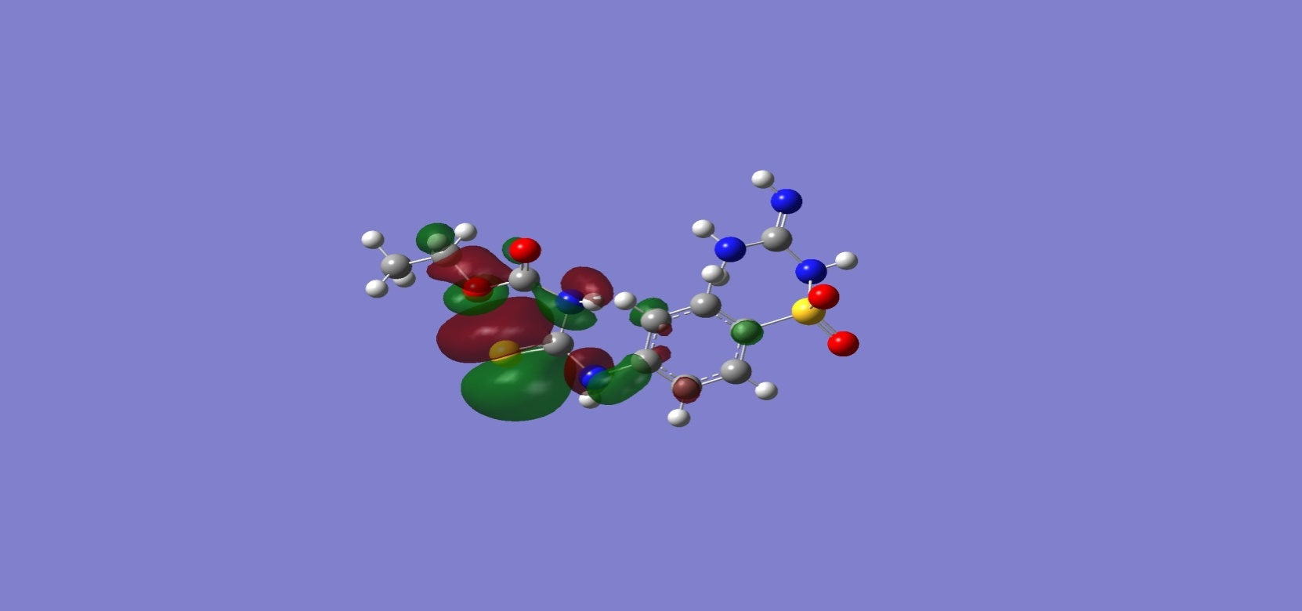 | 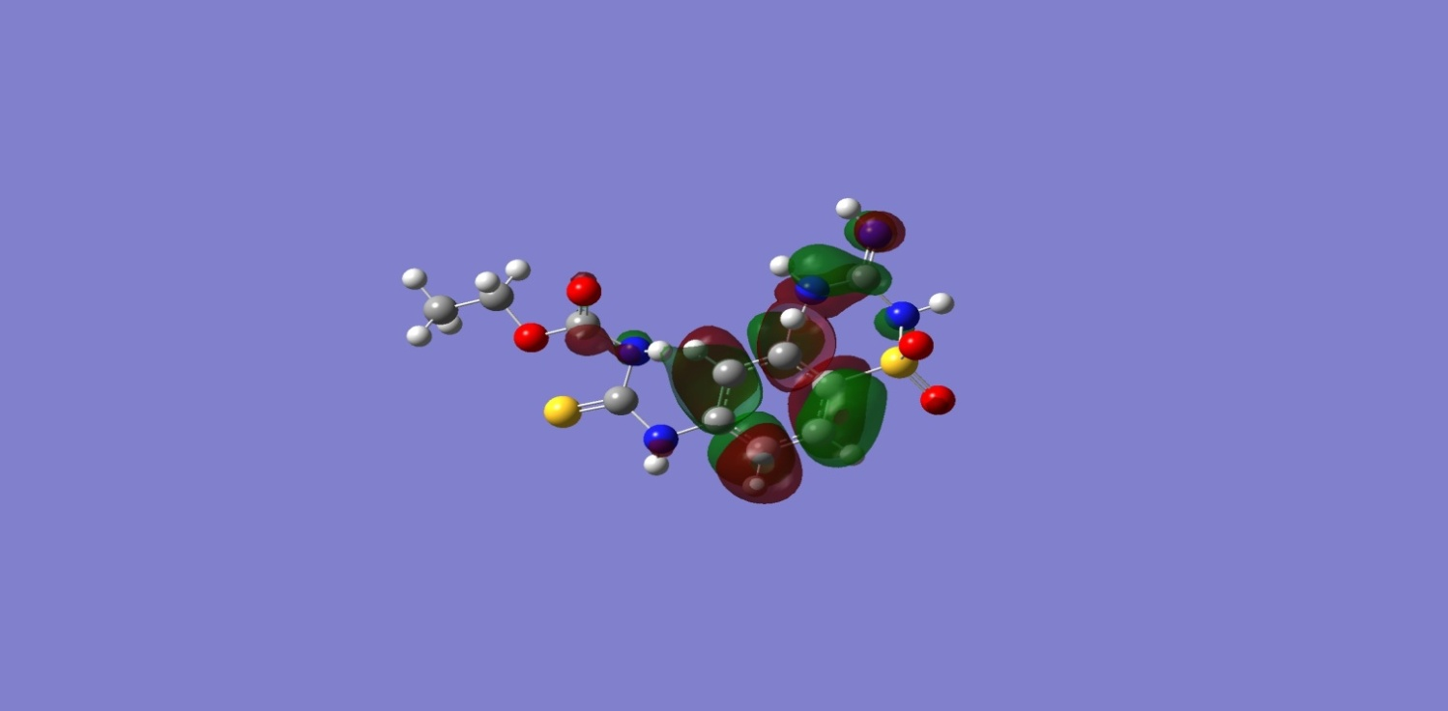
3d
3d | 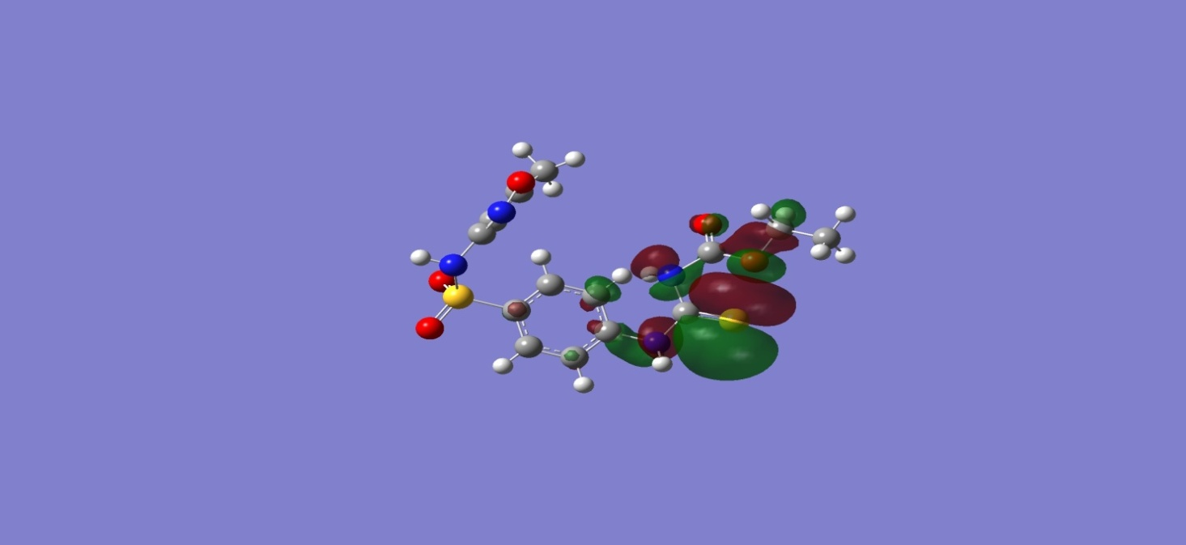 | 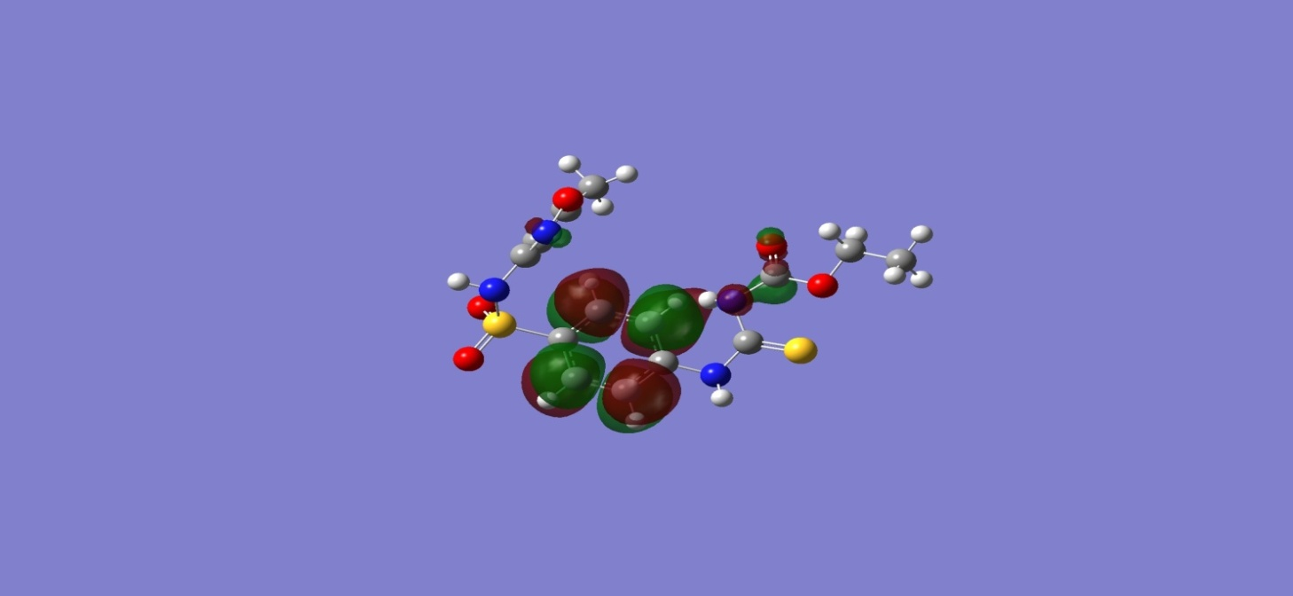
3e
3e | 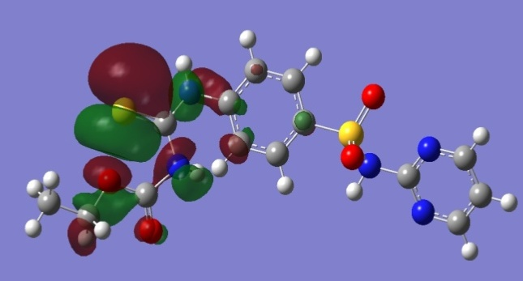 | 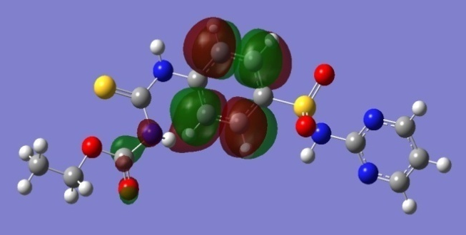
7a
7a | 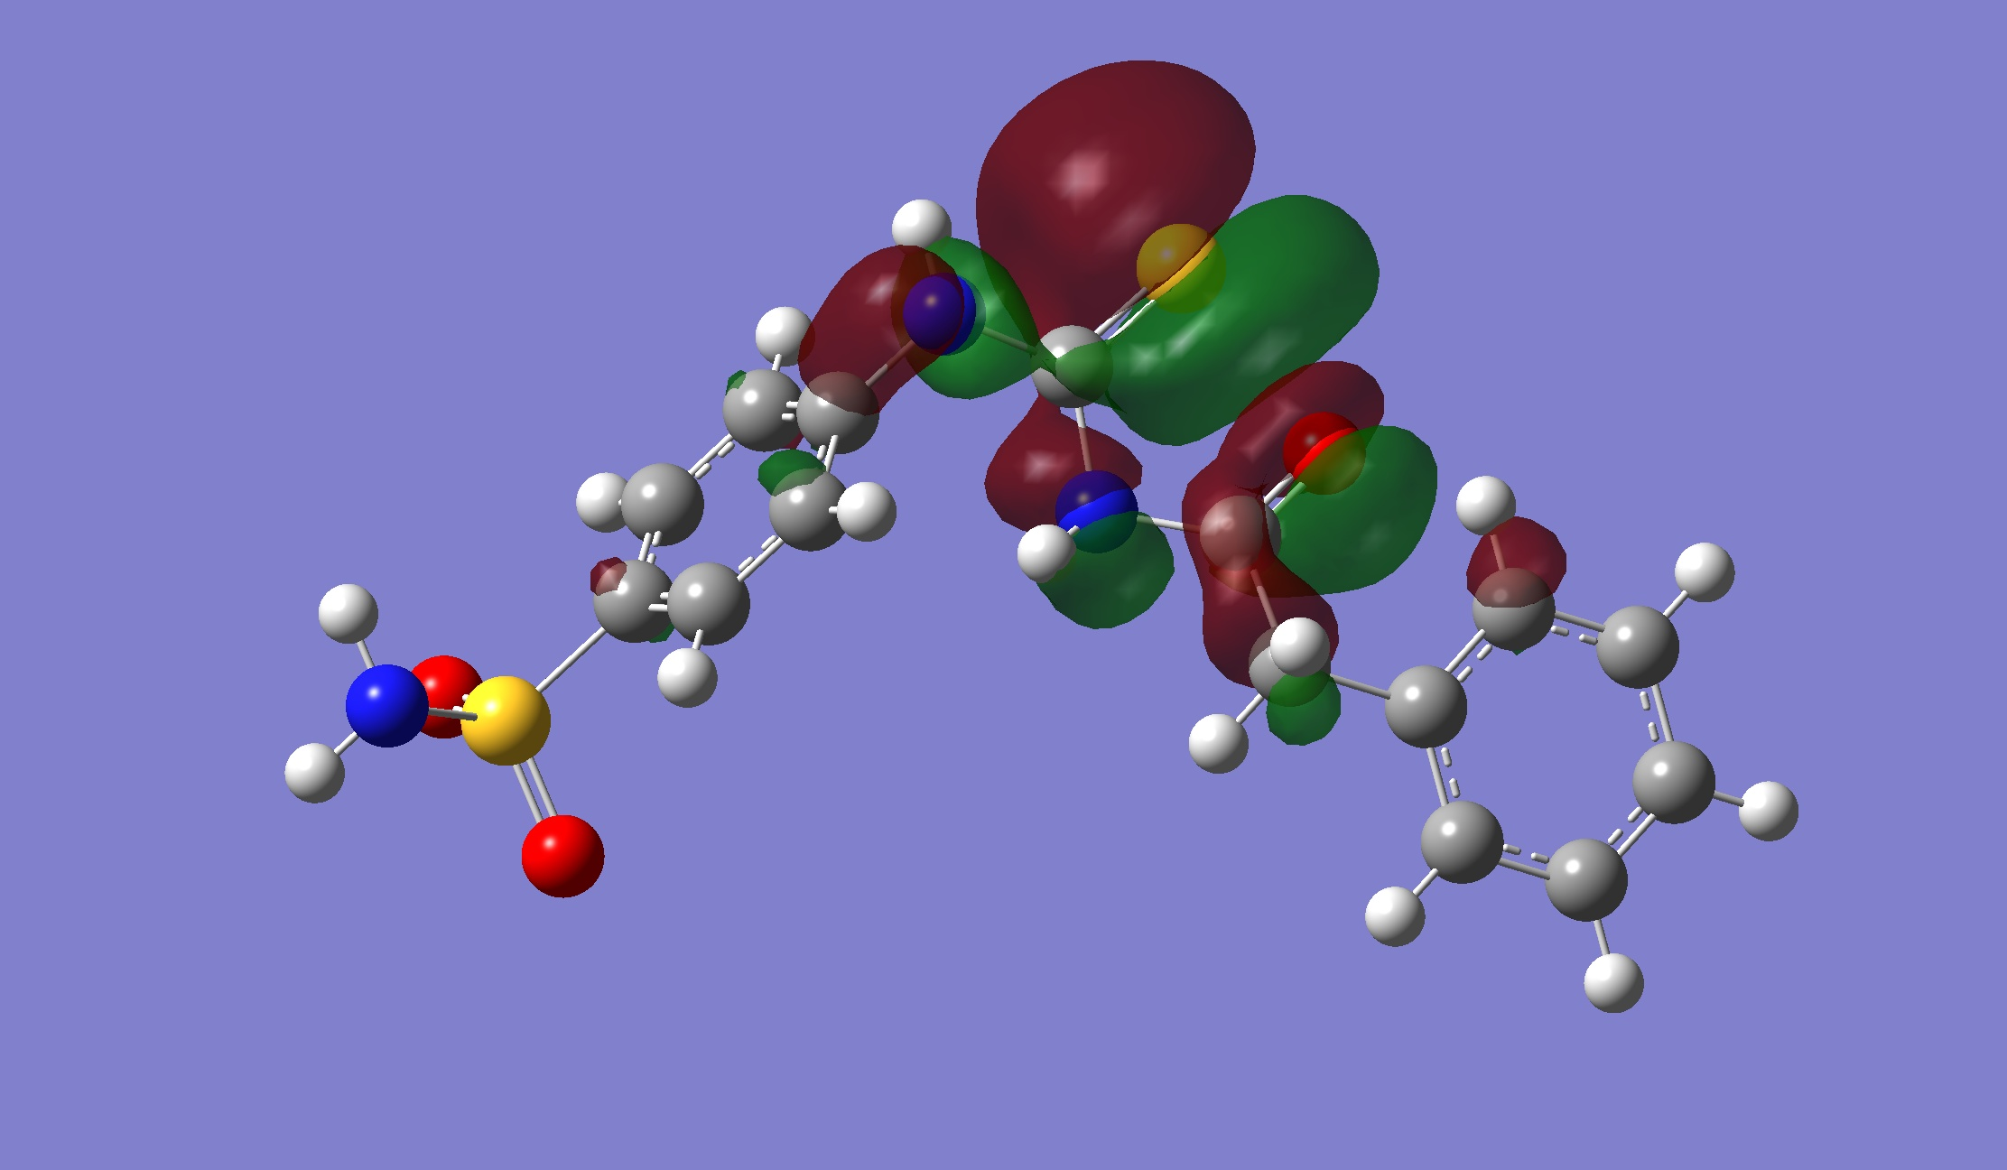 | 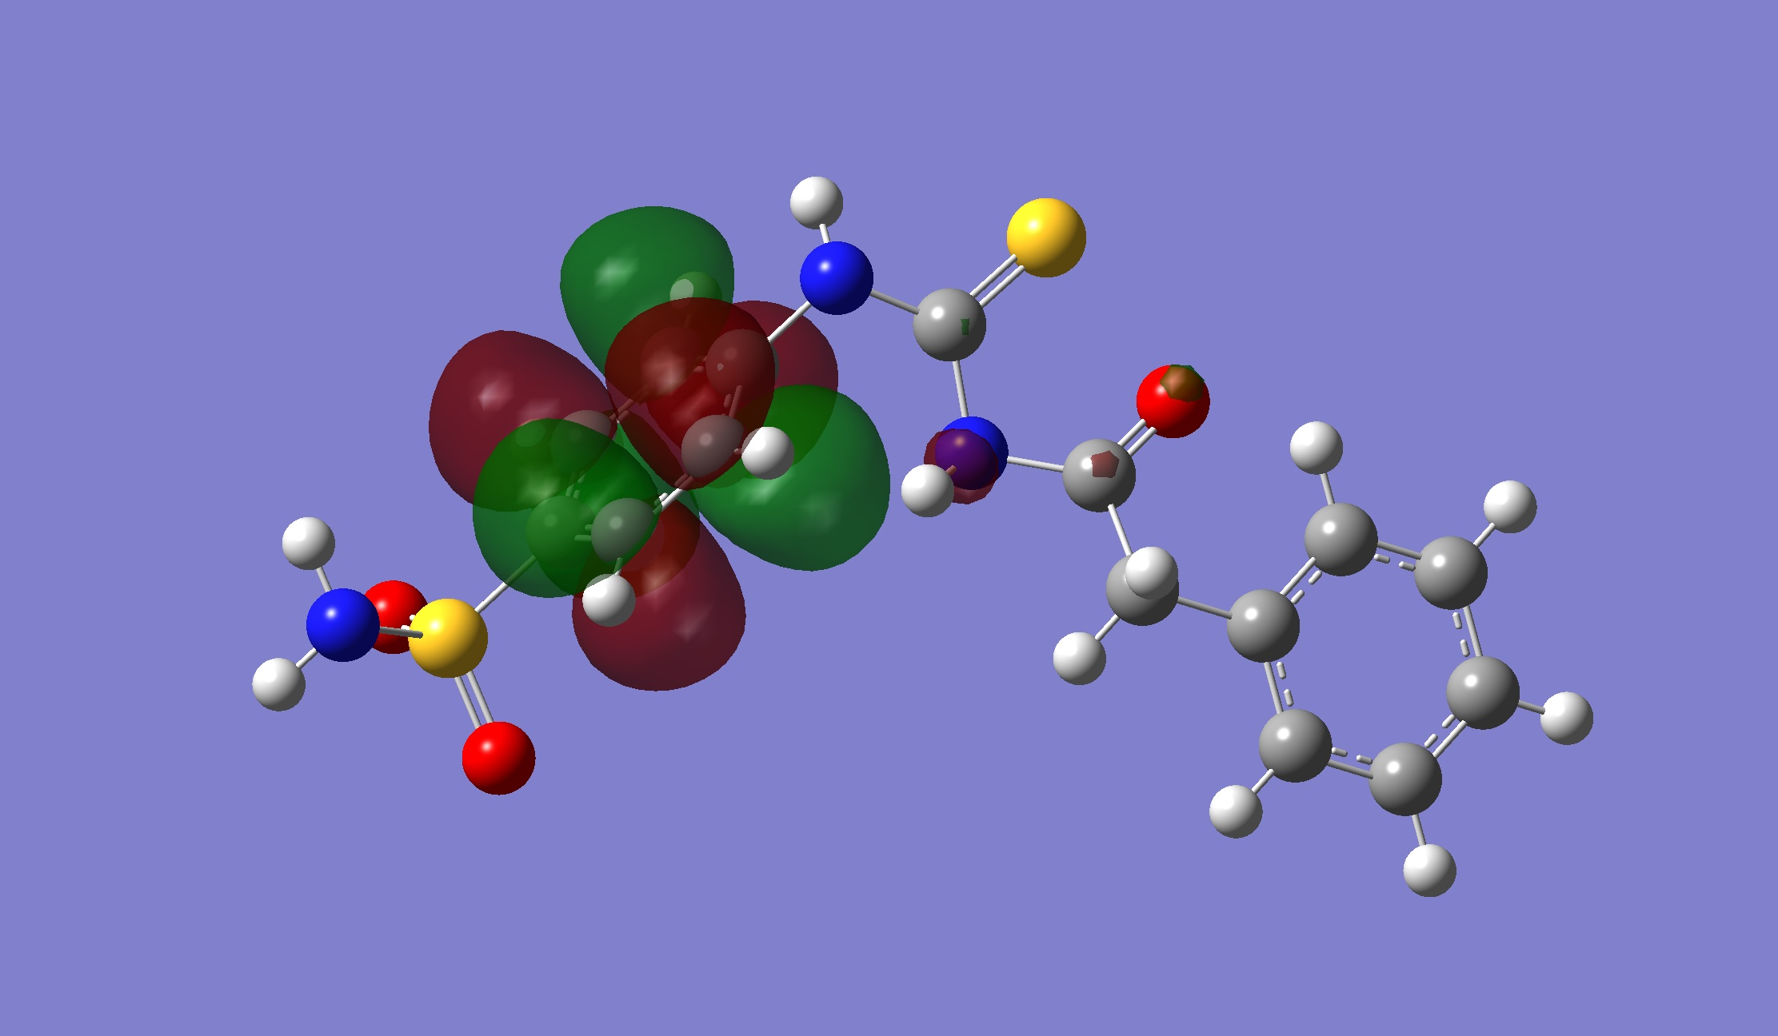
7b
7b | 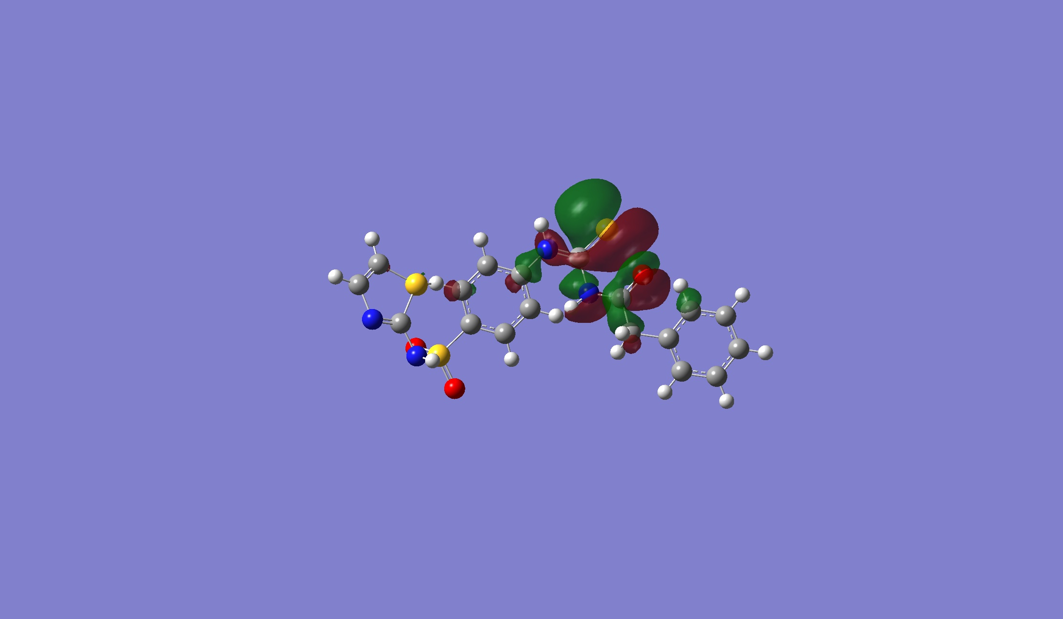 |  | 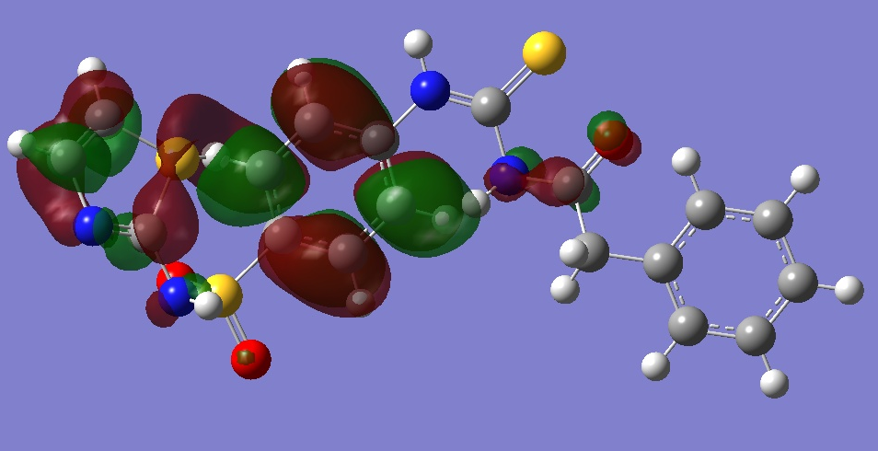
7c
7c | 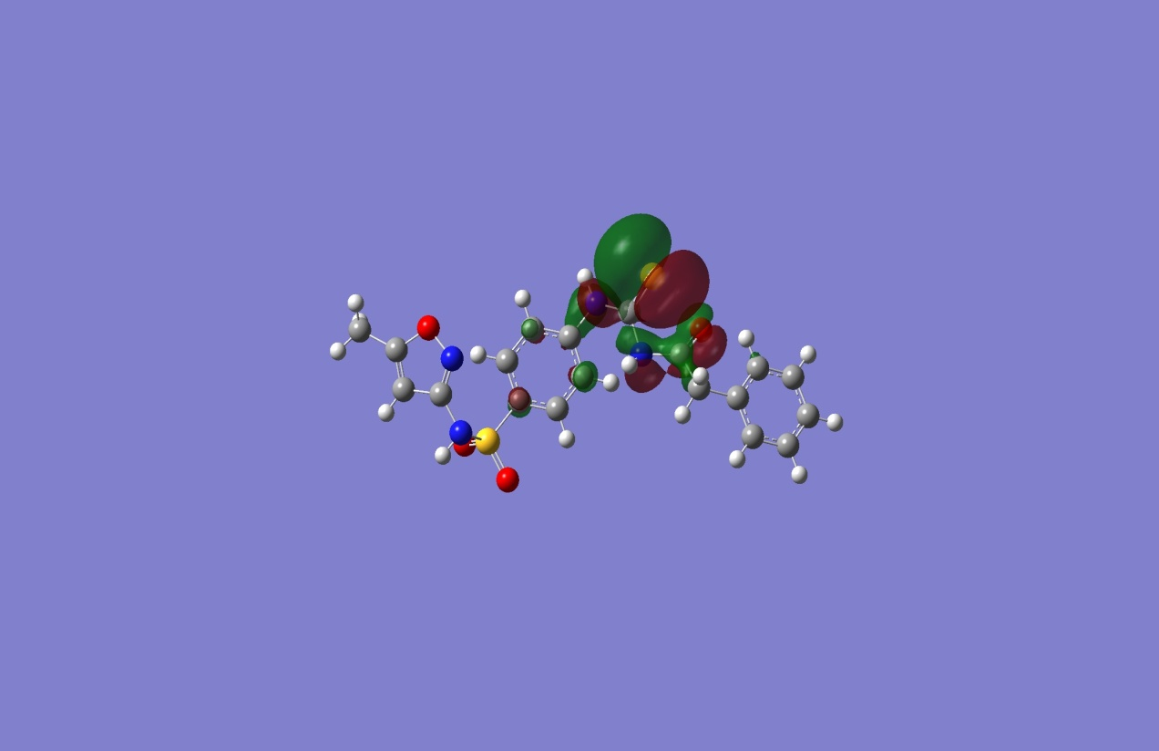 | 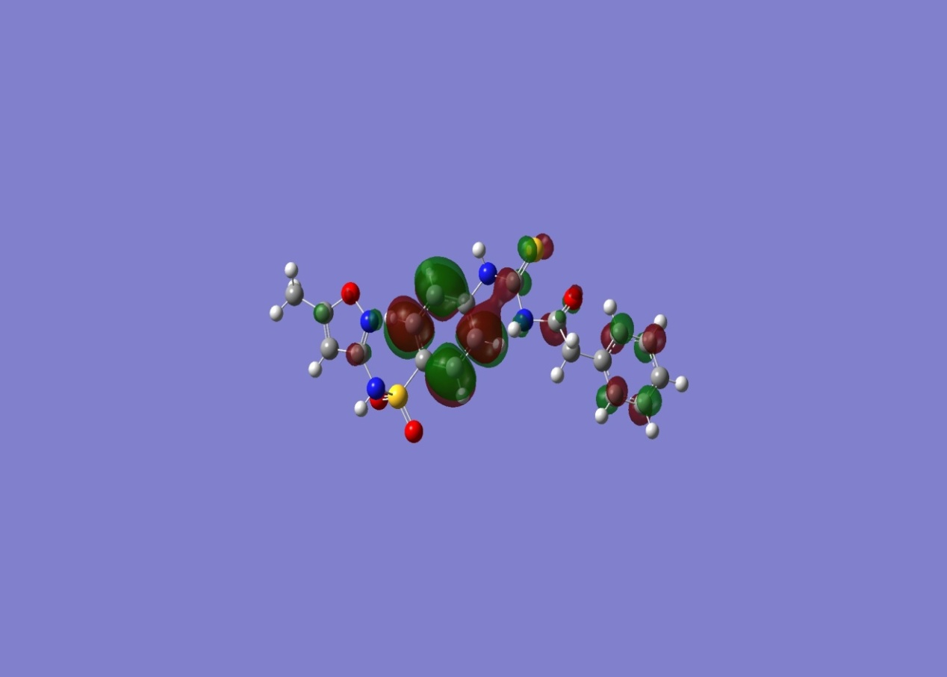
7d
7d | 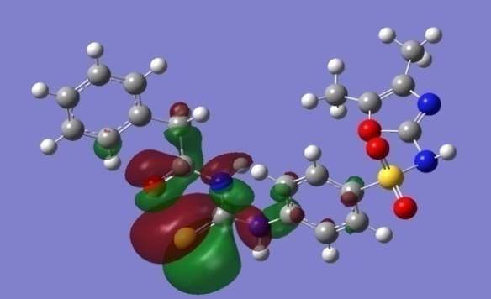 | 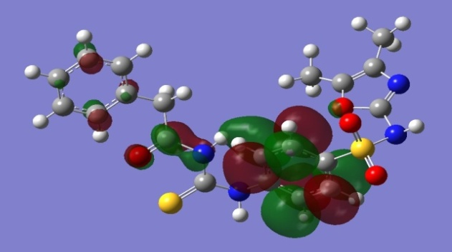
7e
7e | 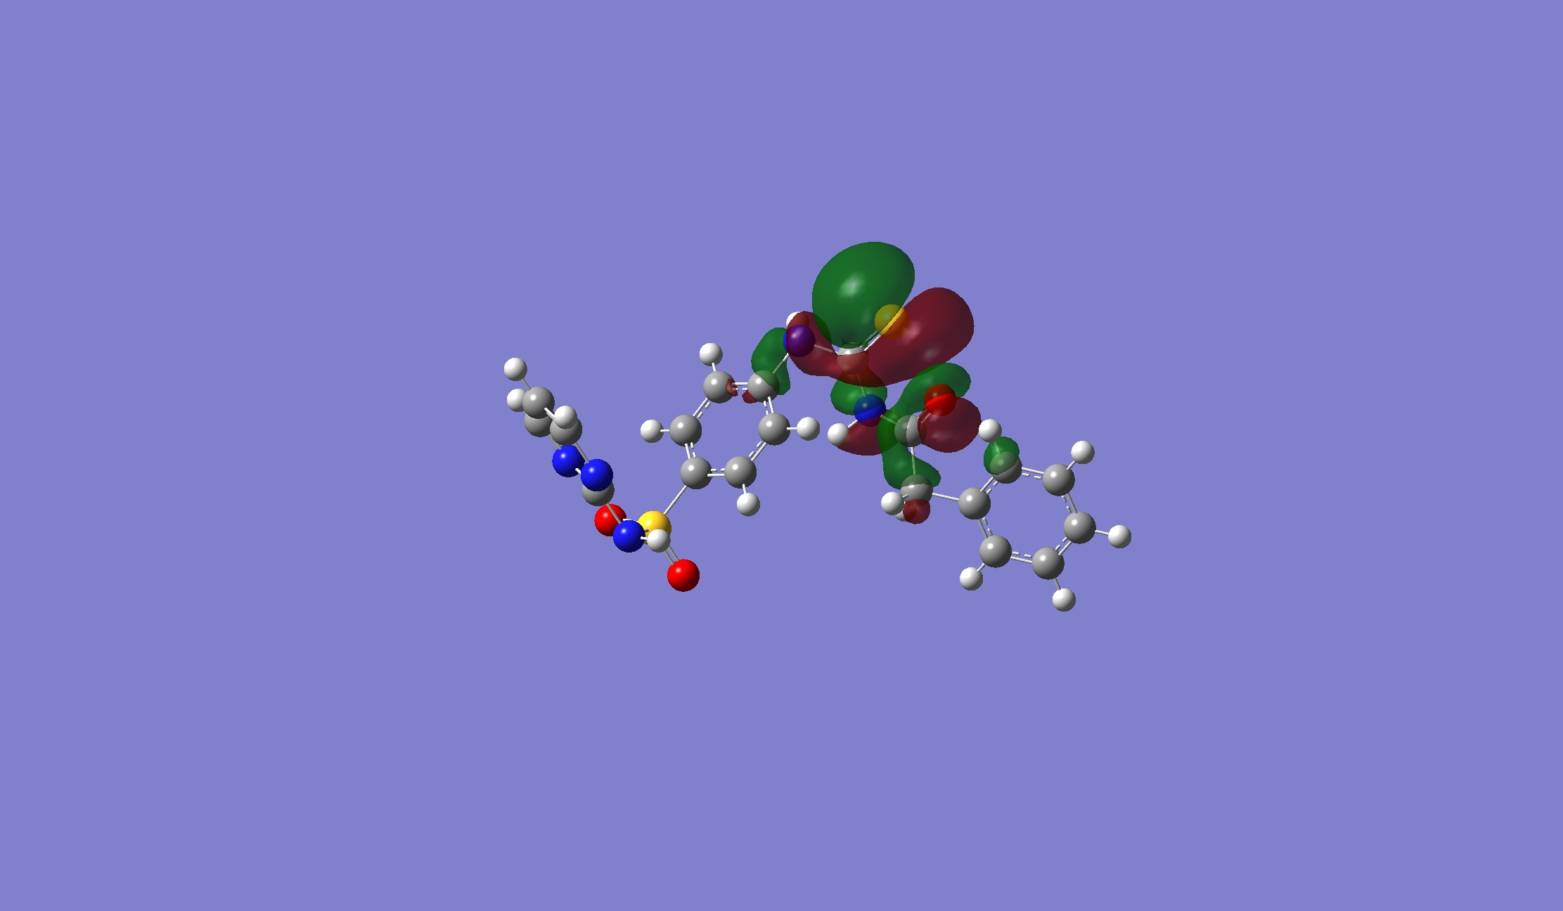 | 