***Ethyl [(4-sulfamoylphenyl)carbamothioyl]carbamate 3a.***

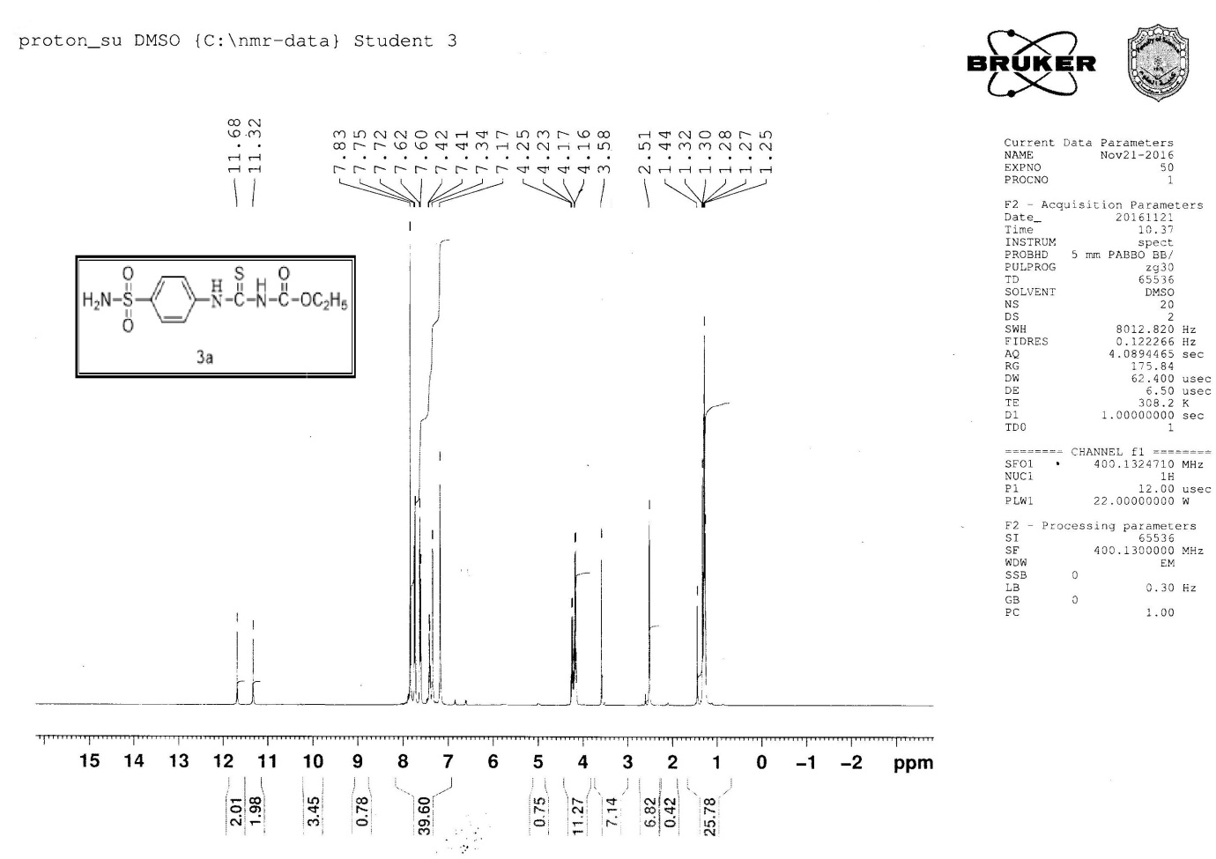

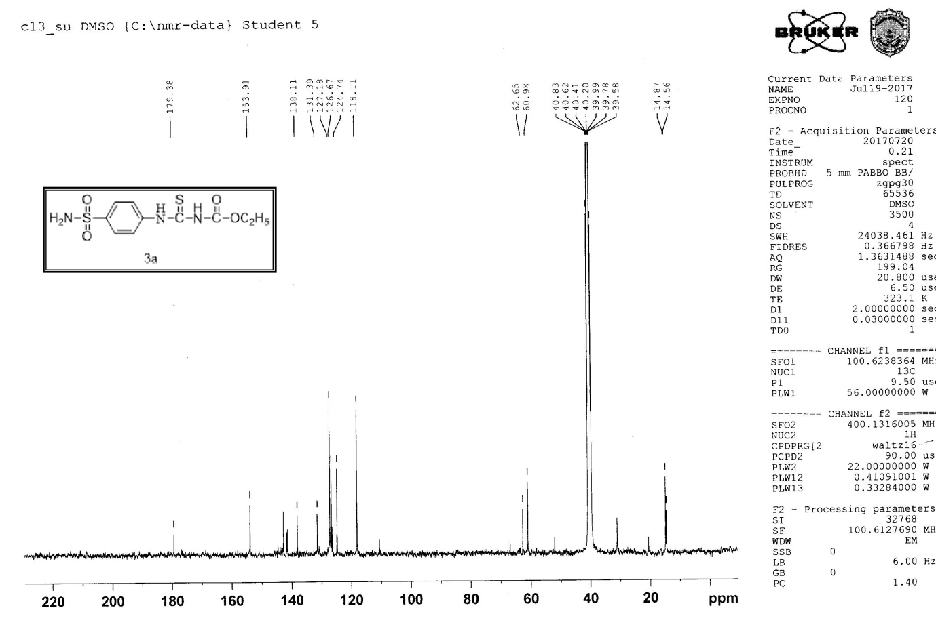

***Ethyl {[(4-carbamidoimidoylsulfamoyl)phenyl]carbamothioyl]carbamate 3b.***

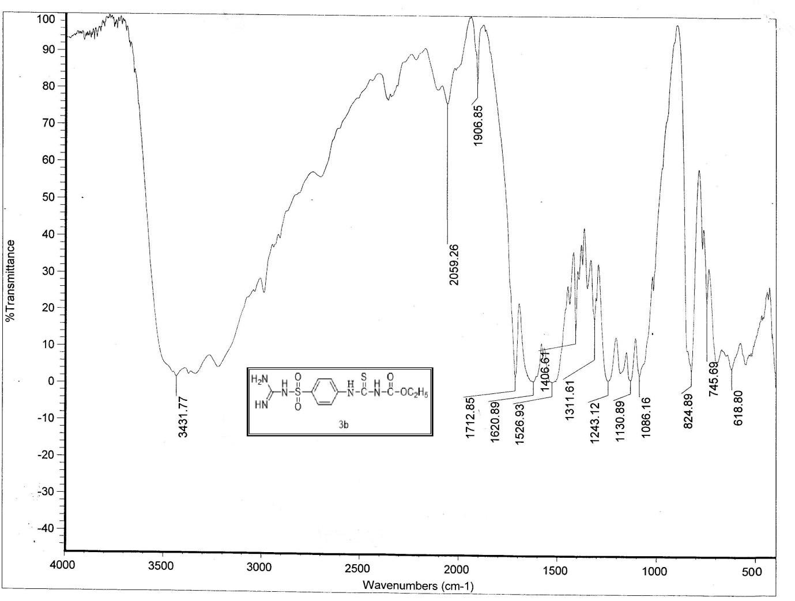

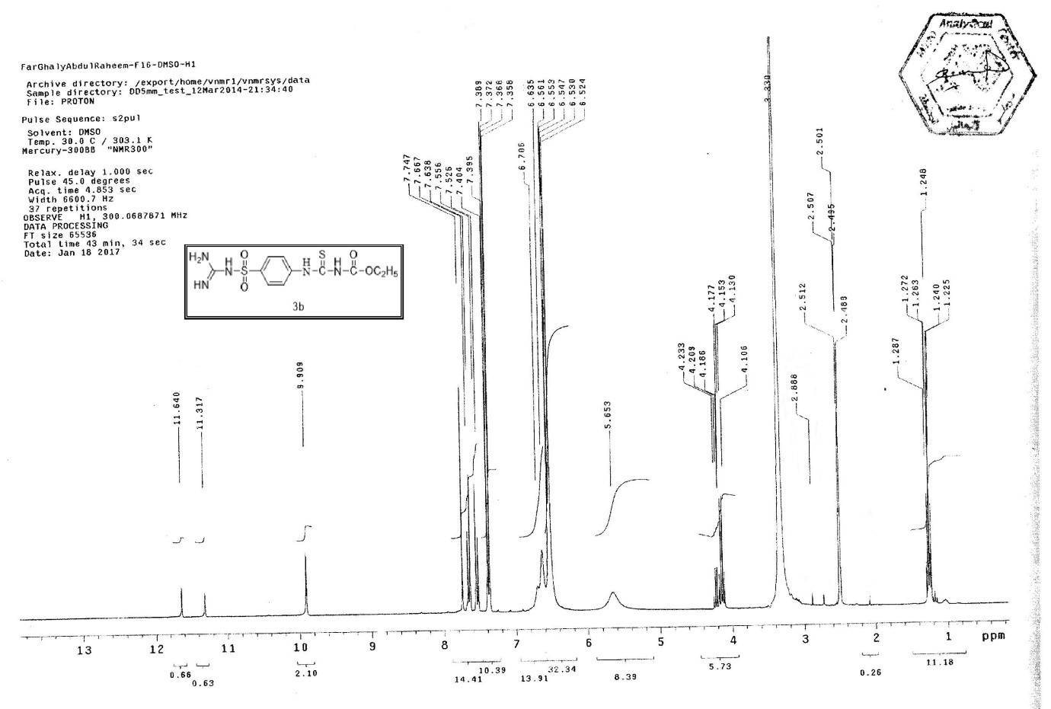

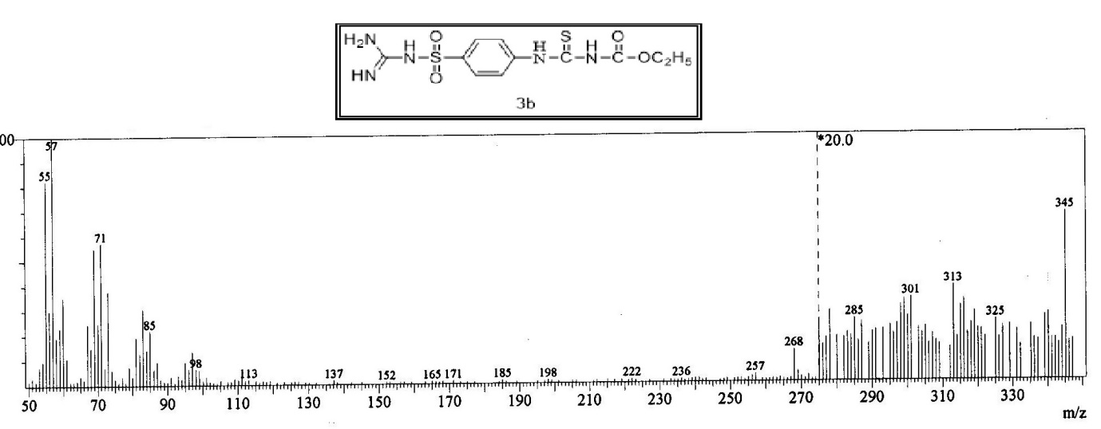

***Ethyl ({4-[(1,3-thiazol-2-yl)sulfamoyl)phenyl]carbamothioyl)carbamate 3c***

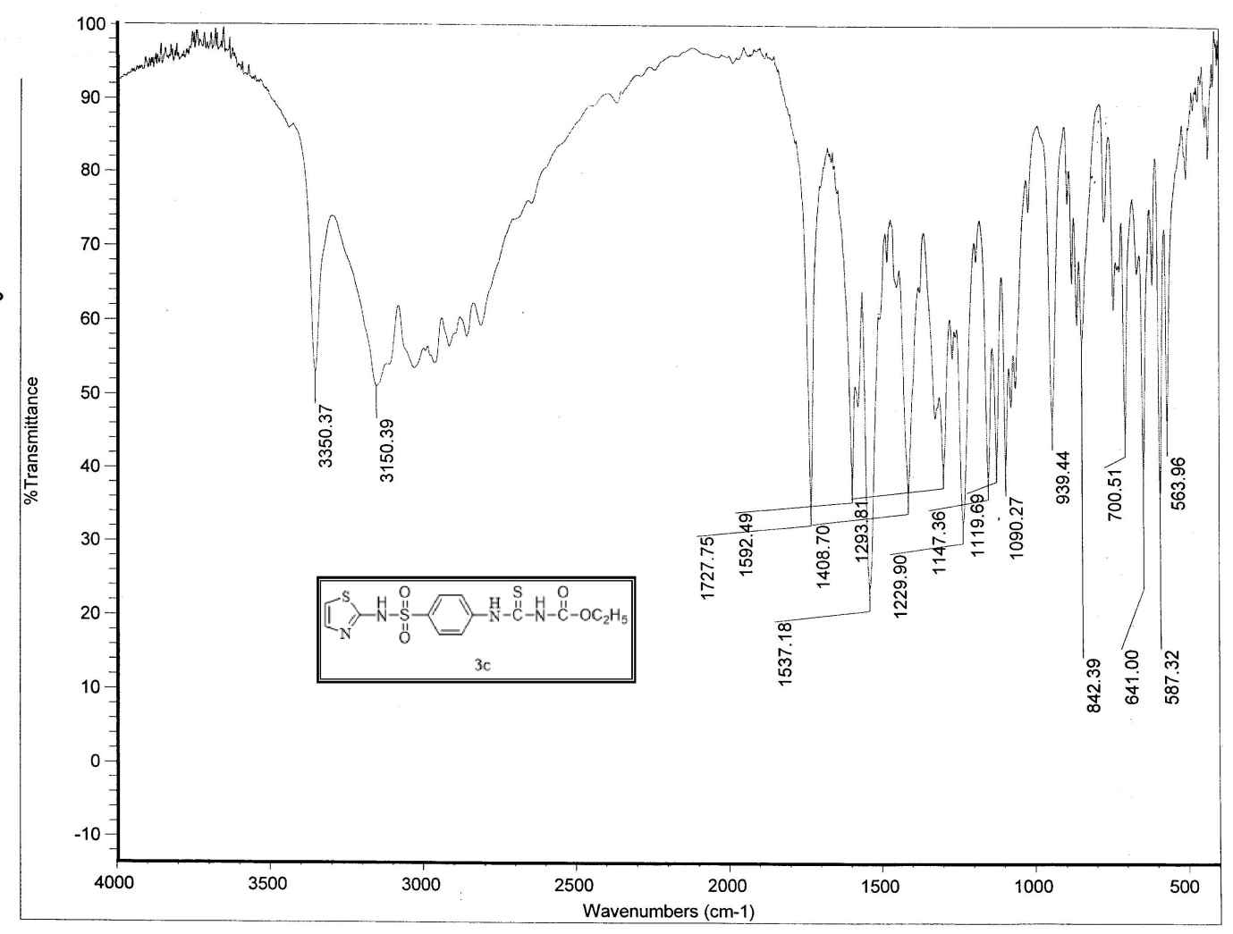

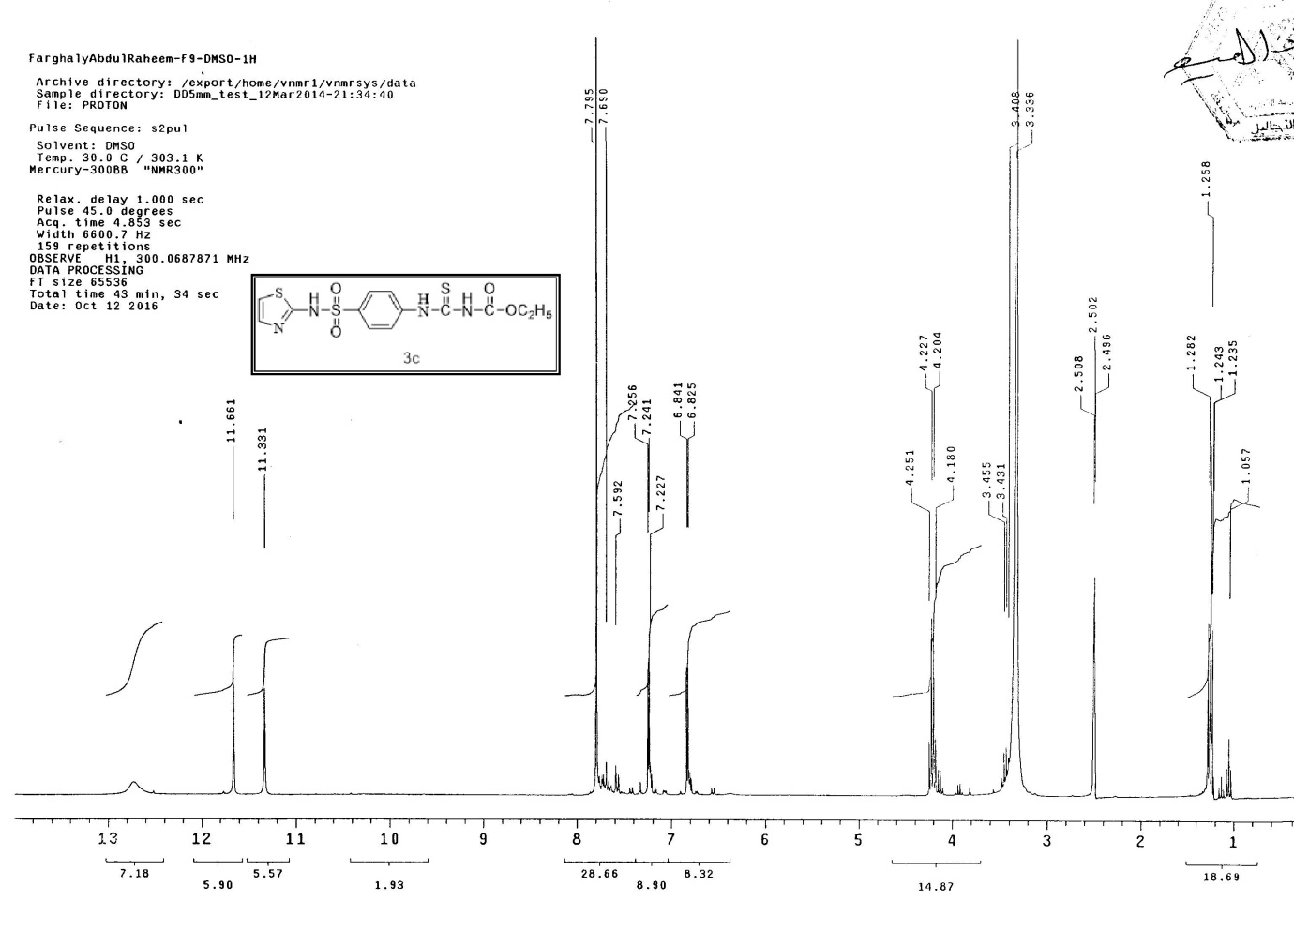

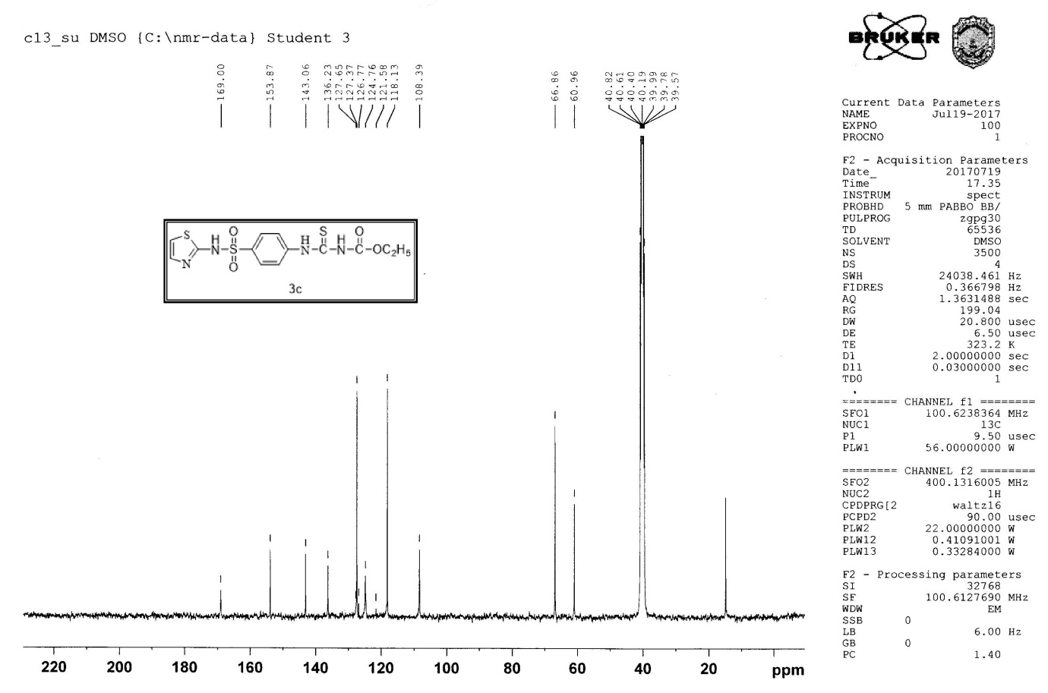

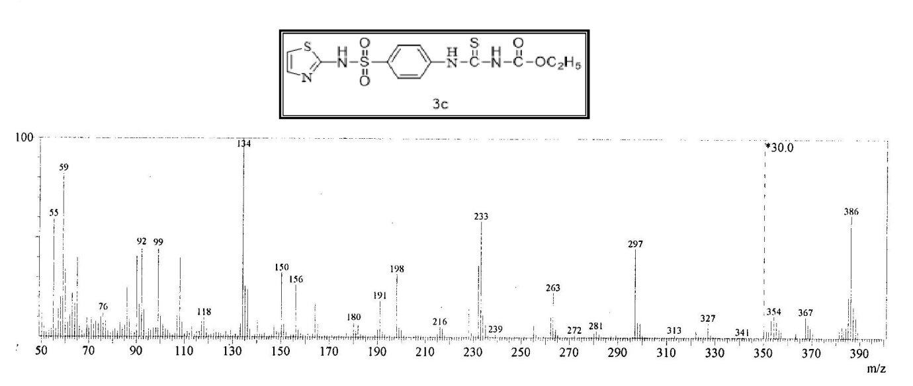

***Ethyl ({4-[(5-methyl-1,2-oxazol-3-yl)sulfamoyl)phenyl]carbamothioyl)carbamate 3d***

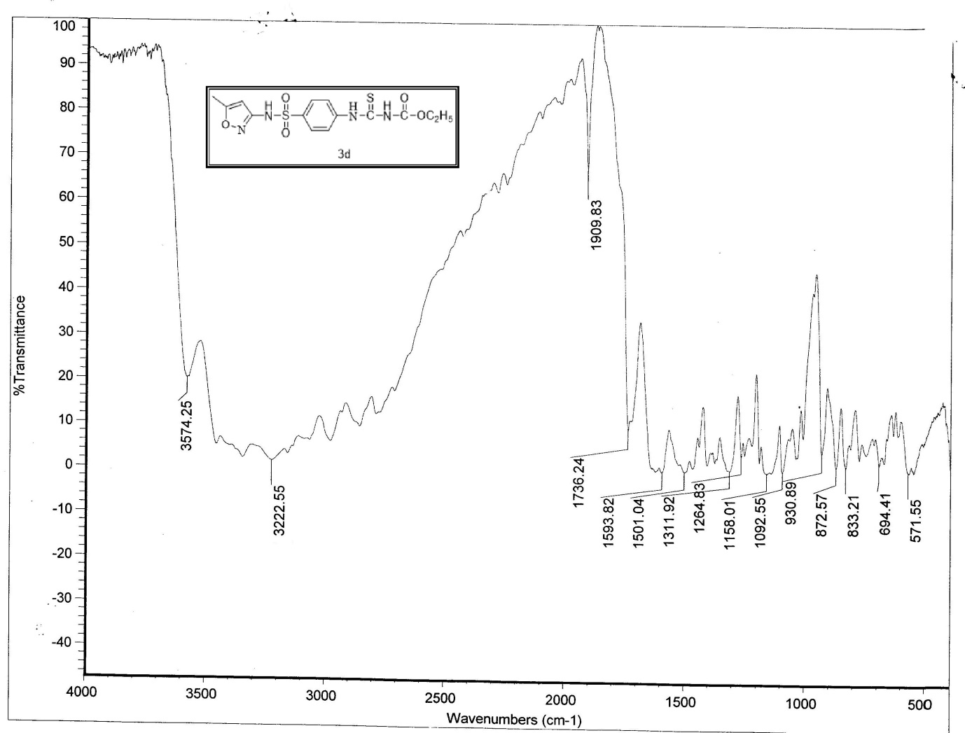

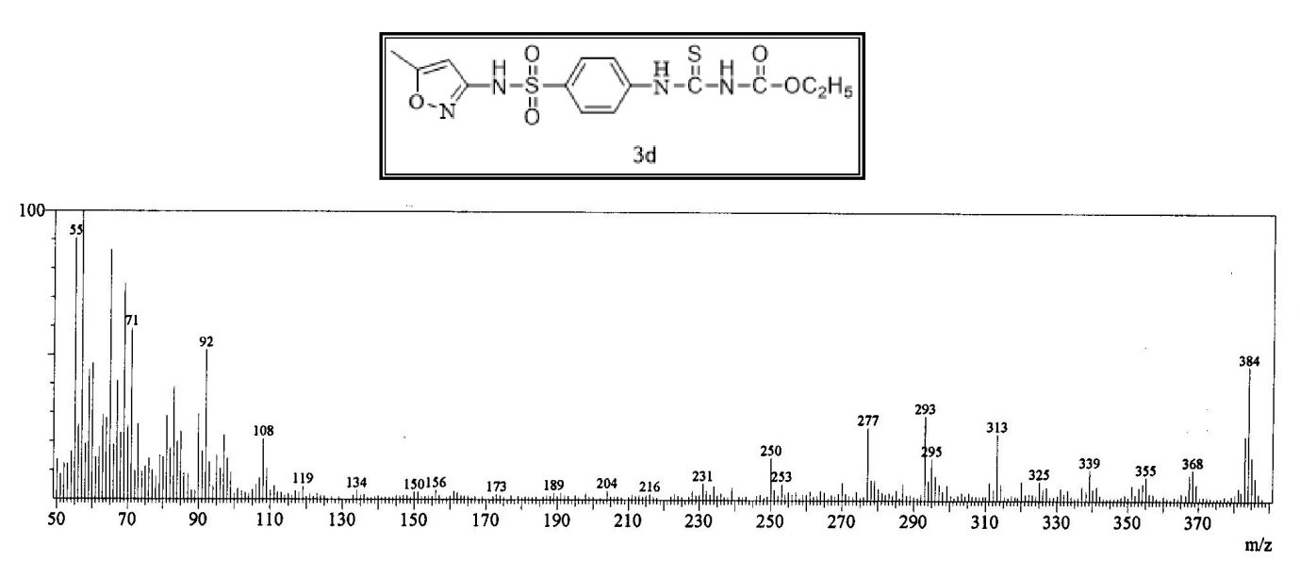

***Ethyl ({4-[(pyrimidin-2-yl)sulfamoyl)phenyl]carbamothioyl)carbamate 3e***

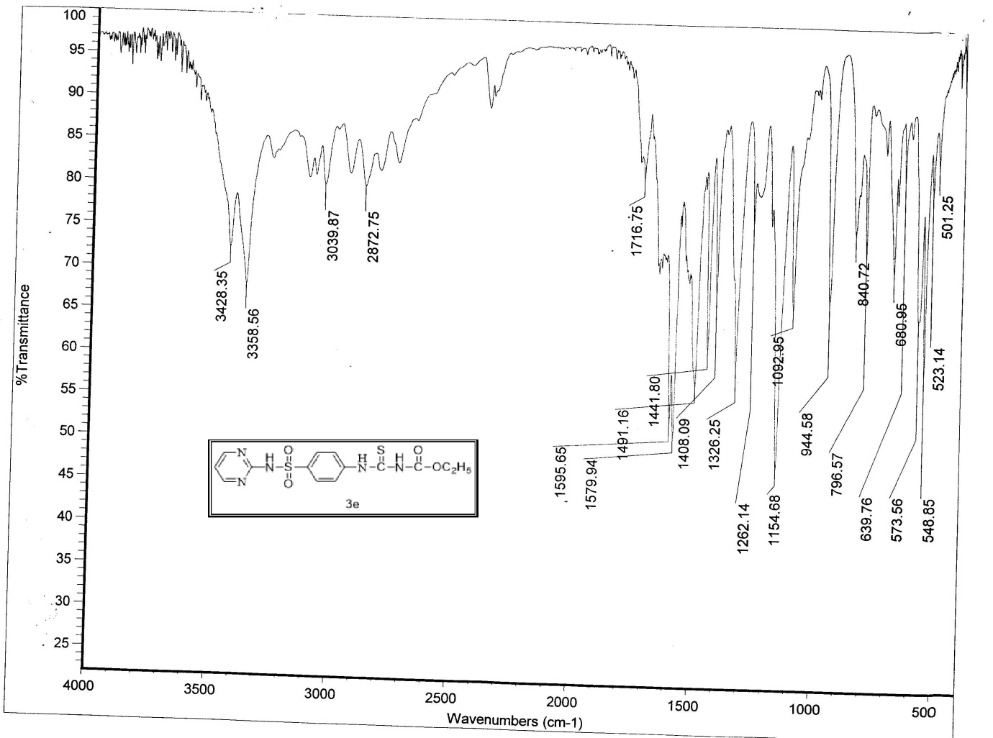

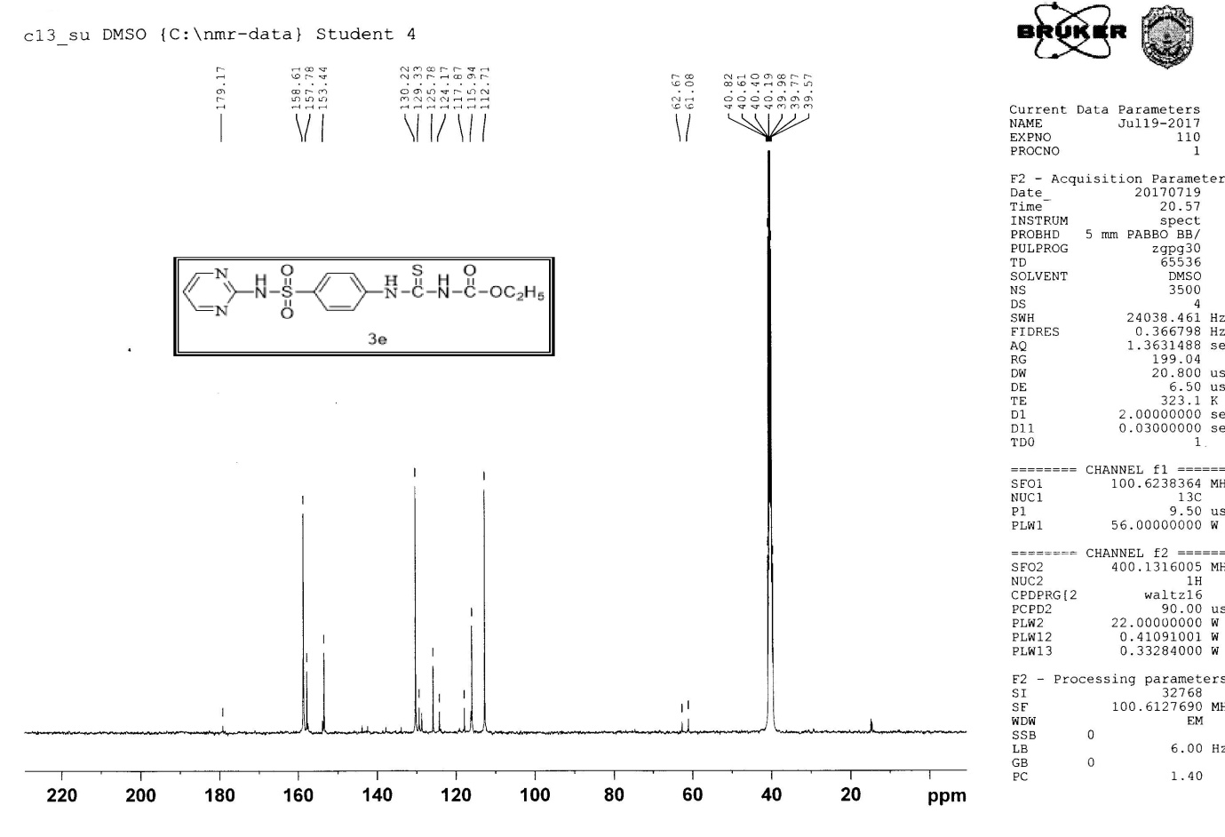

***2-Phenyl-N-((4-sulfamoylphenyl)carbamothioyl)acetamide 7a***

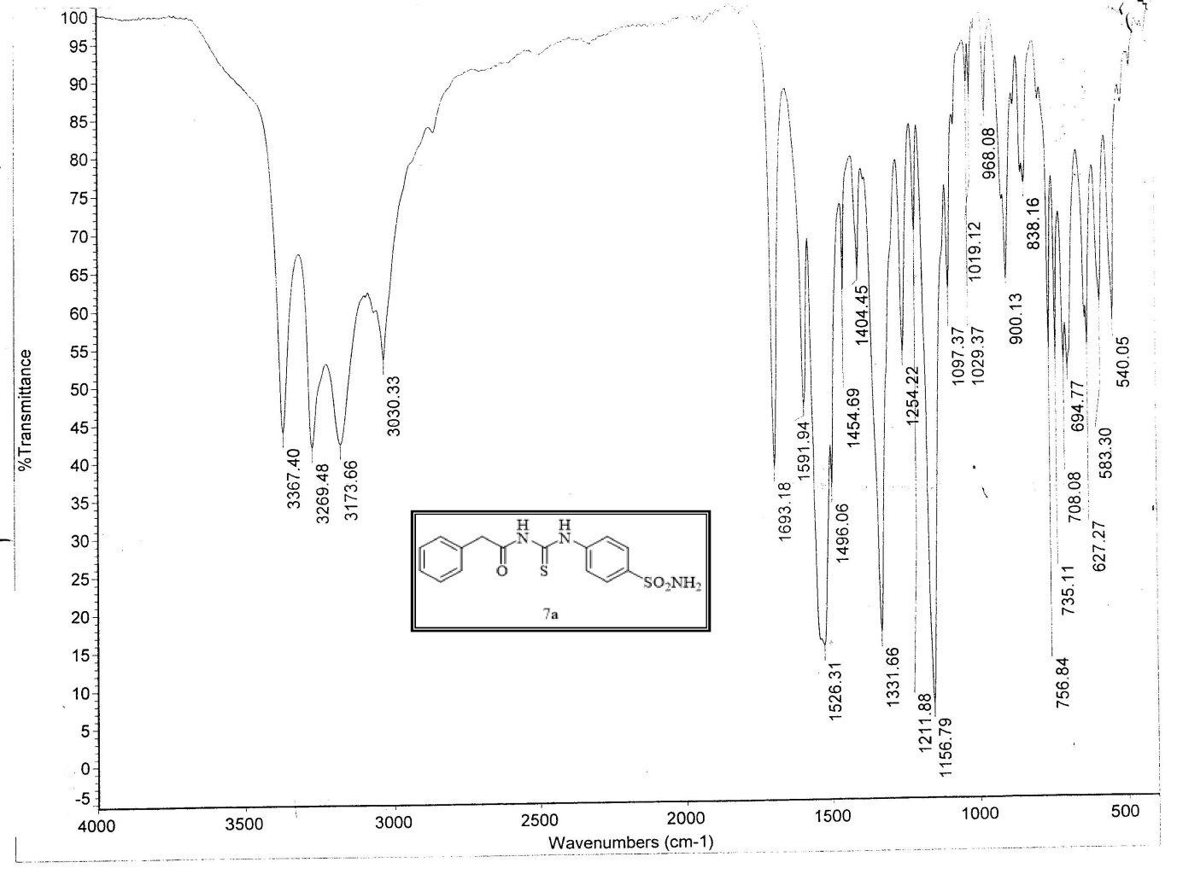

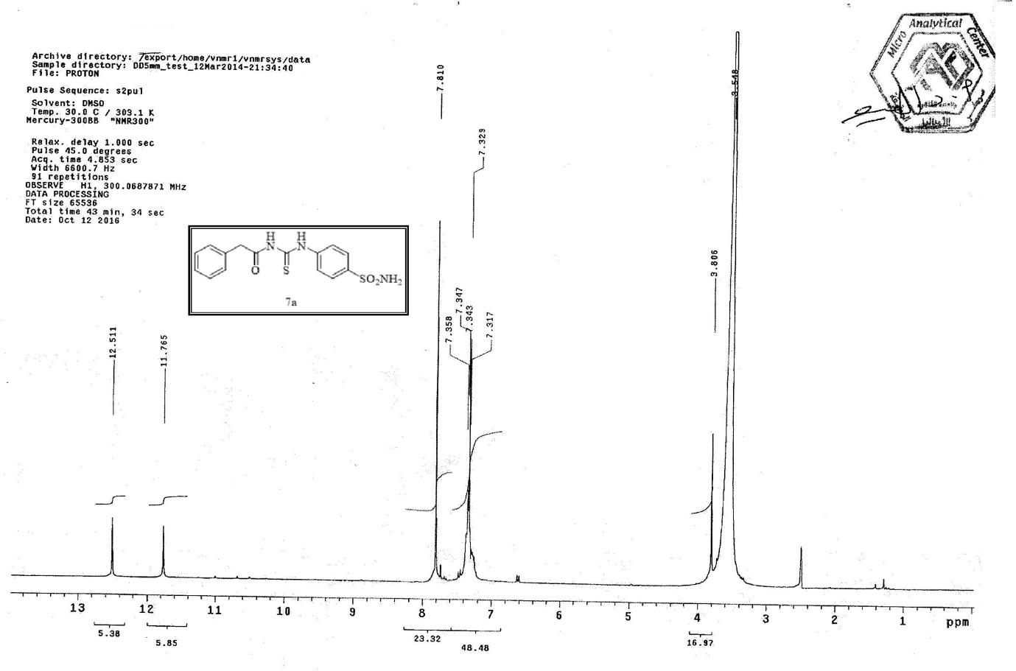

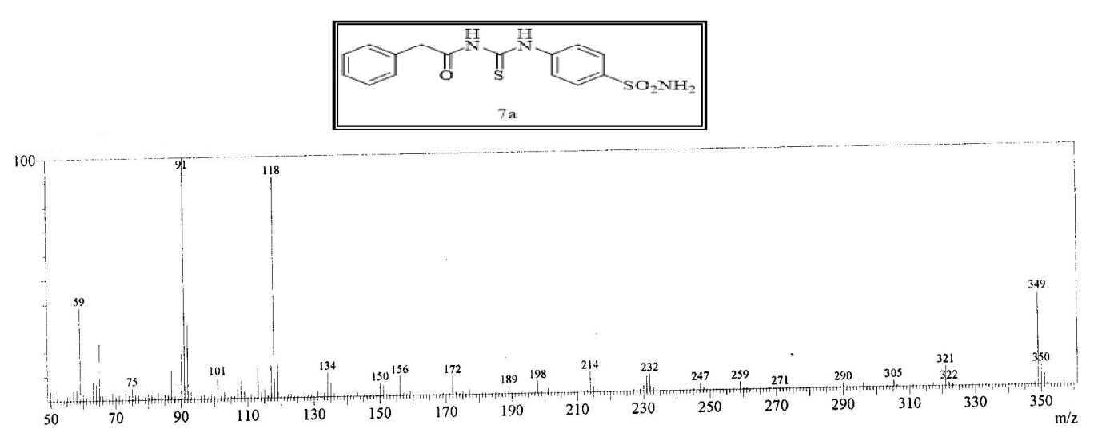

***2-Phenyl-N-((4-(N-thiazol-2-yl)sulfamoyl)phenyl)carbamothioyl)acetamide7b***

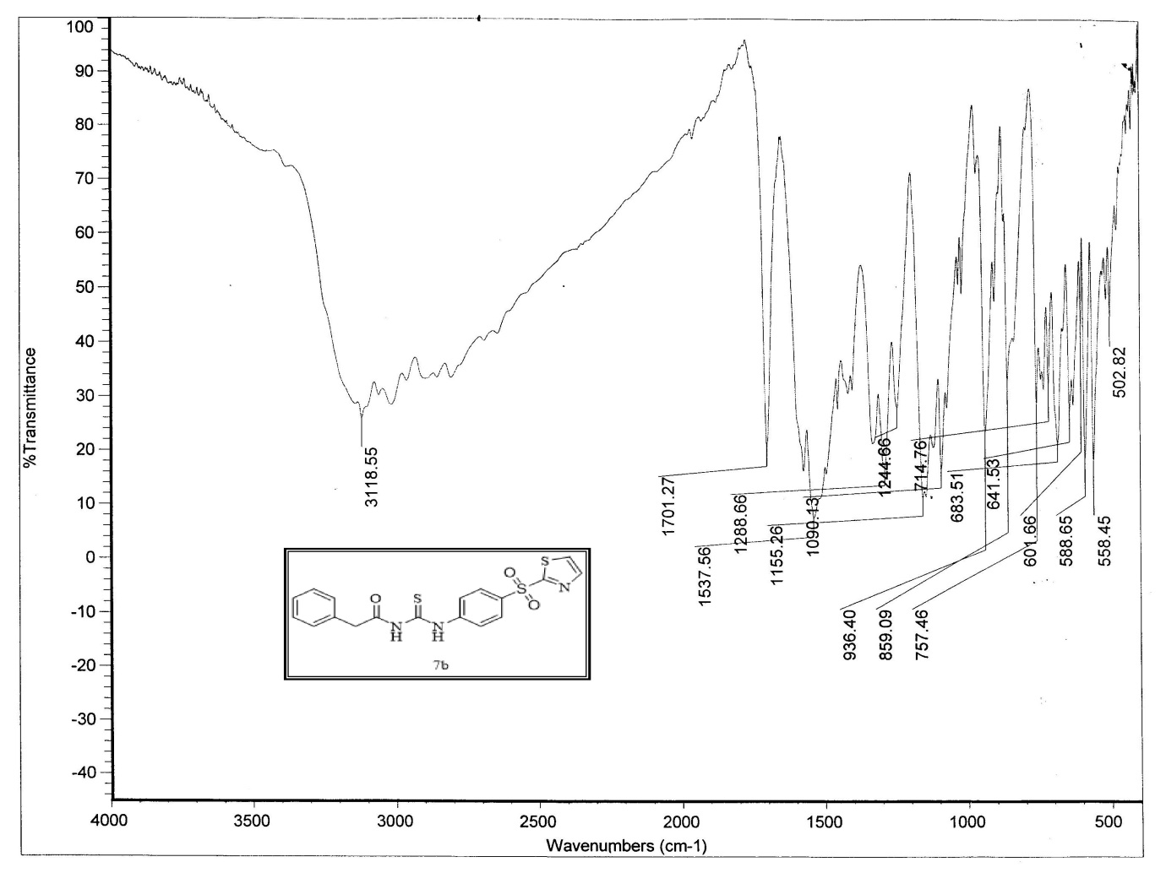

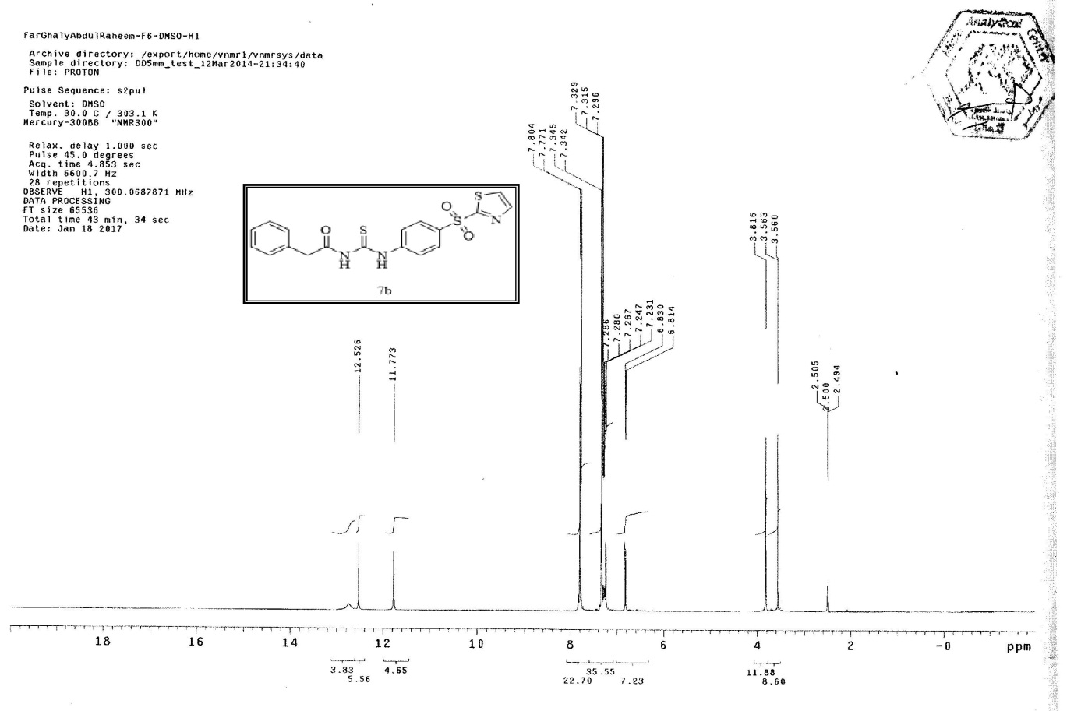

***N-((4-(N-(5-methylisoxazol-3-yl)sulfamoyl)phenyl)carbamothioyl)-2-Phenylacetamide 7c***

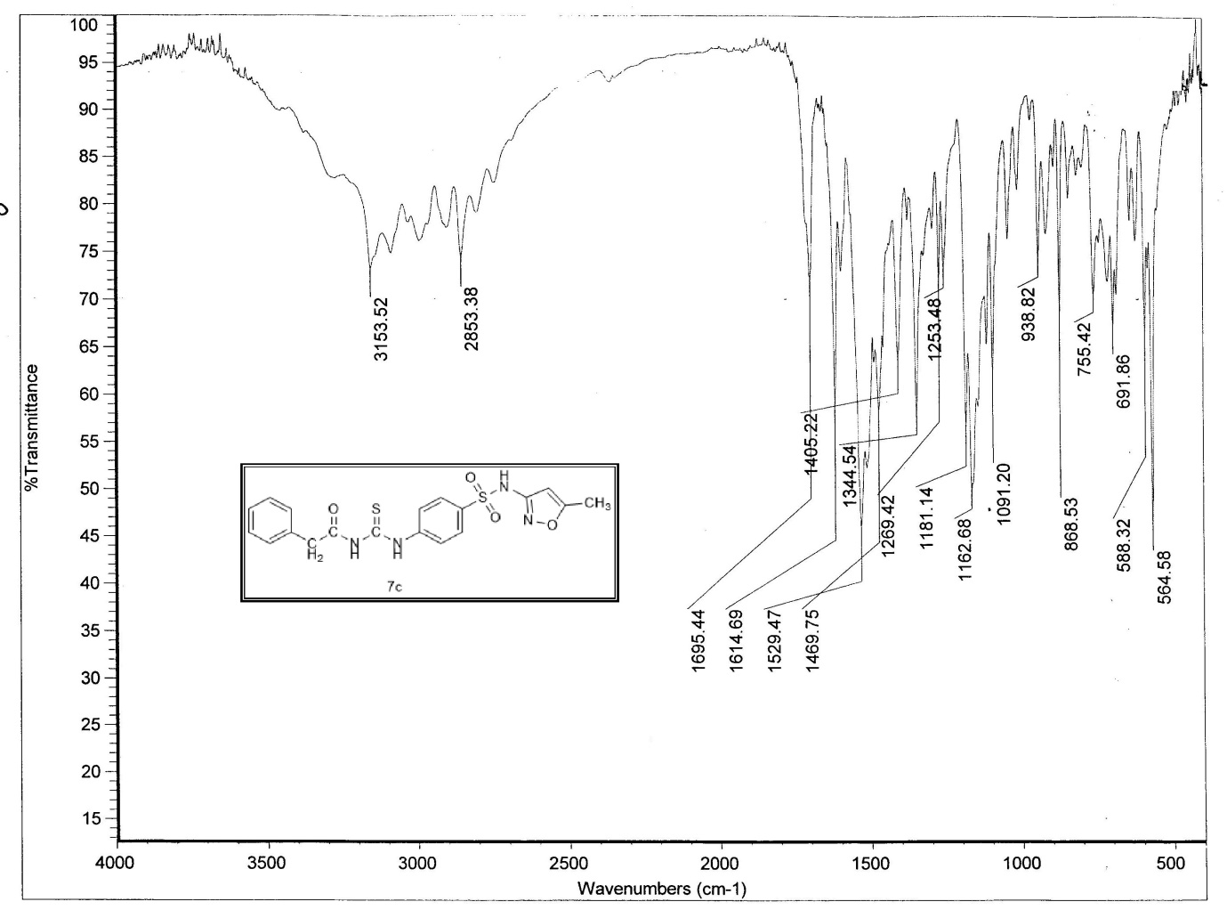

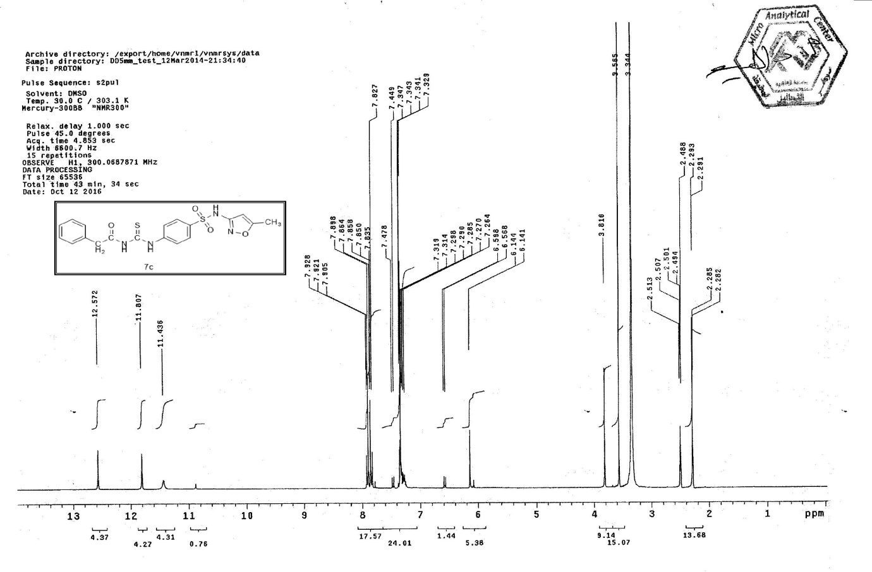

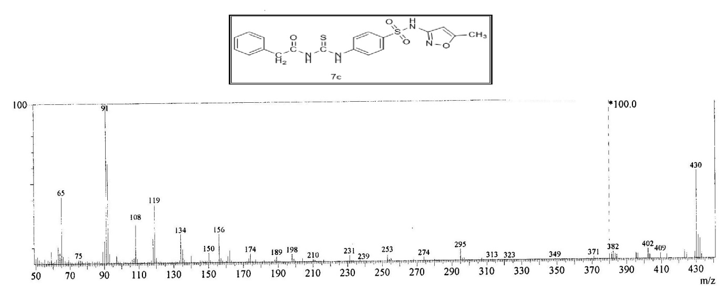

***N-((4-(N-(4,5-dimethyloxazol-2-yl)sulfamoyl)phenyl)carbamothioyl)-2-Phenylacetamide7d.***

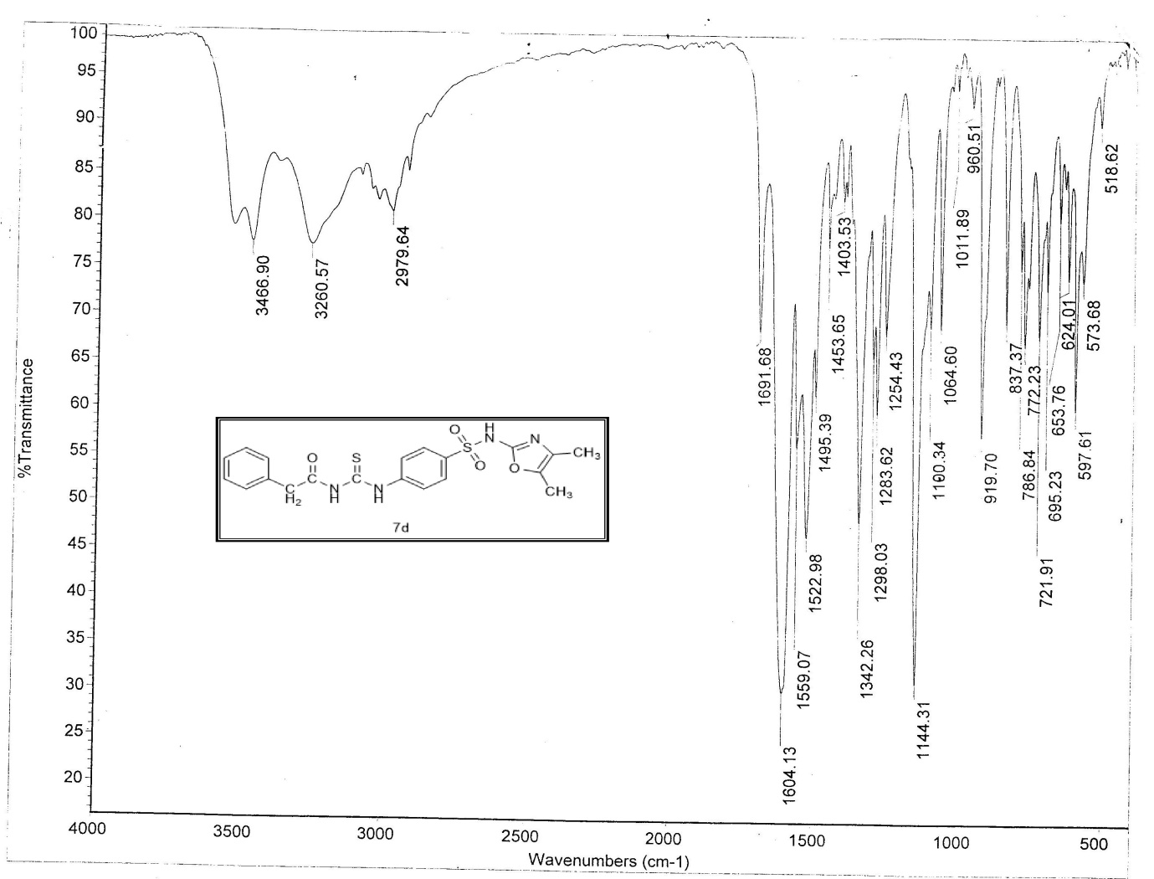

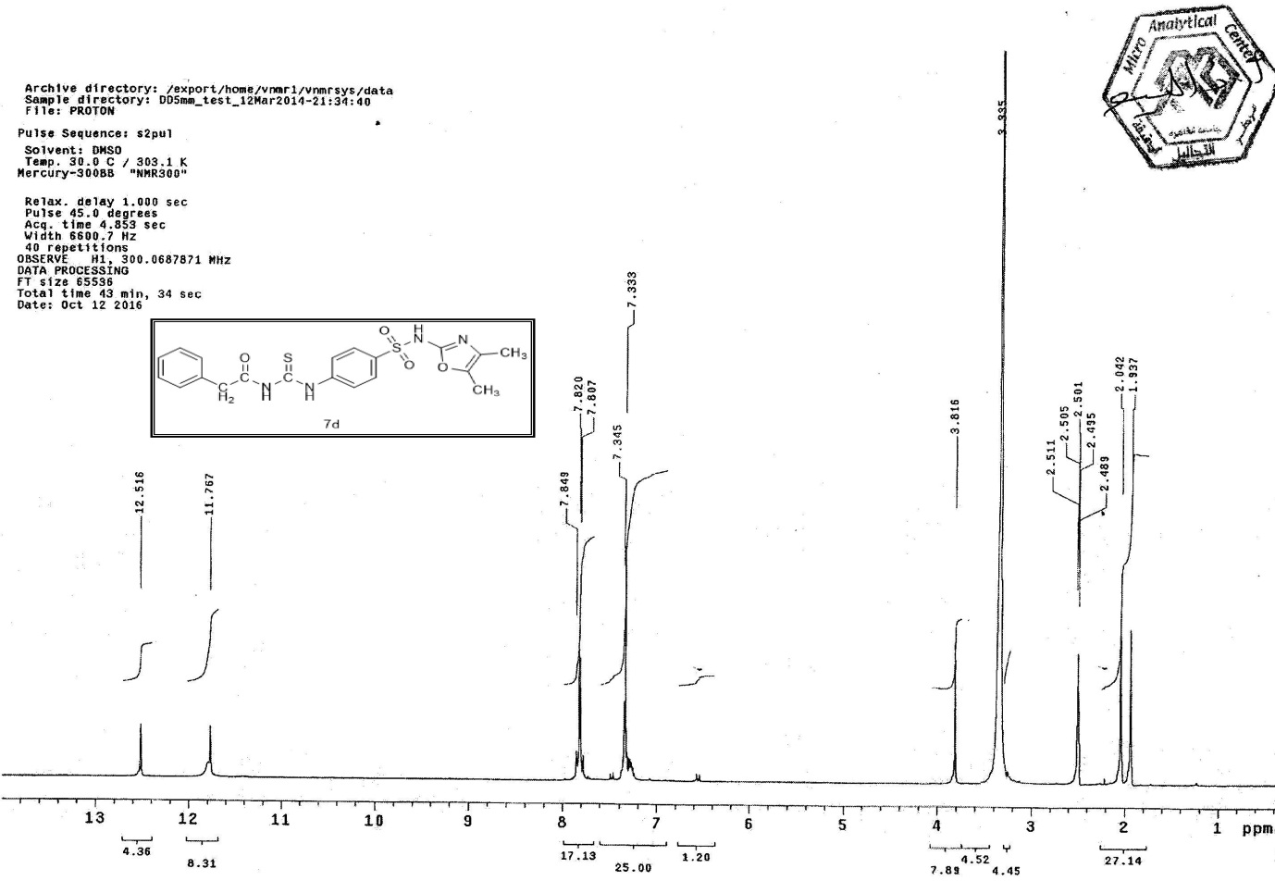

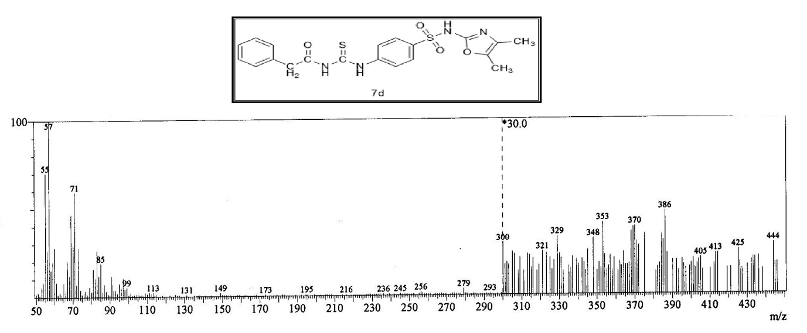

***2-Phenyl-N-((4-(N-(pyrimidin-2-yl)sulfamoyl)phenyl)carbamothioyl)acetamide 7e***

