Supplementary Material

Contents

**Figure S1**: 1H and 13C NMR spectra of compound **1b**.

**Figure S2**: 1H and 13C NMR spectra of compound **3a**.

**Figure S3**: 1H and 13C NMR spectra of compound **1c**.

**Figure S4**: 1H and 13C NMR spectra of compound **2c**.

**Figure S5**: 1H and 13C NMR spectra of compound **5**.

**Figure S6**: 1H and 13C NMR spectra of compound **6a**.

**Figure S7**: 1H and 13C NMR spectra of compound **6b**.

**Figure S8**: 1H and 13C NMR spectra of compound **7**.

**Figure S9**: 1H and 13C NMR spectra of compound **8a**.

**Figure S10**: 1H and 13C NMR spectra of compound **8b**.

**Figure S11**: 1H and 13C NMR spectra of compound **9**.

**Table S1**: Crystal data and structure refinement data for compound **9.**

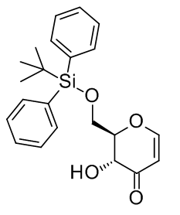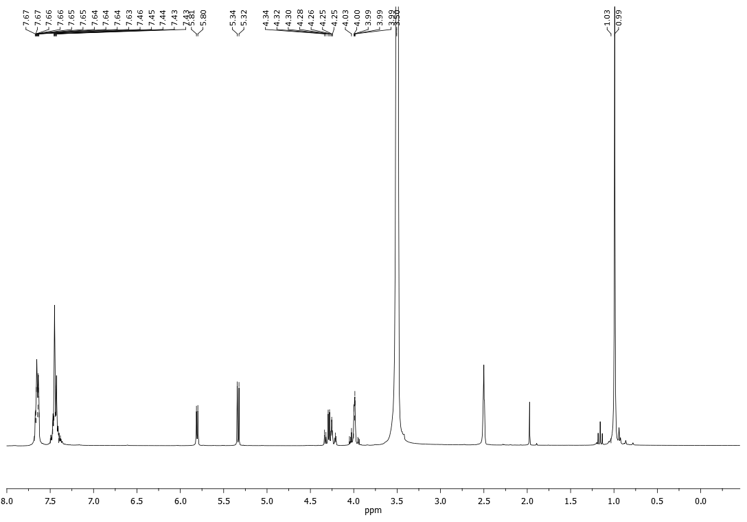

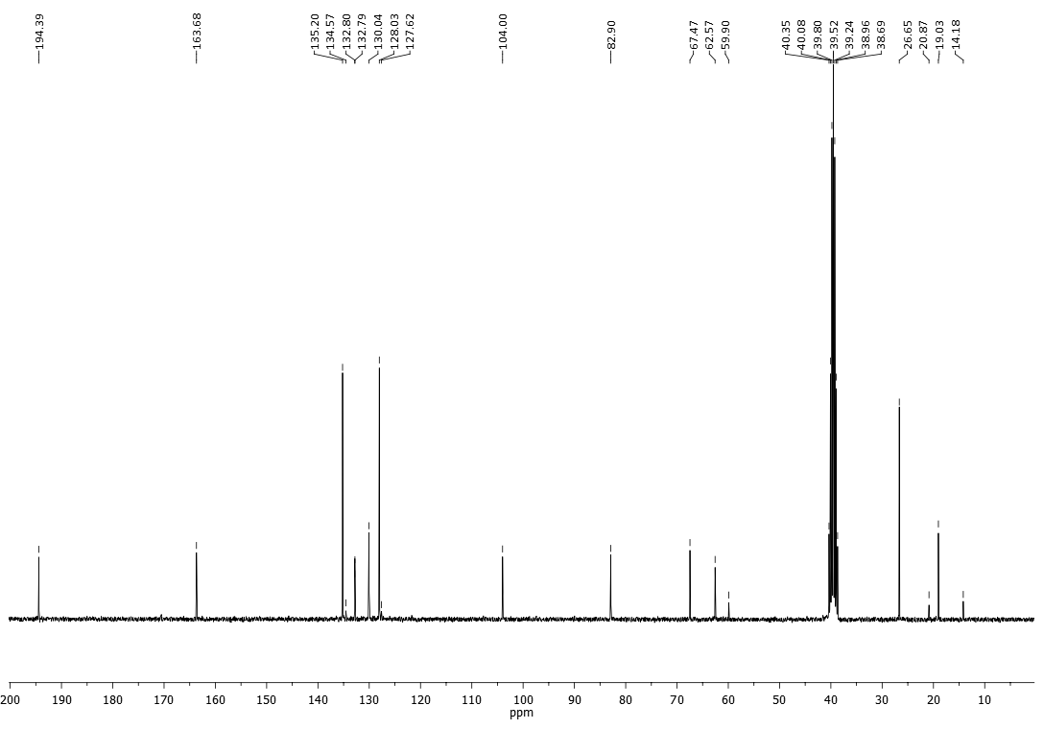

**Figure S1**: 1H and 13C NMR spectra of compound **1b**.

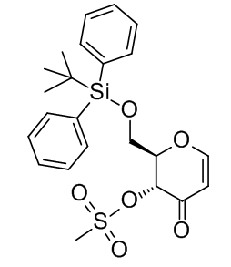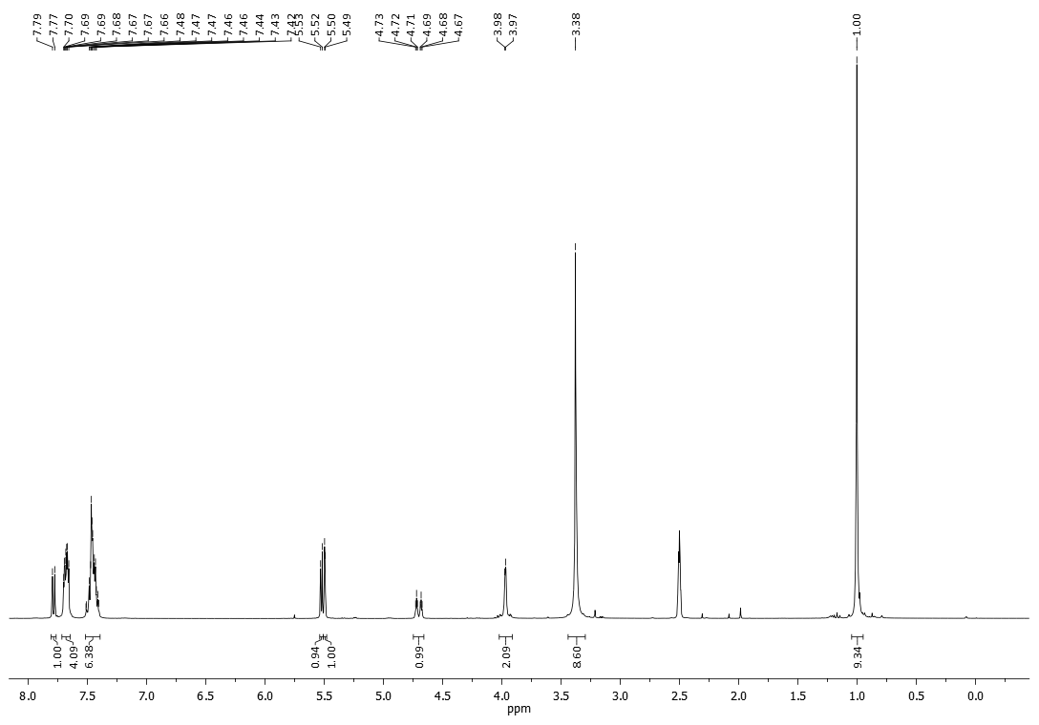

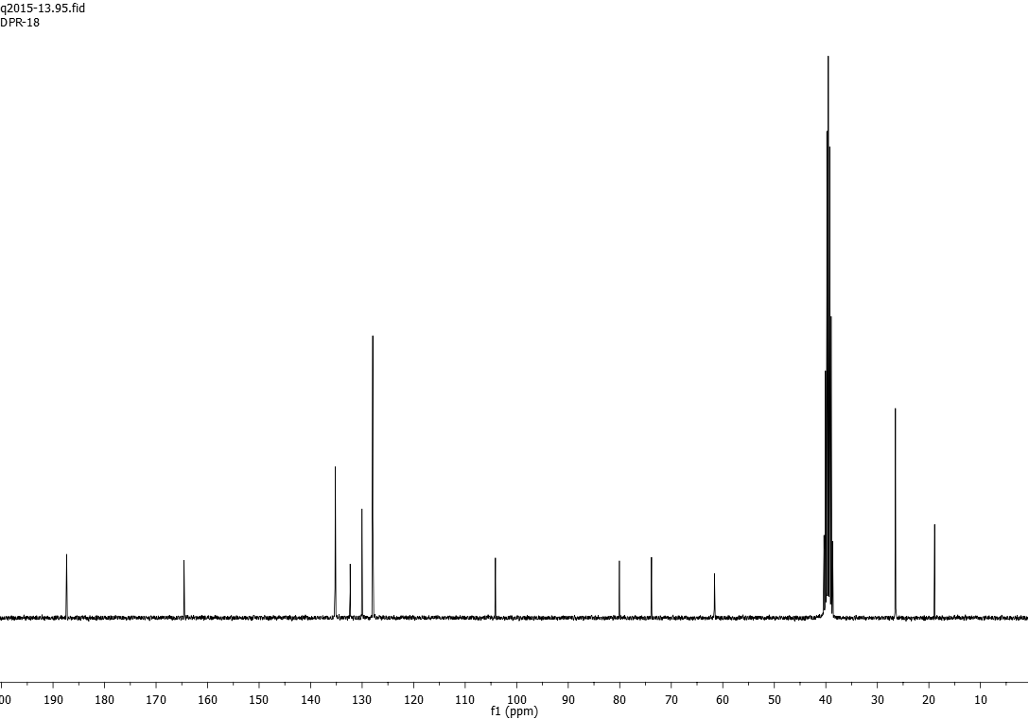

**Figure S2**: 1H and 13C NMR spectra of compound **3a**.

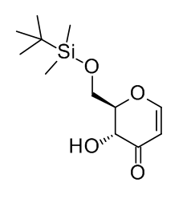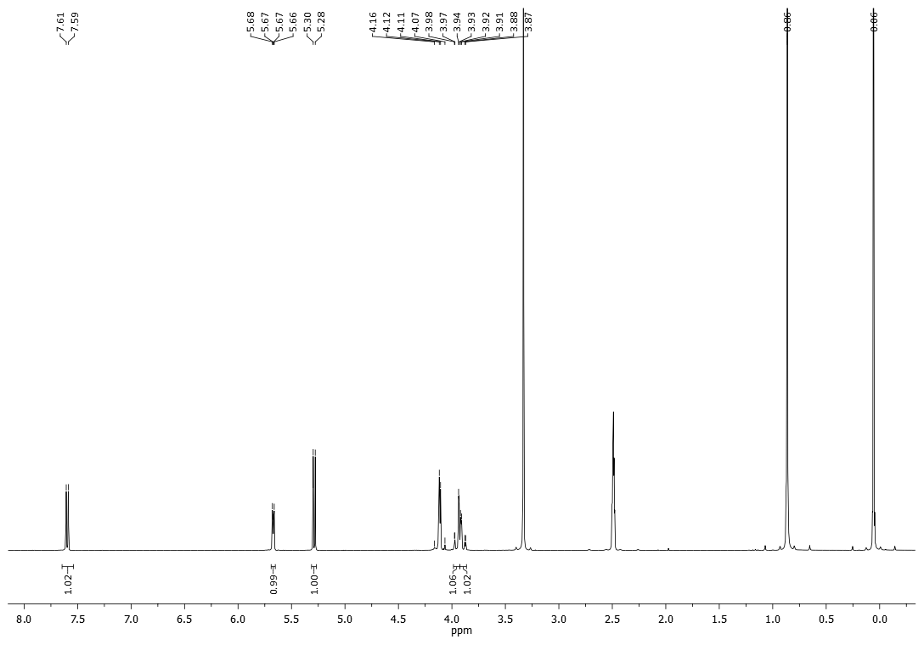

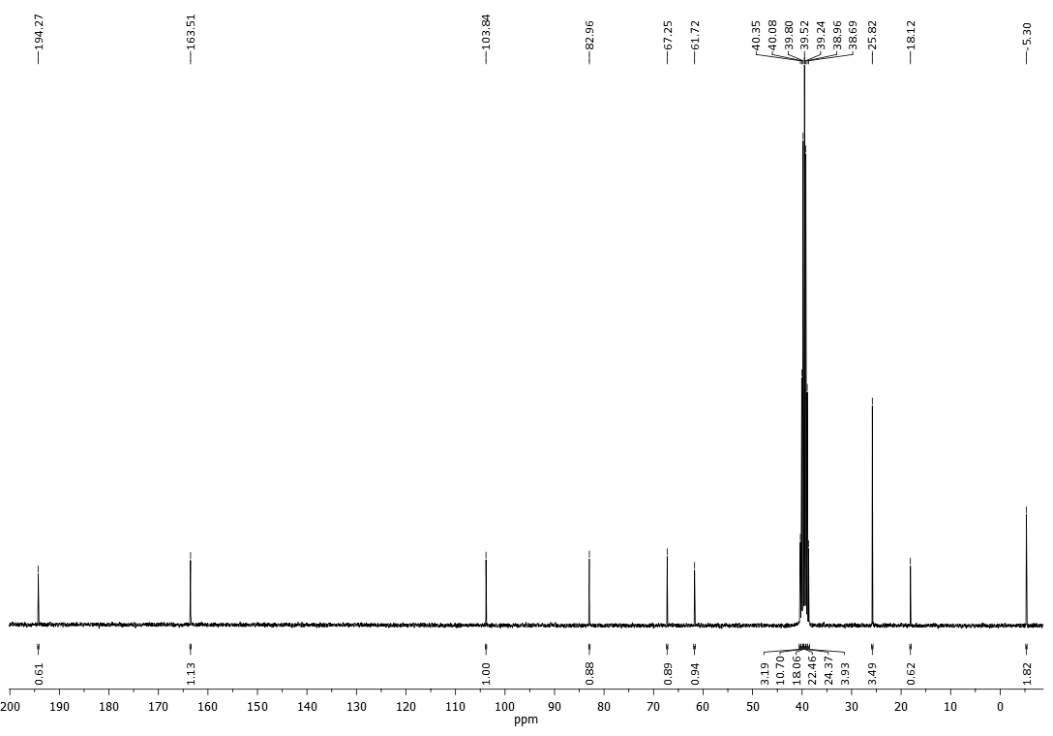

**Figure S3**: 1H and 13C NMR spectra of compound **1c**.

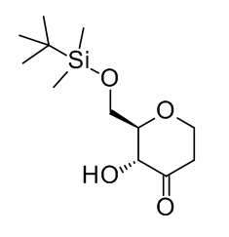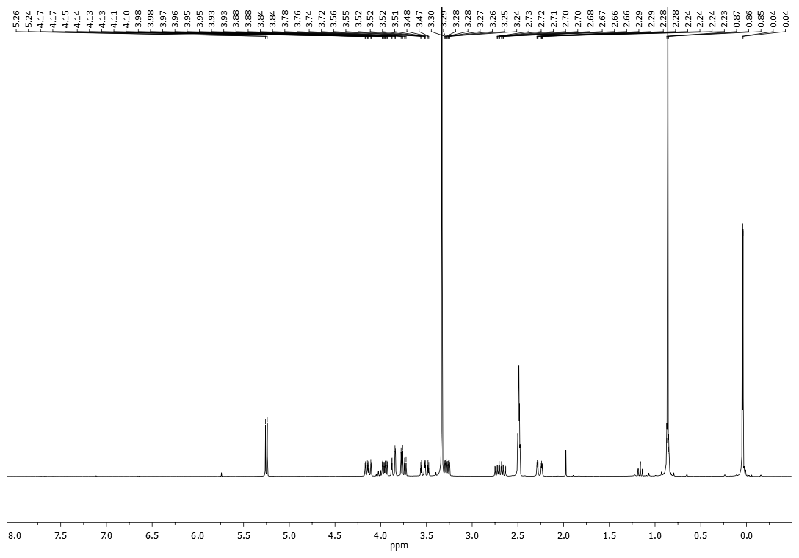

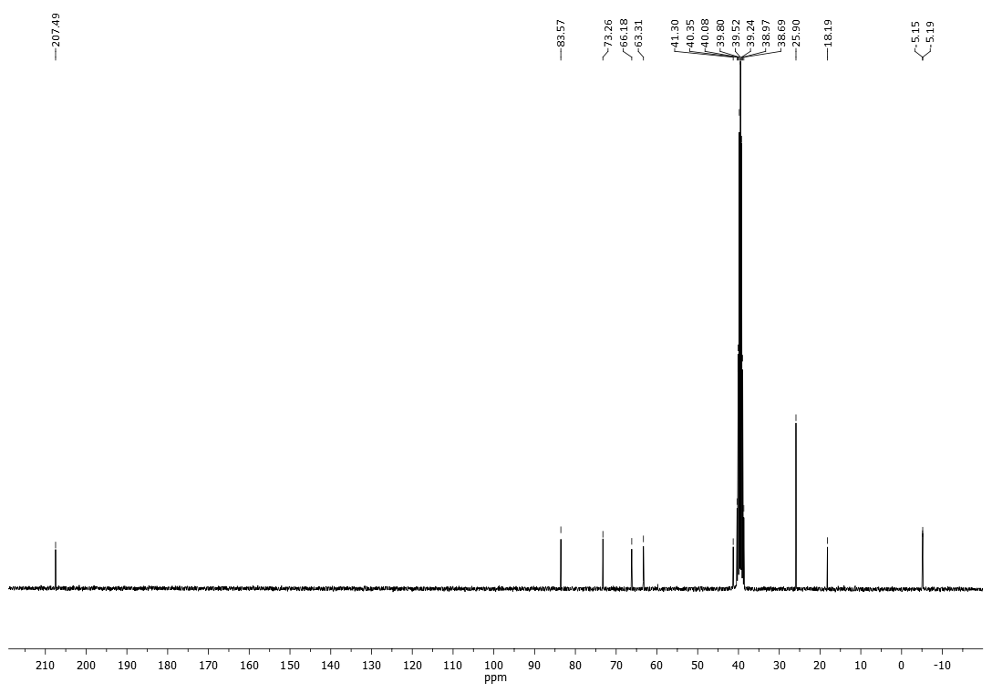

**Figure S4**: 1H and 13C NMR spectra of compound **2c**.

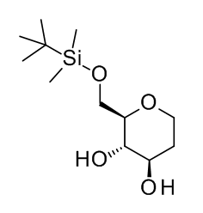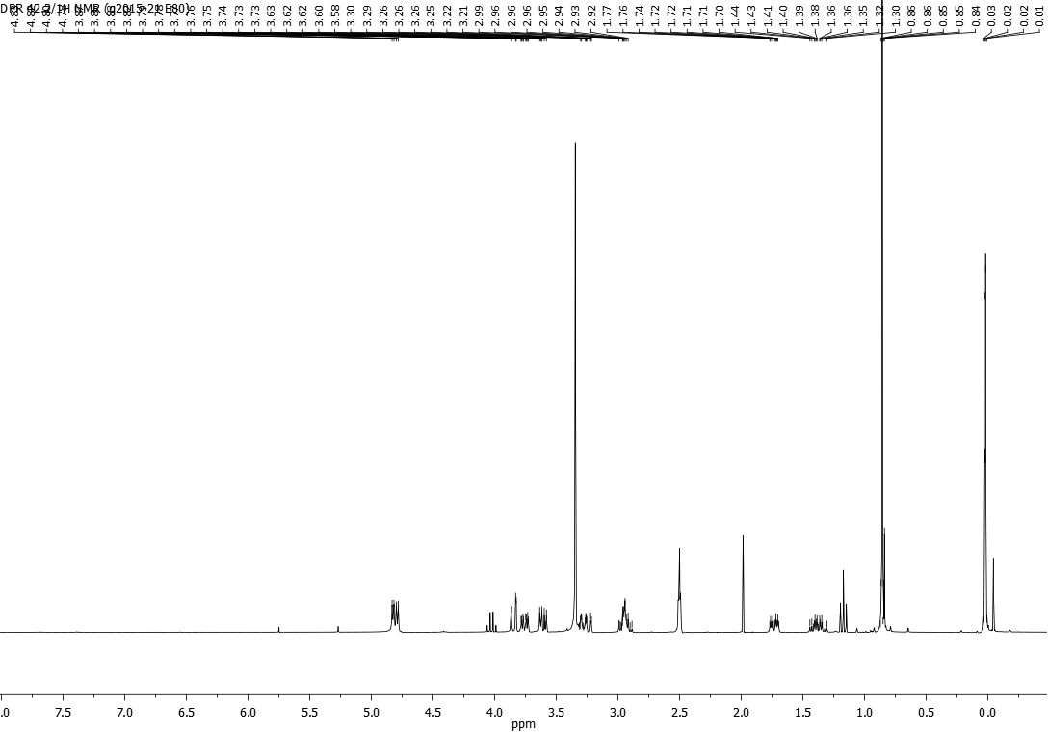

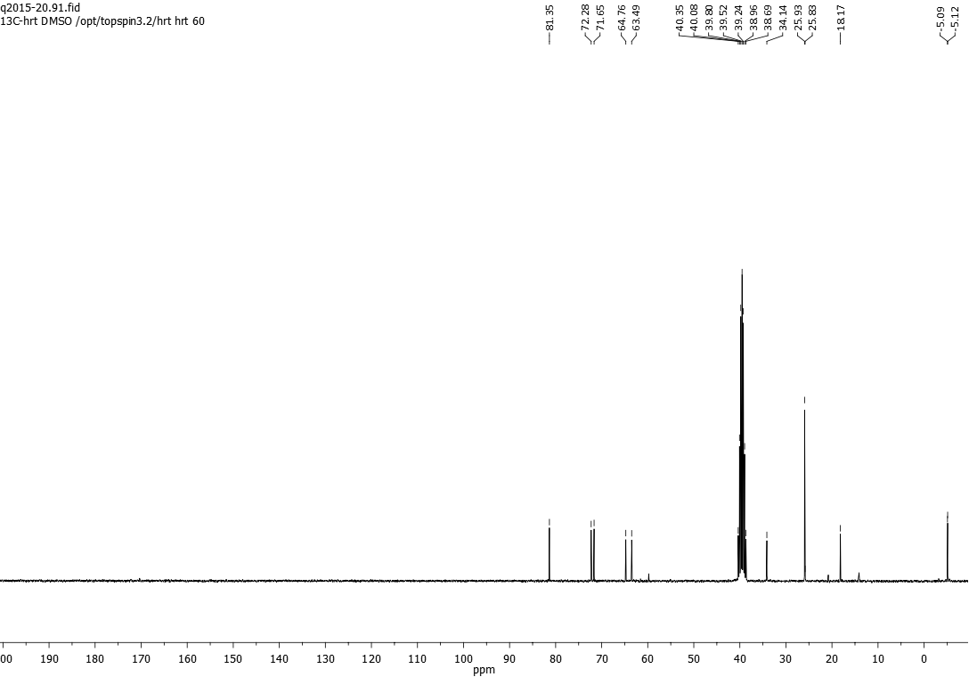

**Figure S5**: 1H and 13C NMR spectra of compound **5**.

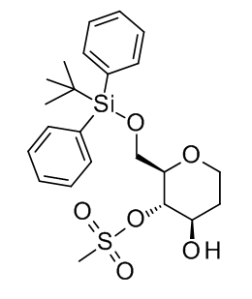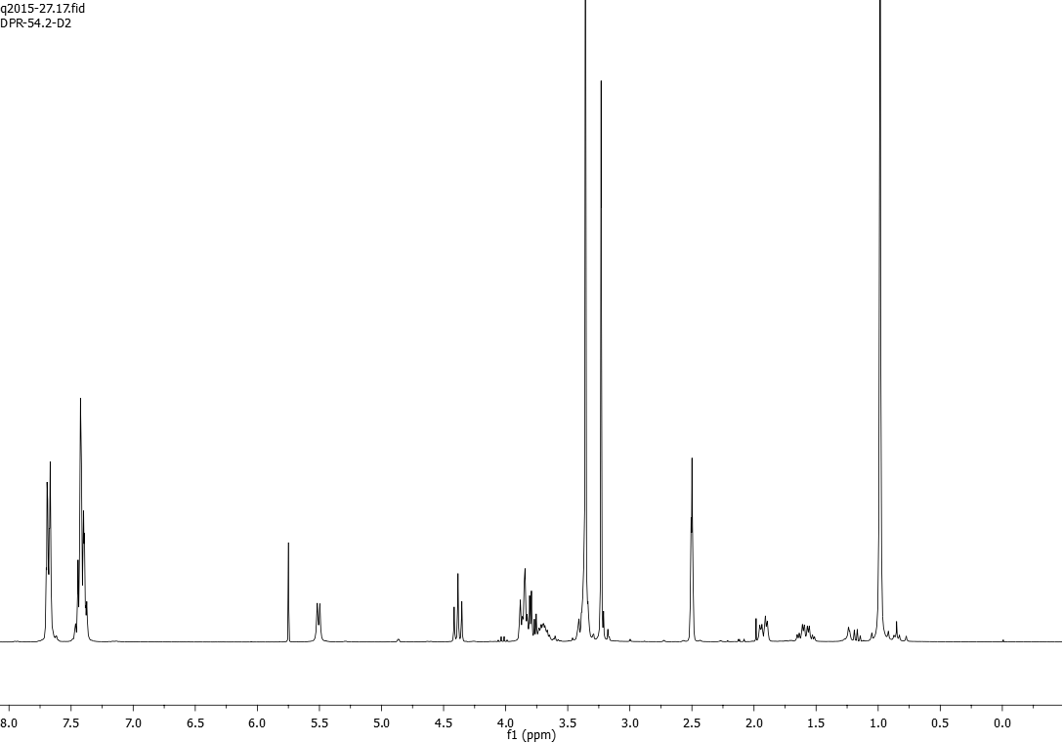

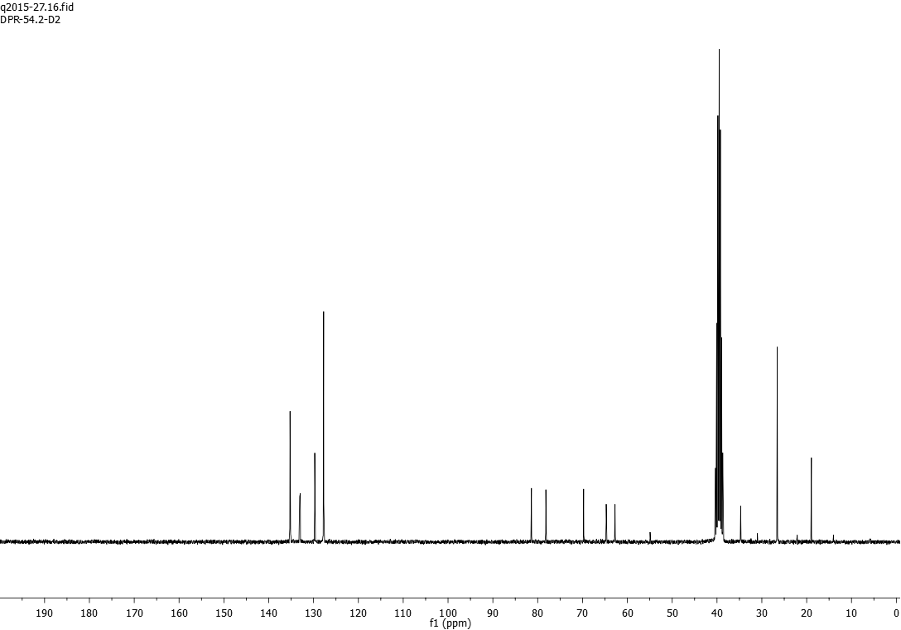

**Figure S6**: 1H and 13C NMR spectra of compound **6a**.

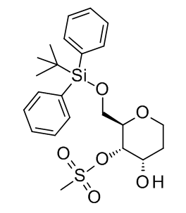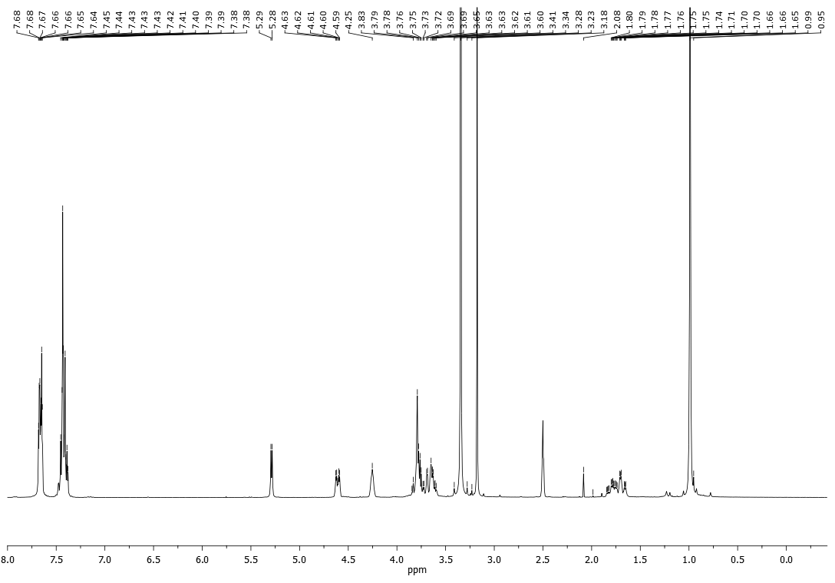

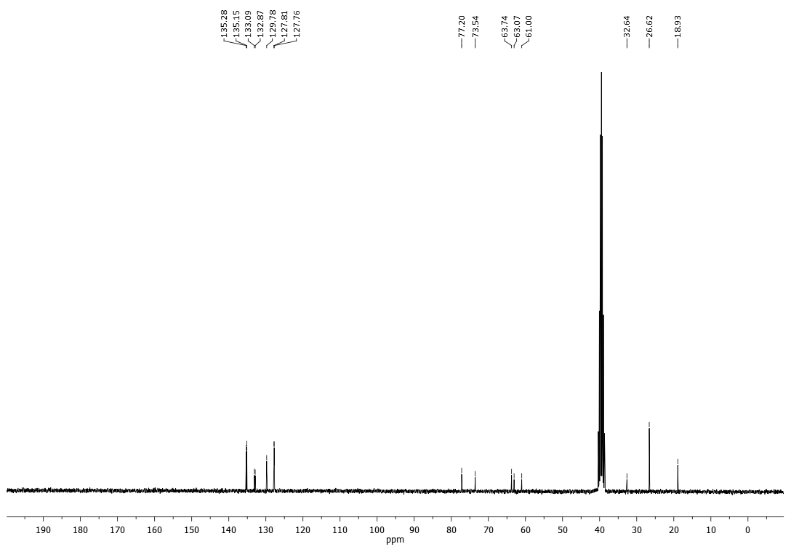

**Figure S7**: 1H and 13C NMR spectra of compound **6b**.

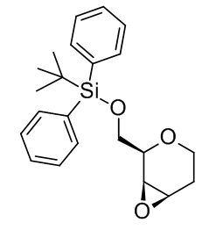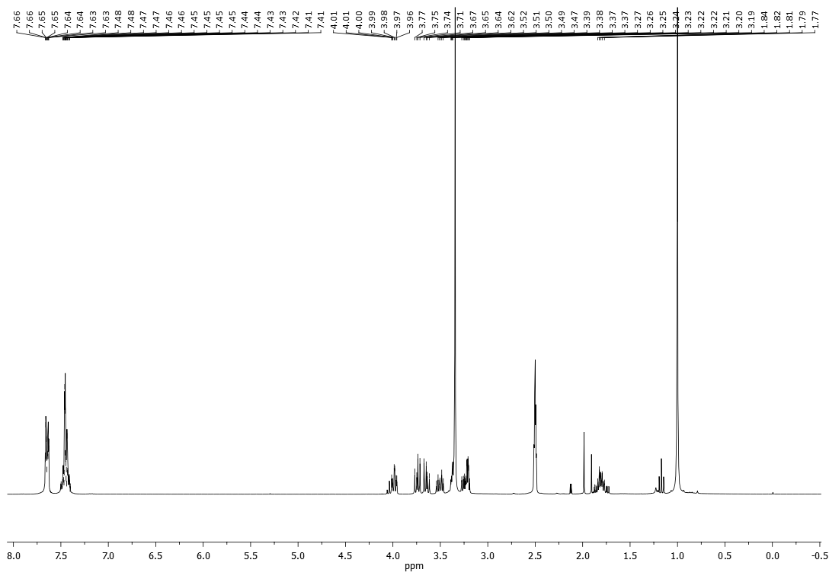

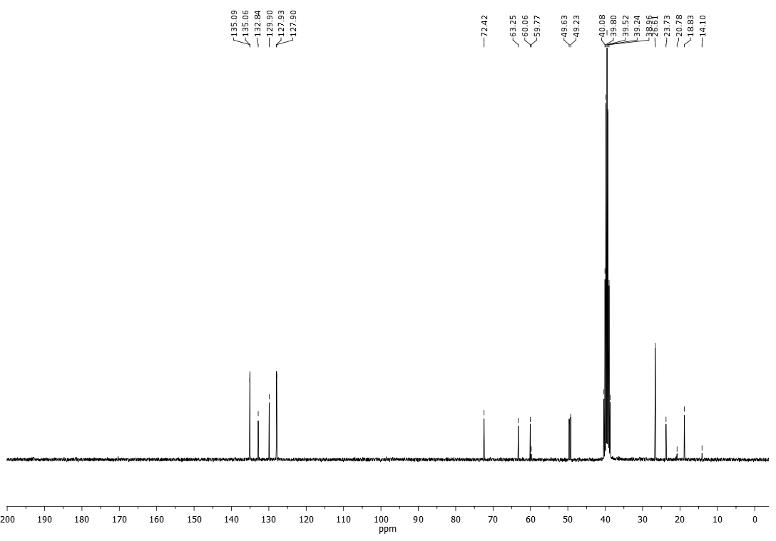

**Figure S8**: 1H and 13C NMR spectra of compound **7**.

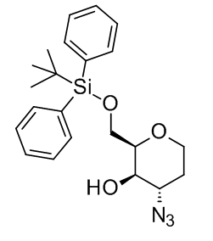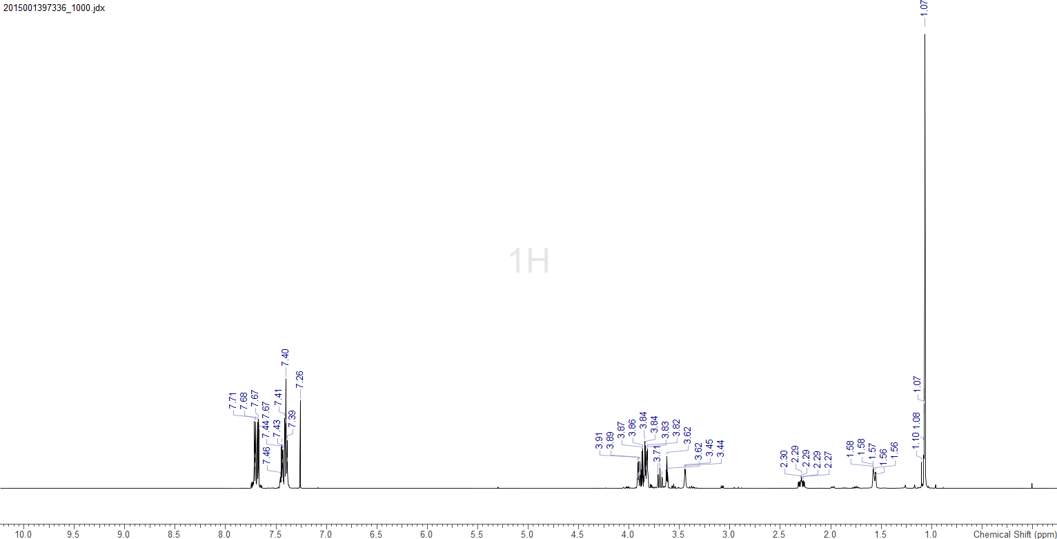

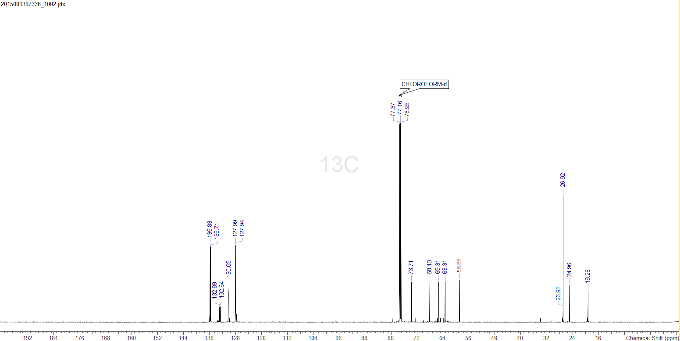

**Figure S9**: 1H and 13C NMR spectra of compound **8a**.

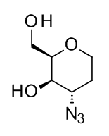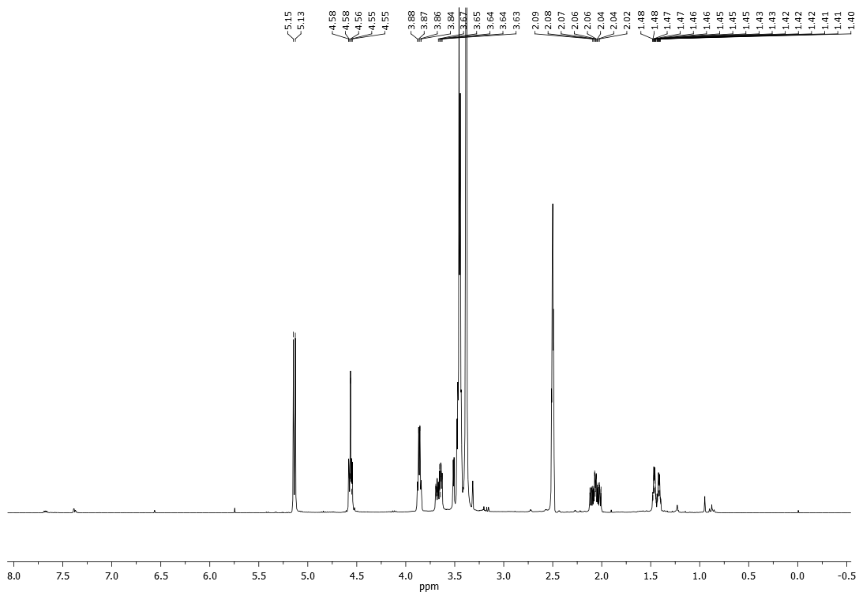

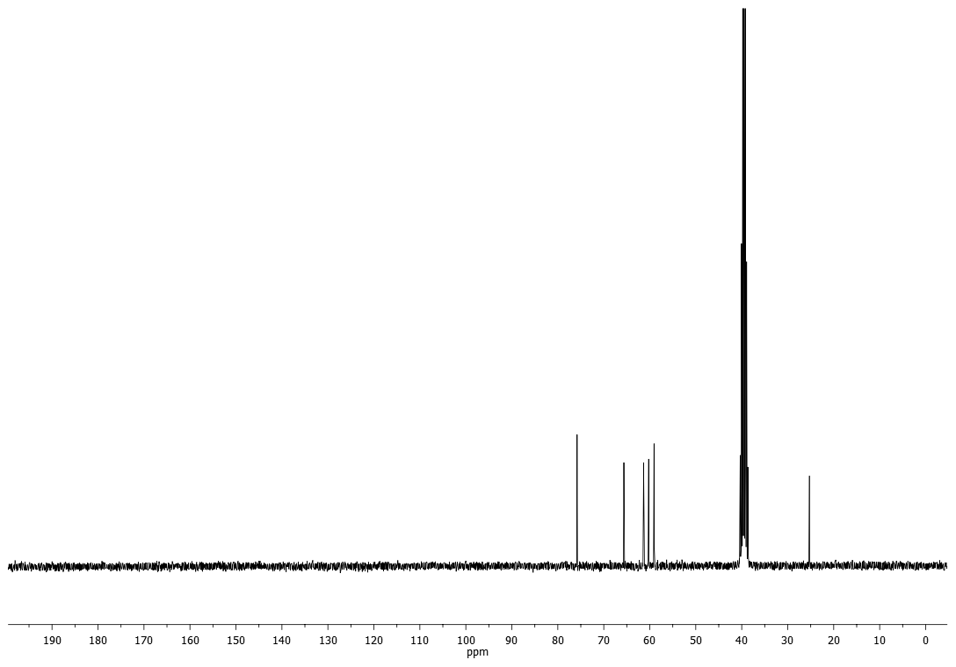

**Figure S10**: 1H and 13C NMR spectra (CD3OD) of compound **8b**.

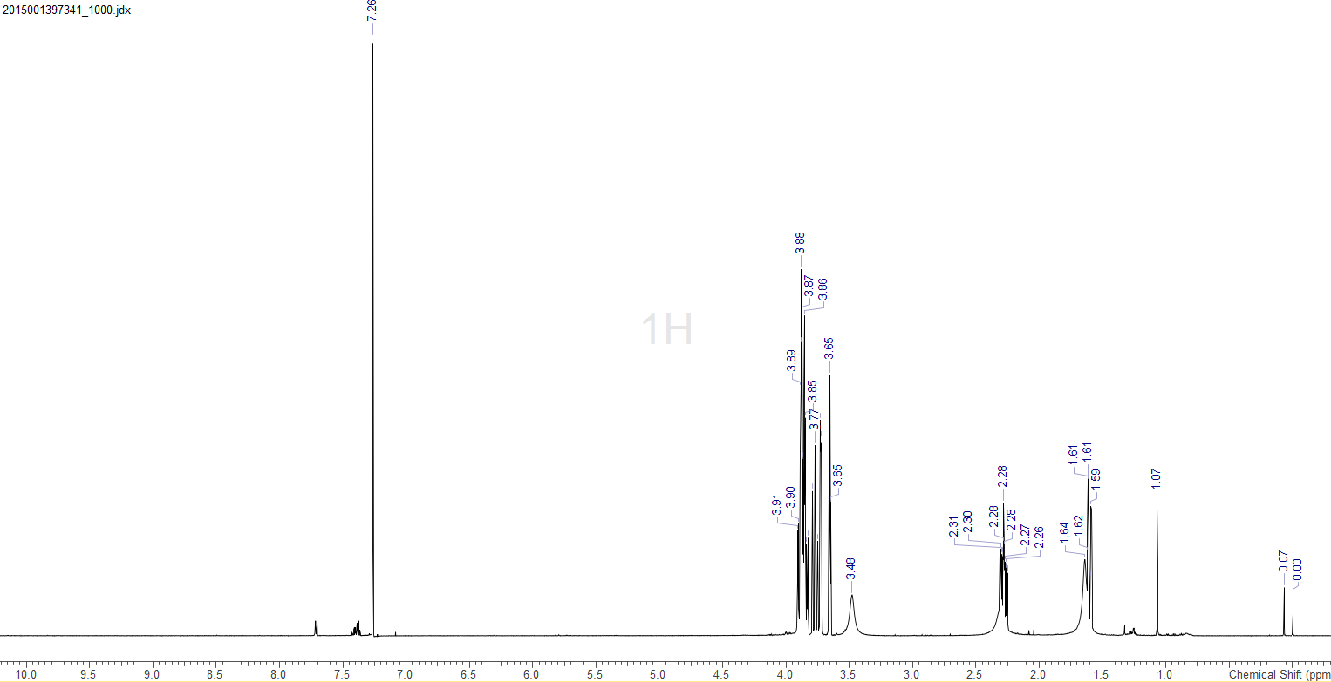

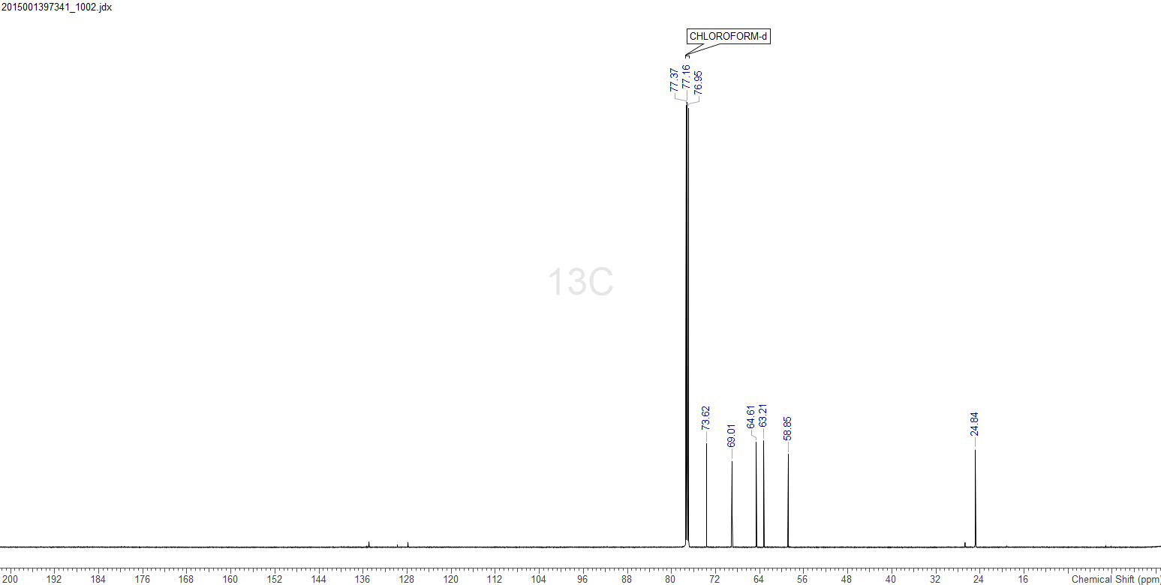

**Figure S10**: 1H and 13C NMR spectra (CDCl3) of compound **8b**.

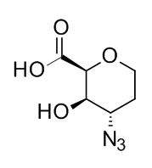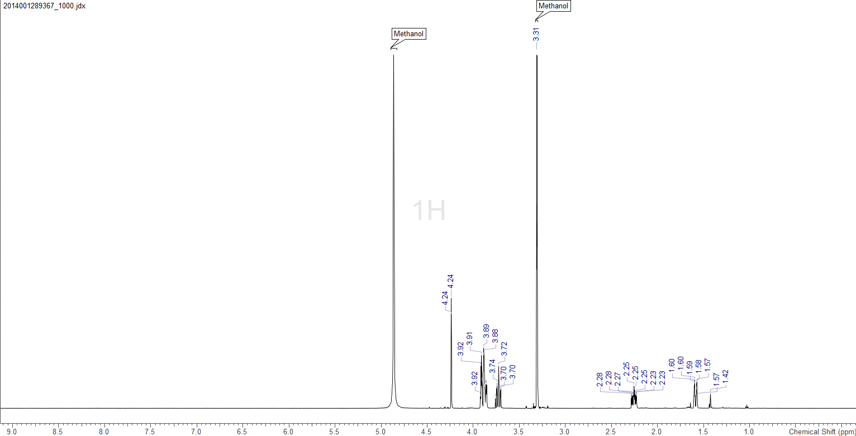

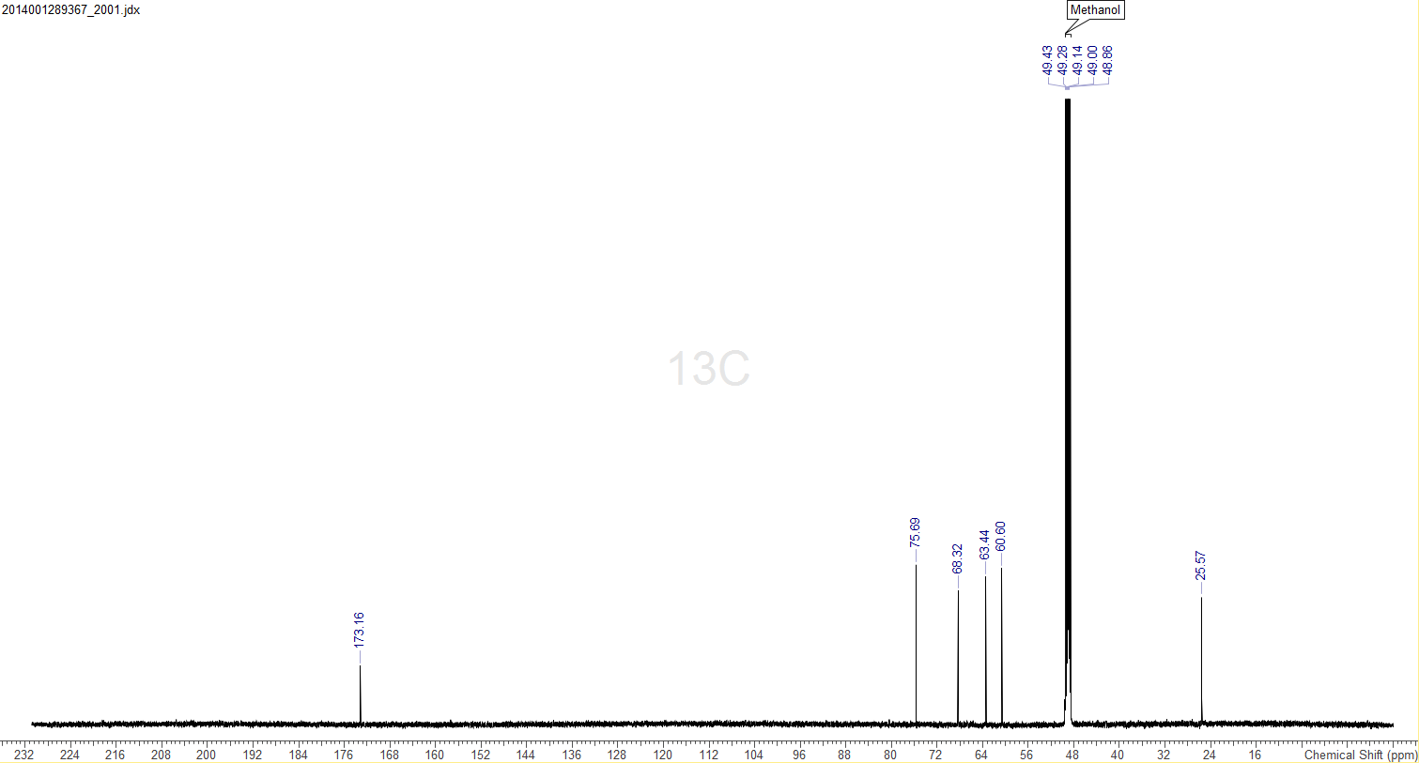

**Figure S11**: 1H and 13C NMR spectra (CD3OD) of compound **9**.

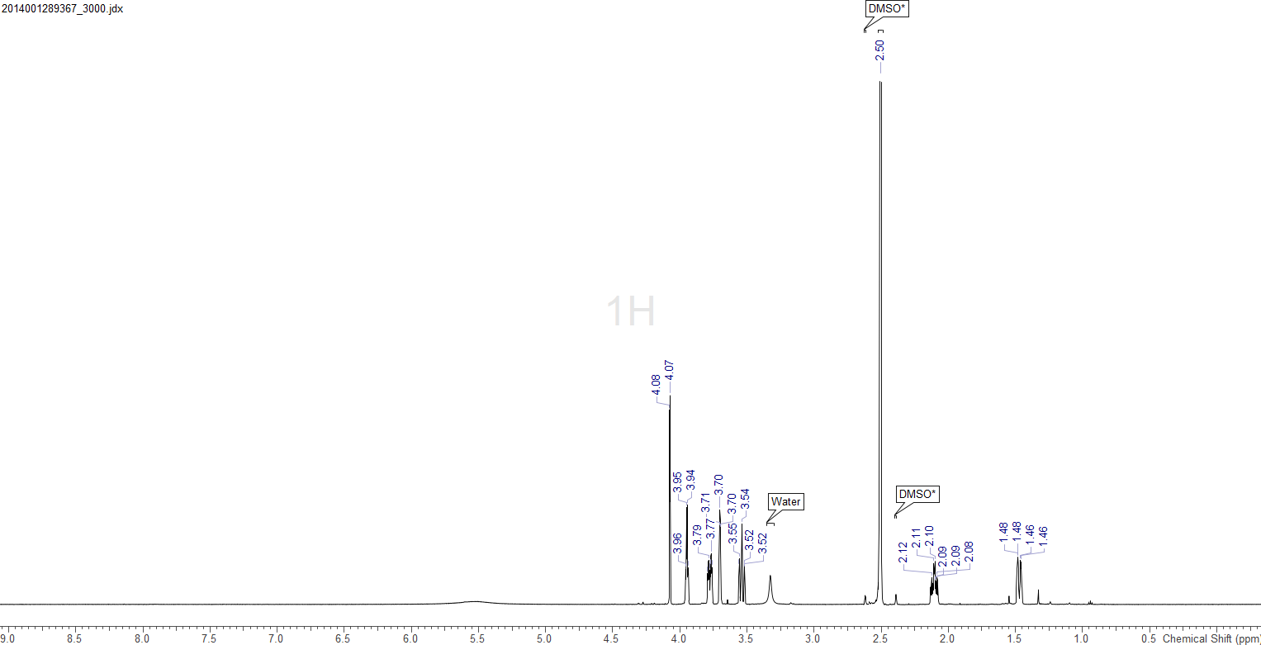

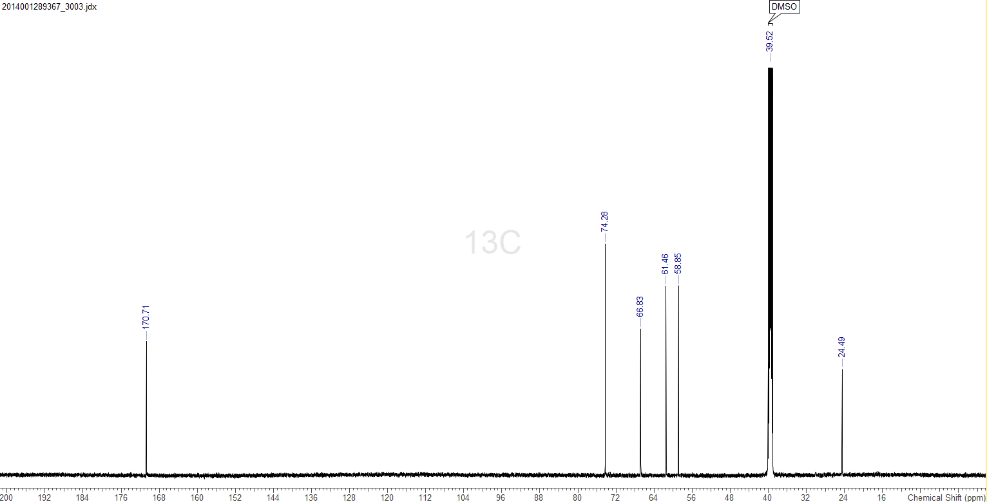

**Figure S11**: 1H and 13C NMR spectra (DMSO-*d*6) of compound **9**.

**Table S1**: Crystal data and structure refinement for compound **9**

Empirical formula C6 H9 N3 O4

Formula weight 187.16

Temperature 100(2) K

Wavelength 1.54184 A

Crystal system, space group Monoclinic, P2(1)

Unit cell dimensions a = 6.3947(5) A alpha = 90 deg.

b = 5.9982(5) A beta = 90 deg.

c = 10.0990(8)A gamma = 90 deg.

Volume 387.36(5) A^3

Z, Calculated density 2, 1.605 Mg/m^3

Absorption coefficient 1.177 mm^-1

F(000) 196

Crystal size 0.15 x 0.15 x 0.10 mm

Theta range for data collection 4.38 to 65.03 deg.

Limiting indices -7<=h<=7, -7<=k<=7, -11<=l<=11

Reflections collected / unique 9428 / 1311 [R(int) = 0.0415]

Completeness to theta = 65.03 100.0 %

Absorption correction Semi-empirical from equivalents

Max. and min. transmission 1.00000 and 0.34881

Refinement method Full-matrix least-squares on F^2

Data / restraints / parameters 1311 / 1 / 154

Goodness-of-fit on F^2 1.043

Final R indices [I>2sigma(I)] R1 = 0.0235, wR2 = 0.0587

R indices (all data) R1 = 0.0240, wR2 = 0.0594

Absolute structure parameter 0.04(16)

Largest diff. peak and hole 0.182 and -0.213 e.A^-3