**Supplementary materials**

**New polyoxygenated polyketide from pathogenic fungus *Cylindrocarpon* *destructans* with α-glycosidase inhibitory activity**

**Dilfaraz Khan1,2, Shah Iram Niaz1, Kamran Tahir2, Muhammad Haroon4, Shahid Ullah Khan5, Syed Badshah2, Shafiullah Khan2 and Lui Lan1**

*1School of Marine Sciences,* *Sun Yat-sen University, Guangzhou* *510006, China.*

*2Institute of Chemical Sciences, Gomal University Dera Ismail Khan 29050, KPK, Pakistan.*

*3Department of Chemistry, University of Science and Technology, Bannu 28100 KPK, Pakistan.*

*4College of Chemical and Biological Engineering Zhejiang University, Hangzhou 310027, China.*

*5College of Plant Sciences and Technology, Huazhong Agriculture University, Wuhan 430070, China.*

**Abstract** Photochemical investigation on pathogenic fungus *Cylindrocarpon destructans* isolated form *Meconopsisgrandis* plant led to the isolation of one new polyoxygenated polyketides, namely *cylindrocarpolide A* (**1**) along with five known compounds (**2-6**). The structures of the isolated compounds were elucidated by 1D and 2D NMR and mass spectroscopic data analysis. The isolated compounds were evaluated for α-glycosidase inhibition activity. The compounds **1**, **5** and **6** showed potent inhibition with IC50 values of 23.4 ± 0.3, 36.5 ± 0.5 and 52.6 ± 0.6 respectively. Compounds **3** and **4** showed moderate anti-diabetic activity with IC50 values of 82.5 ± 0.8 and 66.3 ± 0.5. Compound **2** did not show inhibition activity at all.

**Keywords:** Pathogenic fungus*, Cylindrocarpon destructans, Meconopsis grandis*, α-glycosidase

These authors contributed equally to this work.

*Corresponding authors. Dilfaraz Khan: Email: [dilfarazkhan@gu.edu.pk](mailto:dilfarazkhan@gu.edu.pk)

**Contents**

Table **S1**. 1H and 13C NMR data of compound **1** in Acetone-d6

Figure **S1**. Key HMBC correlation of compound **1**

Figure **S2**. 1H NMR Spectrum (400 MHZ) of compound **1** in Acetone-d6

Figure **S3**. 13CNMR Spectrum (100 MHZ) of compound **1** in Acetone-d6

Figure **S4**. DEPT-135 Spectrum (100MHZ) of compound **1** in Acetone-d6

Figure **S5**. 1H-1H COSY Spectrum of compound **1**

Figure **S6**. HSQC Spectrum of compound **1** in Acetone-d6

Figure **S7**. HMBC Spectrum of compound **1** in Acetone-d6

Figure **S8**. (+)-HRESIMS of compound **1**

Figure **S9**. 1H NMR Spectrum (400 MHZ) of compound **2** in Acetone-d6

Figure **S10**. 13CNMR Spectrum (100 MHZ) of compound **2** in Acetone-d6

Figure **S11**. 1H NMR Spectrum (400 MHZ) of compound **3** in Acetone-d6

Figure **S12**. 13CNMR Spectrum (100 MHZ) of compound **3** in Acetone-d6

Figure **S13**. 1H NMR Spectrum (400 MHZ) of compound **4** in Acetone-d6

Figure **S14**. 13CNMR Spectrum (100 MHZ) of compound **4** in Acetone-d6

Figure **S15**. 1H NMR Spectrum (400 MHZ) of compound **5** in DMSO-d6

Figure **S16**. 13CNMR Spectrum (100 MHZ) of compound **5** in DMSO-d6

Figure **S17**. 1H NMR Spectrum (400 MHZ) of compound **6** in CDCl3

Figure **S18**. 13CNMR Spectrum (100 MHZ) of compound **6** in CDCl3



Figure **S1**. Key HMBC H-C correlation of compound **1**

Figure S2. 1H NMR spectrum of compound 1 in Acetone-d6

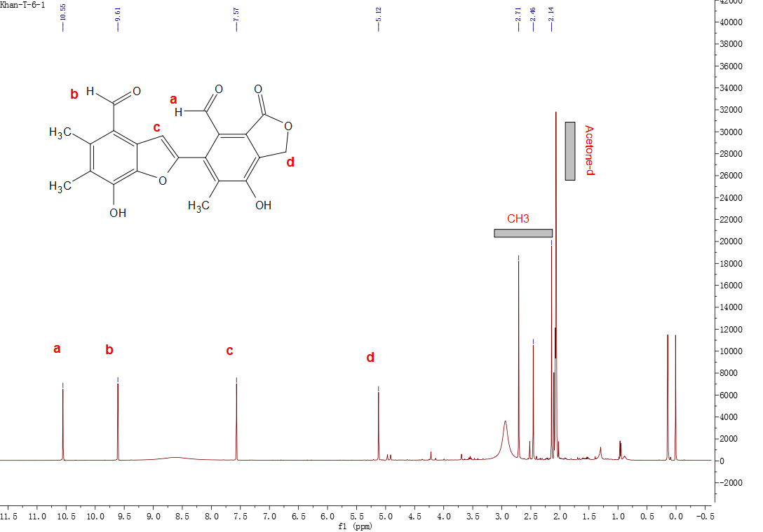

Figure S3. 13C NMR spectrum of compound 1 in Acetone-d6

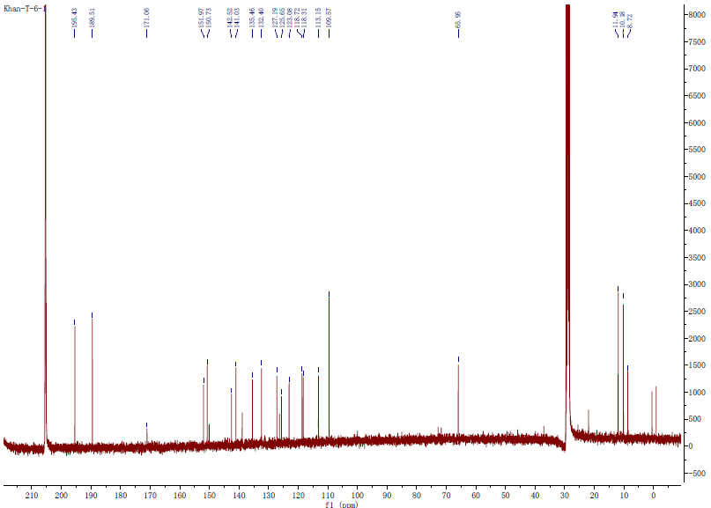

Figure S4. DEPT-135 spectrum of compound 1 in Acetone-d6

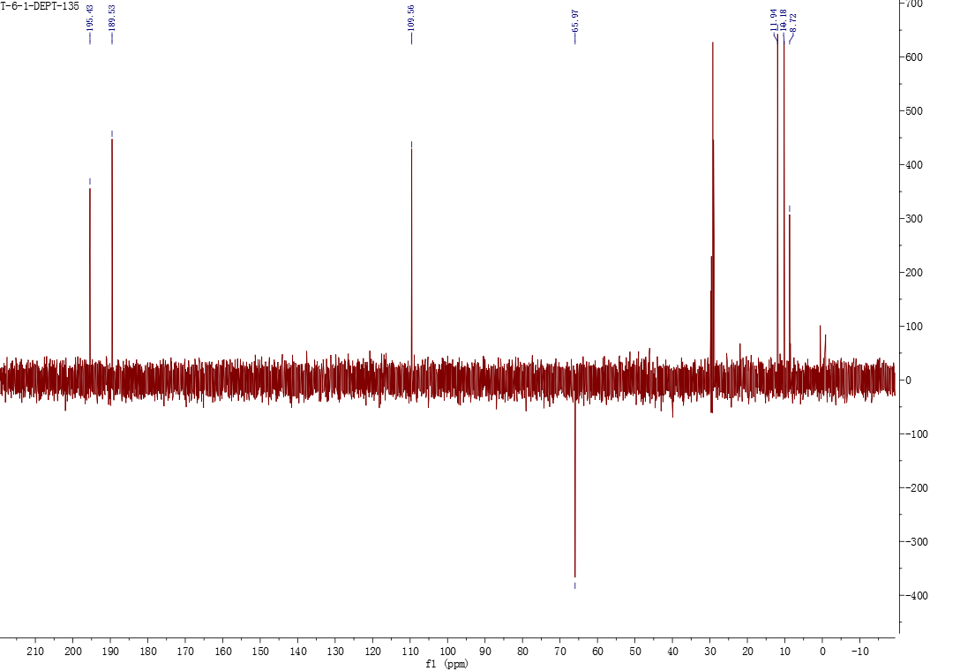

Figure **S5**. The 1H-1H COSEY spectrum of compound **1**

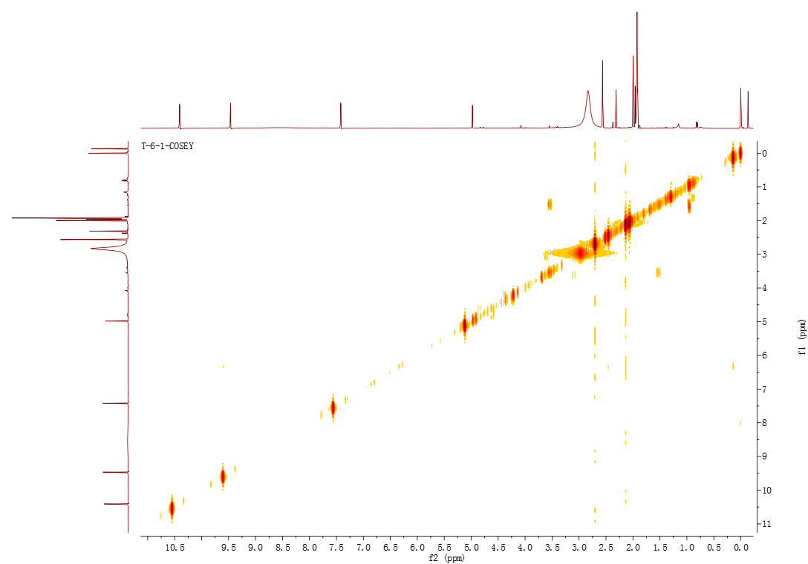

Figure **S6**. HSQC Spectrum of compound **1** in Acetone-d6

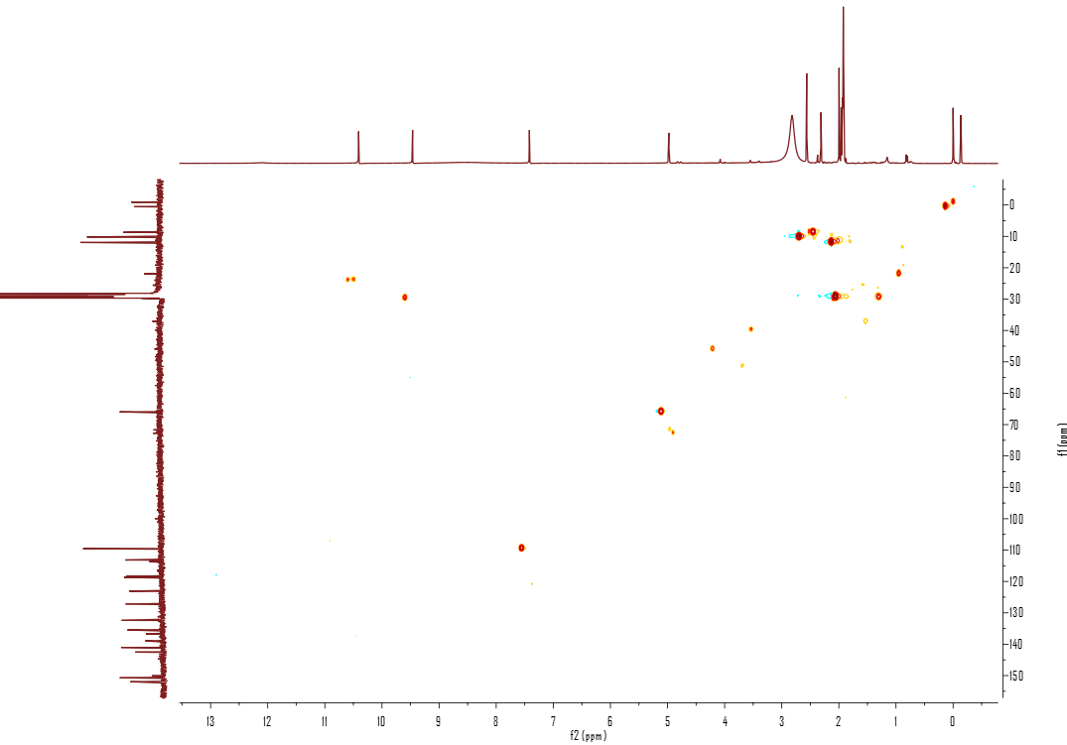

Figure **S7**. HMBC Spectrum of compound **1** in Acetone-d6

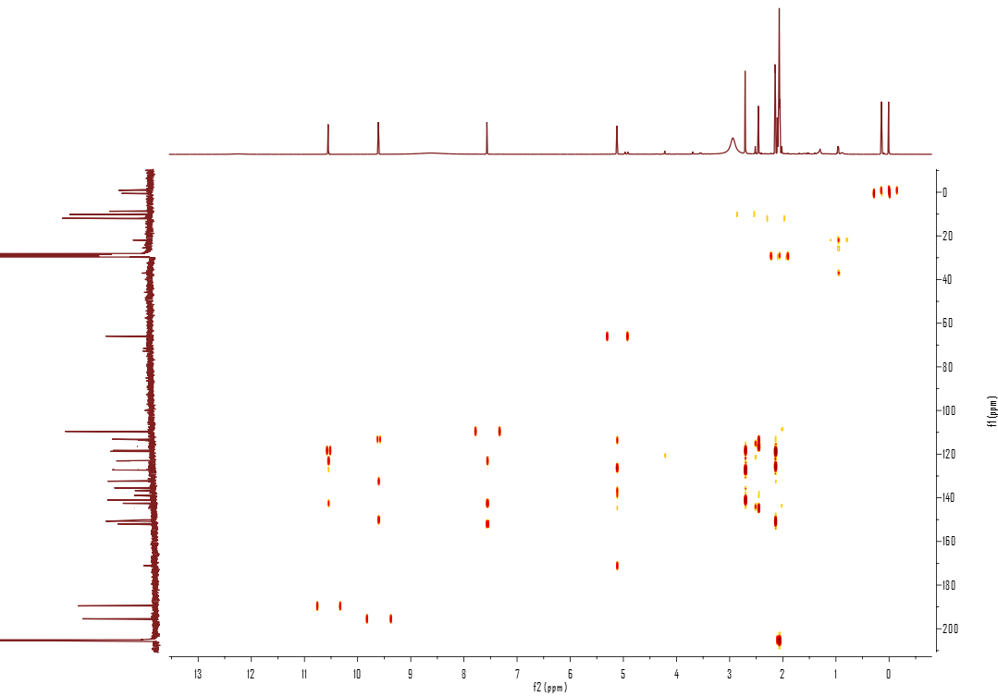

Figure **S8**. (+)-HRESIMS of compound **1**

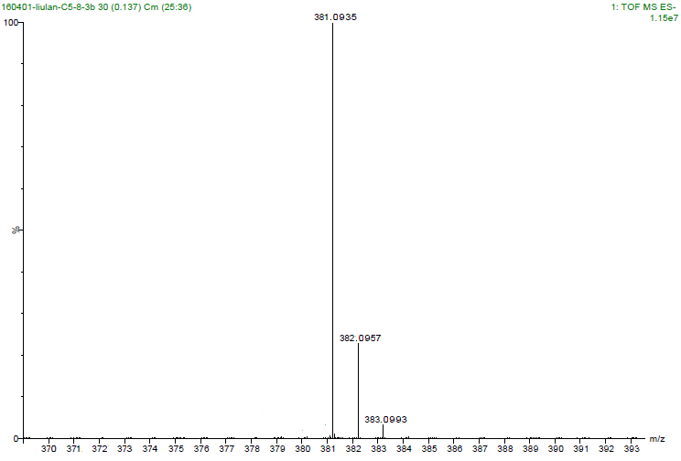

Figure **S9**. 1H NMR Spectrum (400 MHZ) of compound **2** in Acetone-d6

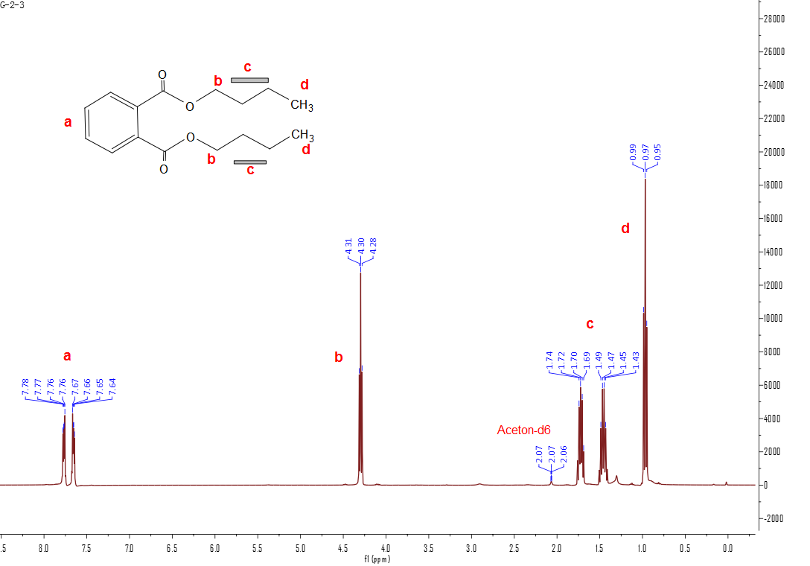

Figure **S10**. 13C NMR Spectrum (100 MHZ) of compound **2** in Acetone-d6

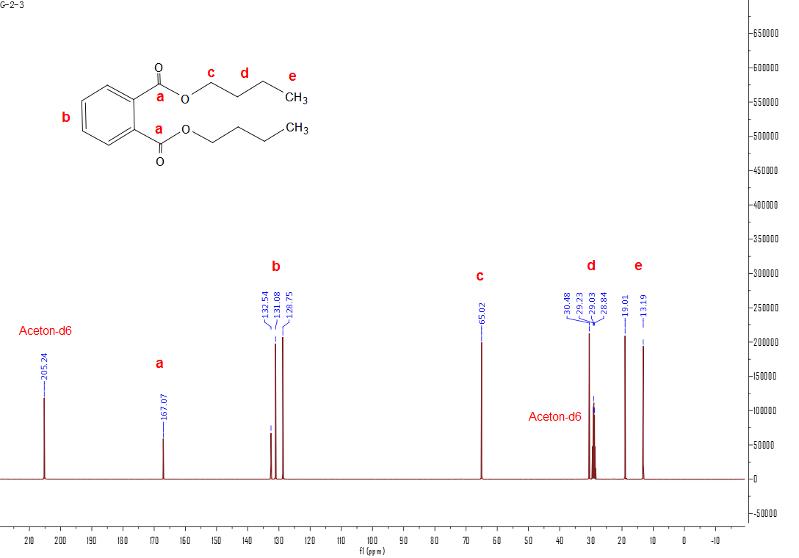

Figure **S11**. 1H NMR Spectrum (400 MHZ) of compound **3** in Acetone-d6

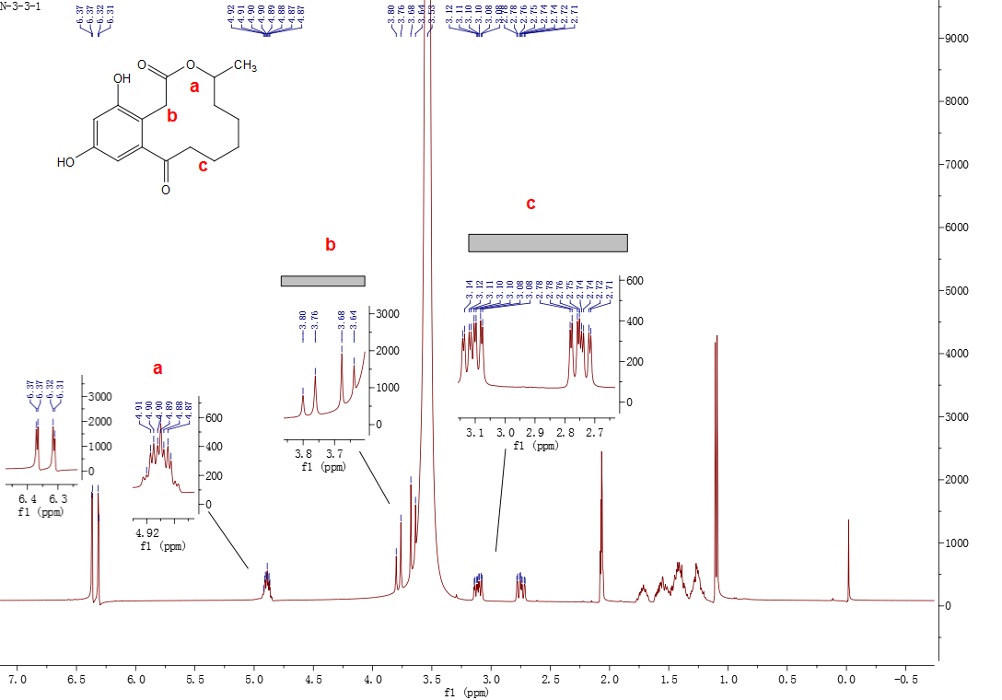

Figure **S12**. 13C NMR Spectrum (100 MHZ) of compound **3** in Acetone-d6

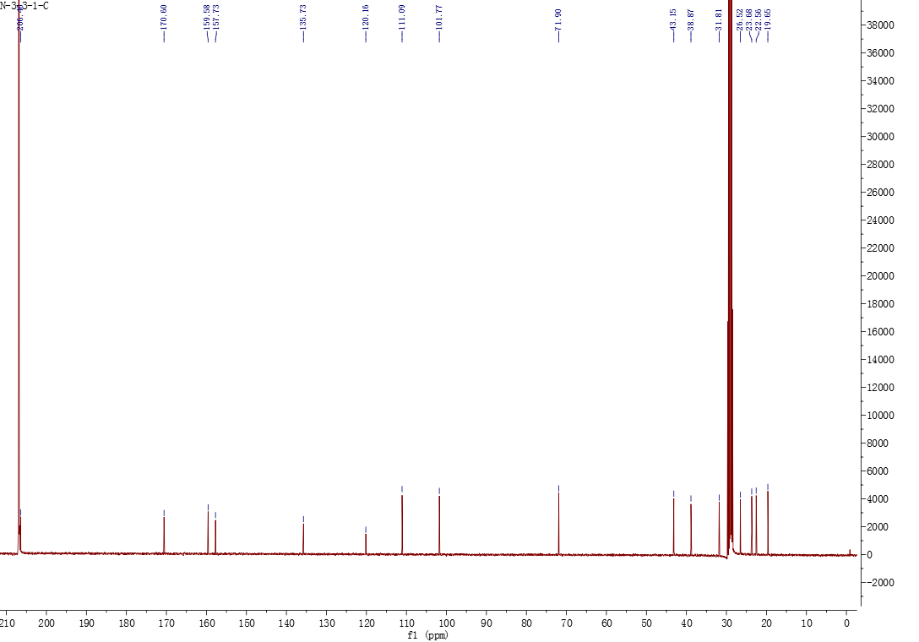

Figure **S13**. 1H NMR Spectrum (400 MHZ) of compound **4** in Acetone-d6

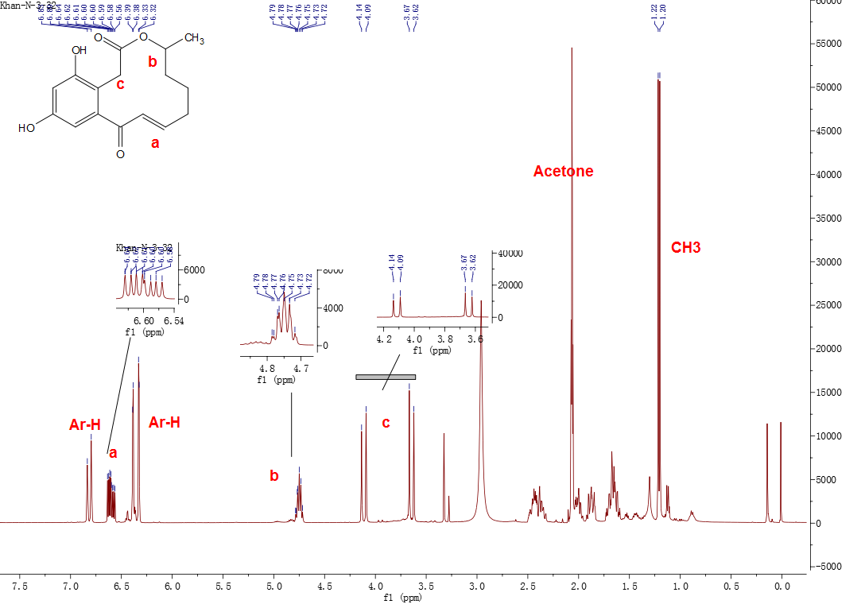

Figure **S14**. 13C NMR Spectrum (100 MHZ) of compound **4** in Acetone-d6

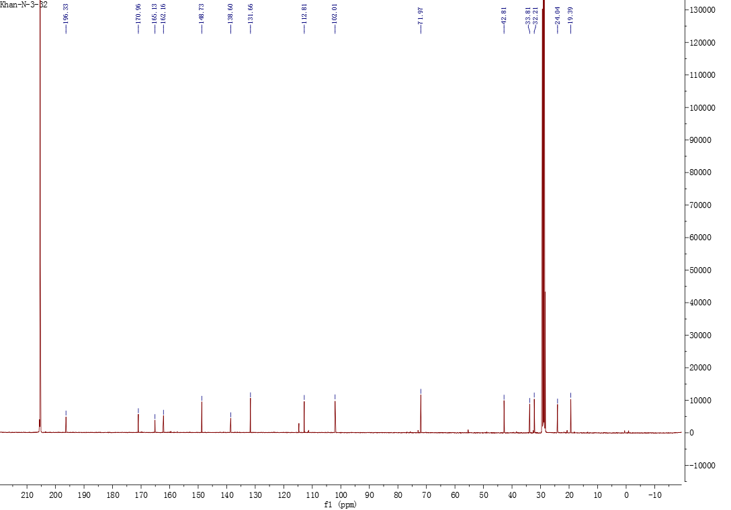

Figure **S15**. 1H NMR Spectrum (400 MHZ) of compound **5** in DMSO-d6

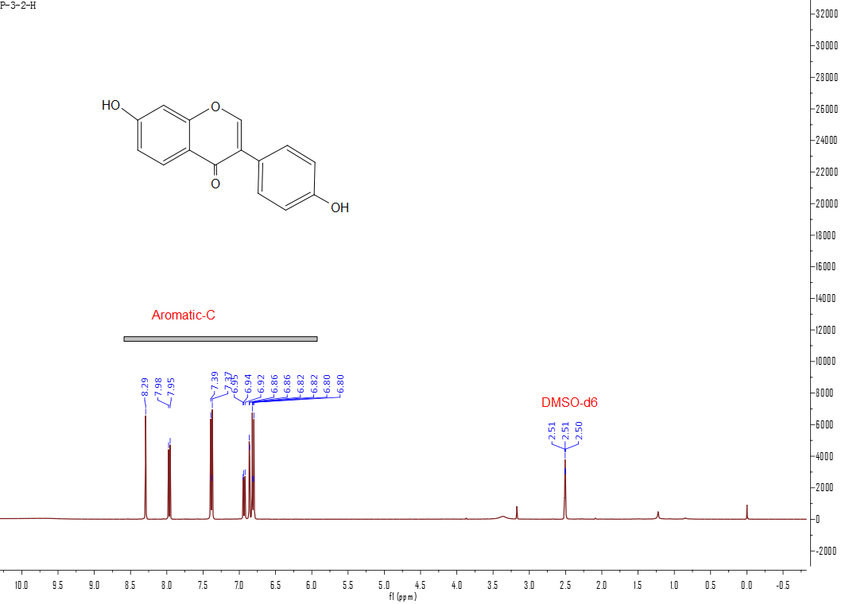

Figure **S16**. 13C NMR Spectrum (100 MHZ) of compound **5** in DMSO-d6

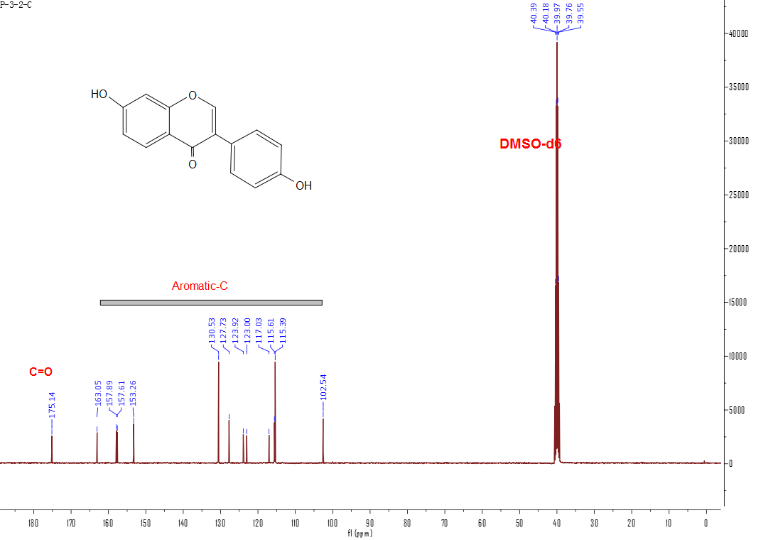

Figure **S17**. 1H NMR Spectrum (400 MHZ) of compound **6** in CDCl3

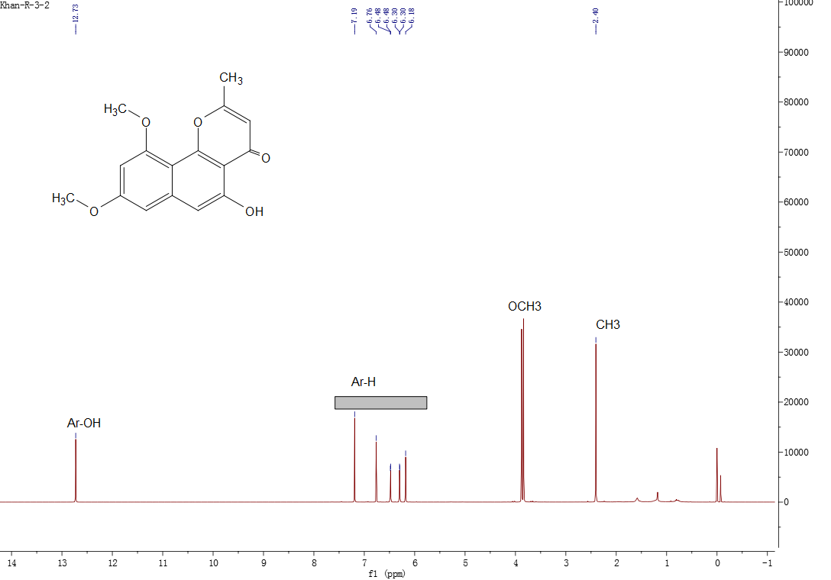

Figure **S18**. 13C NMR Spectrum (100 MHZ) of compound **6** in CDCl3

