**NaOH +H2O2**

**feed**

**Filter, wash and dry**

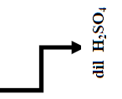

**Oxalic acid**

**feed**

**REEs**

**precipitation**

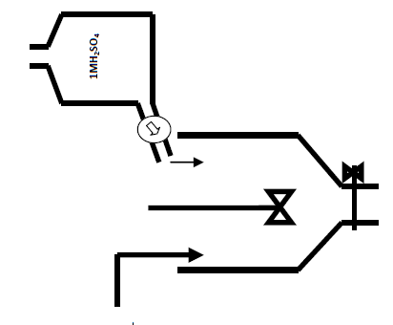

**From monazite digestion, dissolution and Th, REEs, & U separation plants**

**100 Kg REEs hydrated oxides (200 ppm U)**

**Filter, wash and dry**

**RE2O3**

**Dissolution**

**20 g U**

**REEs and U sulfate**

**Eluent feed HCl+NaCl**

**Air**

**U**

**precipitation**

**Resin bed on diaphragm**

**Filtrate**

