Novel 2-mercaptobenzimidazole derivatives: synthesis and evaluation of its antibacterial and antioxidant activities

Latifa El Ouasif¹, Abdelhakim Bouyahya², Mostafa El Ghoul^{1*}, Redouane Achour¹, Hind Chakchak³, Ahmed Talbaoui², Nadia Dakka² and Youssef Bakri².

¹Laboratory of Organic Heterocyclic Chemistry, (URAC 21) Pole of Competence Pharmacochemistry, Mohamme d V University, Faculty of Science, Ibn Battuta Avenue BP 1014 RP, Rabat, Morocco
²Biochemistry-Immunology Laboratory, Mohamed V University, Faculty of Science, Ibn Battuta Avenue BP 1014 RP, Rabat, Morocco
³National Centre for Scientific and Technical Research, Rabat, Morocco
.

Abstract: In the present study, a series of novel 2-mercaptobenzimidazolium were synthesized from 2-mercaptobenzimidazole with hydrocarbon chains. All compounds obtained are reported for the first time, and the structures of these compounds were confirmed by means of ¹H-NMR, ¹³C-NMR and mass spectrometry. The newly synthesized compounds were subjected to in vitro biological evaluation. The antibacterial activity was evaluated will diffusion assay and density optic method. The antioxidant activity was carried out using DPPH free radical scavenging assay. The result indicated that some compounds show convincing antibacterial activities against two microorganisms: Escherichia coli and Staphylococcus aureus. While, these molecules have not shown interesting antioxidant effects.

Keywords: 2-mercaptobenzimidazole, 2-mercaptobenzimidazolium, Antibacterial activity, Antioxidant activity.

Introduction

The benzimidazole ring is an important pharmacophore in modern drug discovery. The compounds bearing benzimidazole moiety are reported to possess a number of interesting biological activities. Its derivatives and particularly 2-mercapto-benzimidazoles were evidenced promising biological efficacies enabling them to perform as new drug. Exceptional structural features of this class of heterocycle and versatile biological applications made it a privileged structural backbone in new drug design and discovery.
2-mercaptobenzimidazole structural motif plays very important roles in numerous pharmaceutical molecules with a wide range of biological properties. They exhibit significant biological and pharmacological activities such as antibacterial, antioxidant ¹⁻³, anticonvulsant ⁴, Antimicrobial ⁵ antihistamine ⁶ neutropic ⁷ and analgesic ⁸ activities. Although a great deal of the scientific literature concerning 2-mercaptobenzimidazole is in the area of medicinal chemistry, 2-mercaptobenzimidazole is also used in non-biological application, it serve as plant growth regulators ⁹ and used as corrosion inhibitor for mild steel ¹⁰⁻¹⁴.
Today, a large number of benzimidazole derivatives as surfactants have been reported in various researches ¹⁵⁻²². Consequently, great effort has been made to develop efficient methods for the preparation of new compounds may present interesting surfactant properties, thus it was of value to synthesize some new benzimidazolium derivates of 2-mercaptobenzimidazole and evaluate their antibacterial and antioxidant activity.

Results and Discussion

Synthesis
We report here our results on the synthesis of 2-mercaptobenzimidazolium using a two-step procedure as shown in (Schemes 1) and (Schemes 2). First, we investigated the reaction conditions for the synthesis of 2-mercaptobenzimidazole N,S-disubstituted. The reaction of 2-mercaptobenzimidazole with n-alkane bromide reagent using K₂CO₃ as base in N,N-Dimethylformamide as the solvent at room temperature for 24 h led to the formation of 2-mercaptobenzimidazole N,S-disubstituted 3a-d in good yields (Table 1).
In continuation of our studies, we then focused to converted these compounds obtained to the corresponding salts by reaction of quaternization. As expected, reaction of compounds 2-mercapto-benzimidazole N,S-disubstituted 3a-d with n-alkane bromide in acetonitrile as solvent under reflux for 72 h furnished the compounds 4a-d in good yields (Table 2).

Scheme 1 1-alkanyl-2-(alkanylthio)-1H-benzimidazole 3a-d

Table 1 1-alkanyl-2-(alkanylthio)-1H-benzimidazole 3a-d yields
Entry | R | Yield %
3a | -CH₂(CH₂)₆CH₃ | 88
3b | -CH₂(CH₂)₇CH₃ | 91
3c | -CH₂(CH₂)₈CH₃ | 93
3d | -CH₂(CH₂)₁₀CH₃ | 93

Scheme 2 Synthesis of 1,3-dialkanyl-2-(alkanylthio)-1H-benzimidazolium bromide 4a-d

Table 2 1,3-dialkanyl-2-(alkanylthio)-1H-benzimidazolium bromide 4a-d yields
Entry | R | Yield %
4a | -CH₂(CH₂)₆CH₃ | 88
4b | -CH₂(CH₂)₇CH₃ | 80
4c | -CH₂(CH₂)₈CH₃ | 83
4d | -CH₂(CH₂)₁₀CH₃ | 78
The structure of the obtained compounds 3a–d and 4a–d was confirmed by the NMR and MS spectra. The proton spectrum ¹H-NMR of 4a taken in CDCl₃ showed a multiplet between 7.18 ppm and 7.26 ppm for the Aromatic protons, triplet at 4.29 ppm for NCH₂ and triplet at 3.38 ppm for SCH₂, a multiplet between 1.24 ppm and 1.86 ppm corresponding to the protons carried by the methylene groups of the hydrocarbon chain and a triplet at 0.85 ppm for CH₃. On the other hand, the ¹³C-NMR spectrum of 4a taken in CDCl₃ present a signal at 168.98 ppm for the carbon bonded to the sulfur atom, signals between 32.85 ppm and 22.62 ppm corresponding to the carbon of the methylene groups and signals at 14.07 ppm for CH₃. The mass spectra were in accord with the structures of the obtained compounds.

Antibacterial activity
Bacteria strains
In order to evaluate the antibacterial activity of the synthesized compounds, two bacteria strains were used: Escherichia coli K12 (Laboratory of Food Microbiology, UCL, Belgium: MBLA) and Staphylococcus aureus CECT 976 (Spanish Type Culture Collection: CECT). Strains are maintained on an inclined agar medium at 4°C. Before use, the bacteria were revived by two subcultures in an appropriate culture medium: Luria-Bertoni (LB) broth at 37°C for 18 to 24 hours. For the test, final inoculums concentrations of 10⁶ CFU/ml bacteria were used.

Evaluation of antibacterial activity using agar-well diffusion assay

A basal layer was prepared by Muller-Hinton agar. After the agar plates were solidified, sterile 8 mm diameter cylinders were deposited. Six ml of LB medium in superfusion containing 0.8% agar were inoculated by a fresh culture of indicator bacterial strain (a final concentration was 10⁶ CFU/mL). After solidification, the wells were filled with 50 μL of diluted molecules at 2.5 mg/mL ²³ After incubation at appropriate temperature for 24 h, all plates were examined for any zone of growth inhibition, and the diameter of these zones were measured in millimeters.
The results of the antimicrobial activity of new benzimidazolium derivates of 2-mercaptobenzimidazole evaluated against two pathogenic strains (E. coli and S. aureus) are presented in (Figure 1) (inhibition zones in the Agar-well diffusion assay). The molecules 4b, 3b and 3d are the most active against tested strains. Therefore, the molecule 4b showed significant activity against S. aureus (Ø=30±2.12 mm) and E. coli (Ø=19.66±1.29 mm). The molecule 3b also and important zones of inhibition (Ø= 15.66±1.93 against E. coli and Ø= 25.33±4.03 against S. aureus). The molecules 3d, 4c and 3a have some antibacterial activity against S. aureus. While, except, the molecule 3d which proved some inhibition against S. aureus, two all other molecules were not active. From our preliminary results, it appears that our molecules have an effect against Gram positive-bacteria more than Gram-negative bacteria. ^{23, 24} Generally, the Gram-negative bacteria are the most sensitive to antibacterial agents than the Gram positive-bacteria. This difference is explained by the extra lipopolysaccharides and protein cell wall of Gram-negative bacteria that provides a permeability barrier to the antibacterial agent. On the other hand, the sensitivity of Gram-positive bacteria is related to the single layer of their cell wall, while the double membrane of Gram-negative bacteria should make them less sensitive ²⁵.

Figure 1. Antibacterial activity of 8 molecules at 2.5 mg/mL against E. coli and S. aureus. Bacterial density was about 10⁶ CFU/mL, the diameter of well (8 mm) is included and the experiment was carried in triplicate. The results are expressed as diameter around the well in mm ± SD

Determination of the minimum inhibitory concentration (MIC) and the minimum bactericidal concentration (MBC)

The minimum inhibitory concentration (MIC) is defined as the minimum level of compound concentration that produces a 90% reduction in the growth (populations) of microbial colonies. The MBC is defined as the minimum level of compound concentration that produces at least a 99.9% reduction in the growth (population) of microbial colonies ²⁶ The MIC and MBC were determined by the optical density and the microdilution agar plate methods. Inoculums were prepared by inoculating medium LB with an overnight culture of S. aureus and E. coli incubating for three hours. 1 mL of aliquot of inoculums was added to 9 mL of medium of LB containing 0.15% of agar. Molecules were added to give the following final concentrations: 15, 10, 5, 2.5, 1.25 and 0.75 mg/mL. After 24 h of incubation at 37°C, the optical density of the broths at 615nm was measured with a UV–visible spectrophotometer. A blank curve of absorbance at 620 nm.
To evaluate the MIC and MBC, only Molecules with inhibition halos with a higher diameter were tested (molecule 4b and 3b). The optical density method using a reference curve of absorbance at 620 nm against the microbial concentration, as CFU/mL, was constructed and used to test the effect of two molecules on the bacterial populations. The resulting points were fitted with a logarithmic tendency line of the form.
Absorbance = 61.901 (CFU/mL) – 7.8769 for S. aureus
Absorbance = 5.9081 e ^{2.5973 (CFU/mL)} for E. coli
The optical densities of cultures of the inoculums in LB with different concentrations of molecules were determined and the equation above was used to infer the microbial populations. In that way, profiles of microbial counts vs. molecules concentration were obtained. For example, in the (Figure 3), the profile for the molecules 4b against S. aureus. The microbial populations for molecule-free tests were 1.5×10⁶ CFU/mL (Standard value). Therefore the MIC was established as the one that resulted in a microbial concentration of 1.5×10⁵ CFU/ml and, likewise, the MBC as the one that resulted in microbial concentration of 1.5×10³ CFU/mL.
The profiles obtained for molecule 3b and 4b are shown in (Figure 2) and (Figure 3) respectively. For two tested molecules, the antibacterial effect is a dose-dependent. Indeed, at low concentrations, small changes in concentration produced large changes in the microbial growth. While, at high concentration, large changes in concentrations were needed to produce only minor changes in microbial growth. The values of MICs and MBCs are represented in (table 3). The molecule 4b showed a MIC value at 6.5 mg/mL against S. aureus and 13 mg/ml against E. coli. While, the molecule 3b has a MIC=11.5 mg/mL against S. aureus and MIC=13 mg/mL. On the other hand, MBC was not reached at the highest concentration tested (15 mg/mL). This difference between MIC and MBC reveals that these two molecules at MIC values have a bacteriostatic action on two bacterial strains. This action could attribute to some specific interaction with bacterial targeting pathways which induce a decrease in bacterial growth without bacterial lysis. Indeed, several studies have showed numerous targeting pathways such as a disruption of potassium transport, protein coagulation and quorum sensing inhibition ²⁷⁻³². These results would be partially in accordance with the results of the Agar-Well diffusion method in which the molecule 4b presented a largest inhibition halo than other molecules including the molecule 3b. Several studies have shown the antibacterial activity of benzimidazole derivates ^{1, 33}. The effects of benzimidazole derivatives have demonstrated an inhibition action at low concentration against the same tested bacteria in our studies (E. coli and S. aureus). The difference between these results is explained by the difference in functional molecular structure and methods used to reveal antibacterial inhibition.

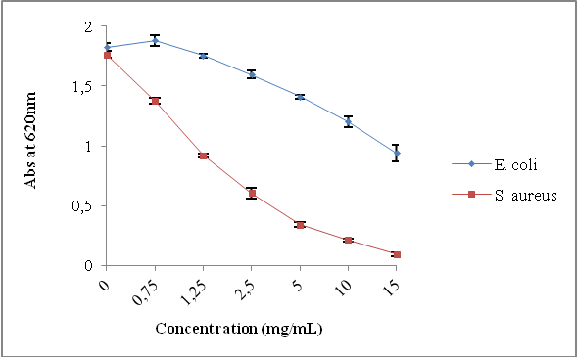

Figure 2. Absorbance at 620 nm of culture media incubated For 24 h with different concentrations of molecule 3b against E. coli and S. Aureus

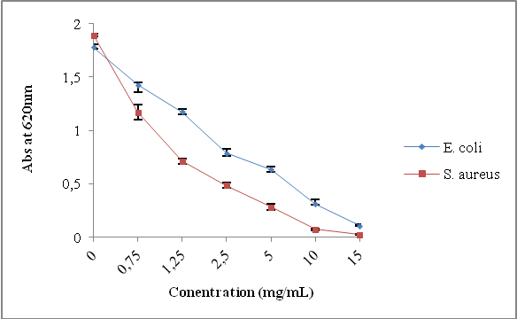

Figure 3. Absorbance at 620 nm of culture media incubated for 24 h with different concentrations of molecule 4b against E. coli and S. aureus

Table 3 Values of MIC and MBC for two molecules obtained by the optical density method
Entry | E. coli |  | S. aureus
Entry | MIC (mg/mL) | MBC (mg/mL) | MIC (mg/mL) | MBC (mg/mL)
3b | 13 | ˃15 | 11.5 | ˃15
4b | 13 | ˃15 | 6.5 | ˃15

Kinetics of bacterial growth

Inoculums were prepared by inoculating medium LB with an overnight culture of S. aureus and E. coli incubating for three hours. 1 mL of aliquot of inoculums was added to 9 ml of medium of LB containing 0.15% of agar. The molecules 4b and 3b were added to each tube to achieve final concentrations of compound of 2 MIC, MIC and MIC/2. The bacterial culture used without compounds was considered as negative control. The tubes were incubated at 37º C. The optical density at a wavelength of 620 nm was measured every hour during the period of growth in order to monitor the bacterial growth. Experiments were performed in triplicate.
This study was conducted to evaluate the effect of molecule 4b (molecule showed the best antibacterial activity) on the kinetics of bacterial growth. Growth curves of bacteria in the presence of different concentrations of this molecule are shown in (Figure 4) against E. coli and (Figure 5) against S. aureus.
For E. coli, it is reduced totally at a concentration 2 MIC = 26 mg/mL. While, at the MIC and MIC/2 = 6.5 mg/mL concentrations the reduction is beginning after 4h of incubation. These results revealed that at a sub-inhibitory affect E. coli in initial phase of growth. While, at concentration of MIC and lower than MIC (MIC/2), this molecule affect only the bacterial growth during stationary stage of growth.
For S. aureus, the molecule 4b affects the bacterial growth at MIC and 2 MIC (13 mg/mL) in after just incubation (action during exponential stage). After 4h of incubation, S. aureus has a normally growth. This result could be explained the development of resistance mechanisms against S. aureus after 4h of incubation (time necessary for S. aureus to establish a resistance mechanism). Indeed, numerous studies have reveled of S. aureus to counterbalance the effects of antibacterial agents by several mechanisms ³⁴⁻³⁶. These results reveal the specific targeting of our molecule against S. aureus and E. coli.

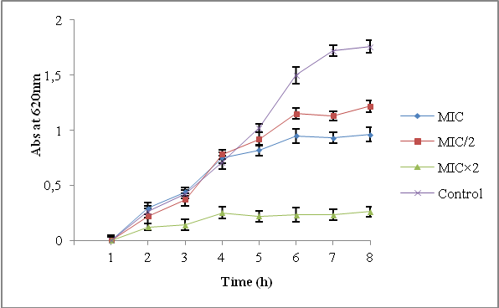

Figure 4. Kinetics of bacterial growth of E. coli of different concentrations of molecule 4b (MIC, MIC/2, MIC×2) and control without molecule. Experiments were performed in duplicate

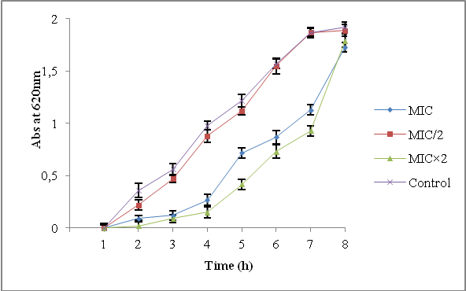

Figure 5. Kinetics of bacterial growth of S. aureus of different concentrations of molecule 4b (MIC, MIC/2, MIC×2) and control without molecule. Experiments were performed in duplicate

Antioxidant activity

DPPH radical scavenging capacity assay
Aliquots (0.2 mL) of various concentrations (6.25–200 mg/mL) of the synthetic compounds samples were added to 1.8 mL of a 0.004% methanolic solution of DPPH. After an incubation period of 30 min in darkness at room temperature, the absorbance was recorded against a blank at 517 nm with a spectrophotometer. Absorption of a blank sample containing the same amount of methanol and DPPH solution acted as the control. DPPH free radical-scavenging activity in percentage (%) was calculated using the following formula:
% Inhibition = [(A_{blanc}-A_{sample})/A_{blanc}] × 100
Where A_{blanc} is the absorbance of the control reaction (containing all reagents except the test compound) and A_{sample} is the absorbance of the test compound.
Compounds concentration providing 50% inhibition (IC₅₀) was calculated from the graph plotted of inhibition percentage.

The results of the antioxidant activity tested by scavenging DPPH radical of ions 2-mercaptobenzimidazolium molecules are shown in the (Figures 6 and 7). They are expressed in scavenging percentage of DPPH radical. All molecules have showed similar antioxidant effect with some non significant variability.

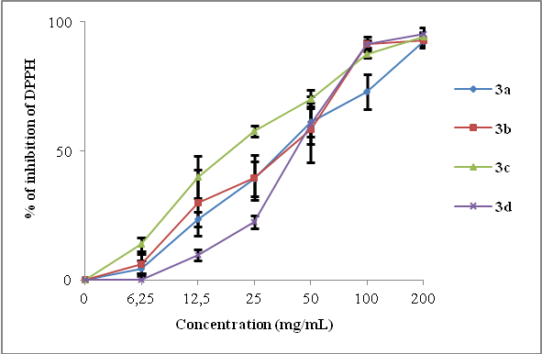

Figure 6. DPPH radical scavenging activities (%) of compounds (3a, 3b, 3c, 3d) Values are means ± standard deviation of three determinations
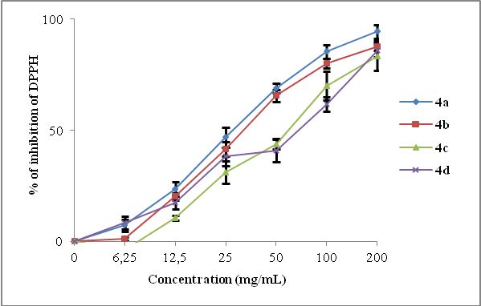

Figure 7. DPPH radical scavenging activities (%) of compounds (4a, 4b, 4c, 4d) Values are means ± standard deviation of three determinations
Furthermore, for each molecule, the ability to reduce the DPPH radical is concentration dependent. Therefore, the calculation of the effective concentration which reduces by 50% the initial concentration of DPPH (IC₅₀) is desirable to express the antiradical activity of molecules studied (Table 4). This capacity was determined from the graph plotted of inhibition capacity (AA in %) against molecules by using linear extrapolation. The value of the antioxidant capacity 50 is inversely proportional to the antiradical effectiveness of the molecules tested. It is clear that all molecules showed a lower capacity to reduce DPPH radical compared to the standard antioxidant (Trolox and ascorbic acid). The molecule 3c is the most active (IC₅₀=19.53 mg/mL). While, 4d was the most inactive molecule (IC₅₀=71.87 mg/mL). Some studies have revealed the antioxidant activity of benzimidazole derivates ^{1, 3}. The difference between results could be attributed to the molecular structure of synthesized molecule and used method to reveal antioxidant properties. The DPPH assay is a very common spectrophotometric method to determine the activity of any antioxidant. We have chosen DPPH radial because of the advantage of this method is that the antiradical activity is measured at ambient temperature, and thus, the risk of the thermal degradation of the molecule tested is eliminated ³⁷.

Table 4 IC₅₀ (mg/mL) values of 3a, 3b, 3c, 3d, 4a, 4b, 4c, 4d

Entry | IC₅₀ (mg/mL)
3a | 37,5
3b | 39,06
3c | 19,53
3d | 43,75
4a | 29,68
4b | 34,37
4c | 62,5
4d | 71,87

Conclusion
In summary, we have developed a facile and an efficient procedure for the synthesis of novel benzimidazolium from 2-mercaptobenzimidazole with hydrocarbon chains. These compounds were screened for their in-vitro antibacterial activity against: Escherichia coli as Gram negative and Staphylococcus aureus as Gram positive. Results revealed that, compounds 4b and 3b showed important activity against tow microorganisms especially against Gram positive-bacteria. The kinetics of bacterial growth showed that molecule 4b has a specific targeting against S. aureus and E. coli. The radical scavenging ability of compounds 3a-d and 4a-d was tested by DPPH assay method. Higher the percentage inhibition for lower concentration is considered to be more antioxidant. It was found that synthesized compounds posses moderate antioxidant activity.
Acknowledgments
The authors thank the Unit of Support for Technical and Scientific Research (CNRST) and the University Mohammed V, Rabat, Morocco.

Experimental

Reagents were purchased from commercial sources and used as received without purification. Solvents were dried by standard procedures. ¹H NMR spectra were recorded in CDCl₃ on a Bruker 300 spectrometer (300 MHz) and ¹³C NMR spectra were recorded in CDCl₃ on a Bruker 300 spectrometer (75 MHz). Chemical shift values were quoted in part per million. Chemical shift multiplicities were reported as s, singlet; d, doublet; t, triplet; q, quartet; and m, multiplet.

General Procedure for Synthesis of 3a-3d
To a solution of (133.10⁻⁴ mol) of 2-mercapto-benzimidazole and 80 ml of N,N-dimethylformamide was added (266.10⁻⁴ mol) of potassium carbonate, (13.3.10⁻⁴ mol) of tetra-n-butylammonium bromide and (399.10⁻⁴ mol) of 1-bromodecane.
The reaction mixture was stirred at room temperature for 24 hours. After filtration, the solvent was removed under reduced pressure. The residue is taken up in dichloromethane, filtered and the solvent was evaporated under reduced pressure.

1-octyl-2-(octylthio)-1H-benzimidazole (3a). Yield: 88%, pale yellow liquid, ¹H NMR spectrum (300 MHz, CDCl₃), δ, ppm (J, Hz): 0.86: (m, 6H, CH₃); 1.25-1.81: (m, 24H, CH₂); 3.44: (t, 2H, SCH₂, J= 14.7); 4.06: (t, 2H, NCH₂, J= 14.7); 7.18-7.73: (4H , m, H Ar). ¹³C NMR spectrum (75 MHz, CDCl₃), δ, ppm (J, Hz): 14.1: (CH₃); 22.61-31.80: (CH₂); 32.82 (SCH₂); 44.28: (NCH₂); 108.821-142.38: (C Ar); 152.07: (C=N). Mass spectrum [MH]∙⁺ m/z= 375.

1-nonyl-2-(nonylthio)-1H-benzimidazole (3b). Yield: 91%, pale yellow liquid, ¹H NMR spectrum (300 MHz, CDCl₃), δ, ppm (J, Hz): 0.97: (6H, m, CH₃); 1.20-1.76: (28H, m, CH₂); 3.42: (t, 2H, SCH₂, J=14.7); 4.05: (t, 2H , NCH₂, J=14.7); 7.16-7.70: (4H , m, H Ar). ¹³C NMR spectrum (75 MHz, CDCl₃), δ, ppm (J, Hz): 14.06: (CH₃); 22.58-31.81: (CH₂); 32.91 (SCH₂); 44.38: (NCH₂); 108.95-141.73: (C Ar); 152.0: (C=N). Mass spectrum [MH]∙⁺ m/z= 403.

1-decyl-2-(decylthio)-1H-benzimidazole (3c). Yield: 93%, pale yellow liquid, ¹H NMR spectrum (300 MHz, CDCl₃), δ, ppm (J, Hz): 0.86: (6H , m, CH₃); 1.24-1.84: (32H, m, CH₂); 3.52: (t, 2H, SCH₂, J=14.7); 4.09: (t, 2H, NCH₂, J=14.7); 7.24-7.80: (4H, m, H Ar). ¹³C NMR spectrum (75 MHz, CDCl₃), δ, ppm (J, Hz): 14.11: (CH₃); 22.66-31.88: (CH₂); 33.14: (SCH₂); 44.57: (NCH₂); 109.04-135.05: (C Ar ); 151.95 : (C=N). Mass spectrum [MH]∙⁺ m/z= 431.

1-dodecyl-2-(dodecylthio)-1H-benzimidazole (3d). Yield: 93%, pale yellow liquid, ¹H NMR spectrum (300 MHz, CDCl₃), δ, ppm (J, Hz): 0.84: (6H, m, CH₃); 1.21-1.81: (40H, m, CH₂); 3.50: (t, 2H, SCH₂, J=14.4); 4.08: (t, 2H, NCH₂, J=14.7); 7.22-7.77: (4H , m, H Ar). ¹³C NMR spectrum (75 MHz, CDCl₃), δ, ppm (J, Hz): 13.89: (CH₃); 22.67-34.06: (CH₂); 36.46: (SCH₂); 44.57: (NCH₂); 109.08-135.02: (C Ar); 151.92: (C=N). Mass spectrum [MH]∙⁺ m/z= 487.

General Procedure for Synthesis of 4a-4d
To a solution of (26.10⁻⁴ mol) of 1-alkanyl-2-(alkanylthio)-1H-benzimidazole and 40 ml of acetonitrile was added (53.10⁻⁴ mol) of 1-bromoalcane.
The reaction mixture was refluxed for 72 hours. After evaporating, the solvent was removed under reduced pressure. The oil obtained is chromatographed on silica gel column (eluent: hexane).

1,3-Dioctyl-2-(octylthio)-1H-benzimidazolium bromide (4a). Yield: 88%, pale yellow liquid, ¹H NMR spectrum (300 MHz, CDCl₃), δ, ppm (J, Hz): 0.85: (6H , m, CH₃); 1.24-1.86: (36H, m, CH₂); 3.38: (t, 2H, SCH₂, J=13.8); 4.29: (t, 2H, NCH₂, J=15.3); 7.18-7.26: (4H, m, H Ar). ¹³C NMR spectrum (75 MHz, CDCl₃), δ, ppm (J, Hz): 14.07: (CH₃); 22.62-32.85: (CH₂); 34.01 (SCH₂); 44.82: (NCH₂); 109.02-132.07: (C Ar); 168.98: (C=N). electrospray ionization mass spectrometry (ESI–MS) [M]⁺ m/z= 487.

1,3-Dinonyl-2-(nonylthio)-1H-benzimidazolium bromide (4b). Yield: 80%, pale yellow liquid, ¹H NMR spectrum (300 MHz, CDCl₃), δ, ppm (J, Hz): 0.85: (6H, m, CH₃); 1.24-1.86: (36H, m, CH₂); 3.38: (t, 2H, SCH₂, J=13.8); 4.29: (t, 2H, NCH₂, J=15.0); 7.17-7.26: (4H, m, H Ar). ¹³C NMR spectrum (75 MHz, CDCl₃), δ, ppm (J, Hz): 14.09: (CH₃); 22.64-32.85: (CH₂); 34.00: (SCH₂); 44.82: (NCH₂); 109.02-132.07: (C Ar); 169.00: (C=N). electrospray ionization mass spectrometry (ESI–MS) [M]⁺ m/z=529.

1,3-Didecyl-2-(decylthio)-1H-benzimidazolium bromide (4c). Yield: 83%, pale yellow liquid, ¹H NMR spectrum (300 MHz, CDCl₃), δ, ppm (J, Hz): 0.84: (6H, m, CH₃); 1.22-1.84: (36H, m, CH₂); 3.36: (t, 2H, SCH₂, J=13.8); 4.27: (t, 2H, NCH₂, J=15.3); 7.16-7.40: (4H, m, H Ar). ¹³C NMR spectrum (75 MHz, CDCl₃), δ, ppm (J, Hz): 14.08: (CH₃); 22.66-32.85: (CH₂); 33.86: (SCH₂); 44.77: (NCH₂); 108.95-132.05: (C Ar); 169.06: (C=N). electrospray ionization mass spectrometry (ESI–MS) [M]⁺ m/z=571.

1,3-Didodecyl-2-(dodecylthio)-1H-benzimidazolium bromide (4d). Yield: 78%, pale yellow liquid, ¹H NMR spectrum (300 MHz, CDCl₃), δ, ppm (J, Hz): 0.87: (6H, m, CH₃); 1.25.1.86: (36H, m, CH₂); 3.38: (t, 2H, SCH₂, J=13.8); 4.29: (t, 2H, NCH₂, J=15.0); 7.17-7.26: (4H, m, H Ar). ¹³C NMR spectrum (75 MHz, CDCl₃), δ, ppm (J, Hz): 14.09: (CH₃); 22.70-32.88: (CH₂); 33.79: (SCH₂); 44.9: (NCH₂); 108.95-132.08: (C Ar); 169.11: (C=N). electrospray ionization mass spectrometry (ESI–MS) [M]⁺ m/z=65

References

  - Anelia Ts. Mavrova, Denitsa Yancheva, Neda Anastassova, Kamelya Anichina, Jelena Zvezdanovic, Aleksandra Djordjevic, Dejan Markovic, Andrija Smelcerovic, Bioorganic & Medicinal Chemistry, 2015, 23 (19), 6317-6326.
  - Mariola Andrzejewska, Lilian Yepez-Mulia, Amparo Tapia, Roberto Cedillo-Rivera, Agnieszka E. Laudy, Bohdan J. Staro´sciak, Zygmunt Kazimierczuk, European Journal of Pharmaceutical Sciences, 2004, 21, 323–329.
  - Sumayya K K, Kamalabhai Amma V K, Babu G, Biju C R, Int. J. Chem. Pharm. Sci, 2013, 1(3), 193-198.
  - K. Anandarajagopal, Ravi N Tiwari, K.G.Bothara, J.Anbu Jeba Sunilson, C. Dineshkumar1 and P. Promwichit, Advances in Applied Science Research, 2010, 1 (2), 132-138.
  - Mauro,V.; Silvia, H.; Joao, V.; Marcus, V., J. Sulfur,Chem., 2007, 28, 17.
  - Marco, M.; Claudia, B.; Rivara, S.; Valentina, Z.; Federica, V.; Uirko, R.; Elisabetta, B.; Simona, B., Bioory, Med. Chem., 2004, 12, 663
  - Bakhareva, E.; Voronkov, M.; Sorokin, M.; Lopyrev, V.; Seredenin, S., Pharm. Chem. J., 1996, 30, 89.
  - Anandarajagopal, K.; Timari, R.; Venkatesshan, N.; Vinothapooshan, G., J. Chem. Pharm. Res., 2010, 2 (3), 230.
  - Rebstock, T.; Ball, C.; Hamner , C.; Sell, J. Articale, 1955, 1691, 382-384.
  - L. El Ouasif, I. Merimi, H. Zarrok, M. El ghoul, R. Achour, M. Guenbour, H. Oudda, F. El-Hajjaji, B. Hammouti, J. Mater. Environ. Sci., 2016, 7 (8), 2718-2730.
  - Makhhuf, M.; El-Shatory, S.; Said, A., Mater. Chem. Phys., 1996, 43 (1), 76.
  - Refaey, S.; Taha, F.; Abd El-Malak, A., Int.J. Electrochem. Sci., 2006, 1, 80-91.
  - Wang, L., Corros. Sci., 2001, 43, 2281.
  - Wang, L.; Pu, J.; Luo, H., Corros. Sci., 2003, 45, 77.
  - Marius C. Costache, Matthew J. Heidecker , E. Manias , Rakesh K. Gupta, Charles A. Wilkie Polymer Degradation and Stability, 2007, 92, 1753-1762.
  - M. El Achaby, H. Ennajih, F.Z. Arrakhiz, A. El Kadib, R. Bouhfid, E. Essassi, A. Qaiss, Composites: Part B 2013, 51, 310-317.
  - Guipeng Cai, Jianxiang Feng, Jin Zhu, Charles A. Wilkie, Polymer Degradation and Stability, 2014, 99, 204-210.
  - Sekar Ramkumar, Kahagala-Gamage UpulWijayantha, David Velayutham, Sambandam Anandan, Journal of Molecular Liquids, 2014,193, 185-188.
  - Sekar Ramkumar, Kahagala-Gamage UpulWijayantha, David Velayutham, Sambandam Anandan, Journal of Molecular Liquids, 2014, 193, 185–188.
  - El Kdib Abdelkrim, Essassi El Mokhtar, Bouhfid Rachid, Ennajih Hamid, N° brevet MA34933 B1, 01.03.(2014)
  - Amita Krishan Lal, Marilyn Daisy Milton, Tetrahedron Letters, 2014,55, 1810–1814.
  - Bousmina Mostapha, Essassi El Mokhtar, Bouhfid Rachid, Ennajih Hamid, N° brevet WO 2012/011793 A1, 26.01. (2012)
  - Bouyahya A, Abrini J, Khay EO, Charfi S, Boujida N, EL Harsal A, Talbaoui A, ET-Touys A, Bakri Y,Dakka N., Biotechnology Journal International, 2016 a , 16, 1-9.
  - Bouyahya A, Abrini J, El-Baabou A, Bakri Y, Dakka N., J Plant Pathol Microbiol, 2016 c , 7, 107-111.
  - Kaur GJ, Arora DS., BMC Complement Altern Med, 2009, 6, 9-30.
  - Skandamis, P., Koutsoumanis, K., Fasseas, K., & Nychas, G. J. E., Italian Journal of Food Science, 2001,13, 65–75.
  - S. Bouhdid, J. Abrini, M. Amensour, A. Zhiri, M. J. Espung, A. Manresa, Journal of Applied Microbiology, 2009, 106, 1558-1568.
  - S. Bouhdid, J. Abrini, M. Amensour, A. Zhiri, M. J. Espung, A. Manresa, Journal of Applied Microbiology, 2010, 109, 1139-1149.
  - Barakat H., Journal of Applied Science & Technology, 2014, 4, 1934-1951.
  - Oliveira BD, Rodrigues AC, Cardoso BMI, Ramos ALCC, Bertoldi MC, Jason Guy Taylor JG, Luciana da Cunha LR, Pinto UM., Industrial Crops and Products, 2016, 84, 59-66.
  - Myszka K, Schmidt MT, Majcher M , Juzwa W, Olkowicz M, Czaczyk K., International Biodeterioration & Biodegradation, 2016, 114, 252-259.
  - Luís A, Duarte A, Gominho J, Domingues F, Duarte AP., Industrial Crops and Products, 2016, 79, 274-282.
  - K. Parikh, D. Joshi, Med Chem Res, 2013, 22, 3688–3697.
  - Lowy F. D., J Clin Invest., 2003, 111 (9), 1265-1273.
  - Pantosti A, Sanchini A, Moaco M., Future Microbiol., 2007, 2(3), 323-34.
  - Hiramatsu K, Cui L, Kuroda M, Ito T., Trends Microbiol., 2001, 9, 486–493.
  - Bondet V, Brand-Williams W, Berset C., LWT-Food Sci. Technol, 1997, 30, 609–615.

