**Spectral Data**

**1-octyl-2-(octylthio)-1H-benzimidazole 3a**

Yield: 88%, pale yellow liquid, 1H NMR spectrum (300 MHz, CDCl3), δ, ppm (*J*, Hz): 0.86: (6H, m, CH3); 1.25-1.81: (24H, m, CH2); 3.44: (2H, t, *J*= 14.7, SCH2); 4.06: (2H, t, *J*= 14.7, NCH2); 7.18-7.73: (4H , m, HAr). 13C NMR spectrum (75 MHz, CDCl3), δ, ppm (*J*, Hz): 14.1: (CH3); 22.61-31.80: (CH2); 32.82 (SCH2); 44.28: (NCH2); 108.821-142.38: (CAr); 152.07: (C=N). Mass spectrum [MH]∙+ m/z= 375. 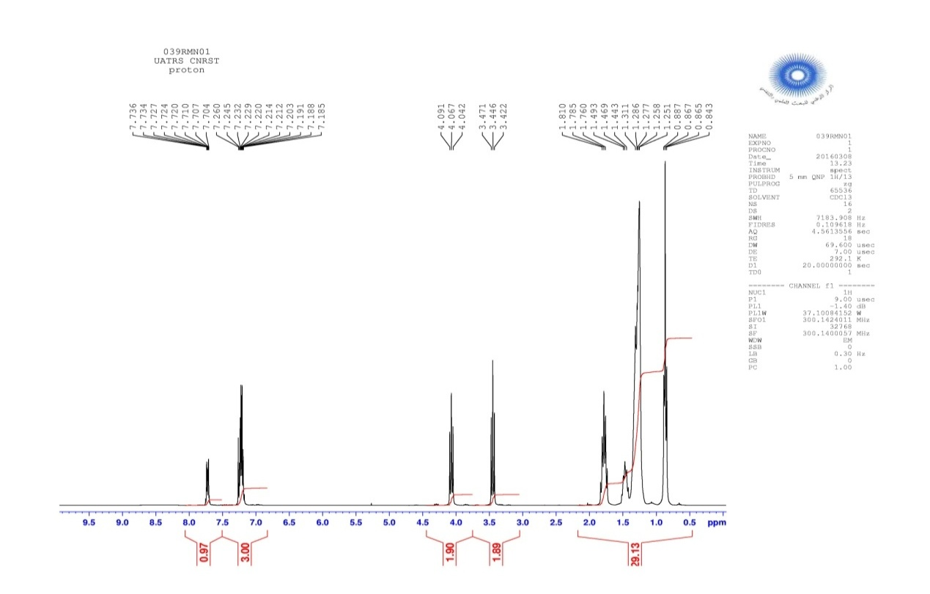

**Figure 1.** The 1H- RMN Spectrum of compound **3a**

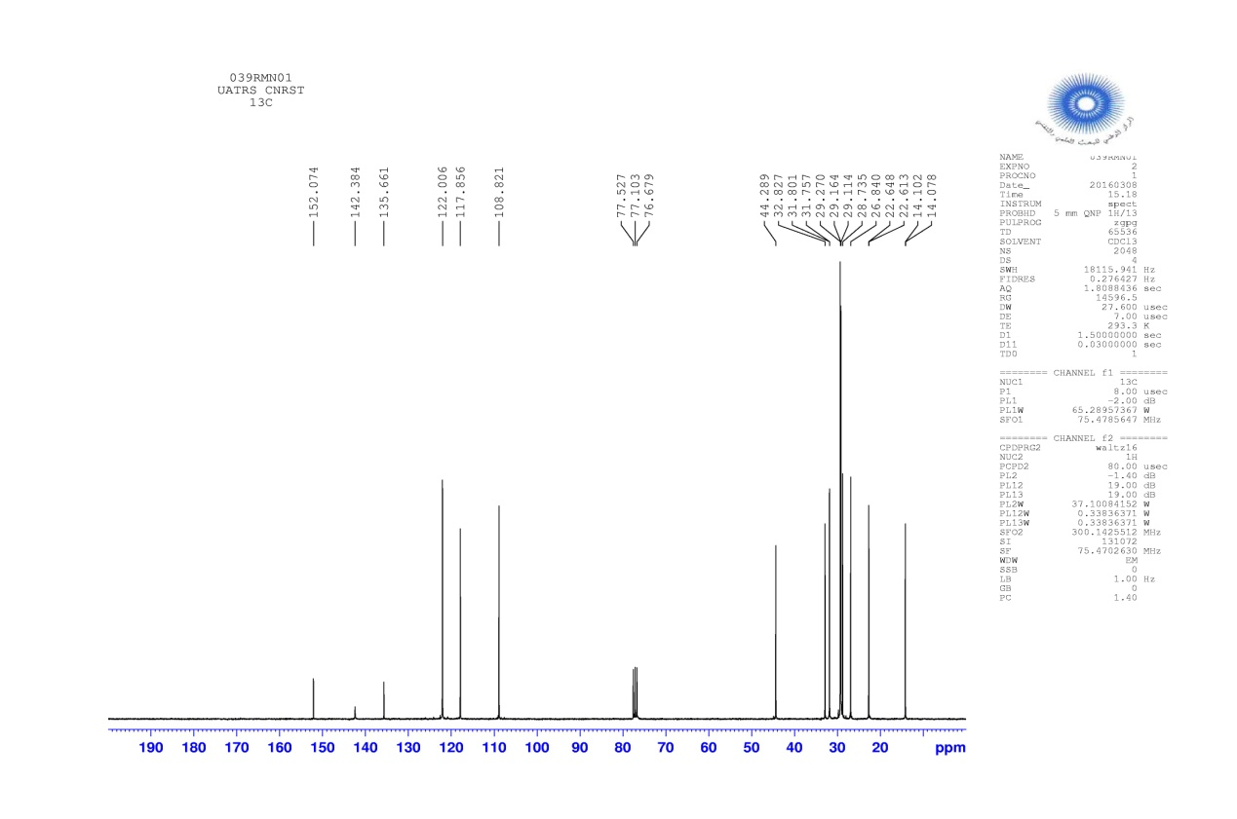

**Figure 2.** The 13C- RMN Spectrum of compound **3a**



**Figure 3.** The CI–MS spectrum of compound **3a**

**1-nonyl-2-(nonylthio)-1H-benzimidazole 3b**

Yield: 91%, pale yellow liquid, 1H NMR spectrum (300 MHz, CDCl3), δ, ppm (*J*, Hz): 0.97: (6H, m, CH3); 1.20-1.76: (28H, m, CH2); 3.42: (2H , t, *J*=14.7, SCH2); 4.05: (2H , t, *J*=14.7, NCH2); 7.16-7.70: (4H , m, H Ar). 13C NMR spectrum (75 MHz, CDCl3), δ, ppm (*J*, Hz): 14.06: (CH3); 22.58-31.81: (CH2); 32.91 (SCH2); 44.38: (NCH2); 108.95-141.73: (CAr); 152.0: (C=N). Mass spectrum [MH]∙+ m/z= 403.

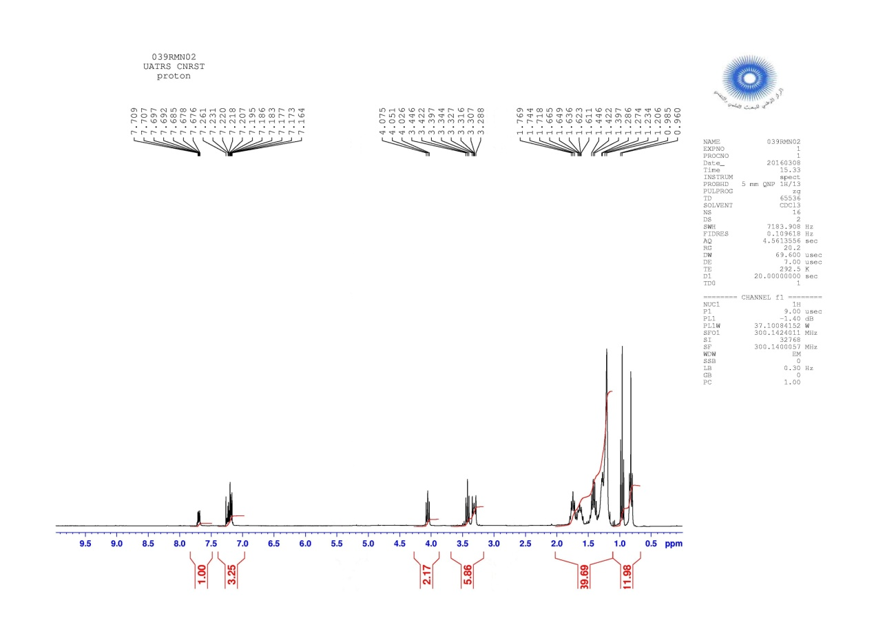

**Figure 4.** The 1H- RMN Spectrum of compound **3b**

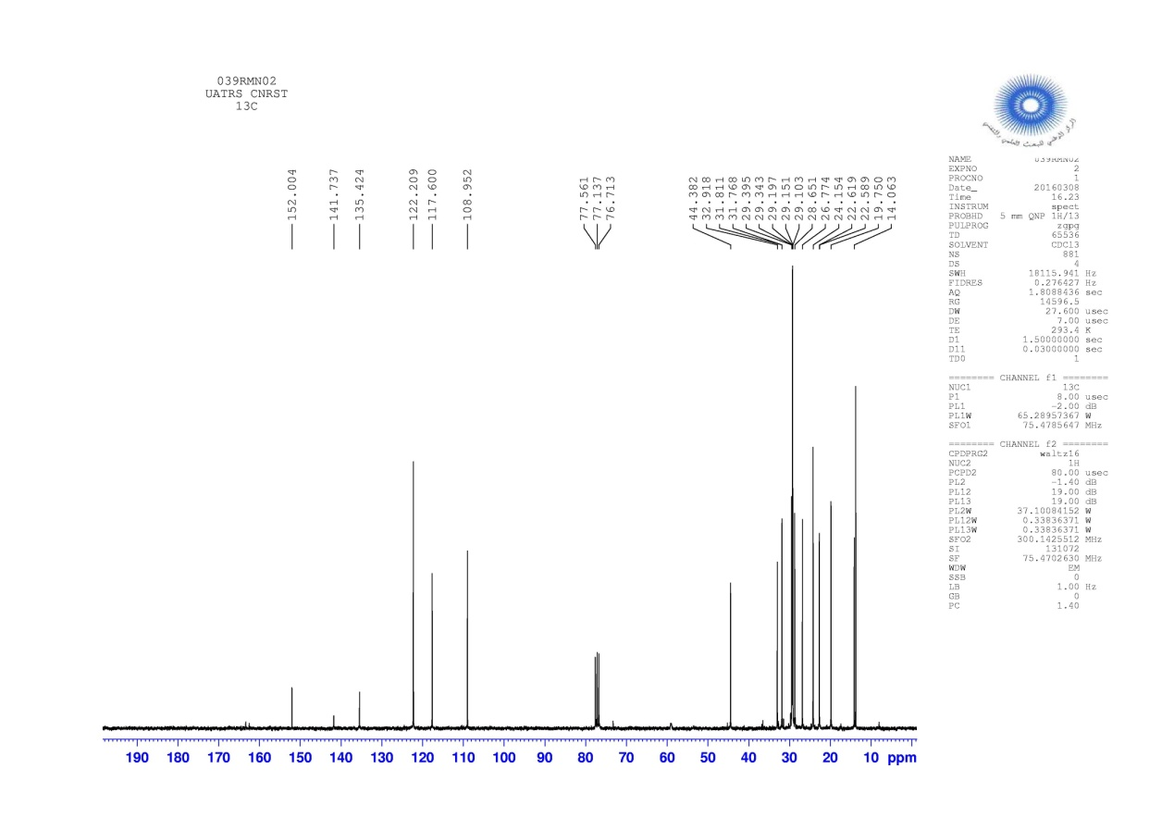

**Figure 5.** The 13C- RMN Spectrum of compound **3b**

 **Figure 6.** The CI–MS spectrum of compound **3b**

**1-decyl-2-(decylthio)-1H-benzimidazole 3c**

Yield: 93%, pale yellow liquid, 1H NMR spectrum (300 MHz, CDCl3), δ, ppm (*J*, Hz): 0.86: (6H , m, CH3); 1.24-1.84: (32H, m, CH2); 3.52: (2H , t, *J*=14.7, SCH2); 4.09: (2H, t, *J*=14.7, NCH2); 7.24-7.80: (4H, m, H Ar). 13C NMR spectrum (75 MHz, CDCl3), δ, ppm (*J*, Hz): 14.11: (CH3); 22.66-31.88: (CH2); 33.14: (SCH2); 44.57: (NCH2); 109.04-135.05: (CAr); 151.95 : (C=N). Mass spectrum [MH]∙+ m/z= 431. 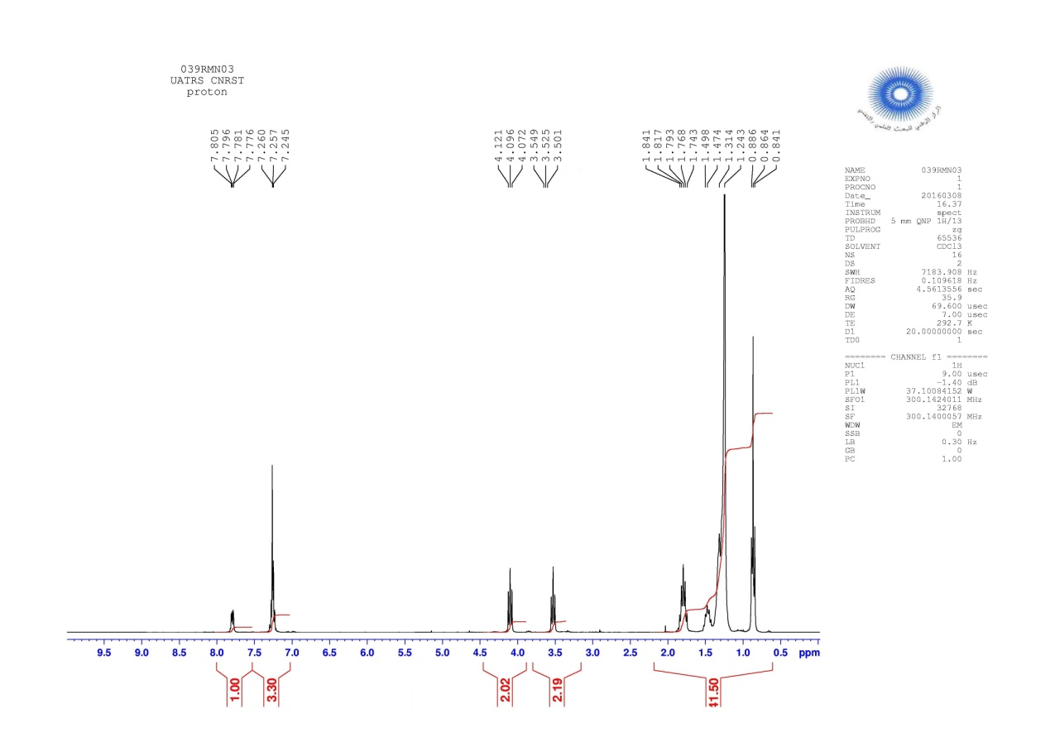

**Figure 7.** The 1H- RMN Spectrum of compound **3c**

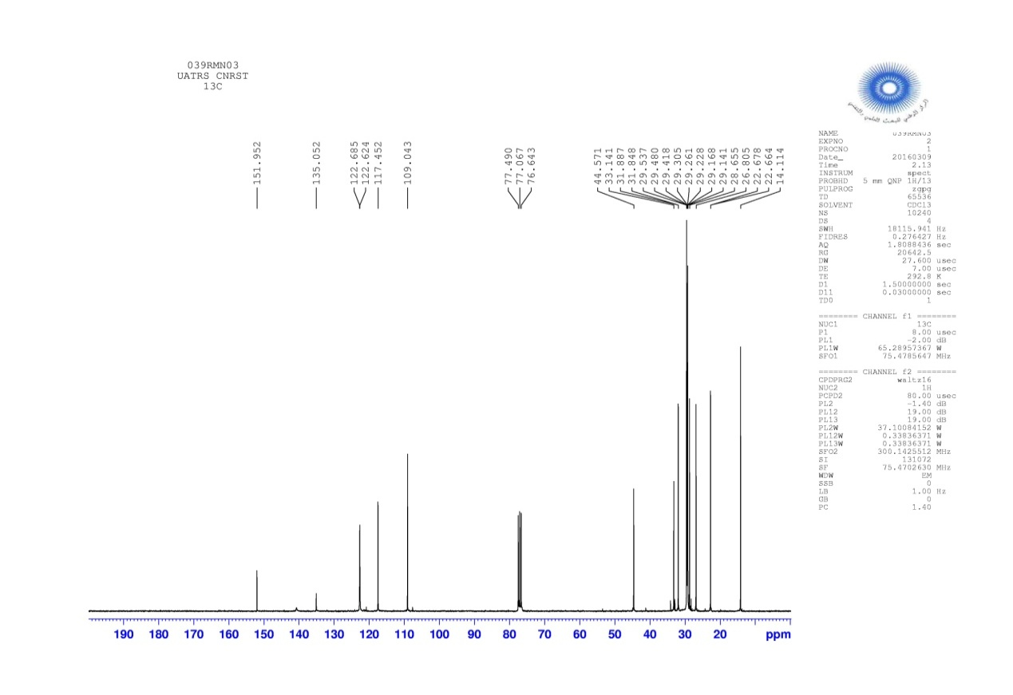

**Figure 8.** The 13C- RMN Spectrum of compound **3c**



**Figure 9.** The CI–MS spectrum of compound **3c**

**1-dodecyl-2-(dodecylthio)-1H-benzimidazole 3d**

Yield: 93%, pale yellow liquid, 1H NMR spectrum (300 MHz, CDCl3), δ, ppm (*J*, Hz): 0.84: (6H, m, CH3); 1.21-1.81: (40H, m, CH2); 3.50: (2H , t, *J*=14.4, SCH2); 4.08: (2H, t, *J*=14.7, NCH2); 7.22-7.77: (4H , m, H Ar). 13C NMR spectrum (75 MHz, CDCl3), δ, ppm (*J*, Hz): 13.89: (CH3); 22.67-34.06: (CH2); 36.46: (SCH2); 44.57: (NCH2); 109.08-135.02: (C Ar); 151.92: (C=N). Mass spectrum [MH]∙+ m/z= 487.

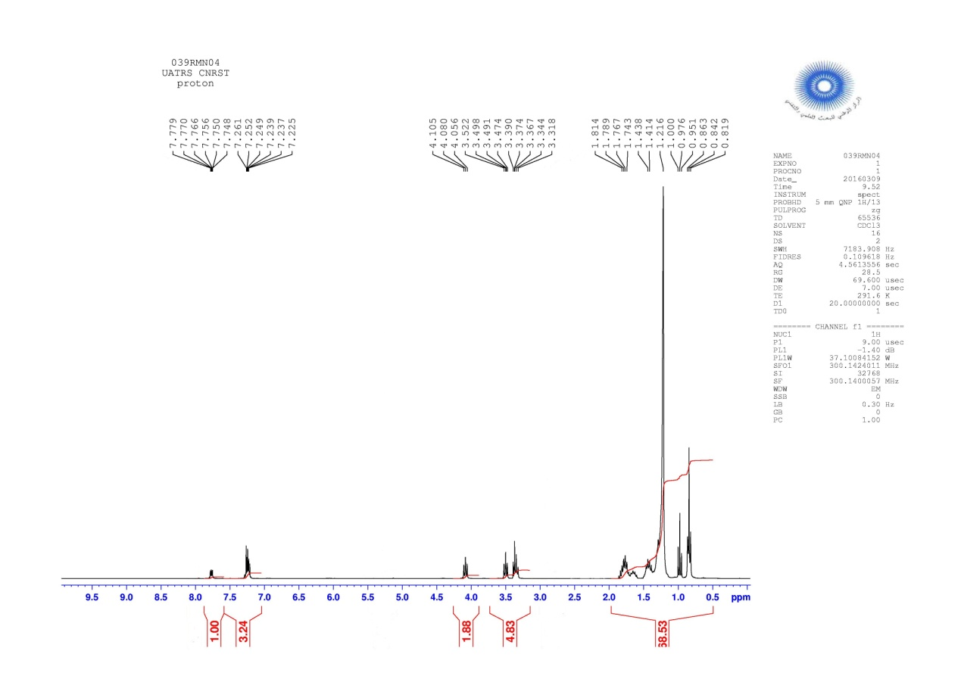

**Figure 10.** The 1H- RMN Spectrum of compound **3d**

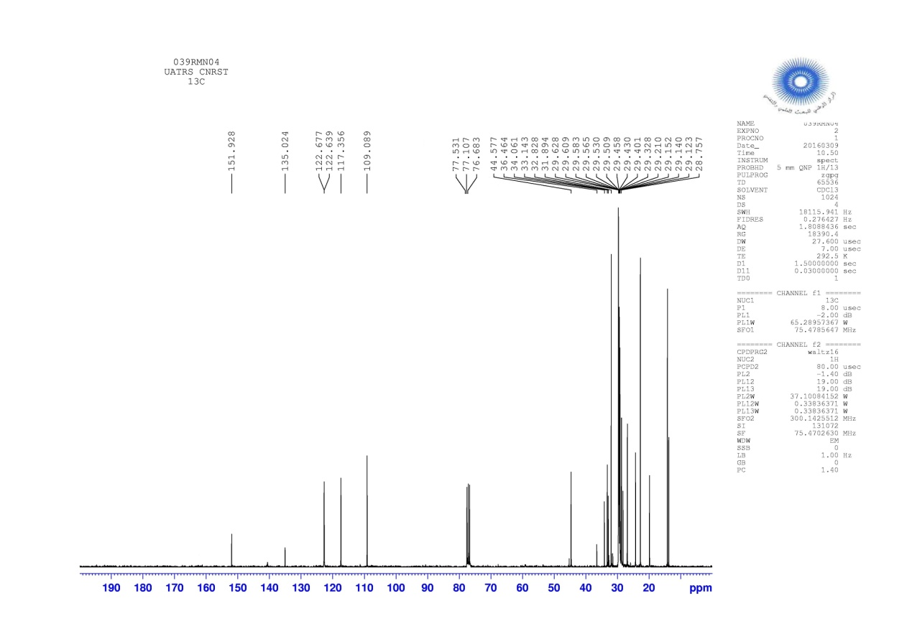

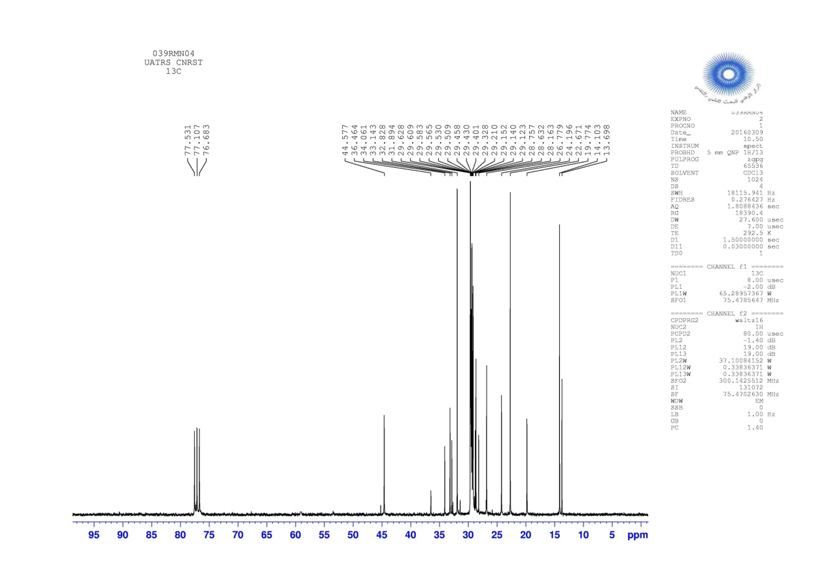

**Figure 11.** The 13C- RMN Spectrum of compound **3d**



**Figure 12.** The CI–MS spectrum of compound **3d**

**1,3-Dioctyl-2-(octylthio)-1H-benzimidazolium bromide 4a**

Yield: 88%, pale yellow liquid, 1H NMR spectrum (300 MHz, CDCl3), δ, ppm (*J*, Hz): 0.85: (6H , m, CH3); 1.24-1.86: (36H, m, CH2); 3.38: (2H, t, *J*=13.8, SCH2); 4.29: (2H, t, *J*=15.3, NCH2); 7.18-7.26: (4H, m, H Ar). 13C NMR spectrum (75 MHz, CDCl3), δ, ppm (*J*, Hz): 14.07: (CH3); 22.62-32.85: (CH2); 34.01 (SCH2); 44.82: (NCH2); 109.02-132.07: (CAr); 168.98: (C=N). Mass spectrum [M]∙+ m/z= 487.

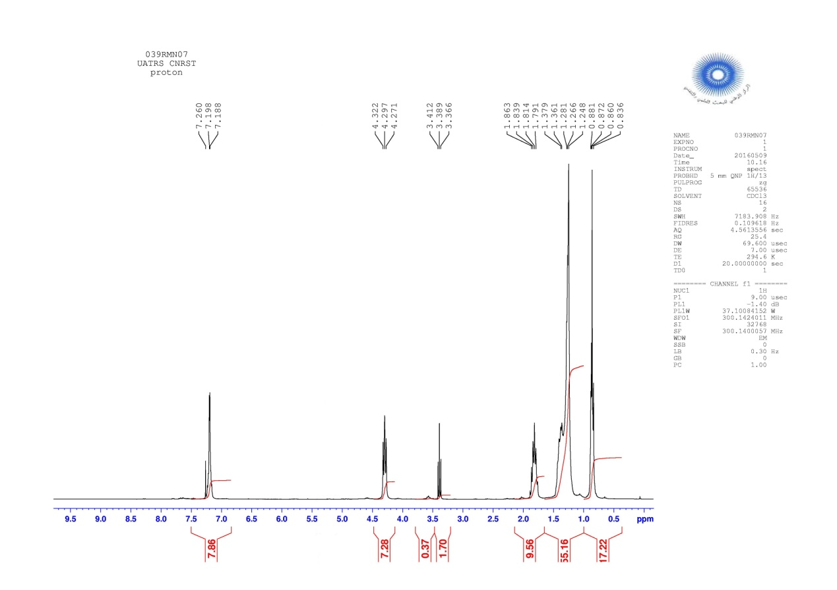

**Figure 13.** The 1H- RMN Spectrum of compound **4a**

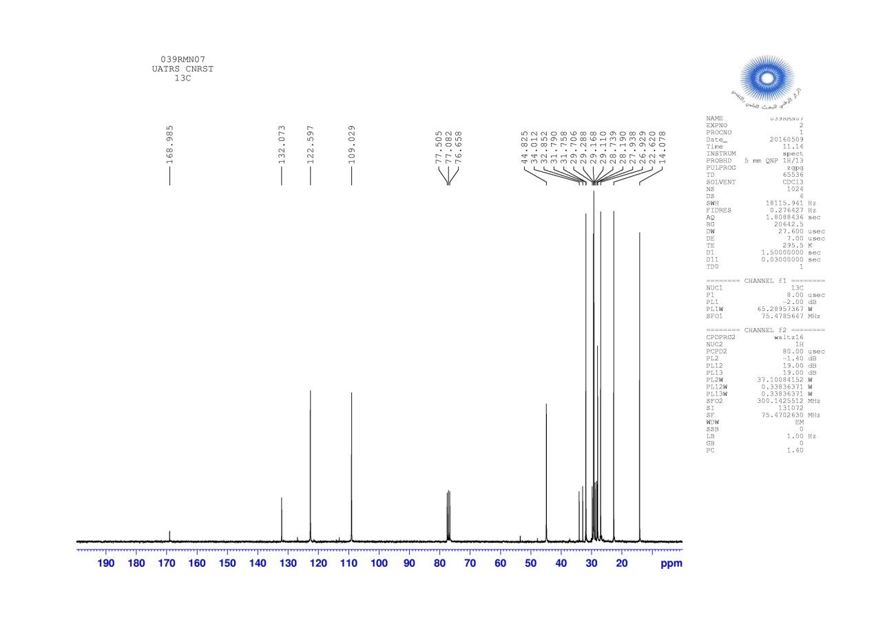

**Figure 14.** The 13C- RMN Spectrum of compound **4a**



**Figure 15.** The EI–MS spectrum of compound **4a**

**1,3-Dinonyl-2-(nonylthio)-1H-benzimidazolium bromide 4b**

Yield: 80%, pale yellow liquid, 1H NMR spectrum (300 MHz, CDCl3), δ, ppm (*J*, Hz): 0.85: (6H, m, CH3); 1.24-1.86: (36H, m, CH2); 3.38: (2H, t, *J*=13.8, SCH2); 4.29: (2H, t, *J*=15.0, NCH2); 7.17-7.26: (4H, m, H Ar). 13C NMR spectrum (75 MHz, CDCl3), δ, ppm (*J*, Hz): 14.09: (CH3); 22.64-32.85: (CH2); 34.00: (SCH2); 44.82: (NCH2); 109.02-132.07: (CAr); 169.00: (C=N). Mass spectrum [M]∙+ m/z=529.

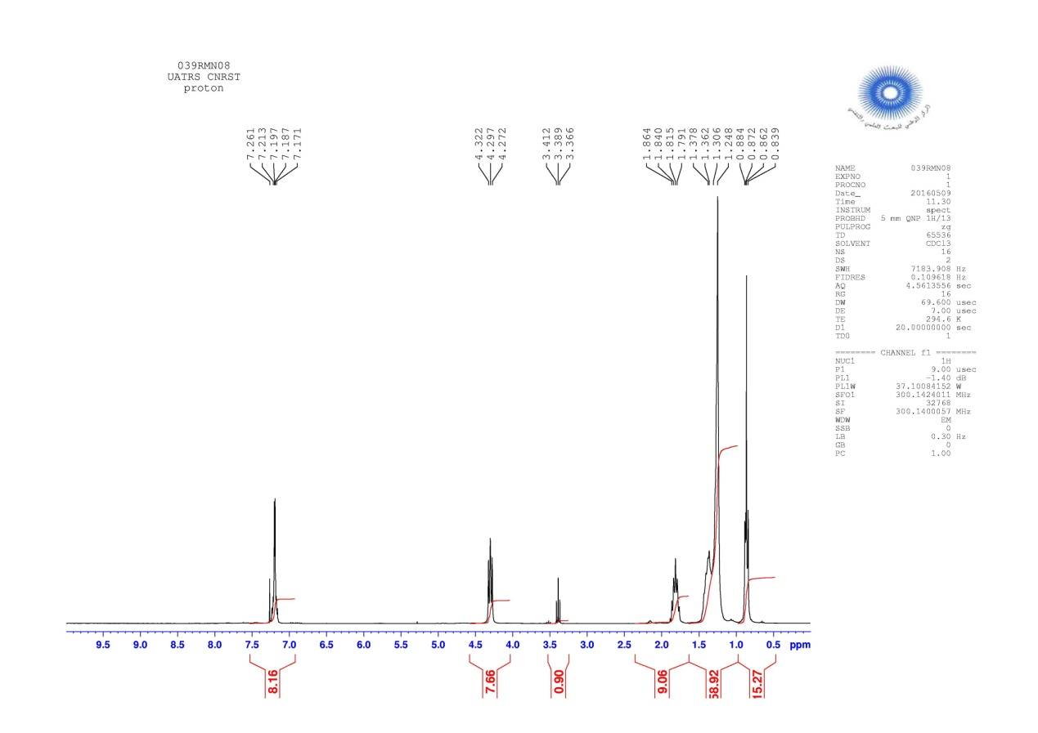

**Figure 16.** The 1H- RMN Spectrum of compound **4b**

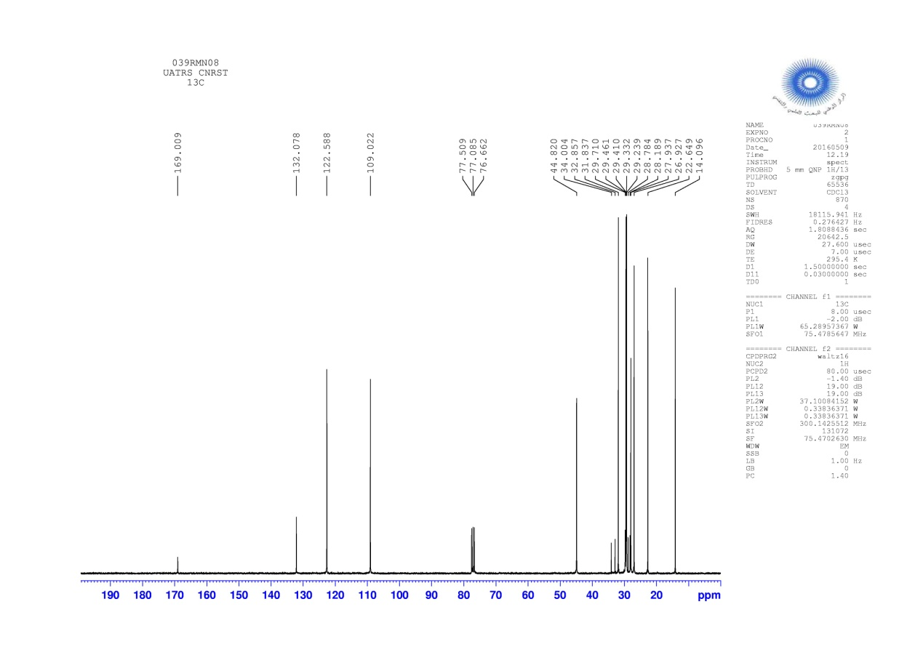

**Figure 17.** The 13C- RMN Spectrum of compound **4b**



**Figure 18.** The EI–MS spectrum of compound **4b**

**1,3-Didecyl-2-(decylthio)-1H-benzimidazolium bromide 4c**

Yield: 83%, pale yellow liquid, 1H NMR spectrum (300 MHz, CDCl3), δ, ppm (*J*, Hz): 0.84: (6H, m, CH3); 1.22-1.84: (36H, m, CH2); 3.36: (2H, t, *J*=13.8, SCH2); 4.27: (2H, t, *J*=15.3, NCH2); 7.16-7.40: (4H, m, H Ar). 13C NMR spectrum (75 MHz, CDCl3), δ, ppm (*J*, Hz): 14.08: (CH3); 22.66-32.85: (CH2); 33.86: (SCH2); 44.77: (NCH2); 108.95-132.05: (CAr); 169.06: (C=N). Mass spectrum [M]∙+ m/z=571.

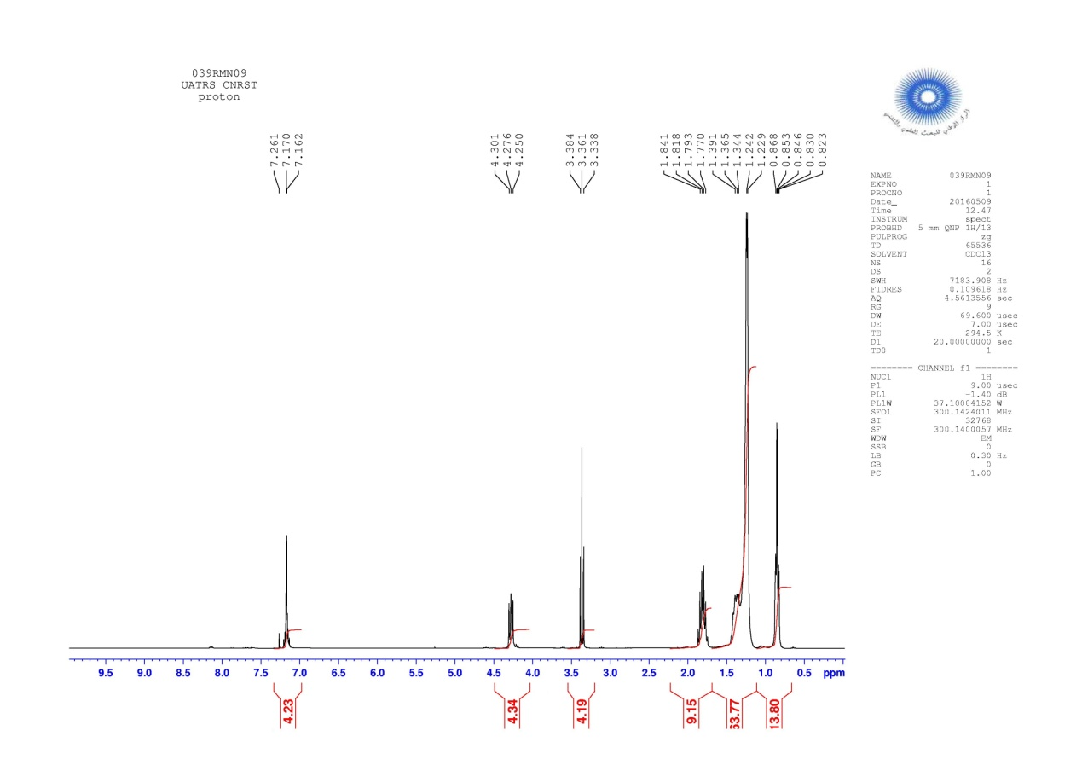

**Figure 19.** The 1H- RMN Spectrum of compound **4c**

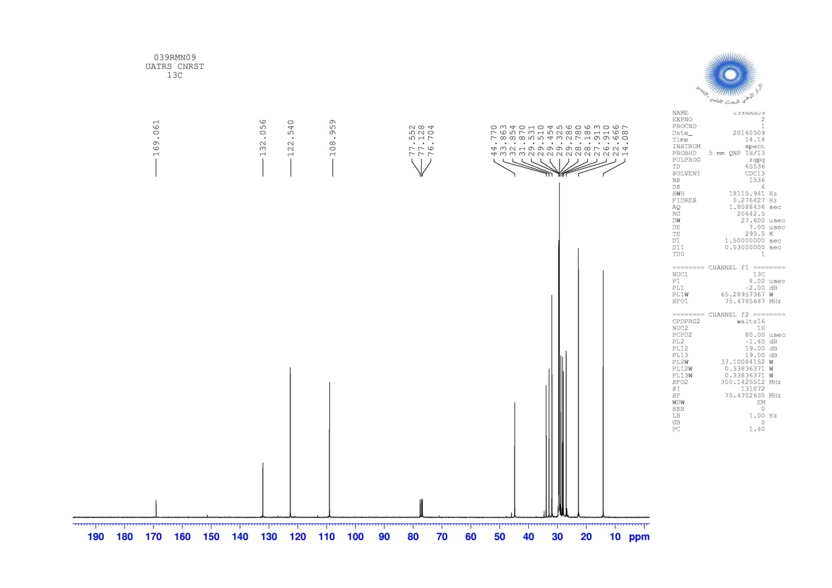

**Figure 20.** The 13C- RMN Spectrum of compound **4c**



**Figure 21.** The EI–MS spectrum of compound **4c**

**1,3-Didodecyl-2-(dodecylthio)-1H-benzimidazolium bromide 4d**

Yield: 78%, pale yellow liquid, 1H NMR spectrum (300 MHz, CDCl3), δ, ppm (*J*, Hz): 0.87: (6H, m, CH3); 1.25.1.86: (36H, m, CH2); 3.38: (2H, t, *J*=13.8, SCH2); 4.29: (2H, t, *J*=15.0, NCH2); 7.17-7.26: (4H, m, H Ar). 13C NMR spectrum (75 MHz, CDCl3), δ, ppm (*J*, Hz): 14.09: (CH3); 22.70-32.88: (CH2); 33.79: (SCH2); 44.9: (NCH2); 108.95-132.08: (CAr); 169.11: (C=N). Mass spectrum [M]∙+ m/z=655.

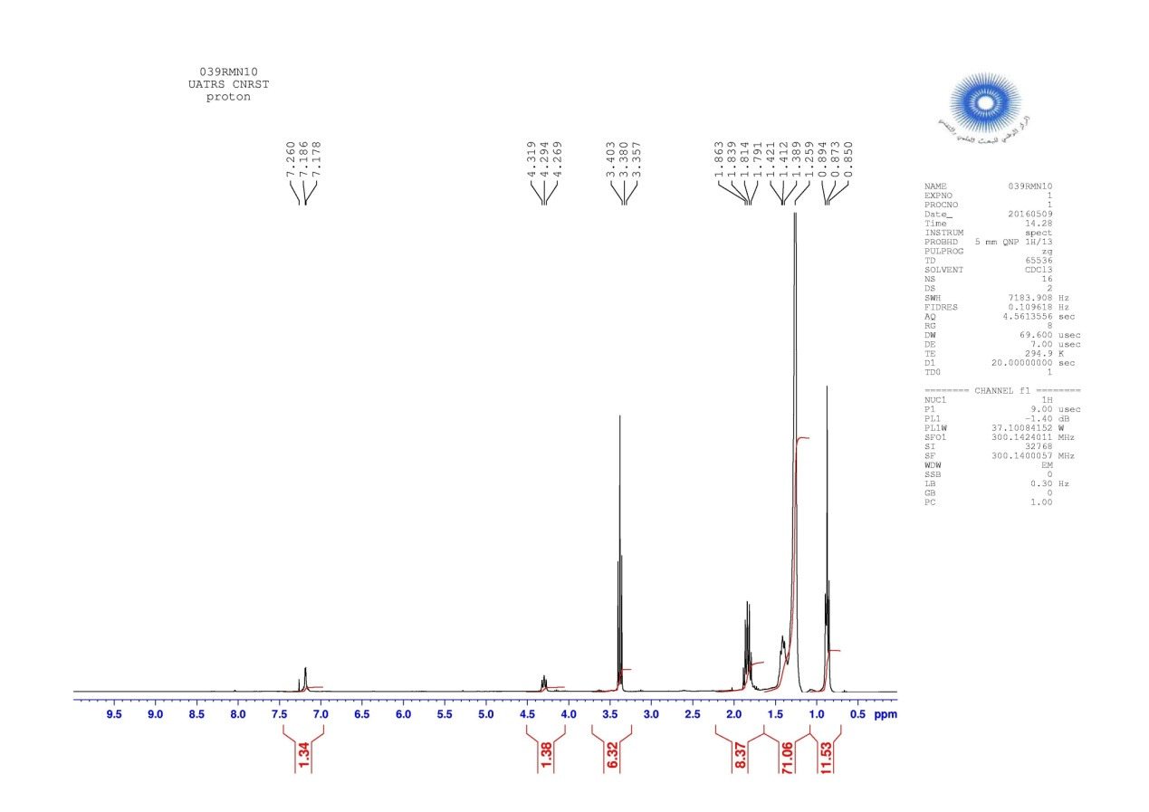

**Figure 22.** The 1H- RMN Spectrum of compound **4d**

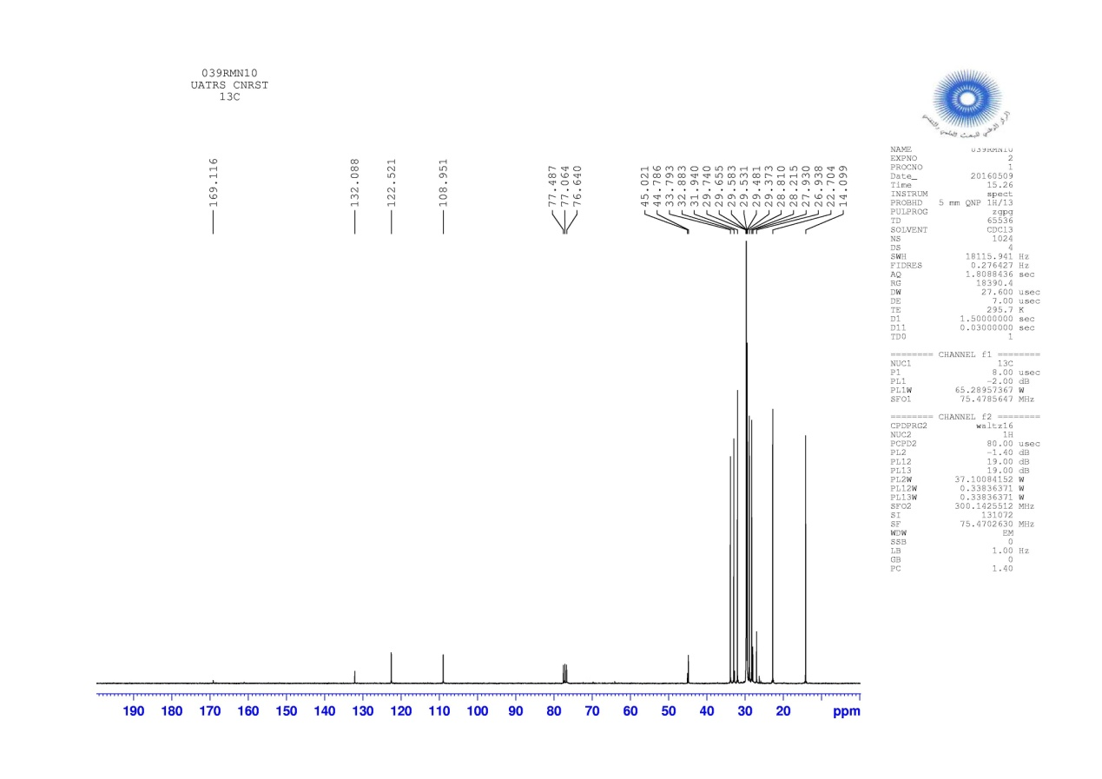

**Figure 23.** The 13C- RMN Spectrum of compound **4d**



**Figure 24.** The EI–MS spectrum of compound **4d**