**Coumarin or benzoxazinone bearing benzimidazolium and bis(benzimidazolium) salts; involvement in transfer hydrogenation of acetophenone derivatives and hCA inhibition**

**Mert Olgun KARATAŞ1,*, Serkan DAYAN2, Nilgün KAYACI2, Ciğdem BİLEN3, Emre YAVUZ3, Nahit GENCER3, Bulent ALICI1, Nilgün ÖZPOZAN KALAYCIOĞLU2, Oktay ARSLAN3**

1Full Address:Department of Chemistry, Faculty of Arts and Sciences, Inonu University, Road of Elazig 15th km., Malatya 44280, Turkey

2 Full Address:Department of Chemistry, Faculty of Science, Erciyes University, Neighborhood of Köşk, Kayseri 38039, Turkey

3 Full Address:Department of Chemistry, Faculty of Art and Sciences, Balıkesir University, Cagis Campus, 10160 Balikesir 10160, Turkey

|  |  |
| --- | --- |
| **Content** | **Page** |
| 1. **1H-NMR spectrum of compound 1a** | **2** |
| 1. **13C-NMR spectrum of compound 1a** | **3** |
| 1. **1H-NMR spectrum of compound 2a** | **4** |
| 1. **13C-NMR spectrum of compound 2a** | **5** |
| 1. **HSQC spectrum of compound 2b** | **6** |
| 1. **LC-MS spectrum of compound 1b** | **7** |
| 1. **LC-MS spectrum of compound 2b** | **7** |
| 1. **CA Inhibition graph of compound 1** | **8** |
| 1. **CA Inhibition graph of compound 2** | **8** |
| 1. **CA Inhibition graph of compound 1a** | **9** |
| 1. **CA Inhibition graph of compound 2a** | **9** |
| 1. **CA Inhibition graph of compound 1b** | **10** |
| 1. **CA Inhibition graph of compound 2b** | **10** |

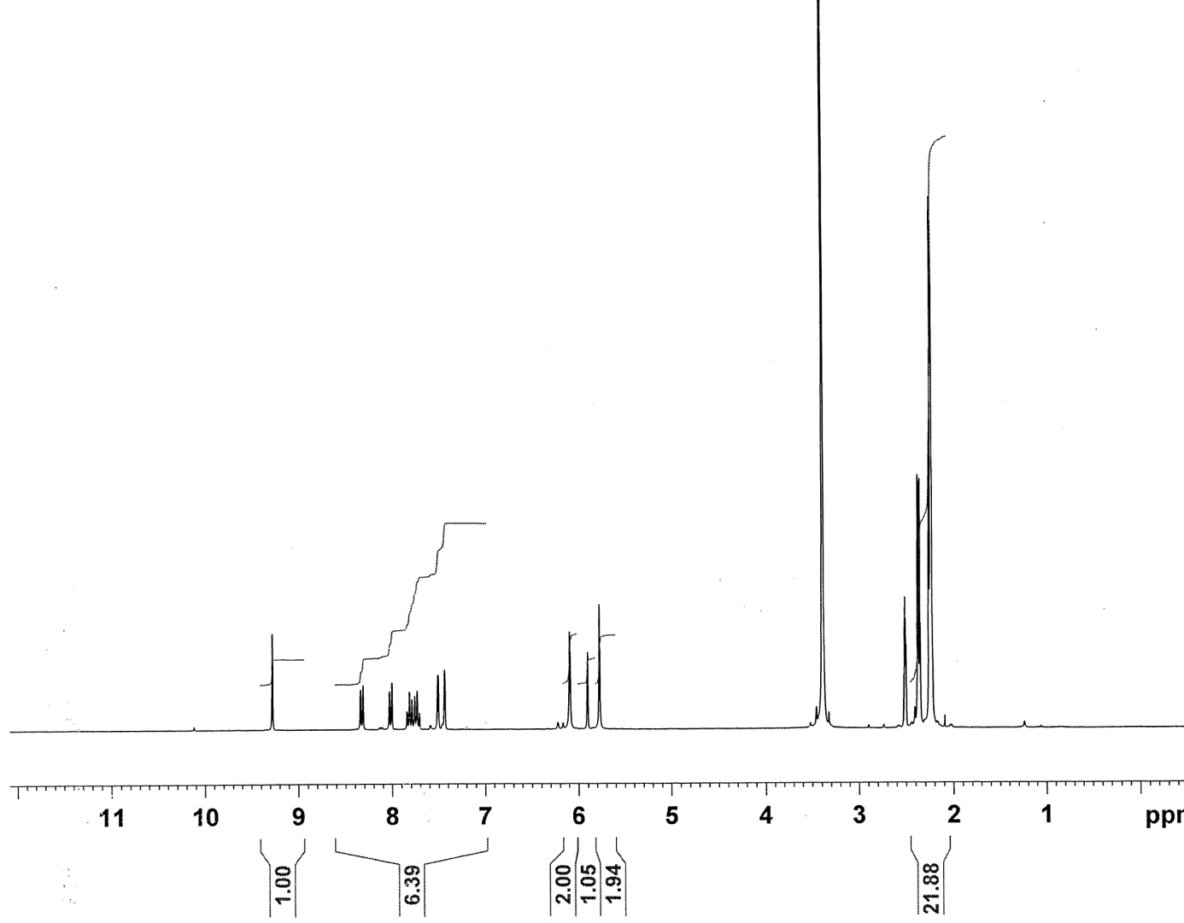

**Figure.** 1H-NMR spectrum of compound 1a

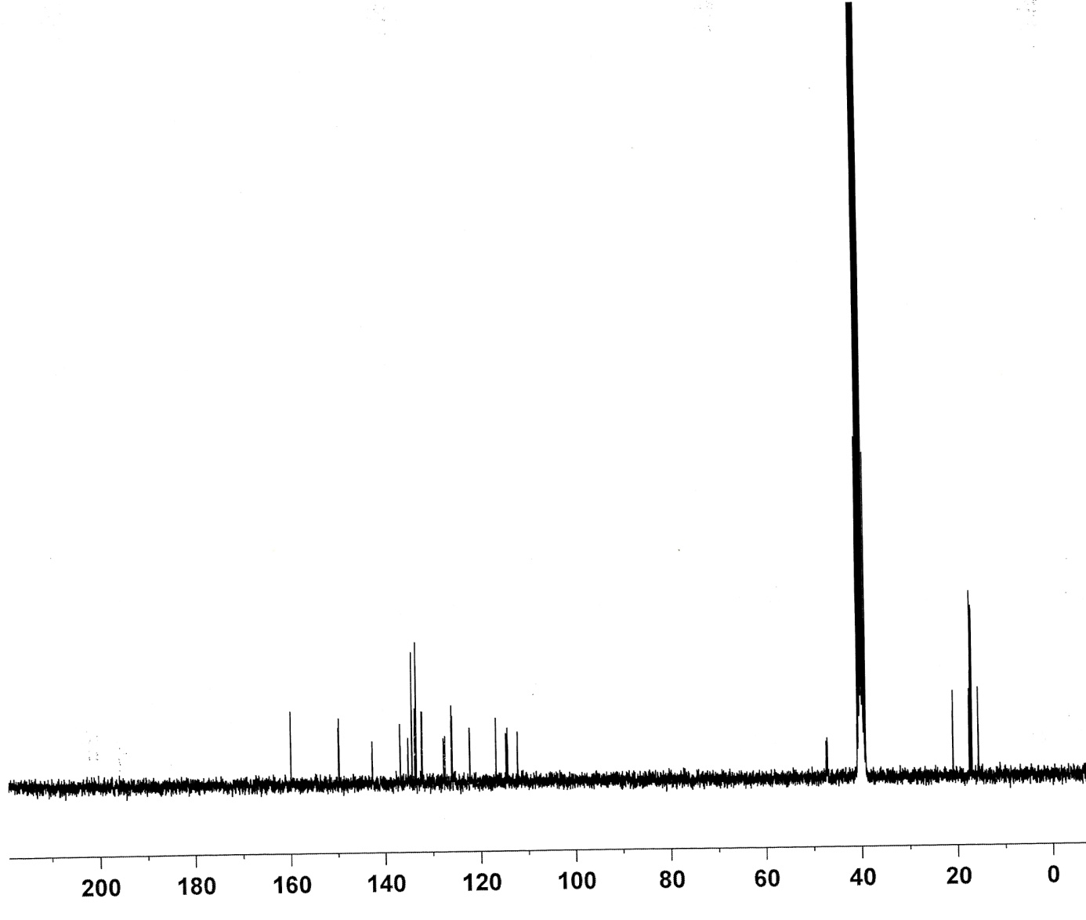

**Figure.** 13C-NMR spectrum of compound 1a

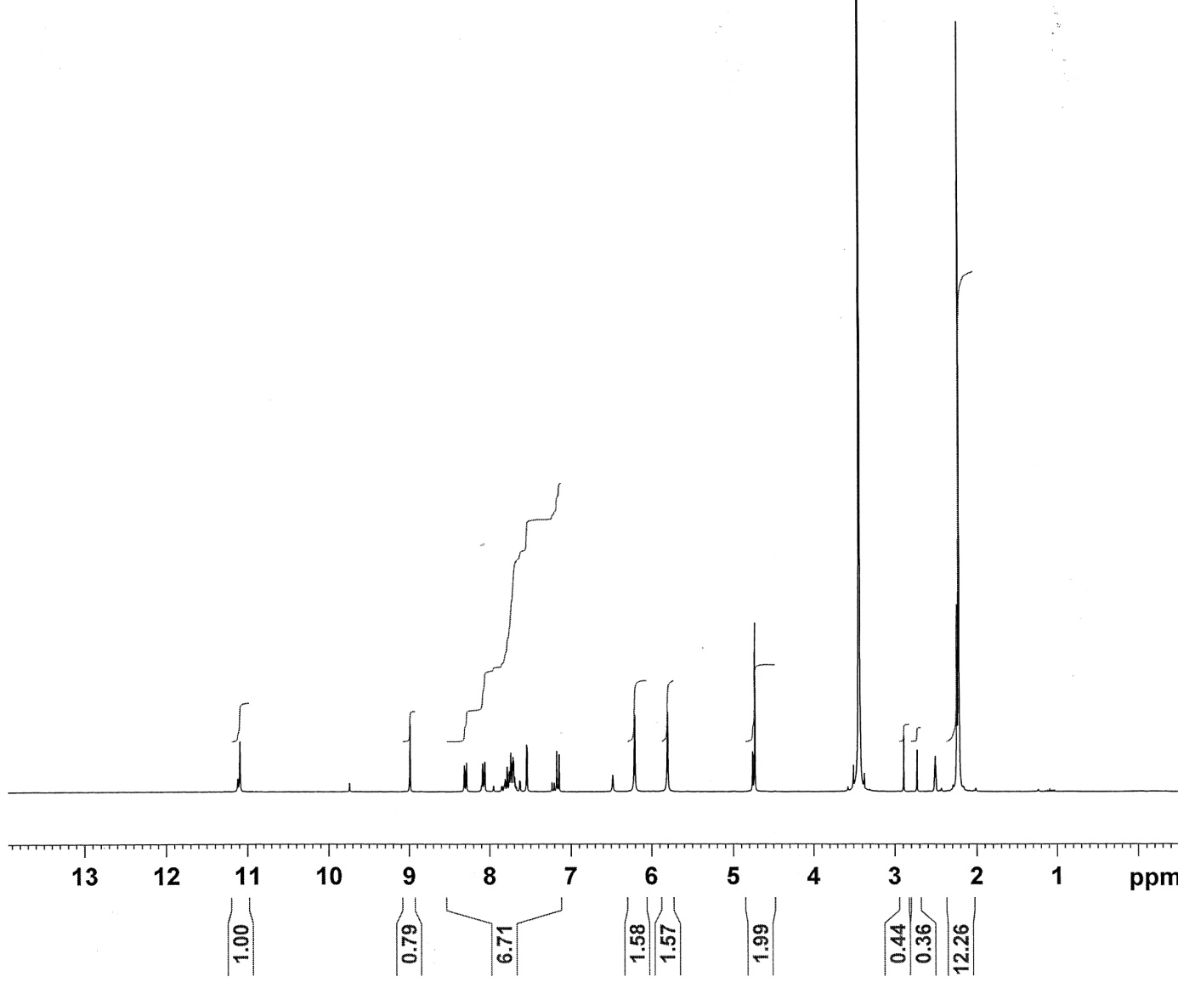

**Figure.** 1H-NMR spectrum of compound 2a

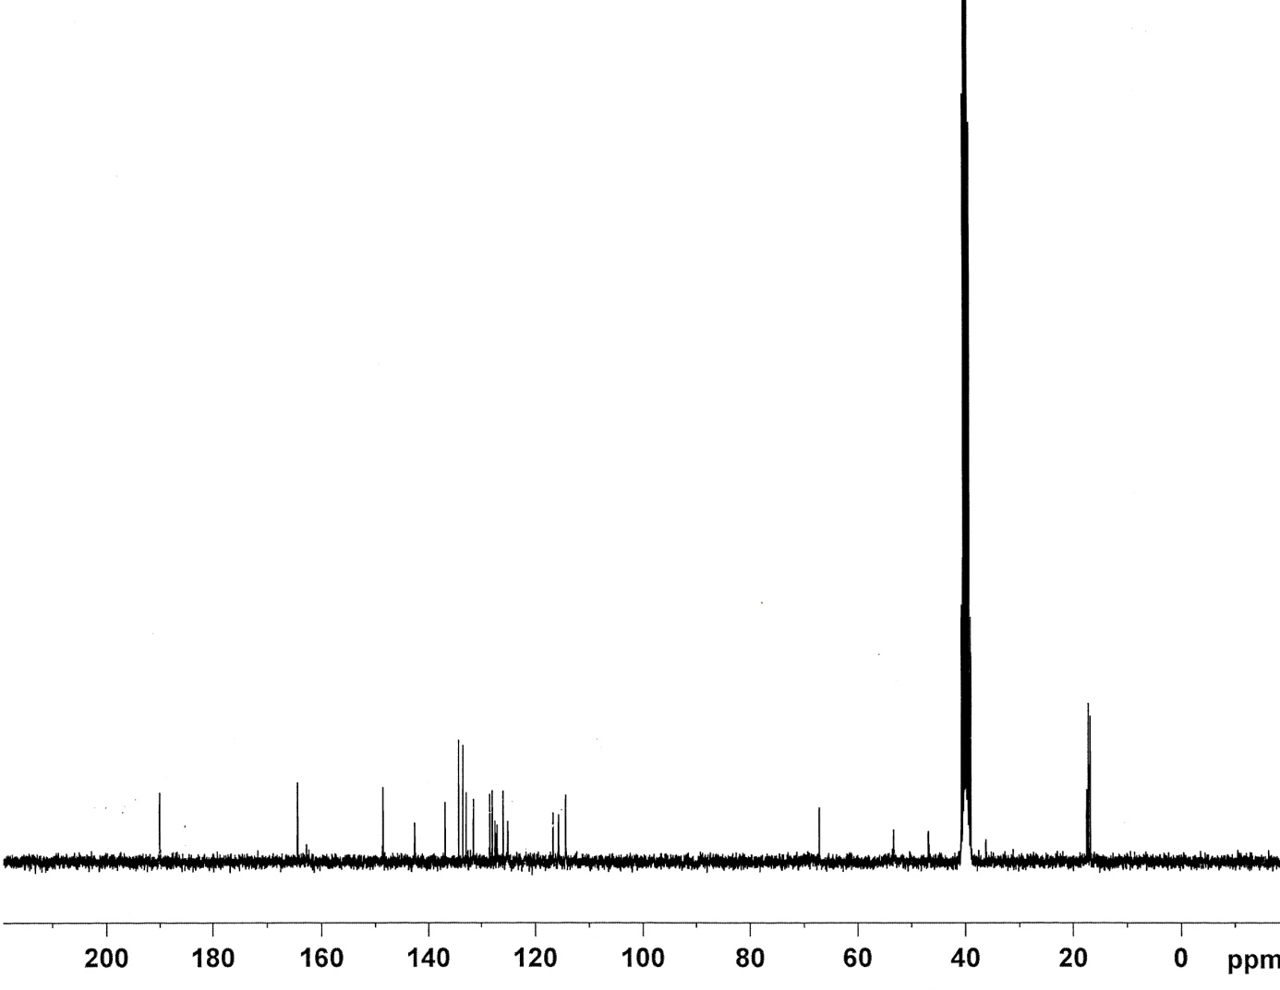

**Figure.** 13C-NMR spectrum of compound 2a

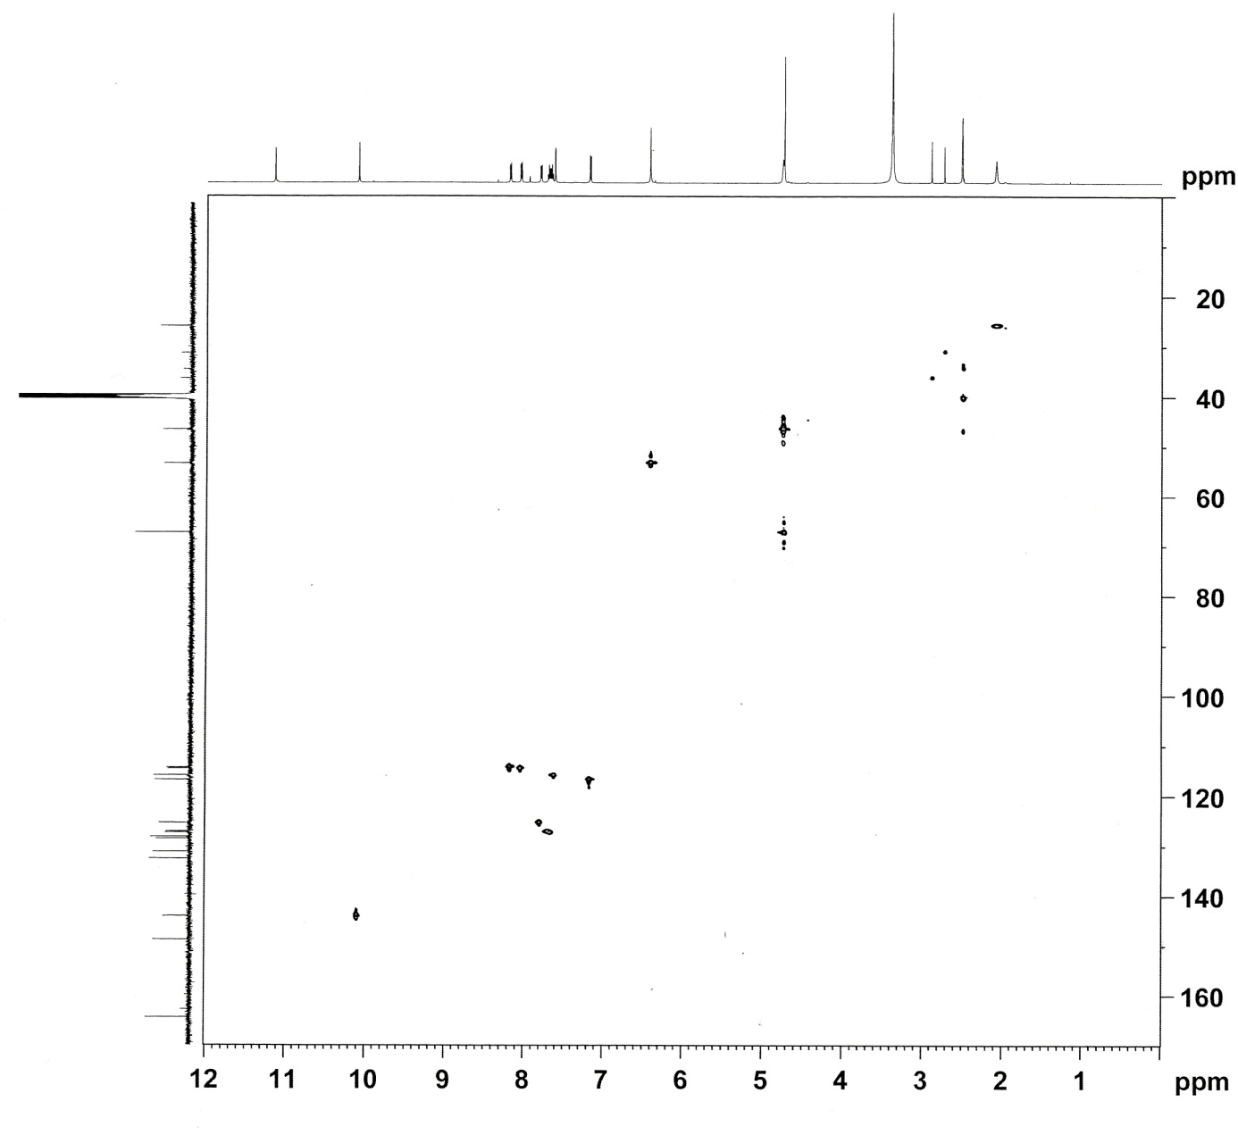

**Figure.** HSQC NMR spectrum of compound 2b

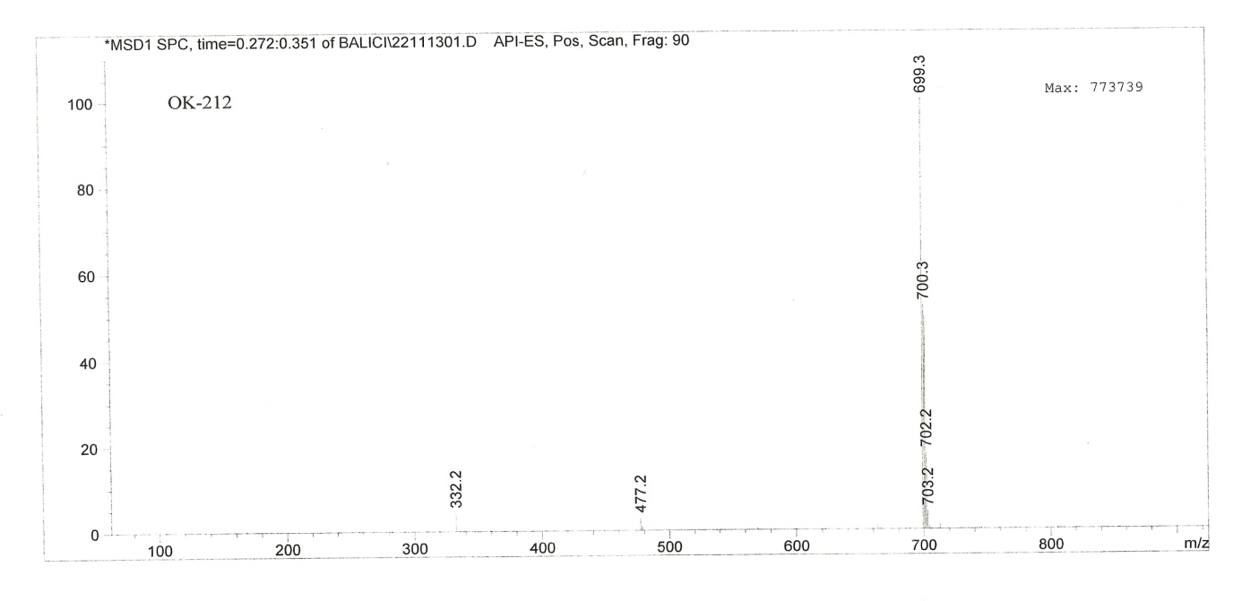

**Figure.** LC-MS spectrum of compound **1b**

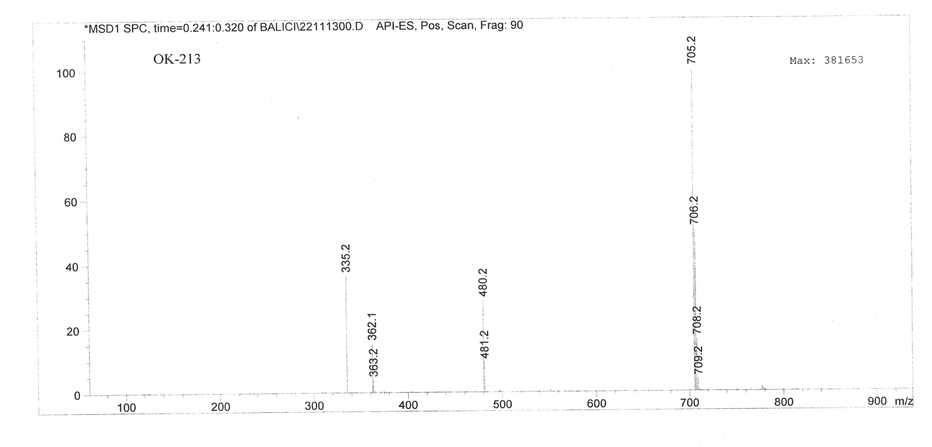

**Figure.** LC-MS spectrum of compound **2b**

**Figure.** CA Inhibition graph of compound 1

**Figure.** CA Inhibition graph of compound 2

**Figure.** CA Inhibition graph of compound 1a

**Figure.** CA Inhibition graph of compound 2a

**Figure.** CA Inhibition graph of compound 1b

**Figure.** CA Inhibition graph of compound 2b