List of Figures

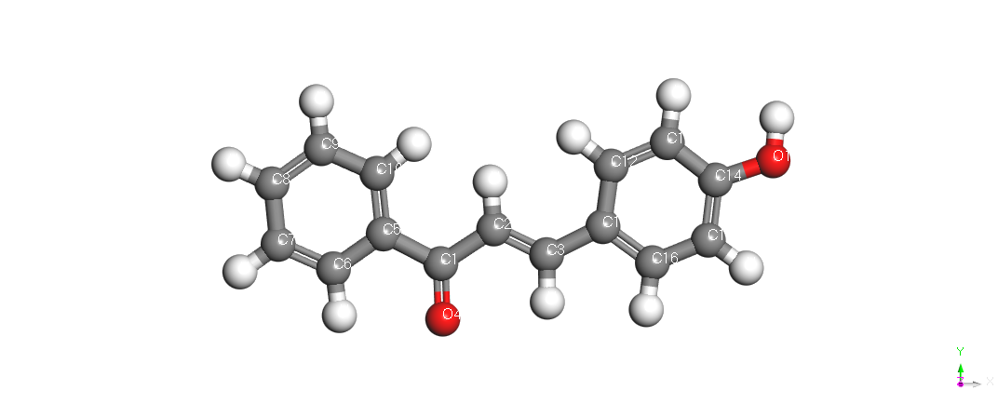 | 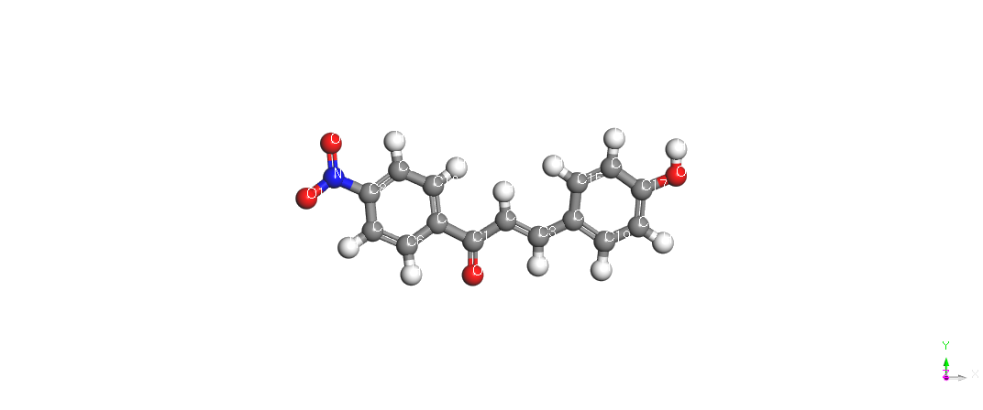
HPP | HNP
Figure 1: Optimized Chemical Structures of Chalcone derivatives

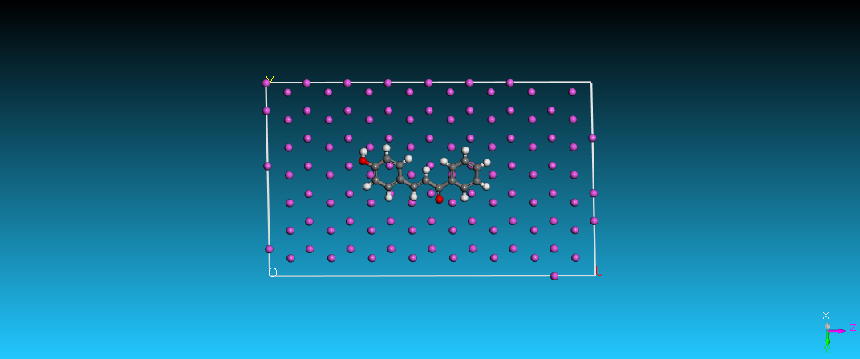  Top view of HPP | 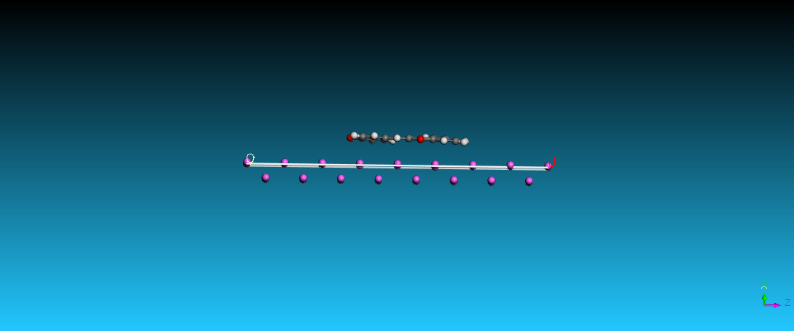  Side view of HPP
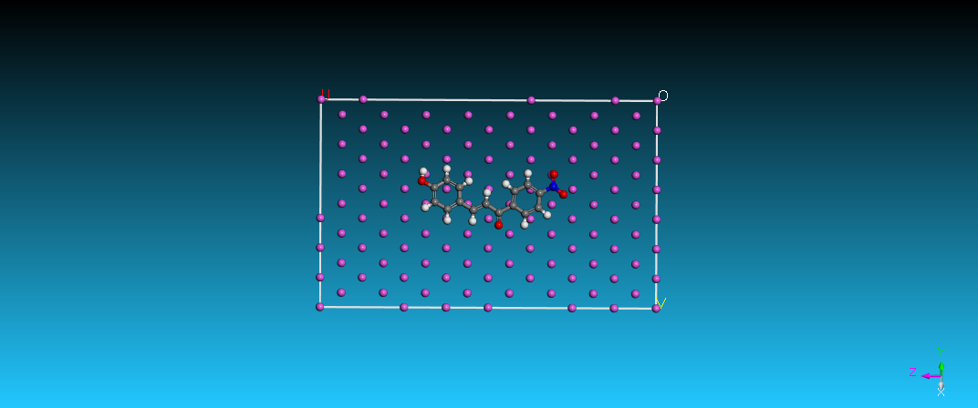  Top view of HNP | 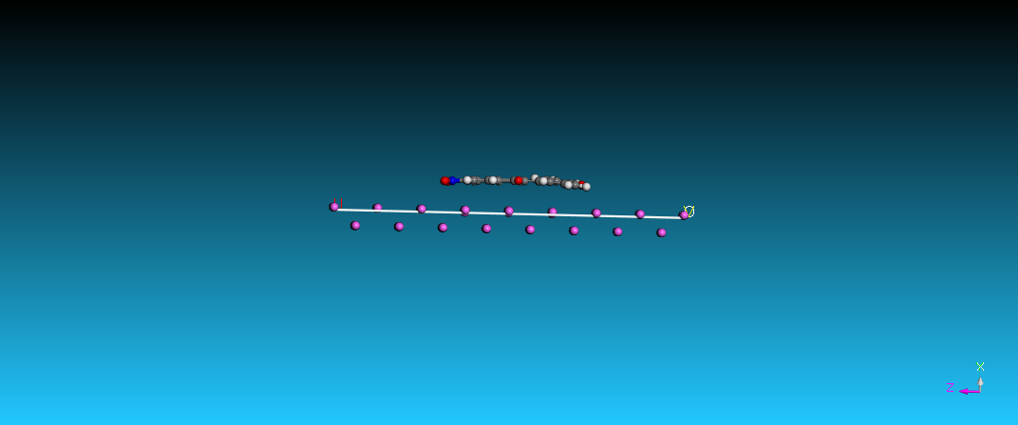  Side view of HNP

Figure 2: Al(1 1 0) Metal Surface configuration of adsorbed HPP and HNP molecules
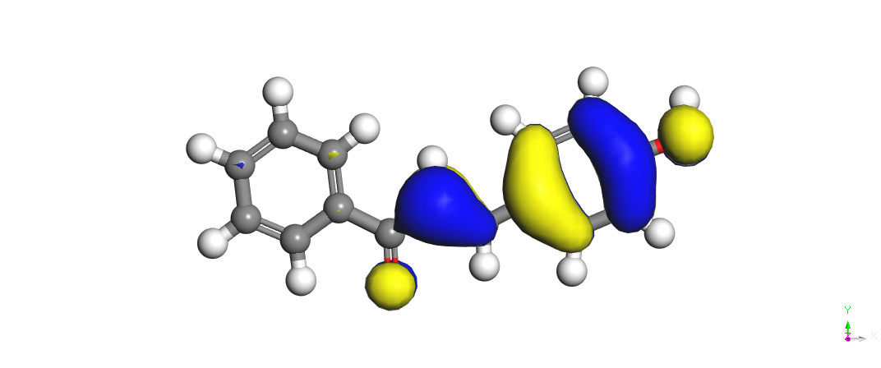  HPP  HOMO ORBITALS | 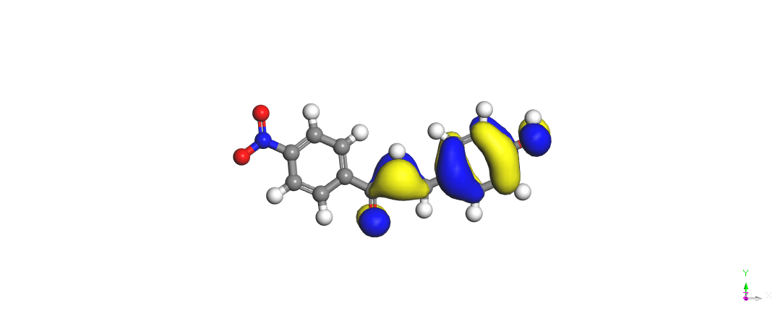  HNP
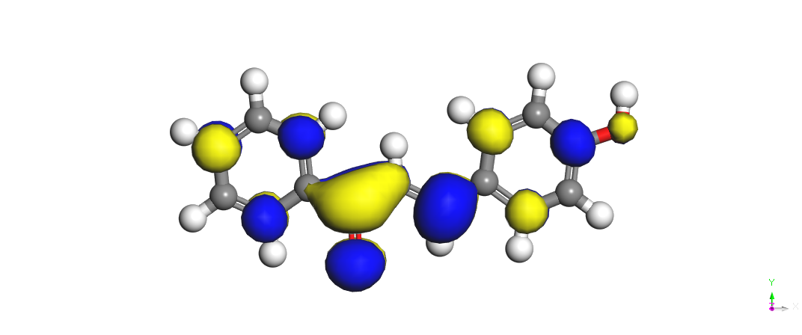  HPP  LUMO ORBITALS | 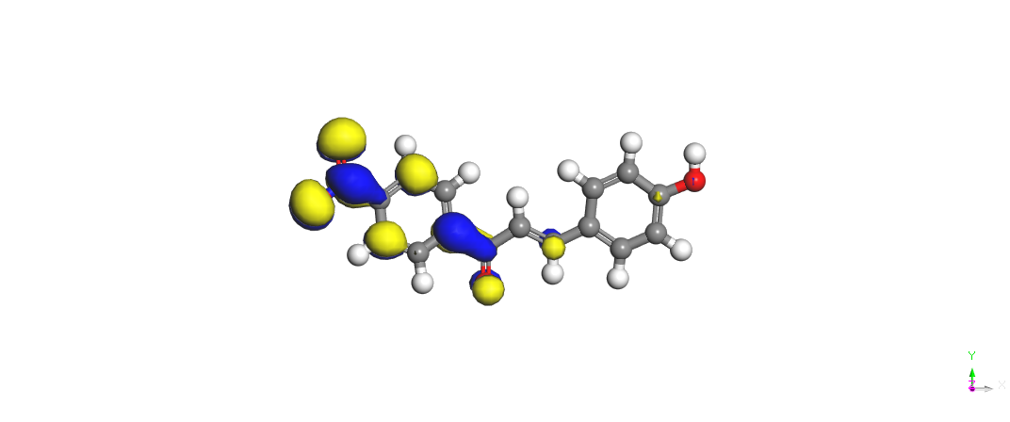  HNP
Figure 3: Orbitals of HOMO and LUMO of HPP and HNP molecules

Figure 4a: Second Fukui Function plot for HPP molecule

Figure 4b: Second Fukui Function plot for HNP molecule
List of Tables
Table 1: The two inhibitor’s interaction and binding energy on the Al(110) metal surface
Inhibitor | E_{Al-inhibitor} (kJ/mol) | E_{binding} (kJ/mol)
HPP | -87.953±0.0 | 55.473±0.0
HNP | -63.756±0.0 | 55.825±0.0
Table 2: Torsion angle, bond length (Å), and bond angle (°) of inhibitor molecules in their optimal neutral form.

Geometry parameters | HPP | HNP
Bond length
C₁-C₂ | 1.456 | 1.464
C₂-C₃ | 1.348 | 1.355
C₃-O₄ | 2.808 | 2.820
O₄-C₅ | 2.384 | 2.378
C₅-C₆ | 1.400 | 1.402
C₆-C₇ | 1.388 | 1.386
C₇-C₈ | 1.398 | 1.395
C₈-C₉ | 1.397 | 1.393
C₉-C₁₀ | 1.395 | 1.393
C₁₀-C₁₁ | 5.326 | -
C₁₁-C₁₂ | 1.401 | -
C₁₂-C₁₃ | 1.394 | -
C₁₃-C₁₄ | 1.399 | -
C₁₄-C₁₅ | 1.388 | 1.404
C₁₅-C₁₆ | 1.381 | 1.390
C₁₆-C₁₇ | 3.623 | 1.399
C₁₇- O₁₈ | - | 1.388
C₁₈-C₁₉ | - | 1.380
Bond angle
C₁-C₂-C₃ | 120.659 | 118.965
C₃-C₄-0₄ | 57.873 | 57.815
C₅-C₆-C₇ | 120.969 | 121.221
C₆-C₇-C₈ | 119.660 | 119.019
C₇-C₈-C₉ | 119.893 | 121.085
C₈-C₉-C₁₀ | 120.360 | 119.248
C₂-C₃-C₁₁ | 127.457 | -
C₃-C₁₁-C₁₂ | 124.387 | -
C₁₁-C₁₂-C₁₃ | 120.548 | -
C₁₂-C₁₃-C₁₄ | 119.451 | -
C₁₃-C₁₄-C₁₅ | 123.692 | -
C₁₄-C₁₅-C₁₆ | 118.953 | 120.656
C₁₆-C₁₇-O₂₀ | - | 123.498
C₁₇-C₁₈-C₁₉ | - | 118.856

Table 3: Calculated quantum chemical parameters of the studied molecules.
Properties | HPP | HNP
E_{HOMO} (eV) | -6.019 | -6.206
E_{LUMO} (eV) | -2.307 | -3.687
ΔE (eV) | -3.712 | -2.529
μ (Debye) | 2.110 | 2.310
IE (eV) | 6.019 | 6.206
AE V | 2.307 | 3.687
χ (eV) | 4.163 | 4.947
η (eV) | 1.856 | 1.259
σ (eV)⁻¹ | 0.539 | 0.794
ω (eV) | 4.669 | 9.719
ε (eV)⁻¹ | 0.214 | 0.103
∆E_{b-d} (eV) | -0.464 | -0.316
ΔN | 0.387 | 0.259
CosAr(A²) | 259.14 | 289.65
CosVol(A³) | 261.14 | 292.83
Table 4: Analysed Molecules Fukui indices
 |  | Nucleophilic Attack (f⁺) |  | Electrophilic Attack (f⁻)
Compound | Atom | Milliken | Hirshfield | Milliken | Hirshfield
HPP  HNP | O₄  O₁₃ | 0.146  0.208 | 0.133  0.191 | 0.073  0.166 | 0.066  0.160

Table 5: Second Fukui function percentage of the inhibitor Molecules
Molecule | F²⁺% | F²⁻%
HPP  HNP | 96.55  77.42 | 3.55  22.58

