About activity of binary Ti-V-O catalysts in isopropanol conversion reaction

N.I. Aghayeva*, S.A. Mammadkhanova

Azerbaijan State Oil and Industry University, Baku, Azadlig avenue 20, AZ1010, Azerbaijan

Abstract: The reactions of dehydrogenation and oxidative dehydrogenation of isopropyl alcohol on binary Ti-V-O catalysts have been studied. It is shown that the products of the reaction of isopropyl alcohol dehydrogenation on the studied catalysts are acetone, propylene. It is established that in the reaction of isopropyl alcohol dehydrogenation on titanium-vanadium oxide catalysts the samples with equimolar ratio of initial elements are active. In the reaction of oxidative dehydrogenation of isopropyl alcohol, except for the catalyst Ti-V=1-9, all other binary titanium-vanadium oxide catalysts have high activity in the reaction of propylene formation. It was found that on binary titan-vanadium oxide catalysts in the reaction of isopropyl alcohol dehydrogenation, the increase in surface acidity leads to an increase in acetone yield and a decrease in propylene yield. In the reaction of oxidative dehydrogenation of isopropyl alcohol, the change of surface acidity does not lead to a change in the yields of reaction products.

Keywords: isopropanol; dehydrogenation; oxidative dehydrogenation; vanadium oxide; isomerization

1. Introduction
In recent years, in connection with the transition to the use of environmentally friendly technologies and the decrease in the negative impact of industry on the environment, there has been an increase in interest in the use of renewable raw materials in the chemical industry, such as ethanol, isopropanol, butanol^{1–3}. Isopropanol is one of the important raw materials for the chemical industry, for example, it is used in the production of acetone, ethers and esters, fuels, etc.⁴⁻⁶. Previously, we have shown that isopropanol on binary vanadium-containing catalysts is converted at a high rate into such products as propylene and acetone^{7, 8}. One of the properties of solid catalysts that affect its activity is the acidic properties of their surface^{9–11}. To characterize the acidic properties of the surface of binary titanium–vanadium oxide catalysts under conditions close to catalysis, we used the isomerization reaction of butene-1 to butenes-2, which is convenient due to its simplicity^{12, 13}. In this regard, this work is devoted to the study of the effect of the composition of the catalyst surface acidity on the activity of binary titanium-vanadium oxide catalysts in the reactions of dehydrogenation and oxidative dehydrogenation and isopropyl alcohol.

2. Experimental

Binary titanium-vanadium oxide catalysts of various compositions were prepared by co-precipitation from aqueous solutions of ammonium, titanium tetrachloride and ammonium metavanadate. The resulting mixtures were evaporated at 95-100°C, then the precipitates formed were dried at 100-120°C and then decomposed until complete release of nitrogen oxides at a temperature of about 250°C. The obtained solid masses were calcined at a temperature of 700°C for 10 hours. Thus, 9 catalysts were synthesized with an atomic ratio of elements from Ti:V=1:9 to Ti:V=9:1. The activity of the synthesized catalysts was studied in a flow-through unit with a tubular reactor in the temperature range of 150–450°C. The volumetric feed rate of the raw material was 1200 h-1. The ratio of initial reagents was isopropyl alcohol: air: H2O = 1:5:4. The yields of isopropyl alcohol conversion products, as well as the amount of unreacted alcohol, were determined on a chromatograph with a flame ionization detector and a 2-m column filled with a specially treated Polysorb-1 sorbent. The amount of carbon dioxide formed was determined on a chromatograph with a 6-meter column filled with a Celite sorbent coated with vaseline oil.

3. Results and Discussion

The study of the activity of the studied samples showed that the reaction products of the conversion of isopropyl alcohol in the absence of oxygen on the Ti-V-O catalytic system are acetone, propylene and, at high temperatures, an insignificant amount of carbon dioxide and decomposition products. The dependence of the activity of the Ti-V=1-9 catalyst in the isopropyl alcohol conversion reaction on temperature is shown in Figure 1. As can be seen, the isopropyl alcohol conversion reaction on this catalyst begins at 150°C with the formation of 3.4% acetone and 4.5% propylene. As the reaction temperature increases, the yields of acetone and propylene pass through a maximum at a temperature of 300°C. At this temperature, the highest yields of acetone and propylene are observed, which are respectively equal to 23.8% and 40.5%. In addition to acetone and propylene, the formation of carbon dioxide is also observed on the studied sample starting from 250°C. The yield of carbon dioxide increases with an increase in the reaction temperature over the entire temperature range studied. The maximum yield of carbon dioxide is observed at 400°C and is 7.1%. Figure 1 shows that the conversion of isopropyl alcohol on the Ti-V=1-9 catalyst at 400°C is 69.9%.

Figure 1. Effect of temperature on the yields of products of ethanol dehydrogenation reaction on Ti-V=1-9 catalyst.
We also studied the influence of catalyst composition on their activity in the reaction of isopropyl alcohol conversion in the absence of oxygen. Figure 2 shows the dependence of yields of products of isopropyl alcohol conversion reaction on the atomic ratio of titanium to vanadium in the composition of Ti-V-O catalysts at a temperature of 250 °C. It can be seen that with increasing titanium content in the catalyst composition, the yields of acetone, propylene and isopropyl alcohol conversion pass through a maximum at the sample Ti-V=5-5. At this catalyst, the yields of acetone and propylene are 17% and 51%, and the conversion of isopropyl alcohol is 68%. The formation of carbon dioxide at this temperature is not observed on the studied samples.

Fig. 2. Dependence of activity of titanium-vanadium oxide catalysts in isopropyl alcohol dehydrogenation reaction on their composition. T=250°C.

In contrast to low reaction temperatures, at higher temperatures, the conversion of isopropyl alcohol on binary titanium-vanadium oxide catalysts produces carbon dioxide in addition to acetone and propylene. Figure 3 shows the dependence of yields of isopropyl alcohol conversion reaction products on the atomic ratio of titanium to vanadium in the composition of Ti-V-O catalysts at a temperature of 300 °C. It can be seen that with increasing titanium content in the catalyst composition the acetone yield tends to decrease, while the propylene yield increases. The exception is the sample Ti-V=5-5, which shows the highest propylene yield and isopropyl alcohol conversion.
The yield of the product of deep oxidation of isopropyl alcohol carbon dioxide at 300°C on the studied catalysts does not exceed 2% and with the increase of titanium content in the catalyst decreases and on samples rich in titanium carbon dioxide is practically not formed.

Fig. 3. Dependence of activity of titanium-vanadium oxide catalysts in isopropyl alcohol dehydrogenation reaction on their composition. T=300°C
Summarizing the above, we can say that the main products of isopropyl alcohol conversion in the absence of oxygen on titanium-vanadium oxide catalysts are acetone and propylene. The catalysts with equimolar ratio of initial elements are active in the reaction of formation of these products.
In the transformation of isopropyl alcohol in the presence of oxygen on titanium-vanadium oxide catalysts, the reaction products are acetone, propylene carbon dioxide and at high temperatures destructive decomposition products.
Figure 4 shows the results of the study of isopropyl alcohol oxidation reaction on Ti-V=1:9 catalyst. As can be seen from the table, the oxidation of isopropyl alcohol begins at a temperature of 150°C. At this temperature, 37.4% acetone and 4.5% propylene are formed. As the reaction temperature increases, the yield of acetone increases to 39.1% with a selectivity of 56.3% at 200°C, after which it begins to decrease and at 400°C is already 4.5%.
As the reaction temperature increases, the propylene yield also passes through a maximum. The highest propylene yield is observed at 250°C and is 44.4%. In addition to these products, the formation of carbon dioxide is also observed in the studied sample. The formation of carbon dioxide starts from 200°C and with increasing reaction temperature its yield increases in the whole temperature range studied. The maximum yield of carbon dioxide is 15.1%. As can be seen from the figure, the conversion of isopropyl alcohol at 400°C reaches 79.9%

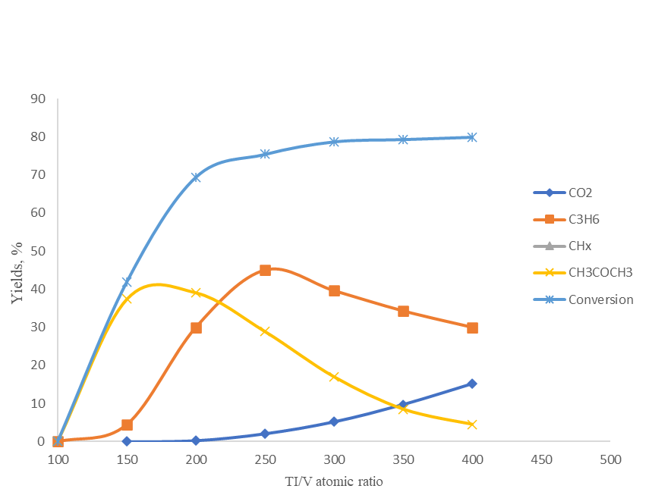
Figure 4. Effect of temperature on the yields of products of the reaction of isopropyl alcohol oxidation on the catalyst Ti-V=1-9.
Comparison of the activity of all titanium-vanadium oxide catalysts showed that their activity depends on the atomic ratio of titanium to vanadium in the composition of the binary catalyst. Figure 5 shows the dependence of yields of products of the reaction of isopropyl alcohol oxidation on the atomic ratio of titanium to vanadium in the composition of Ti-V-O catalysts at a temperature of 200°C. It can be seen that with increasing titanium content in the catalyst composition the acetone yield slightly decreases to 20% and then passes through the maximum (37.4) on the sample Ti-V=7-3. The propylene yield with increasing titanium content in the catalyst composition passes through the maximum at the sample Ti-V=3-7 and then starting from the sample Ti-V=6-4 increases up to 45% at the sample Ti-V=9-1. The nature of change in isopropyl alcohol conversion from catalyst composition is similar to the change in acetone yield. On this catalytic system at 200°C the conversion of isopropyl alcohol reaches 74.9%. The formation of carbon dioxide is not observed on the studied samples.

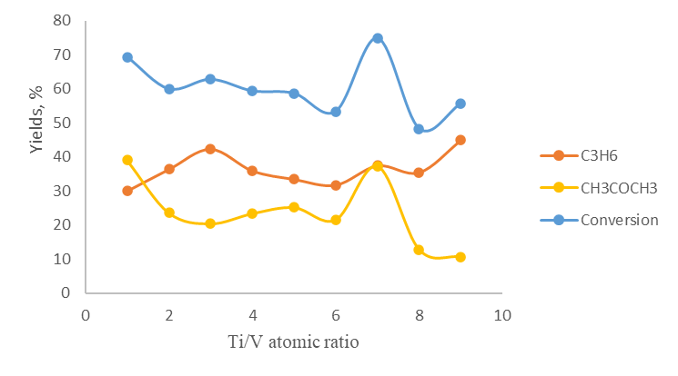
Fig. 5. Dependence of activity of titanium-vanadium oxide catalysts in the oxidation reaction of isopropyl alcohol on their composition. T=200°C
A different character of the dependence of the activity of catalysts in the oxidation reaction of isopropyl alcohol is observed at temperatures above 300°C. Figure 6 shows the dependence of yields of products of the reaction of isopropyl alcohol oxidation on titanium-vanadium oxide catalysts on their composition at 350°С. At 350°C, in addition to acetone and propylene, the formation of carbon dioxide and products of destructive decomposition of isopropyl alcohol are observed in the reaction products. It can be seen that the yields of acetone and carbon dioxide from the atomic ratio of titanium to vanadium at 350°C depend almost little on the composition of the catalyst. From the data shown in Figure 6, it can be seen that, except for the catalyst Ti-V=1-9, all other samples have high activity in the reaction of propylene formation. The maximum conversion of isopropyl alcohol at 350°C on the studied catalysts reaches 92.3%.

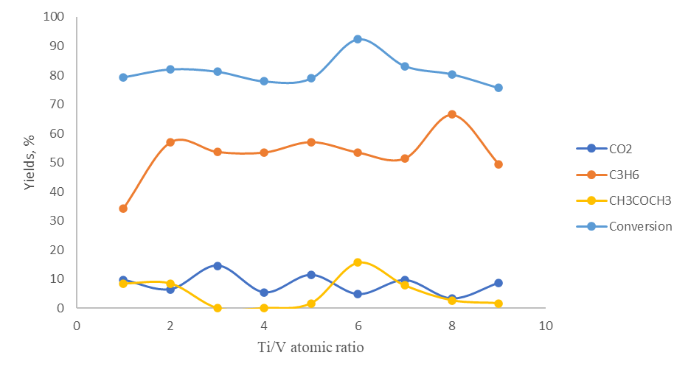
Fig. 6 Dependence of activity of titanium-vanadium oxide catalysts in the oxidation reaction of isopropyl alcohol on their composition. T=350°C

To evaluate the influence of surface acidity, we compared the activities of titanium-vanadium oxide catalysts in isopropyl alcohol conversion reactions and in the reaction of butene-1 isomerization into trans and cis butenes-2. Fig. 7 shows the dependence of the activity of titanium-vanadium oxide catalysts in the reaction of isopropyl alcohol conversion in the absence of oxygen on the degree of isomerization of butene-1 into butenes-2. As can be seen from Fig. 7 with increasing activity of titanium-vanadium oxide catalysts in the reaction of isomerization of butene-1 to butenes-2 (increasing the acidity of the catalyst surface) the yields of acetone, propylene and total conversion of isopropyl alcohol pass through the maximum. This suggests that increasing the degree of isomerization of butene-1 to butenes-2 (surface acidity) leads to an increase in the reaction rate of conversion of isopropyl alcohol to acetone propylene. This suggests that a certain value of surface acidity is necessary for a high rate of conversion of isopropyl alcohol into acetone and propylene on titanium-vanadium oxide catalysts.

Fig. 7. Activity dependence of titanium-vanadium oxide catalysts in the reaction of isopropyl alcohol dehydrogenation on the degree of isomerization of butene-1 to butene-2. T=300°C

Dependences of activity of titanium-vanadium oxide catalysts in the reaction of isopropyl alcohol conversion in the presence of oxygen on the degree of isomerization of butene-1 to butenes-2 are shown in Fig. 8. Fig. 8 shows that with increasing activity of titanium-vanadium oxide catalysts in the reaction of isomerization of butene-1 to butenes-2 the yields of acetone, propylene and total conversion of isopropyl alcohol practically do not change This indicates the absence of influence of acid centers on the reaction of oxidation of isopropyl alcohol on titanium-vanadium oxide catalysts.

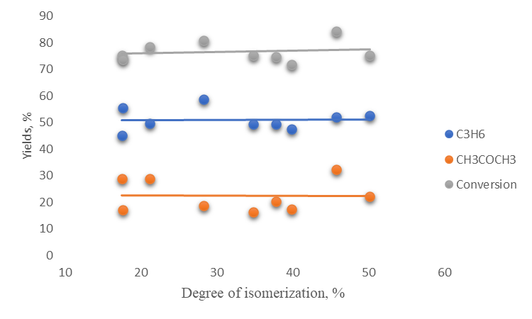
Fig. 8. Activity dependence of titanium-vanadium oxide catalysts in the oxidative dehydrogenation reaction of isopropyl alcohol on the degree of isomerization of butene-1 to butene-2. T=300°C

4. Conclusion

The following conclusions can be drawn on the basis of the conducted studies:
1. Acetone and propylene are the main products of the reaction of isopropyl alcohol dehydrogenation on titanium-vanadium oxide catalysts. The catalysts with equimolar ratio of initial elements are active in the reaction of formation of these products;
2. In the reaction of oxidative dehydrogenation of isopropyl alcohol, except for the catalyst Ti-V=1-9, all other binary titanium-vanadium oxide catalysts are highly active in the reaction of propylene formation.
3. On binary titan-vanadium oxide catalysts in the reaction of isopropyl alcohol dehydrogenation, the increase in surface acidity leads to an increase in acetone yield and a decrease in propylene yield.
4. In the reaction of oxidative dehydrogenation of isopropyl alcohol, the change in surface acidity does not lead to a change in product yields.

References

- Chaowat Autthanit, Piyasan Praserthdam, Bunjerd Jongsomjit. Oxidative and non-oxidative dehydrogenation of ethanol to acetaldehyde over different VOx/SBA-15 catalysts. Journal of Environmental Chemical Engineering, 2018, Volume 6, Issue 5, Pages 6516-6529
- Deepak Kulkarni, Israel E. Wachs. Isopropanol oxidation by pure metal oxide catalysts: number of active surface sites and turnover frequencies. Applied Catalysis A: General, 2002, V. 237, p. 121–137
- Xueya Dai, Fan Li, Di Wang, Miao Guo, Yunli Bai, Wei Qi. An oxygen-assisted conversion of butanol to value-added products on nanocarbon catalysts: tuning product selectivity via nitrogen doping. Catalysis Science & Technology, 2023, V. 13, I. 9, p. 2855-2863
- Wei Zhou, Zirui Gao, Genghuang Wu, Junfeng Rong, Ding Ma. Direct conversion of isopropanol to C6+ branched compounds as high-octane gasoline blendstocks. Green Chemistry, 2022, V. 24, I. 13, p. 5083-5087
- Hani Nasser Abdelhamid, Mohamed N. Goda, Abd El-Aziz A. Said, Selective dehydrogenation of isopropanol on carbonized metal–organic frameworks. Nano-Structures & Nano-Objects, 2020, V. 24, 100605
- Sin Tee Tan, Akrajas Ali Umar, Muhamad Mat Salleh. Synthesis of defect-rich, (001) faceted-ZnO nanorod on a FTO substrate as efficient photocatalysts for dehydrogenation of isopropanol to acetone. Journal of Physics and Chemistry of Solids, 2016, V. 93, p. 73-78
- Dushdurova N.İ., Mammadkhanova S.A. Modeling of Dehydrogenation and Oxidative Dehydrogenation of Isopropyl Alcohol Over Ti-V-O Catalyst. 11th World Conference “Intelligent System for Industrial Automation” (WCIS-2020), AİSCб. 2021, V. 1323б p.596-603
- Aghayeva N.İ., Mammadkhanova S.A. Activity of MO-V-O catalysts in reactions of isopropyl alcohol conversion. Processes of petrochemistry and oil refining, 2023, Vol. 24, No. 2, pp. 371-378
- B. Imelik, C. Naccache, G. Coudurier, Y. Ben Taarit, J.C. Vedrine, Catalysis by acids and bases. Studies in Surface Science and Catalysis, 1985, 20, p. 1–445
- G. Busca, B. Onida, D. Tichit, A. Vaccari, Catalysis by acids and bases: new materials and surface studies: 6th world congress on catalysis by acids and bases. Catal. Today, 2010, 152, p. 1–118
- K.Aghayeva, V.Baghiyev. Dependence of the activity of copper-tungsten oxide catalysts in the ethanol oxidation reaction on their acidic properties. Mediterranean Journal of Chemistry 2022, 12(1), 67-70
- Jacques C. Védrine. Acid–base characterization of heterogeneous catalysts: an up-to-date overview, Research on Chemical Intermediates, 2015, v.41, p. 9387–9423.
- Michel Guisnet, Ludovic Pinard. Characterization of acid-base catalysts through model reactions. Catalysis Reviews, 2018, v.60, i.3, p. 337-436.

