**SUPPLEMENTARY DATA**

*Materials and Instrumentation*

The following substances were purchased from Merck: 1, 10-phenanthroline monohydrate (phen), 2, 2'-bipyridine (bpy), 2-(1H-Pyrrol-2-yl)-1H-indole (tbz) CT-DNA (Calf thymus DNA) was bought from Aldrich, and stored at 20°C. All studies used 18.2 mX ultrapure Milli-Q water. All additional chemicals and solvents came from already-established local sources. Prior to usage, all solvents underwent normal processes for purification [1]. By dissolving calculated amounts of metal complexes in DMSO and adjusting the concentrations with the right buffer, a stock solution of metal complexes was created.

A PerkinElmer 1605 Fourier transform I.R. spectrometer was utilised to record the I.R. spectra on KBr discs. Dimethyl-d6 sulfoxide (DMSO-d6) was used as the solvent and tetra methyl silane served as the internal standard to record the 1H NMR spectra on a Bruker 400-MHz spectrometer at room temperature. The UV-VISIBLE spectra were captured with a Shimadzu UV-2600 spectrophotometer. The luminescence spectrum data were recorded using a Spectrofluorometer (serial number of the Cary Eclipse instrument, MY12400004) to assess the binding constant.

*Electronic absorption studies*

DNA binding studies were conducted for the purpose of studying DNA-binding interactions. Double distilled water was used to prepare each solution. In Tris buffer (5mM Tris-HCL, 50 mM NaCl, pH 7.1) investigations involving the interaction of Ru(II) complex with CT-DNA were carried out. After preparation, the stock solution of CT-DNA was kept at 4º⸰ C in the dark and used within three days. Ru (II) complex stock solutions in DMSO were prepared. By treating a fixed concentration of complex (10μM) with increments (0-120μM) of the protein free DNA stock solution (0.617×10−4 M) [2], the absorption experiment for steps 1-3 in the buffer was carried out. Solutions were given 5 min to incubate before recording the complex-DNA mixture’s absorption spectra. After each measurement, UV-vis spectra were taken. After each addition of DNA solution and the intrinsic binding constant (Kb) calculated by using Equation (1) [3].

[DNA]∕(𝜀a − 𝜀f) = [DNA]∕(𝜀b − 𝜀f) + 1∕Kb(𝜀b–𝜀f) ….. (1)

εa, εb and εf stands for the apparent absorption coefficient Aobs/[complex], the extinction coefficient for the complex in its fully bound form, and, the extinction coefficient for the free complex, respectively. [DNA] is the concentration of DNA. The intrinsic binding constant is represented Kb, a graph plotted between [DNA] / (εa- εf) and [DNA]. Kb is derived using the slope-to-intercept ratio.

*Fluorescence Emission*

By increasing the concentration of DNA until the complex concentration was fixed, measurements of the Ru(II) complexes’ emission intensities were made. The spectra were acquired between 540nm and 760nm. Equation 2 was used to calculate the binding constant [4].

C b = Ct[(F − F0) ∕ (Fmax − F0)] ….. (2)

Where F0 is the intensity in the absence of DNA, F is the observed fluorescence emission intensity at a specific DNA concentration, and Fmax is the intensity of the maximum complex bound to DNA. Ct stands for the total complex concentration.

r∕Cf = Kb(1 – nr) …..(3)

A graph between r/Cf versus r was used to derive the binding constant using the Scatchard equation 3, where r is the Cb/[DNA] ratio and Cf is the concentration of the free complex. The excitation wavelength for the fluorescence titration investigations was fixed at 425 nm, and the spectra were acquired by altering the pH of the solutions.

*Quenching studies*

In this luminescent experiment, quenching investigations with [Fe(CN)6]-4 were expanded to better understand how these complexes bind to DNA.Fluorescence quenching studies with [Fe(CN)6]-4provide some additional insight into the complexes binding to DNA. To the 3mL of the complex, the quencher(0.01M) is added in Tris HCl buffer in the presence of DNA and the absence of DNA (1:20 and 1:200, i.e., in excess) was used to execute emission quenching investigations at room temperature. Sterne Volmer equation 4 was applied to determine the quenching constant Ksv. Where Q is the concentration of the quencher, I0 and I are the fluorescence intensities in the presence and absence of the quencher, respectively, and Ksv is a linear Sterne Volmer quenching constant that may be calculated from the slope [5]

I0/I=1+KSV [Q] …..(4)

*Viscosity studies*

Viscosity investigations were done by using an Ostwald viscometer which was submerged in a thermostat bath in order to maintain a consistent temperature of 30±0.10C using BPE buffer (6 mM Na2HPO4, 2 mM NaH2PO4, 1Mm Na2EDTA, pH=7.0). To reduce the complexes brought on by DNA flexibility, the 200 base pair average length CT-DNA samples were processed by sonication [6]. An average flow time was computed after each sample was repeated three times and the flow time was recorded using a digital stopwatch. The estimated information was displayed as (η/η0)1/3 vs [Ru(II)/[DNA] concentration [7], where η is the viscosity of DNA in the presence of the complex and η0is the viscosity of DNA alone. Viscosity values can be calculated from the observed ‘t’ using the flow time of DNA-containing solutions corrected for the flow time of the buffer alone (t0)[8, 9].

*References*

1. D. Perrin, W.L.F. Annarego, D.R. Perrin. Purification of Laboratory Chemicals, 2nd Edn, Pergamon Press, New York, NY (1980).
2. E.A. Steck, A.R. Day. J. Am. Chem. Soc., 65, 452 (1943). <https://doi.org/10.1021/ja01243a043>
3. A. Wolfe, G.H. Shimer, T. Meehan. Biochem., 26, 6392 (1987).   
   https://doi.org/10.1021/bi00394a013
4. J.D. McGhee, P.H. von Hippel. J. Mol. Biol., 86, 469 (1974). <https://doi.org/10.1016/0022-2836(74)90031-X>
5. Lakowicz, J. R.; Weber, G. Quenching of Fluorescence by Oxygen. A Probe for Structural Fluctuations in Macromolecules. Biochemistry. 1973, 12, 4161–4170. <https://doi.org/10.1021/bi00745a020>
6. J.B. Chaires, N. Dattagupta, D.M. Crothers. Biochem., 21, 3927 (1982). 1982 <https://doi.org/10.1021/bi00260a004>
7. S. Satyanarayana, J.C. Dabrowiak, J.B. Chaires. Biochem., 32, 2573 (1993).
8. Satyanarayana S, Dabrowiak JC, Chaires JB (1992) Neither. DELTA.- nor.LAMBDA.-tris(phenanthroline)ruthenium(II) binds to DNA by classical intercalation. Biochemistry 31:9319–9324. https:// doi. org/ 10. 1021/ bi001 54a001
9. Long EC, Barton JK (1990) On demonstrating DNA intercalation. Acc Chem Res 23(9):271–273. https:// doi. org/ 10. 1021/ ar00177a001

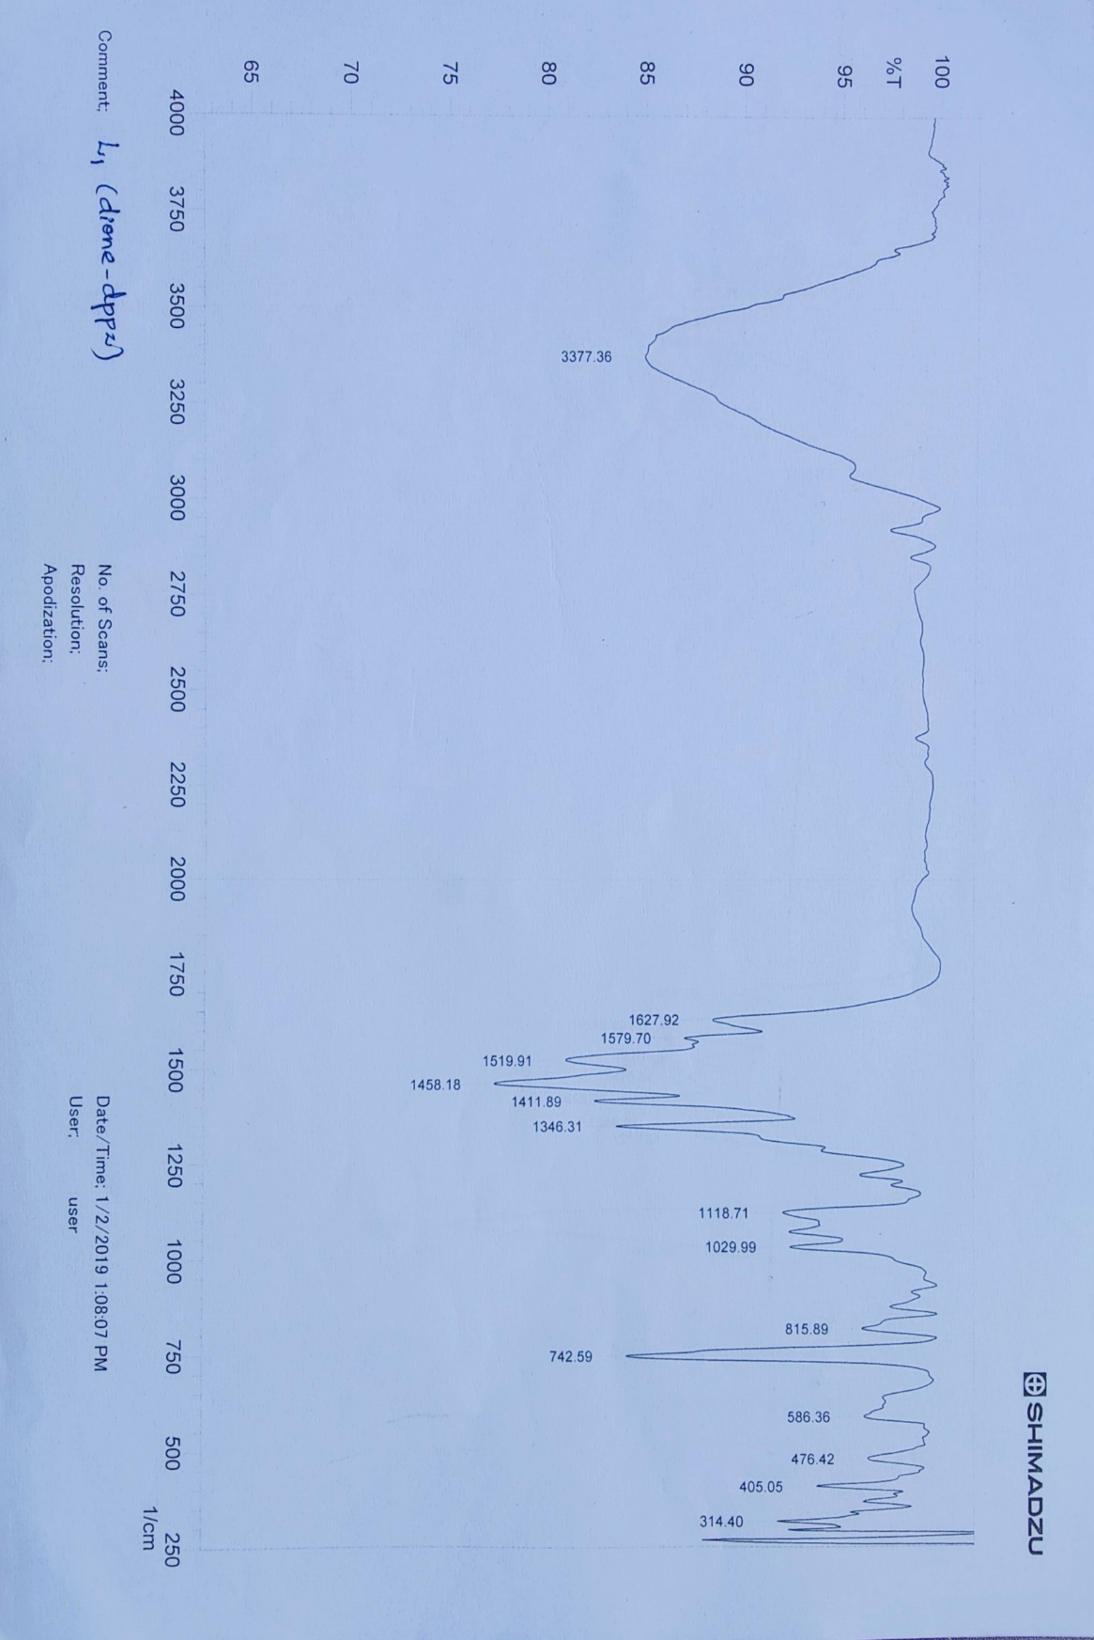

**Figure S1**. IR Spectra of Intercalator, Ligand qpd.

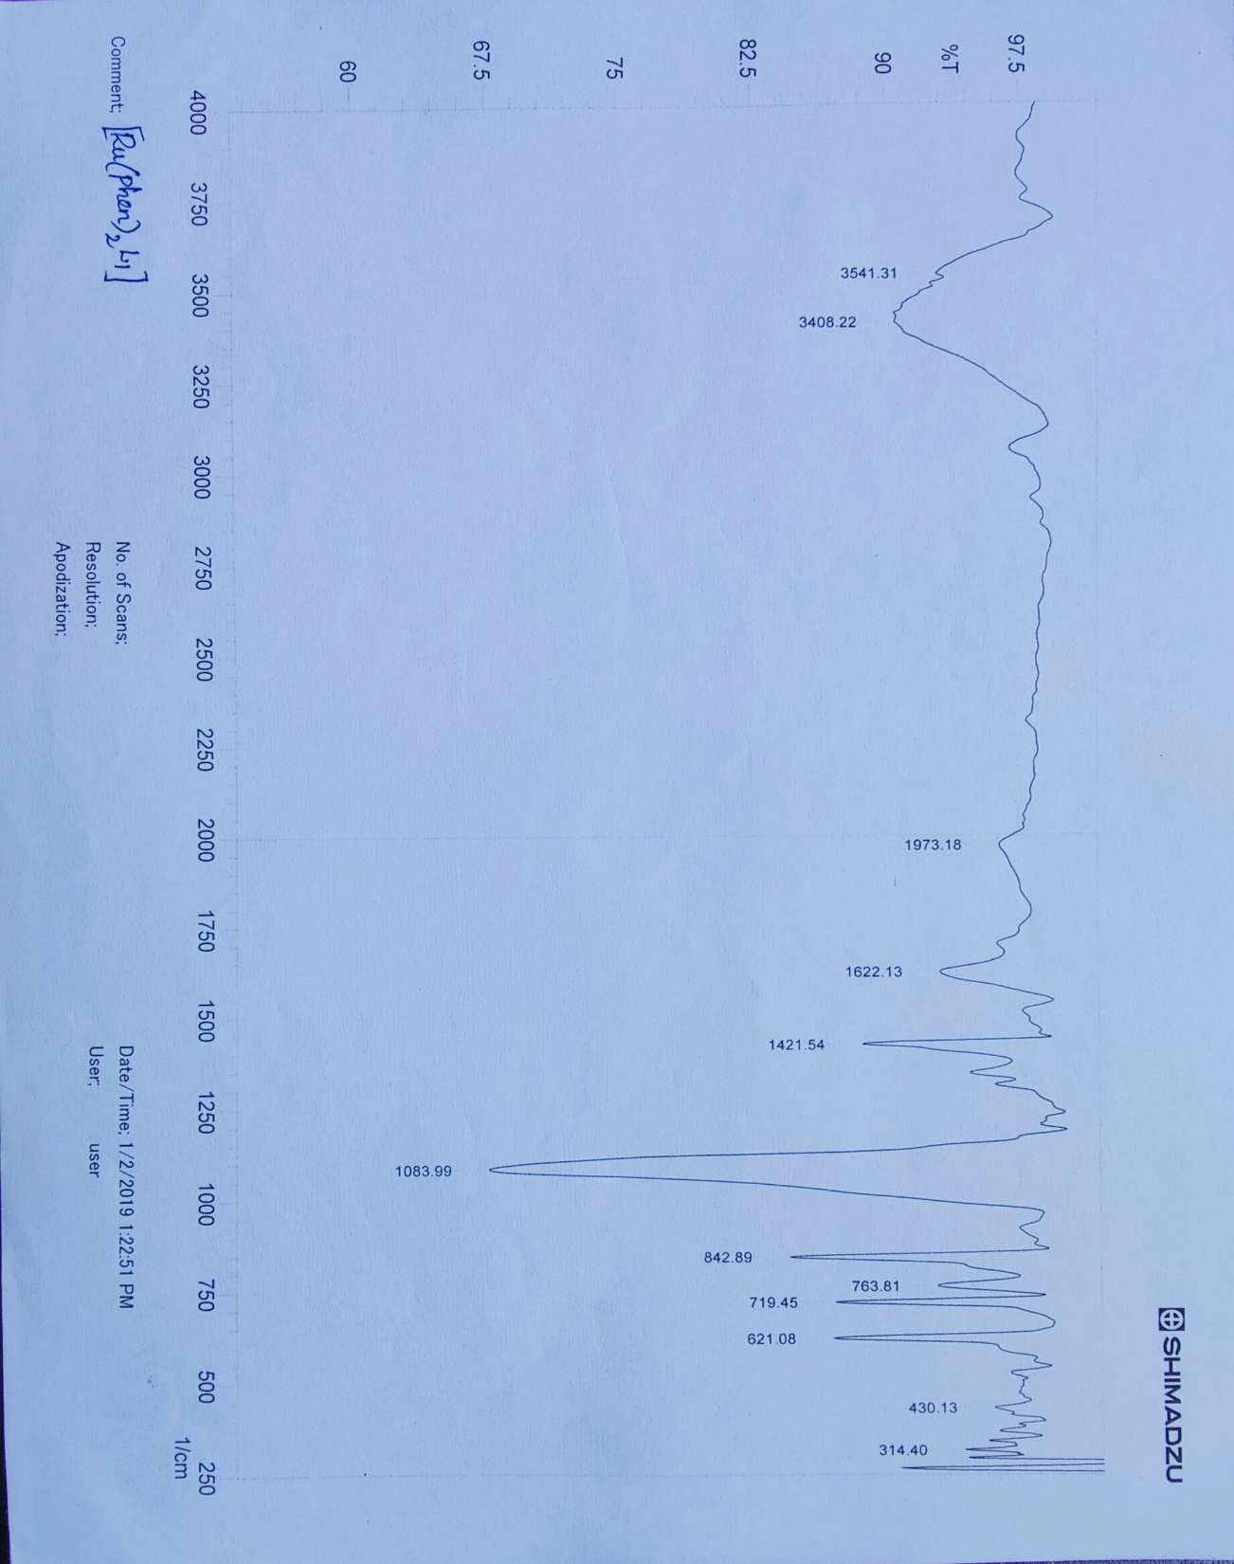

**Figure S2**. IR Spectra of [Ru(phen)2 qpd ]2+

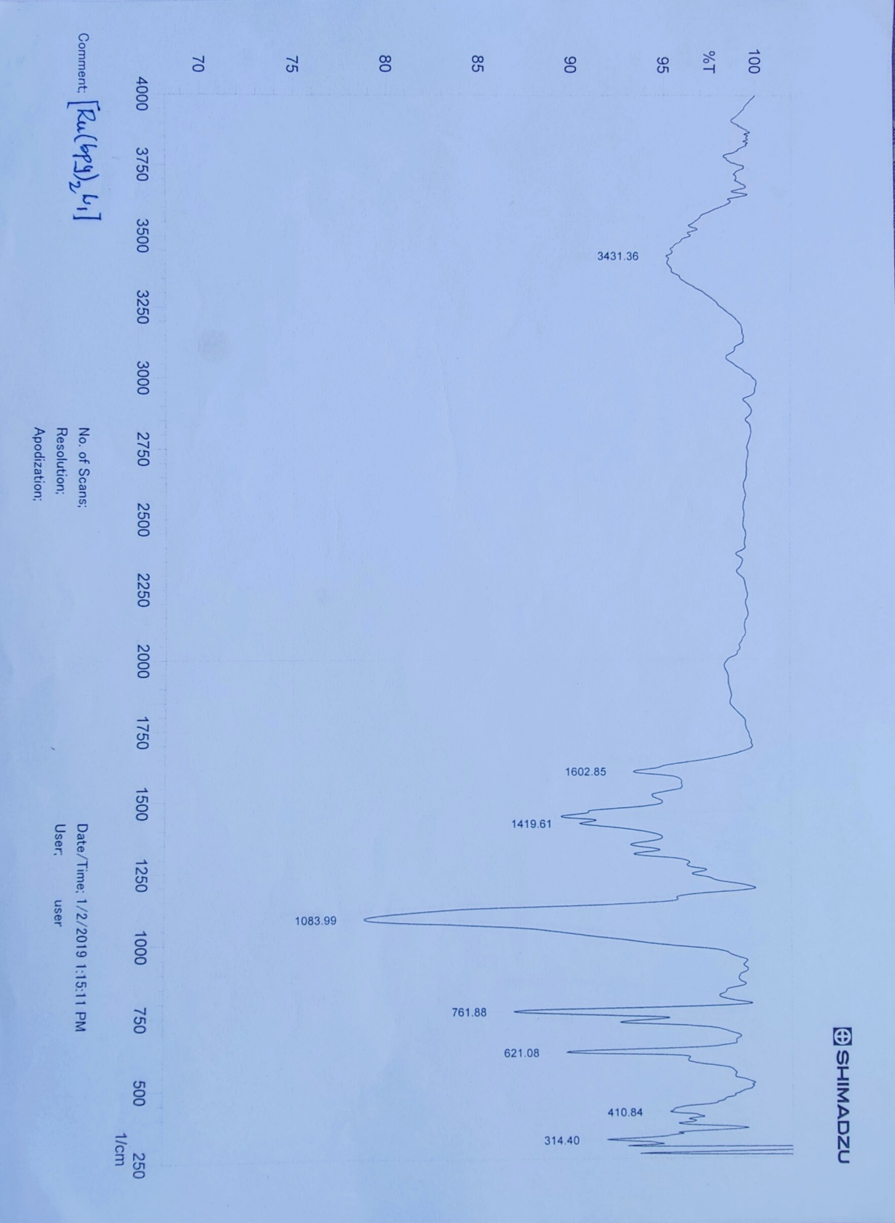

**Figure S3**. IR Spectra of [Ru(bpy)2 qpd ]2+

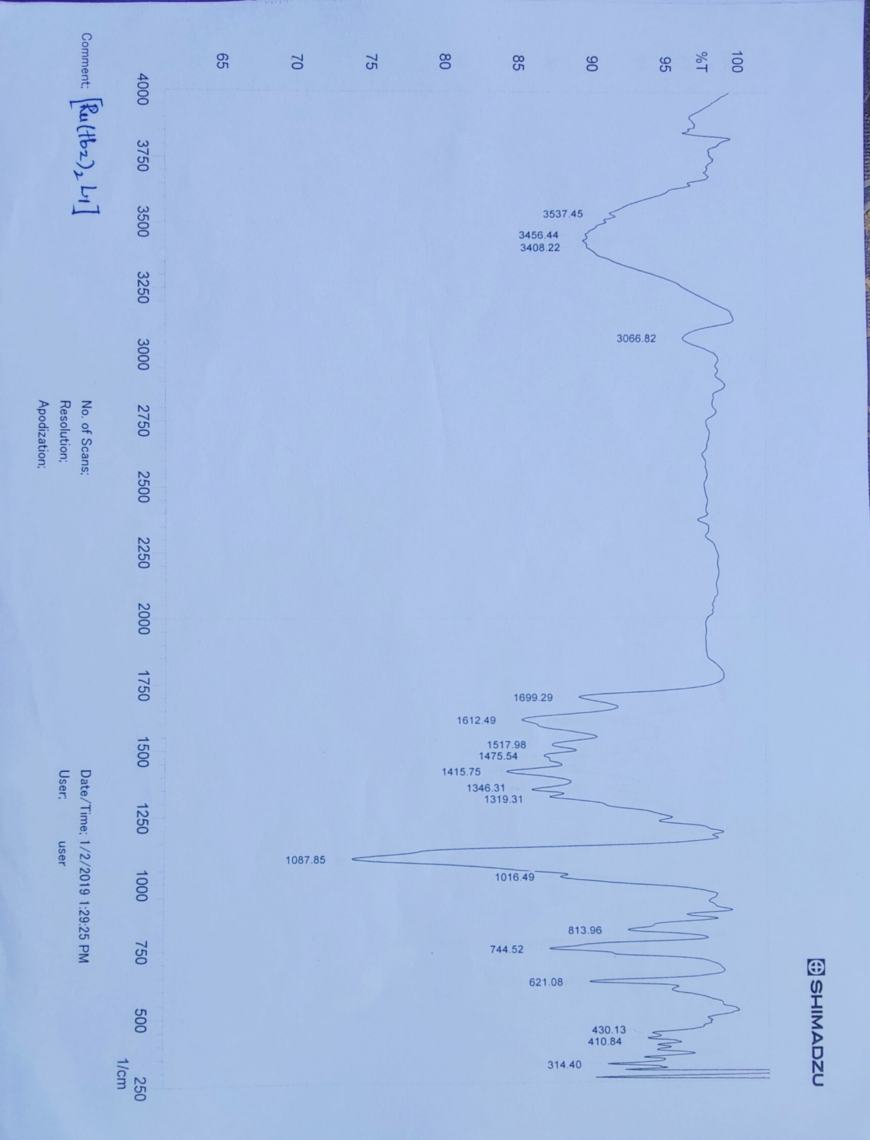

**Figure S4**. IR Spectra of [Ru(tbz)2 qpd]2+



**Figure S5**. 1H NMR Spectra of [Ru(phen)2 qpd ]2+



**Figure S6**. 1H NMR Spectra of [Ru(bpy)2 qpd ]2+



**Figure S7**. 1H NMR Spectra of [Ru(tbz)2 qpd]2+

F:\DRAFT\Figure 5.tif

**Figure S8**. 3D model of the Ru – complexes.

1. [Ru(phen)2(qpd)]+2, (2) [Ru(bpy)2(qpd)]+2, (3) [Ru(tbz)2(qpd)]+2]

Table S1. Mulliken atomic charges distribution of [Ru(A)2QDPD] (ClO4)2.2H2O complex, performed at B3LYP/ LanL2DZ basis set.

|  |  |  |  |
| --- | --- | --- | --- |
| QUEN (QDPD) | phen | *bpy* | tbz |
| -  -  -  -    N1 -0.132442  N 2 -0.132365  C3 -0.028050  C4 0.015953  C5 0.018551  C6 -0.041547  7 C 0.383051  8 C -0.040967  9 C -0.028059  10 C 0.015932  11 C 0.019291  12 C 0.380721  13 C -0.120342  14 C -0.121644  15 N -0.129716  16 N -0.128998  17 C 0.090833  18 C 0.089656  19 C -0.129770  20 C 0.145985  21 C 0.144319  22 C -0.129132  23 N -0.148471  26 N -0.147460  24 C 0.099519  25 C 0.099920    27 C -0.047224  28 C 0.024815  29 C 0.024636  30 C -0.046994 | Ru- 0.909327  N6-0.276738  N5-0.276747  N4-0.277444  N3 -0.277174  N1-0.277192  N2-0.277441  C7 -0.091266  C8 -0.091252  C9 0.565278  C10 -0.237886  C11 -0.237888  C12 0.565270  N13 0.047818  C13 0.088161  C15 0.088162  N16 0.047819  C17 -0.187585  C18 0.079549  C19 -0.187585  C20 0.079549  N21 0.019212  C22 0.049254  N23 0.019213  C24 0.049254  C25 0.040586  C26 0.079387  C27 -0.019673  C28 -0.031674  C29 0.067210  C30 -0.031674  C31 0.067210  C32 -0.019674  C33 0.036612  C34 0.084678  C35 -0.040393  C36 0.472347  C37 -0.146668  C38 -0.146401  C39 -0.040134  C40 0.046024  C41 0.036615  C42 0.472428  C43 0.038073  C44 0.085522  C45 -0.040135  C46 -0.146399  C47 -0.146666  C48 0.046240  C49 0.472348  C50 -0.040392  C51 0.084677  C52 0.046248  C54 0.472430  C55 0.046016  C56 0.085521  C57 0.038068  C58 0.040588  C59 0.079387 | Ru- 1.464861  N6-0.543732  N5-0.543723  N4 -0.542302  N3 -0.542287  N1-0.534033  N2-0.534057  C7 -0.542287  C8 0.333343  C9 0.331168  C10 -0.019137  C11 0.116902  C12 0.057539  C13 0.146257  C14 -0.018913  C15 0.117096  16 C 0.056519  17 C 0.143488  18 C 0.333372  19 C 0.331168  20 C 0.146249  21 C 0.057541  22 C -0.019136  23 C 0.116897  24 C -0.018920  25 C 0.143497  26 C 0.056517  27 C 0.117091  28 C 0.043022  29 C 0.043066  30 C 0.455048  31 C 0.128334  32 C 0.043728  33 C 0.074316  34 C 0.128324  35 C 0.043730  36 C 0.074318  37 C 0.455056  38 C -0.147994  39 C -0.148007  40 N -0.102475  41 C 0.136084  42 C 0.136098  43 N -0.102472  44 C -0.132153  45 C 0.119537  46 C -0.132155  47 C 0.119539  48 N -0.118361  49 C 0.083156  50 N -0.118362  51 C 0.083155  52 C -0.018735  53 C 0.059836  54 C 0.059836  55 C -0.018734 | Ru- 0.952675  N6-0.330042  N5-0.249082  N4 -0.339893  N3 -0.267614  N1-0.287698  N2-0.278142  C7-0.287698  C8 0.039050  C9 0.078288  C10 -0.021071  11 C -0.094007  12 C 0.572499  13 C -0.087258  14 C 0.050327  15 C 0.081107  16 C -0.026223  17 C 0.576634  18 C -0.239684  19 C -0.244384  20 N 0.048248  21 N 0.048359  22 C 0.087994  23 C 0.088582  24 C -0.187636  25 C 0.079379  26 C 0.079437  27 C -0.188193  28 N 0.019342  29 C 0.049092  30 C 0.049218  31 N 0.019092  32 C -0.031678  33 C 0.067116  34 C 0.067087  35 C -0.031881  36 C 0.135140  37 C 0.488420  38 N -0.067103  39 C 0.248983  40 C -0.031170  41 C 0.018070  42 C -0.076129  43 C 0.077786  44 C -0.310253  45 C 0.242110  46 C -0.196171  47 S 0.368538  48 C 0.144920  49 C 0.220569  50 N -0.055238  51 C 0.241945  52 C -0.036618  53 C 0.019611  54 C -0.079694  55 C 0.522782  56 C -0.129016  57 C -0.367773  58 S 0.396324  59 C 0.074930 |