**Supporting File**

**Synthesis of pyridine 4-Carboxaldehyde and thiosemicarbazide derived Schiff base ligand, Their Biological Activity and Molecular Docking Studies of Two Novel Schiff Base and their 3d transition metal complexes**

**Karuna Chourasia1, Himanshu Pandey and Ritu Yadav**

**Department of Chemistry Dr. Harisingh Gour Vishwavidyalaya Sagar M.P.**

**Corresponding author:(i)** [**Karuchem128@gmail.com**](mailto:Karuchem128@gmail.com)

**(ii) drmsyry@gmail.com**

# LIST OF CONTENTS –

|  |
| --- |
| Table S1 - Docking results synthesized compounds |
| Figure S1 -I.R. spectra of KL-3 |
| Figure S2 -I.R. Spectra of KL-4 |
| Figure S3 – NMR spectra of KL-3 |
| Figure S4 -NMR spectra of KL-4 |
| Figure S5 -U. V spectra of KL-3 ligand and their corresponding metal complexes |
| Figure S6 --U. V spectra of KL-3 ligand and their corresponding metal complexes |
| Figure S7 -Mass spectra of KL-3 |
| Figure S8 - Mass spectra of KL-4 |
|  |
| Figure S9- Anti-Microbial activity of KL-3 and KL-4 |

Table S1

**Comparison of docking scores of KL-3 and KL4 Ligands with STD DRUGS**

|  |  |
| --- | --- |
| Compound | DOCKING SCORE in Kcal/mol |
| KL-3  KL-4  PYRAZINAMIDE(Z)  CIPROFLOXACIN | -6.0  -7.1  -4.69  -6.45 |

**Figure S1-**



**IR spectra of KL-3**

**Figure S2-**

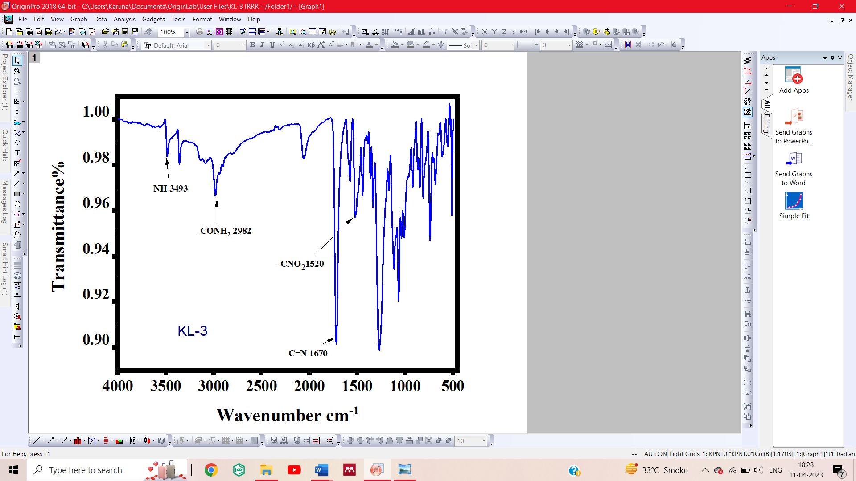

**Figure S3-**

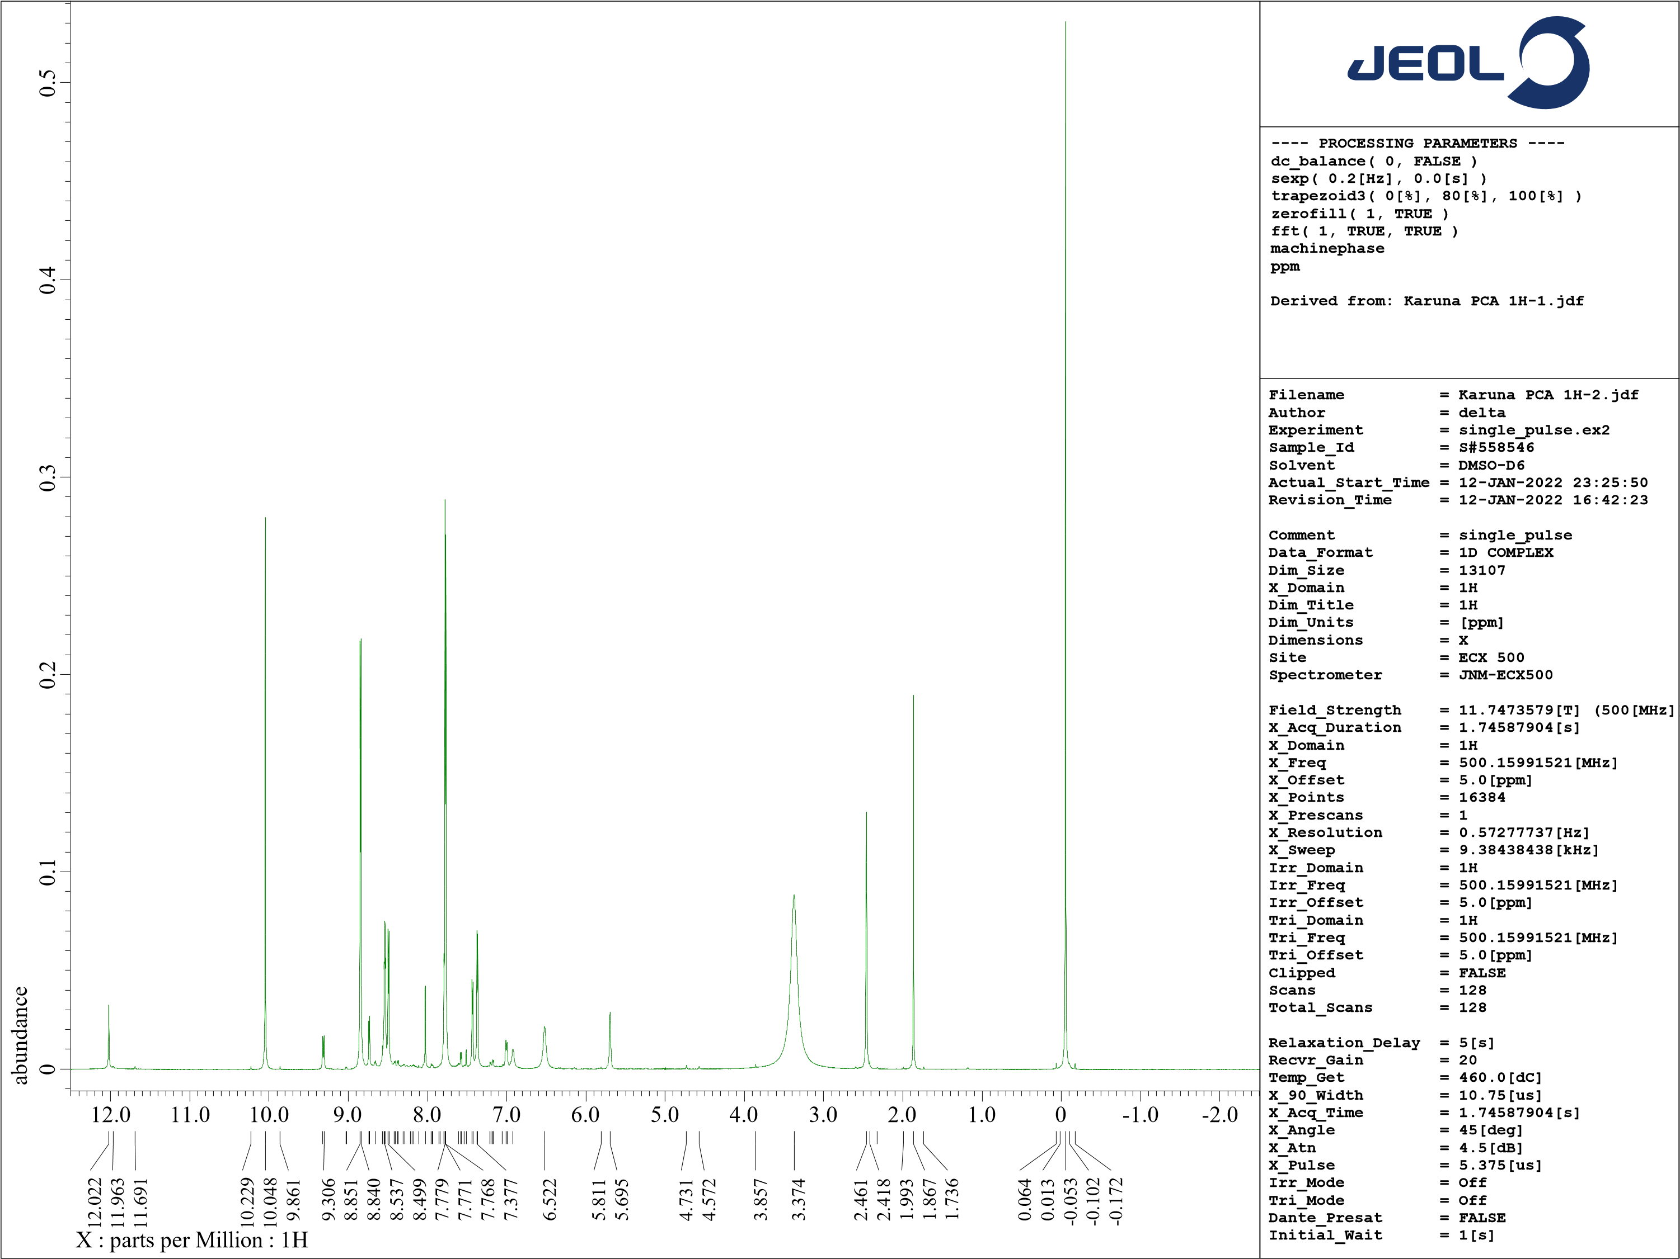

NMR spectra of KL-3

**Figure S-4**



**Figure S-5** 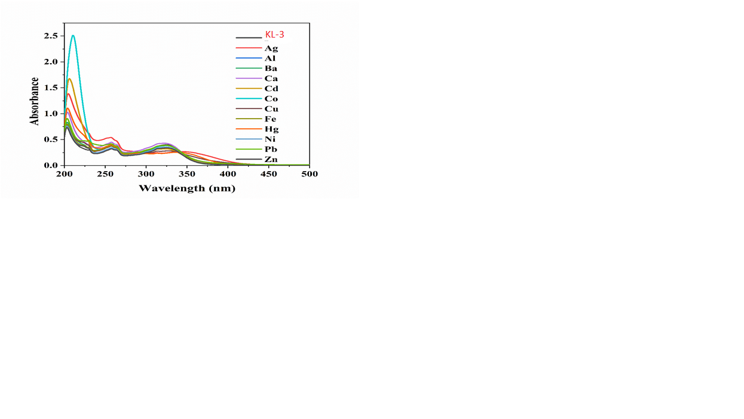

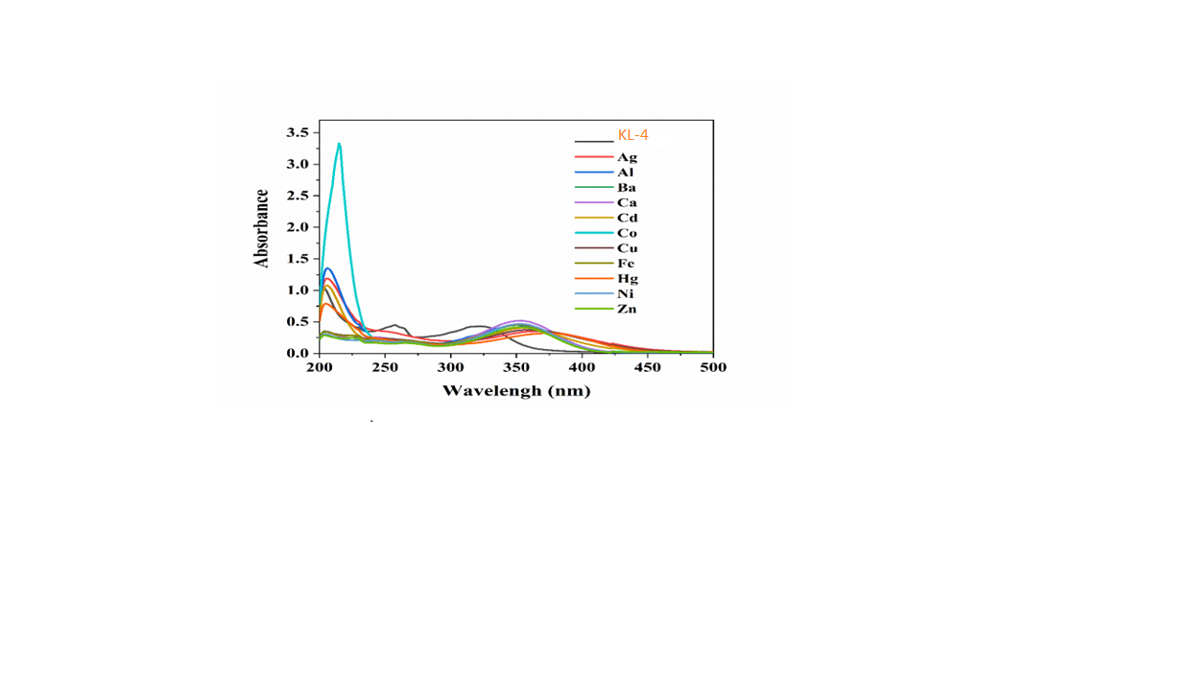

**Figure S-6**

**Figure S-7-**

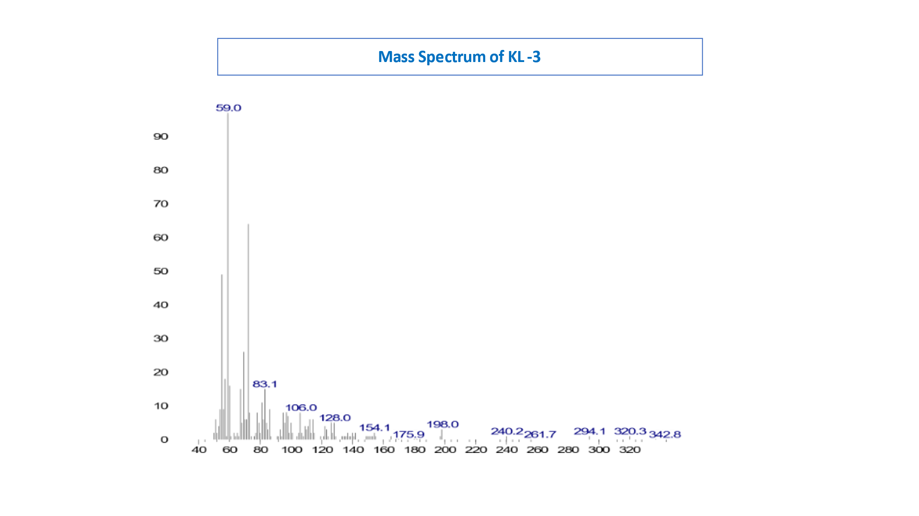

**Figure S-8-**

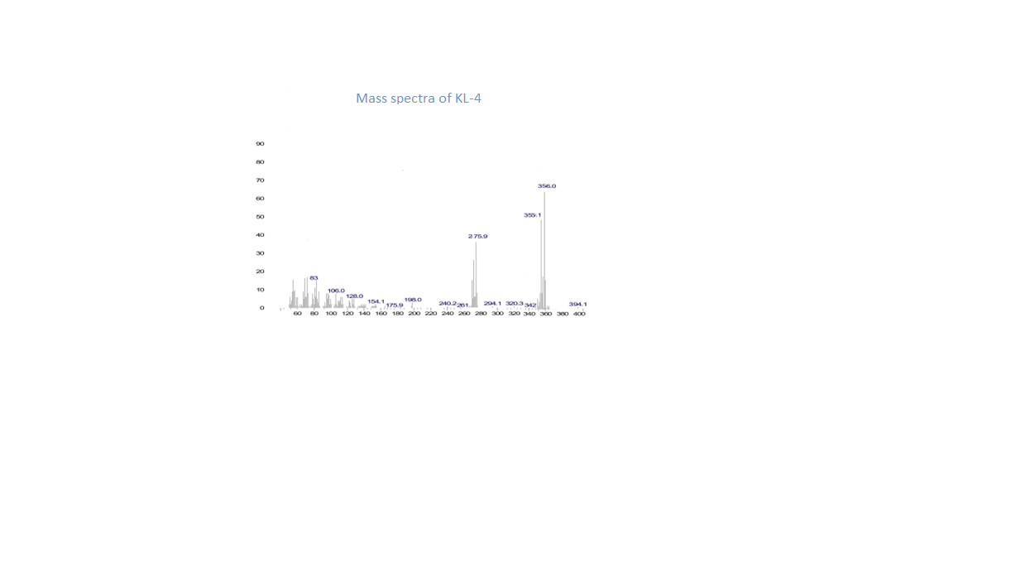

**Figure S-9-**