**Influence of the activation method on the activity of the nickel catalyst**

**Elshan Zeynalov**

Azerbaijan State Oil and Industry University, Baku, Azadlig avenue 20, AZ1010, Azerbaijan

**Abstract**. The results of a comparative analysis of the influence of the activation method on the catalytic properties of a nickel diatomaceous earth catalyst during the conversion of isopropyl alcohol to acetone are presented. Studies of the activity of the catalyst in the reaction of gas-phase dehydrogenation of isopropyl alcohol were carried out on a flow-type laboratory installation at a temperature of 150-350ºC. The mechanical activation of the nickel diatomaceous earth catalyst was carried out in a planetary mill; traditional activation included pre-heat treatment of nickel diatomaceous earth catalyst in an atmosphere of O2 and H2 at 250°C; IR radiation was carried out using an incandescent lamp. It is shown that the nature of the activator determines the features of the formed surface nickel complexes. The activity of samples of the nickel diatomaceous earth catalyst subjected to activation by thermal reduction and thermal oxidation, as well as IR irradiation, testified to the low efficiency of these methods. An analysis of the entire set of experimental data allows us to conclude that it is promising to use the activation of a nickel diatomaceous earth catalyst by an unconventional mechanical method. The mechanically activated sample is characterized by higher activity and stability. It has been established that the mechanical activation of a nickel diatomaceous earth catalyst is more efficient than the traditional ones (thermal reduction and oxidation), as well as IR irradiation.

**Keywords:** nickel catalyst; activation; activity; dehydration.

**1. Introduction**

Nickel-based catalysts are widely used in industrial catalysis. A large number of works are devoted to their study, despite this number of publications devoted to this topic does not decrease1-3. Nickel catalysts are active catalysts for various hydrocarbon conversion reactions and are widely used in industry4-6. However, when using nickel catalysts for some processes, it is necessary to increase their activity and selectivity. These tasks are successfully solved by selecting methods for the physical and chemical activation of catalytic systems and determining the optimal technological parameters of the processes. An analysis of the extensive material presented in the scientific and technical literature shows that at present, along with the development of a number of new original methods for the preliminary activation of metal-containing catalysts, traditional processes are also being studied.

Previously, it was shown that industrial nickel diatomaceous earth catalyst is effective in the processes of dehydrogenation of aliphatic alcohols to ketones7-10. A relationship was established between the catalytic activity and the processes of phase transformations, electronic, magnetic and morphological properties of catalysts.

In this paper, we consider data from a comparative analysis of the effectiveness of using various activation methods on the catalytic properties of an industrial nickel diatomaceous earth catalyst in the process of isopropyl alcohol dehydrogenation to acetone.

**2. Experimental**

In the course of the experiments, samples of nickel diatomaceous earth catalyst were used in the form of 4x4 mm tablets taken from an industrial batch (TU 38.101396-89Е).

Studies of the activity of the catalyst in the reaction of gas-phase dehydrogenation of isopropyl alcohol were carried out on a flow-type laboratory installation at a temperature of 150-350ºC. The experiments were carried out at an alcohol flow rate of 600 h-1. The methodology for the analysis of raw materials and the products obtained is described in detail in the works7-10.

The mechanical activation of the nickel-kieselguhr catalyst was carried out in an MP/0.5 planetary mill with steel balls 5–10 mm in diameter at a drum rotation frequency of 10 s–1 and a drum volume of 200 sm3.

Conventional activation included pre-heat treatment of the nickel diatomaceous earth catalyst in an atmosphere of O2 and H2 at 250°C. The activation medium was applied to the surface of the catalyst at a rate of 20 ml/min for 2 hours.

IR irradiation was carried out using an incandescent lamp, which is a glass flask with an internal mirror coating, in which a tungsten spiral is placed. IR activation was carried out at room temperature for 2 h.

**3. Results and its discussion**

Under the conditions of catalysis, the nickel diatomaceous earth catalyst is in a reducing medium containing hydrogen formed during the reaction. Its effect on the catalytic process consists not only in changing the equilibrium composition of the gas phase, but also in the degree of oxidation of the metal, the formation of the active nickel phase and, accordingly, its catalytic properties.

According to our previous studies, in the process of alcohol dehydrogenation, a homogeneous nickel phase is formed on the surface of a nickel diatomaceous earth catalyst, which has a spinel structure: a cubic close-packed lattice of oxygen ions, in the tetrahedral and octahedral voids of which nickel ions are located. Under the influence of the reaction medium, the reduced metallic nickel is introduced into the crystal lattice of nickel oxide, deforming it, making it more favorable for the dehydrogenation reaction. On the other hand, any preliminary physicochemical treatment of the catalyst will inevitably lead to a change in the composition, properties, and mechanism of formation of surface complexes. In this regard, in order to study the features of the state of the active phase formed on the surface of the catalyst under conditions of different pre-activation of the nickel diatomaceous earth catalyst, a series of catalysts was studied (Table 1).

Table 1

Activation conditions

|  |  |  |  |
| --- | --- | --- | --- |
| Sample No. | Method of catalyst activation | Activation conditions | Activation duration |
| 1 | Thermal recovery | In H2 atmosphere, 523 K | 2 h |
| 2 | Thermal oxidation | In an O2 atmosphere, 523 K | 2 h |
| 3 | IR irradiation | In air atmosphere, 295 K | 2 h |
| 4 | Mechanical activation | In air atmosphere, 295 K | 90 sec |

A comparative analysis of quantitative indicators (conversion, acetone yield and selectivity) of the process indicated a significant effect of the activation method (Fig. 1). It is important to note that the dehydrogenation of alcohol to acetone took place in all samples, however, with some peculiarities. It was found that the activity of the studied samples decreased in the series:

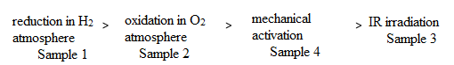

Comparison of the activated samples showed that in the first case (sample 1), hydrogen, presumably, along with participation in the reduction of surface nickel oxide, was also physically adsorbed on the catalyst surface. A high yield of acetone is associated with this: the reaction proceeds simultaneously along two routes: through the surface decomposition of alcohol and its interaction from the gas phase with the available adsorbed hydrogen.

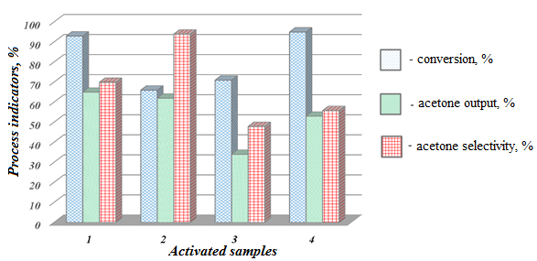

**Fig.1.** Comparative analysis of activated samples of nickel diatomaceous earth catalyst. (1-4 are numbers of activated samples, see Table 1).

The lower yield of acetone in the presence of sample 2 can be explained by the fact that the supplied oxygen partially fills the surface, with the formation of a more or less thermally unstable surface compound, which is retained by nonspecific van der Waals adsorption. It is likely that the formation of a surface form of adsorbed oxygen prevents the selective reduction of nickel ions and is responsible for the relatively low activity of the catalyst.

It is known that during the mechanical processing of solids, the accumulation of point defects, dislocations, amorphous regions on the surface and in the volume, an increase in the area of intergranular areas, strong loosening, the formation of new surfaces, as well as the activation of chemical bonds, and other changes occur11,12.

The conducted studies showed that no obvious change in the color scale of the catalyst (initially having an intense black color) was observed during mechanical activation.

The absence of visible signs of a phase transition, however, does not exclude the possibility of amorphization of the system and partial reduction of nickel, which is in good agreement with the data available in the literature, according to which the mechanical treatment of the cobalt-iron precursor was accompanied by the formation of metallic cobalt.

The lowest activity was characteristic of sample 3 subjected to IR irradiation. In its presence, the yield of acetone was 34%, which is 19, 28, and 31%, respectively, lower than in the presence of the sample activated mechanically, as well as in H2 and O2 atmospheres. It should be noted that the degree of alcohol conversion in this case reached 71%. Having a good penetrating ability, infrared radiation, however, did not contribute to the change in the valence state of nickel, its photoreduction, and the formation of the active phase.

A more detailed study of the activation mechanism was continued using such a convenient factor from the point of view of characterizing the operational properties of the catalyst as the duration of the process (Fig. 2).

When considering the experimental results, the presence of certain periods of induction attracts attention: with a change in the duration of the process, the dynamics of the release of acetone for all four samples becomes stable after passing through a certain minimum.

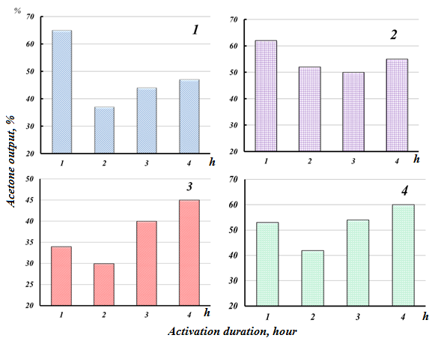

Fig.2. The dynamics of the output of acetone on the duration of the process in the presence of activated samples:

1 – thermal recovery; 2 – thermal oxidation; 3 – IR irradiation; 4 – mechanical activation.

At the initial stage of the process, the sample subjected to thermal reduction exhibited high activity for the target product, which is probably associated with the presence of adsorbed hydrogen; for the same reason, in the second hour of work, its initial indicators sharply decrease and over time do not reach the previous indicators again.

It is possible that the repeated supply of hydrogen can lead to the effect of a short-term increase in activity. However, in the long run, the excess presence of hydrogen can lead to the generation of a wide range of valence states of nickel ions, many of which do not participate in catalysis.

In contrast to the thermally reduced catalyst, the catalytic activity of the oxidized sample, although slightly inferior to the latter (28% versus 12%), does not change so sharply during the process. It is possible that part of the adsorbed oxygen (not passing into the chemisorbed state) is directly involved in the formation of surface nickel complexes, which are precursors of active centers.

The data obtained with the participation of an IR-activated sample show that their catalytic activity is significantly inferior to those reduced in O2 and H2. At the same time, it should be noted that after 8 hours of catalyst operation, the acetone yield indicators for IR- and H2-activated samples become almost the same, which indicates that at this stage the influence of the activation method is practically exhausted.

The activity of the mechanically activated sample over time is comparable to the activity of one of the best samples, thermally oxidized (sample 2). Obviously, mechanoactivation, as well as the presence of oxygen, induces activity. However, two interesting facts should be noted: the presence of an induction period in this case is limited to 2 hours (against 3 hours in the presence of O2), after which the catalyst begins to exhibit a higher activity than the initial one. And the second effect of mechanoactivation is a significantly greater stability of catalytic properties (activity is maintained throughout the experiment) than in the case of using other methods. Probably, the mechanical activation of the nickel diatomaceous earth catalyst promotes the accumulation of energy in crystals in the form of defects or other changes in the solid, which make it possible to reduce the activation energy of the subsequent chemical transformation of the substance and improve the steric conditions for the process. In addition, as noted above, the possibility of increasing the ratio of deeply reduced nickel in the surface layer will affect the Ni/Ni2O3/NiO ratio. In turn, this will lead to an increase in the rate of formation of active surface intermediates "reagent-catalyst" and, in general, to an acceleration of the reaction of isopropyl alcohol conversion into acetone.

**4. Conclusion**

The activity of samples of the nickel diatomaceous earth catalyst subjected to activation by thermal reduction and thermal oxidation, as well as IR irradiation, indicated the low efficiency of these methods. An analysis of the entire set of experimental data allows us to conclude that it is promising to use the activation of a nickel diatomaceous earth catalyst by an unconventional mechanical method. The mechanically activated sample is characterized by higher activity and stability.

**References**

1. Samira Zafarnak, Mohammad Reza Rahimpour. Co-Ni bimetallic supported on mullite as a promising catalyst for biogas dry reforming toward hydrogen production. Molecular Catalysis, 2023, Volume 534, 112803.
2. Dieu-Phuong Phan, The Ky Vo, Van Nhieu Le, Jinsoo Kim, Eun Yeol Lee. Spray pyrolysis synthesis of bimetallic NiMo/Al2O3–TiO2 catalyst for hydrodeoxygenation of guaiacol: Effects of bimetallic composition and reduction temperature. Journal of Industrial and Engineering Chemistry, 2020, Volume 83, pages 351-358.
3. A.V. Vutolkina., A.P. Glotov, A.V. Zanina, D.F. Makhmutov, A.L. Maximov, S.V. Egazar’yants, E.A. Karakhanov. Mesoporous Al-HMS and Al-MCM-41 supported Ni-Mo sulfide catalysts for HYD and HDS via in situ hydrogen generation through a WGSR. Catalysis Today, 2019, Volume 329, pages 156-166.
4. H.G. El-Shobaky, Y.M. Fahmy. Nickel cuprate supported on cordierite as an active catalyst for CO oxidation by O2. Applied Catalysis B: Environmental, 2006, Volume 63, Issues 3–4, pages 168-177.
5. Knyazheva O.A., Baklanova O.N., Lavrenov A.V. Mechanochemical synthesis of nanocrystalline nickel-molybdenum compounds, their morphology and application in catalysis: I. Effect of the Ni: Mo atomic ratio on the structure and properties of nickel-molybdenum compounds prepared under mechanochemical synthesis conditions // Kinetics and Catalysis. 2011. – V. 52. – № 6. – pages 886-895.
6. Zhenghao Wang, Li Wang, Yongkang Cui, Yi Xing, Wei Su. Research on nickel-based catalysts for carbon dioxide methanation combined with literature measurement. Journal of CO2 Utilization, 2022, Volume 63, 102117.
7. Guseinova E.A., Adzhamov K.Yu. Electron properties of the system of Ni on kieselguhr. Russian Journal of Physical Chemistry A., 2011, V. 85. № 11. pages 1965-1970.
8. Guseynova E.A., Adzhamov K.Yu. Electronic properties of the nickel surface compound in the conversion of isopropyl alcohol. Herald of the Azebaijan Engineering Academy 2014, V.6, №1, pages 113-119.
9. E.Guseynova, E.Zeynalov, K.Adzhamov. Physicochemical and catalytic properties of nano-nickel in the process of conversion of isopropyl alcohol to acetone. Nanoindustry, 2014, №5, pages 46-53.
10. E. A. Guseinova, E. T. Zeinalov, K. Yu. Adzhamov. Commercial nickel-kieselguhr isopropanol dehydrogenation catalysts: Morphology and catalytic and electronic properties. Catalysis in Industry, 2015, Volume 7, issue 3 pages: 227 – 233.
11. V.V. Zyryanov. Mechanochemical synthesis of complex oxides. Russian Chemical Reviews, 2008, V.77, N 2, pages 105–135.
12. V.V. Boldyrev. Mechanochemistry and mechanical activation of solids. Russian Chemical Reviews, 2006, V. 75 N 3, pages 177–189.