MEDITERRANEAN JOURNAL OF CHEMISTRY

Graphical Abstract

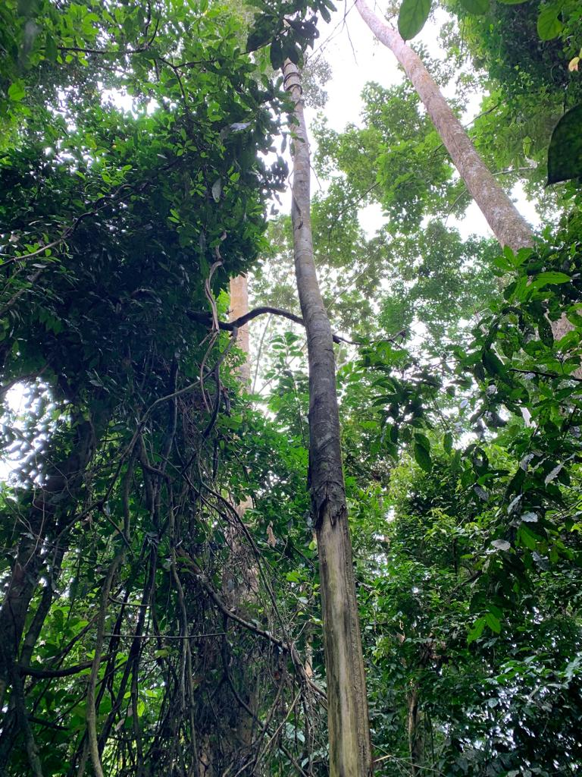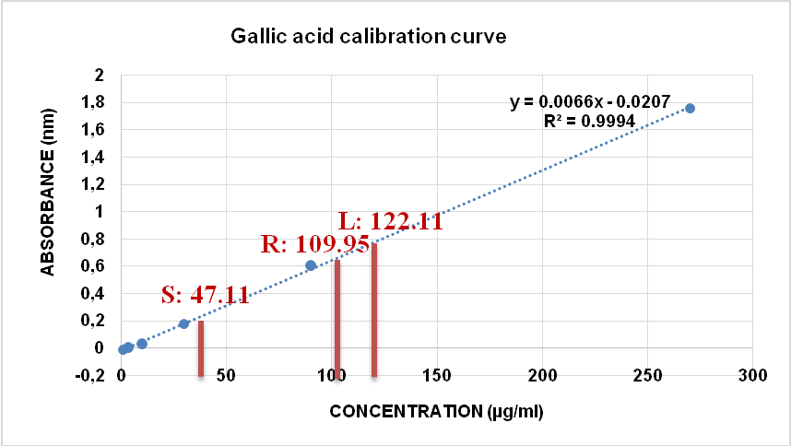
Annickia affinis organs Total phenol content DPPH radical scavenging activity

