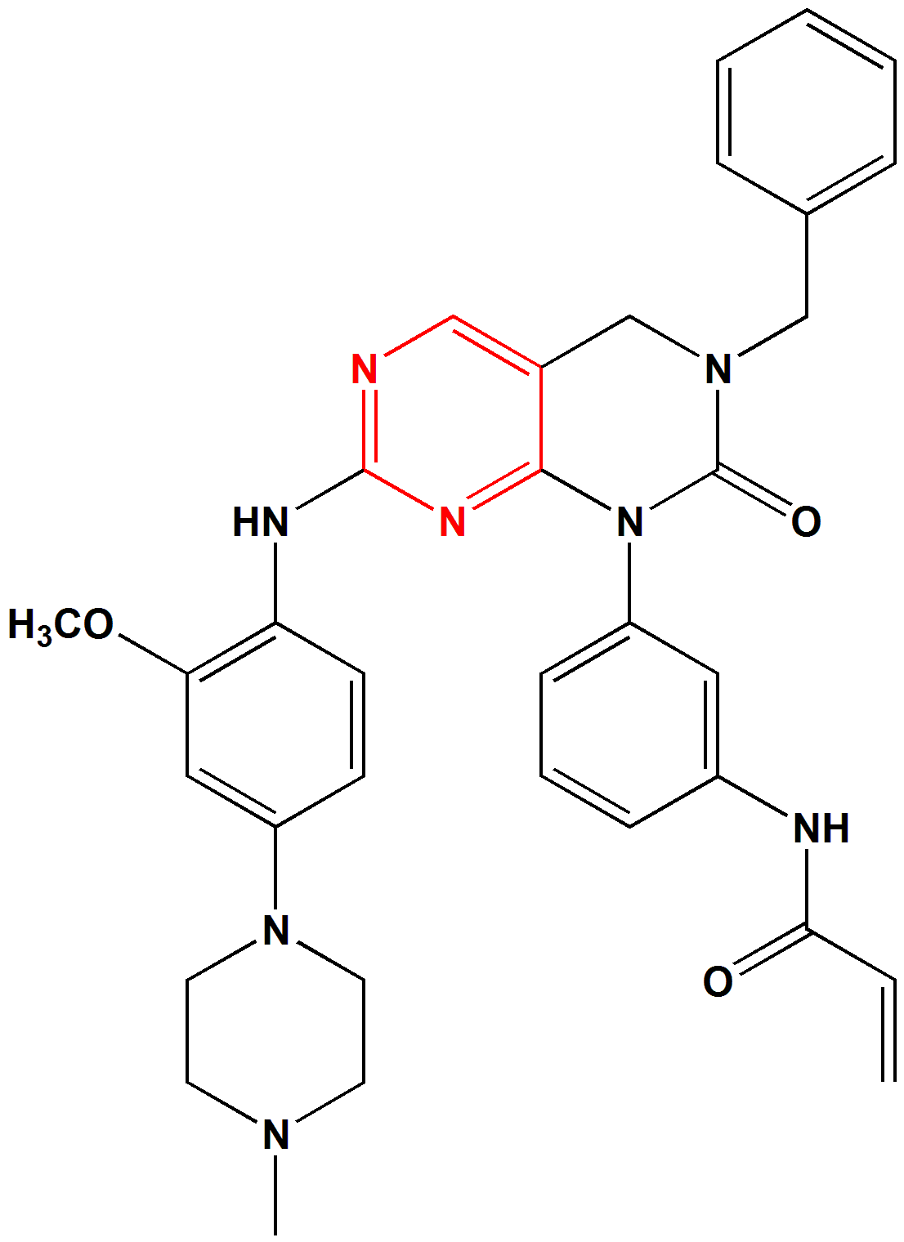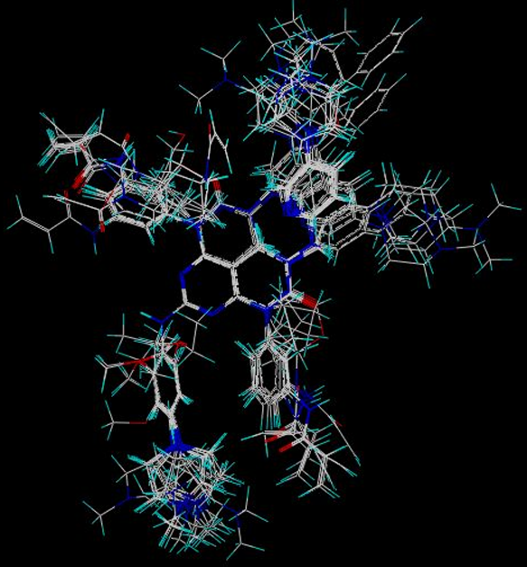
(A) (B)
Figure 1. Molecular alignment. (A) template for alignment: compound 17, red colored part of the structure is the core for alignment; (B) distill rigid alignment of training set compounds.

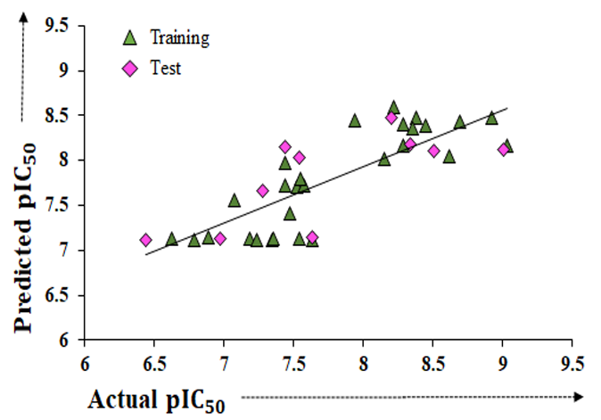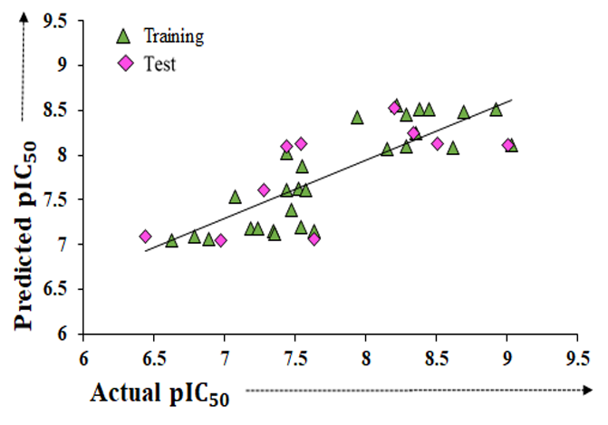
- (B)
Figure 2. Scatter plot of actual versus predicted pIC₅₀ values of the training set and test set compounds, for (A) CoMFA and (B) CoMSIA model.

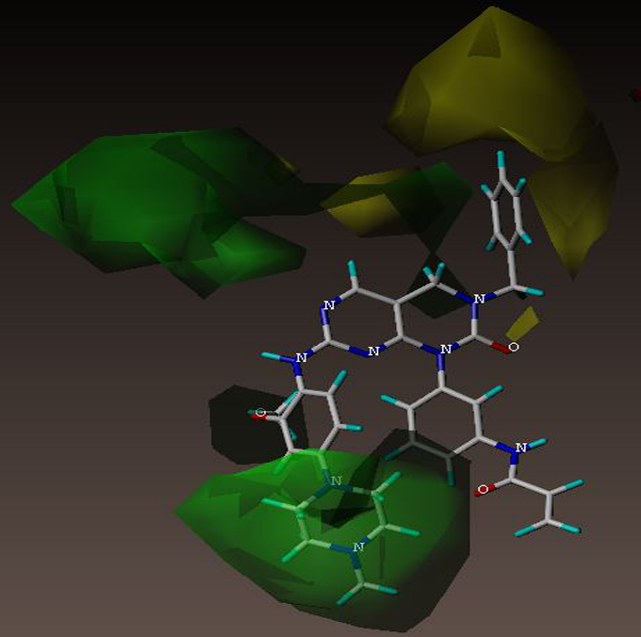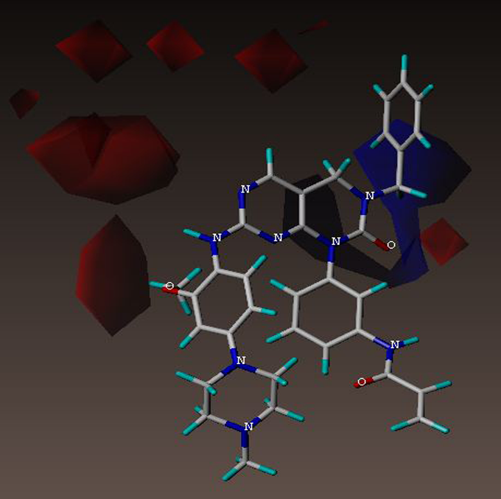
(A) (B)
Figure 3. CoMFA contour maps presented with template compound 17. (A) CoMFA steric field contour map (green contour is favored; yellow contour is disfavored); (B) CoMFA electrostatic field contour map (blue contour is favored for electropositive groups; red contour is favored for electronegative groups).

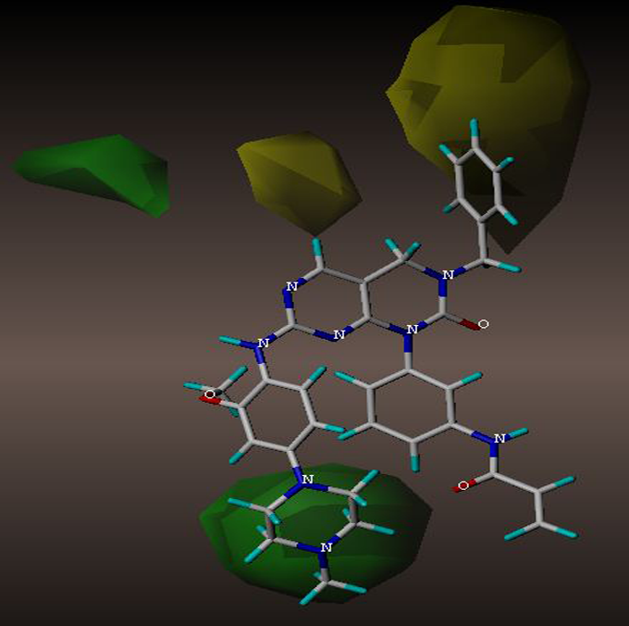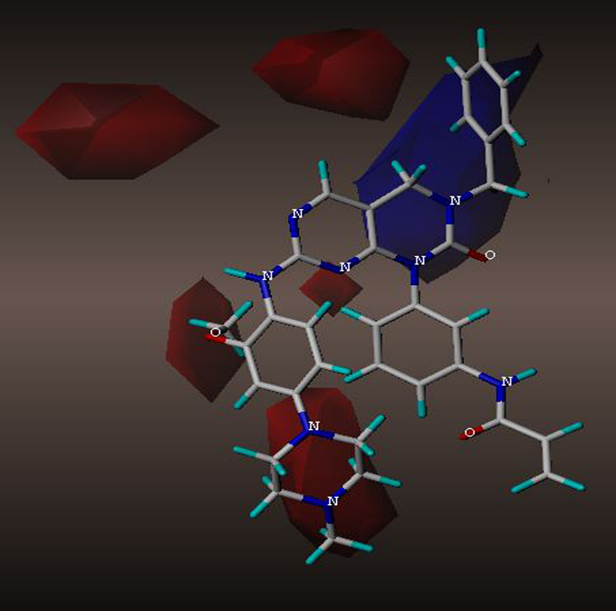
- (B)
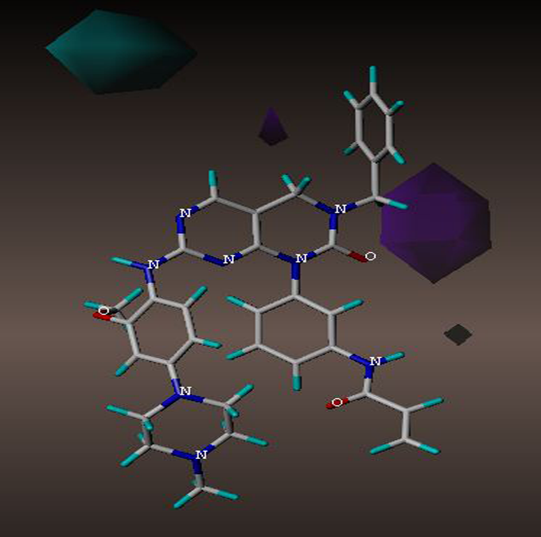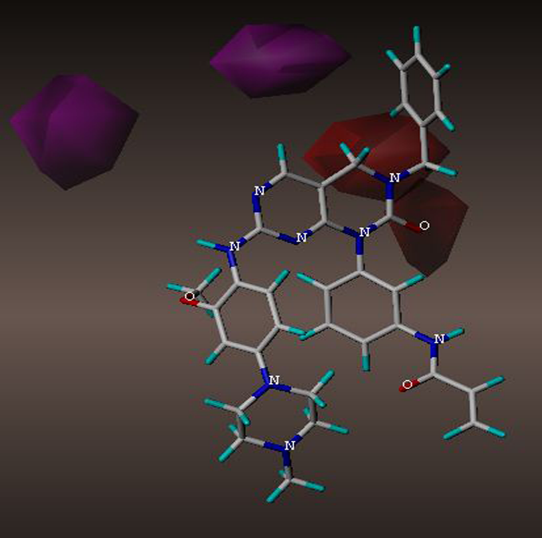
(C) (D)
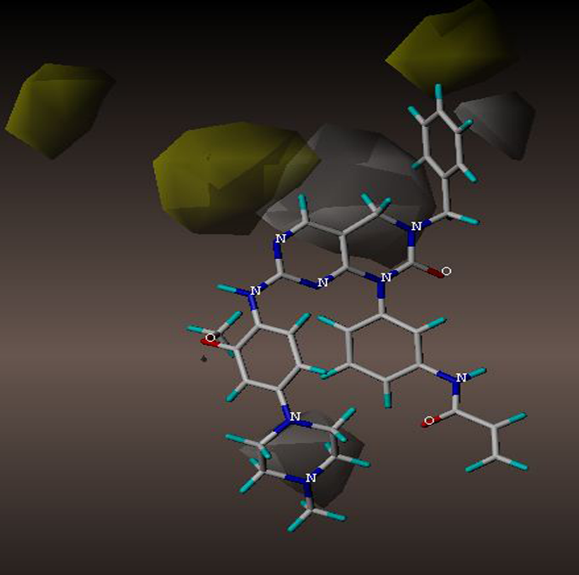
(E)
Figure 4. CoMSIA contour maps presented with most potent compound, 17. (A) CoMSIA steric field contour map (green contour is favored; yellow contour is disfavored); (B) CoMSIA electrostatic field contour map (blue contour is favored for electropositive groups; red contour is favored for electronegative groups); (C) CoMSIA hydrogen donor field contour map (cyan contour is favored; purple contour is disfavored); (D) CoMSIA hydrogen acceptor field contour map (magenta contour is favored; red contour is disfavored); (E) CoMSIA hydrophobic field contour map (yellow contour is favored; white contour is disfavored).

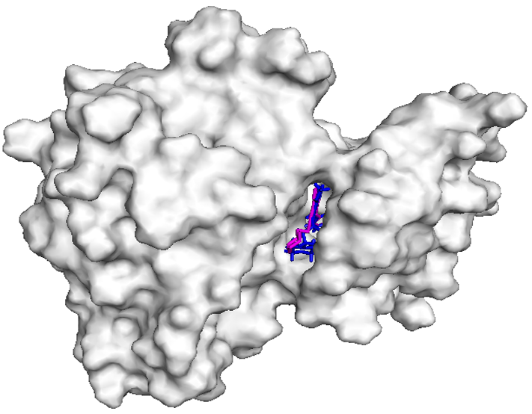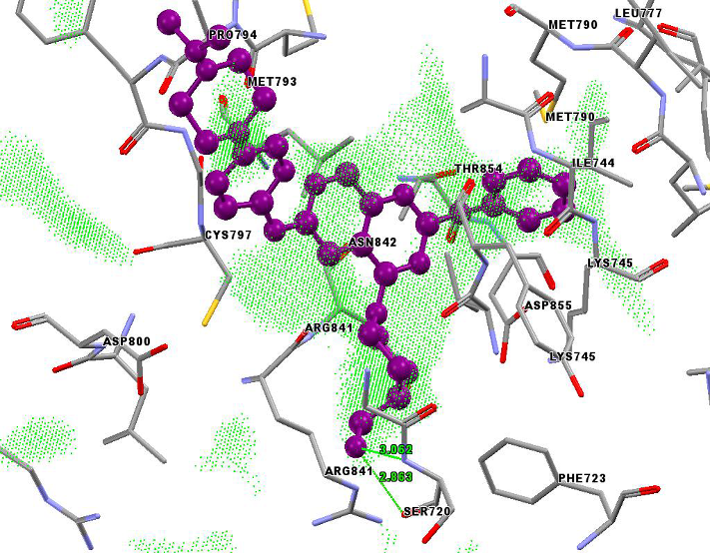
(A) (B)

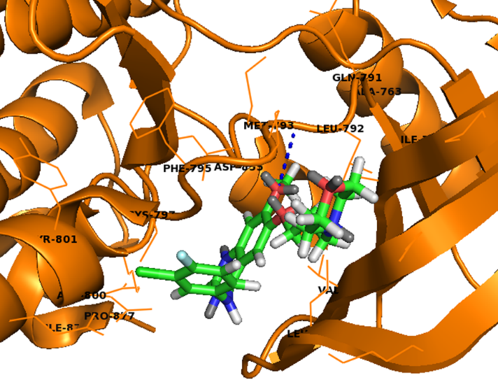
(C)
Figure 5. Docking results. (A) Molecular surface of the protein presented with co-crystalized ligand (pink) and compound 29 (blue) at the binding cavity of the protein; (B) Well occupancy of the fit points (green dots) by compound 29 (violet); (C) Binding interactions in between co-crystalized ligand gefitinib and mutant EGFR^{L858R/T790M}.

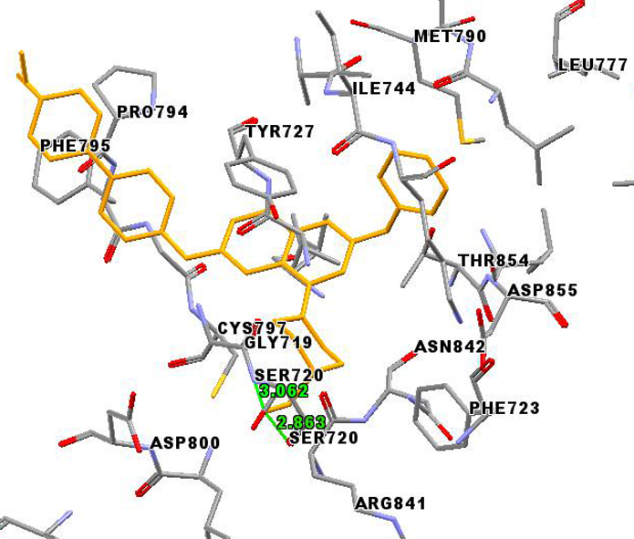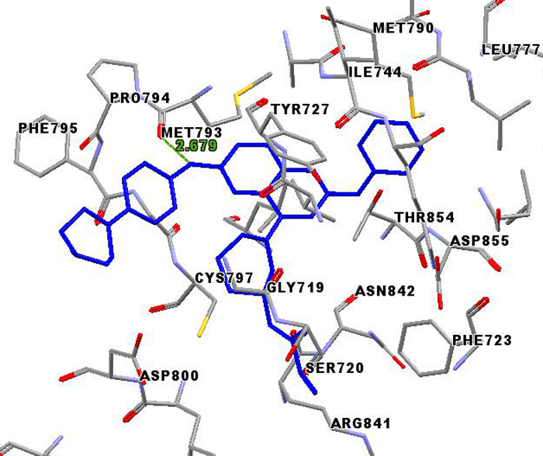
(A) (B)
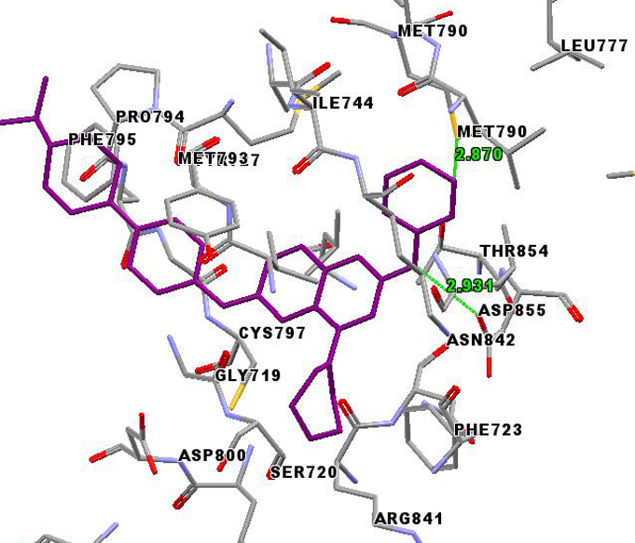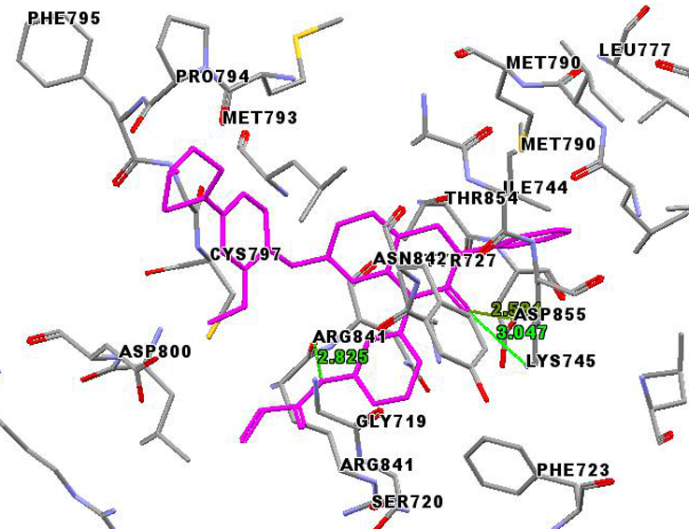
(C) (D)

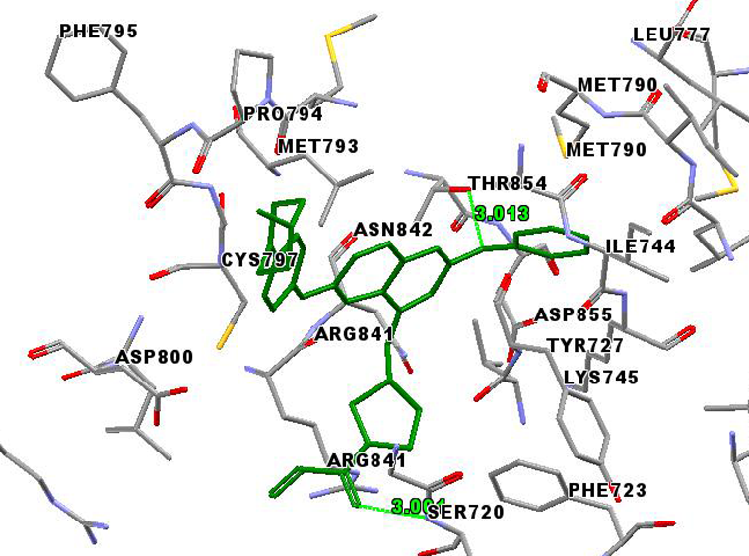
(E)
Figure 6. Binding interactions. (A) in between compound 29 (yellow) and amino acid residues (labeled in black); (B) in between compound 34 (blue) and amino acid residues; (C) in between compound 26 (violet) and amino acid residues; (D) in between compound 15 (pink) and amino acid residues; (E) in between compound 35 (green) and amino acid residues.

Figure 7. Alignment of amino acid sequences of EGFR obtained from ten different species as Homo sapiens (Human), Drosophila melanogaster (Fruit fly), Mus musculus (Mouse), Macaca mulatta (Rhesus macaque), Rattus norvegicus (Rat), Mesocricetus auratus (Golden hamster), Xenopus tropicalis (Frog), Danio rerio (Zebrafish), Pelodiscus sinensis (Turtle), and Meleagris gallopavo (Wild turkey). Residues are colored by conservation index.

Figure 8. Simplified presentation of conservation consistency of important amino acid residues.

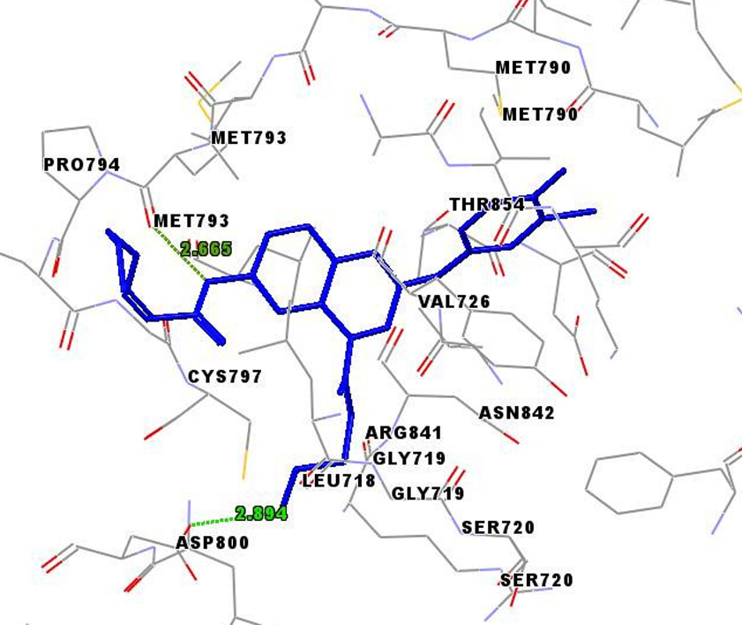
Figure 9. Binding interactions in between compound N7 and EGFR^{L858R/T790M} protein.

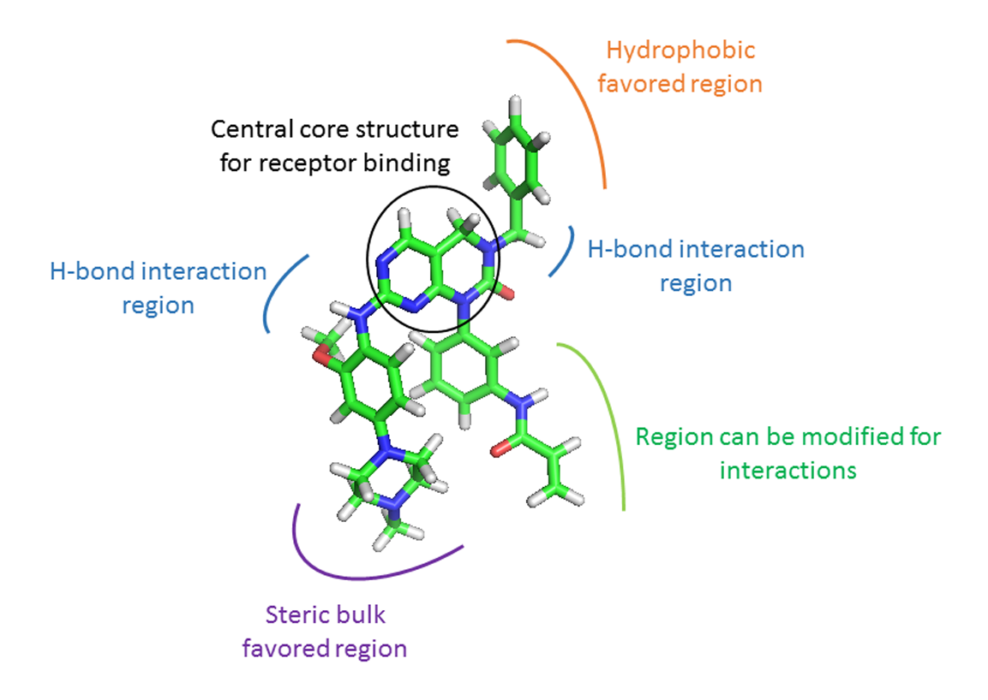
Figure 10. Identified structural requirements of novel pyrimidine derivatives as EGFR^{T790M/L858R} inhibitors summarized on template compound 17.

