**Supplementary information**

**Structural identification of novel pyrimidine derivatives as epidermal growth factor receptor inhibitors using 3D QSAR, molecular docking and MMGBSA analysis: a rational approach in anticancer drug design**

Pradip Jana a, Shivangi Agarwal a, Sushil K. Kashaw a, *

aDepartment of Pharmaceutical Sciences, Dr. Harisingh Gour University (A Central University), Sagar, MP, India



**Supplementary Figure 1.** Superimposition of co-crystalized gefitinib (sky) and re-docked co-crystalized gefitinib (purple) in the binding site of EGFRL858R/T790M protein (PDB ID: 4I22).

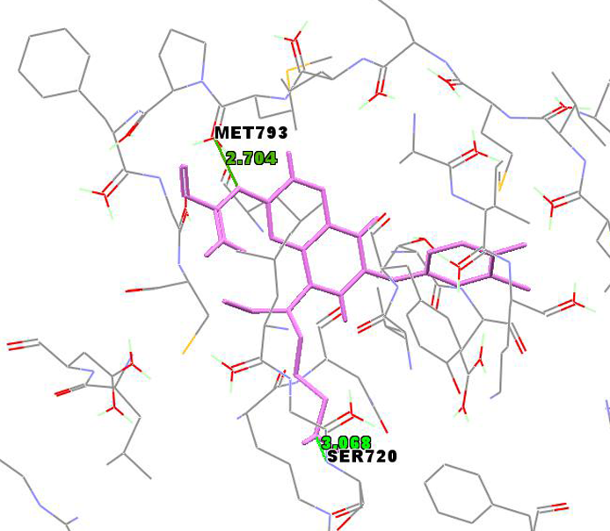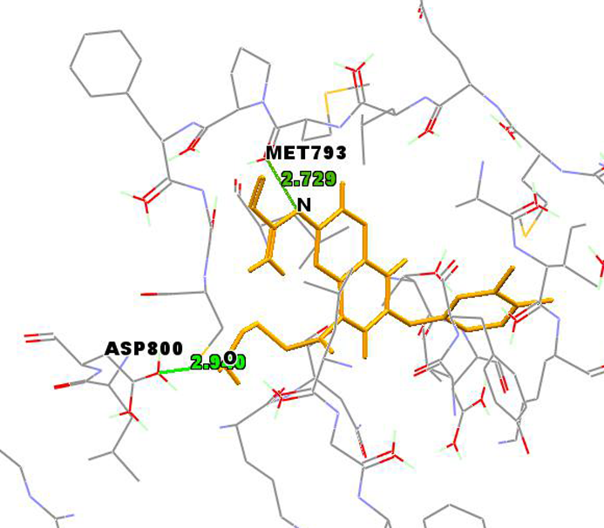

**(A) (B)**

**Supplementary Figure 2.** Binding interactions in between EGFRL858R/T790M protein and newly designed compounds. (A) Compound N4; (B) Compound N1.