Synthesis, X-ray structure and antibacterial evaluation of *P*-[{[bis (dimethylamino)phosphoryl]amino]} (2-chloroquinolin-3-yl)methyl]-, *P*- (quinolin-3-yl) tetramethylphosphonic diamides

Mona Arsanious1*● Ibtisam Henawy1● Lara Gigli2





 

**Fig. (1)**. Structures of phosphorotriamidate phosphonate and α-aminophosphonic acid derivatives



Fig. 2 Starting material

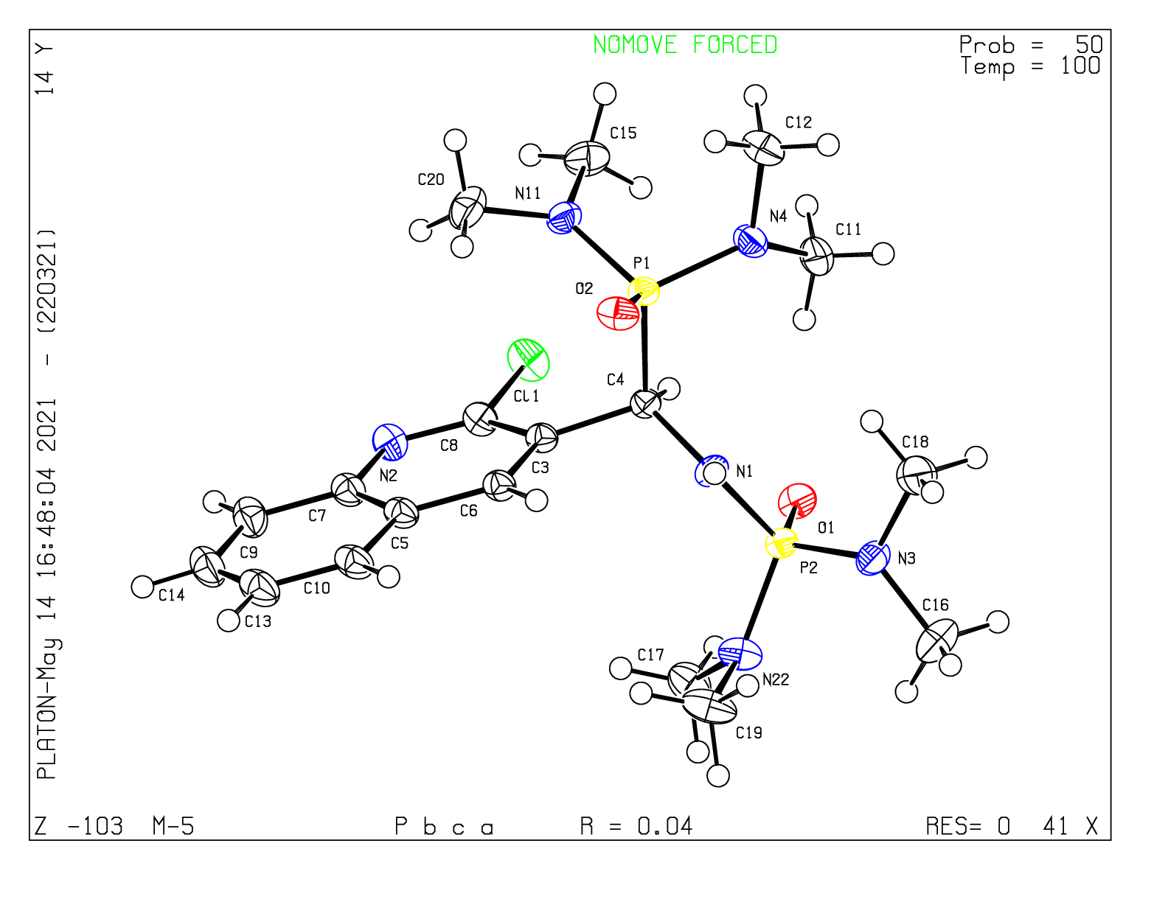

**Fig 3.** ORTEP diagram of compound **3**

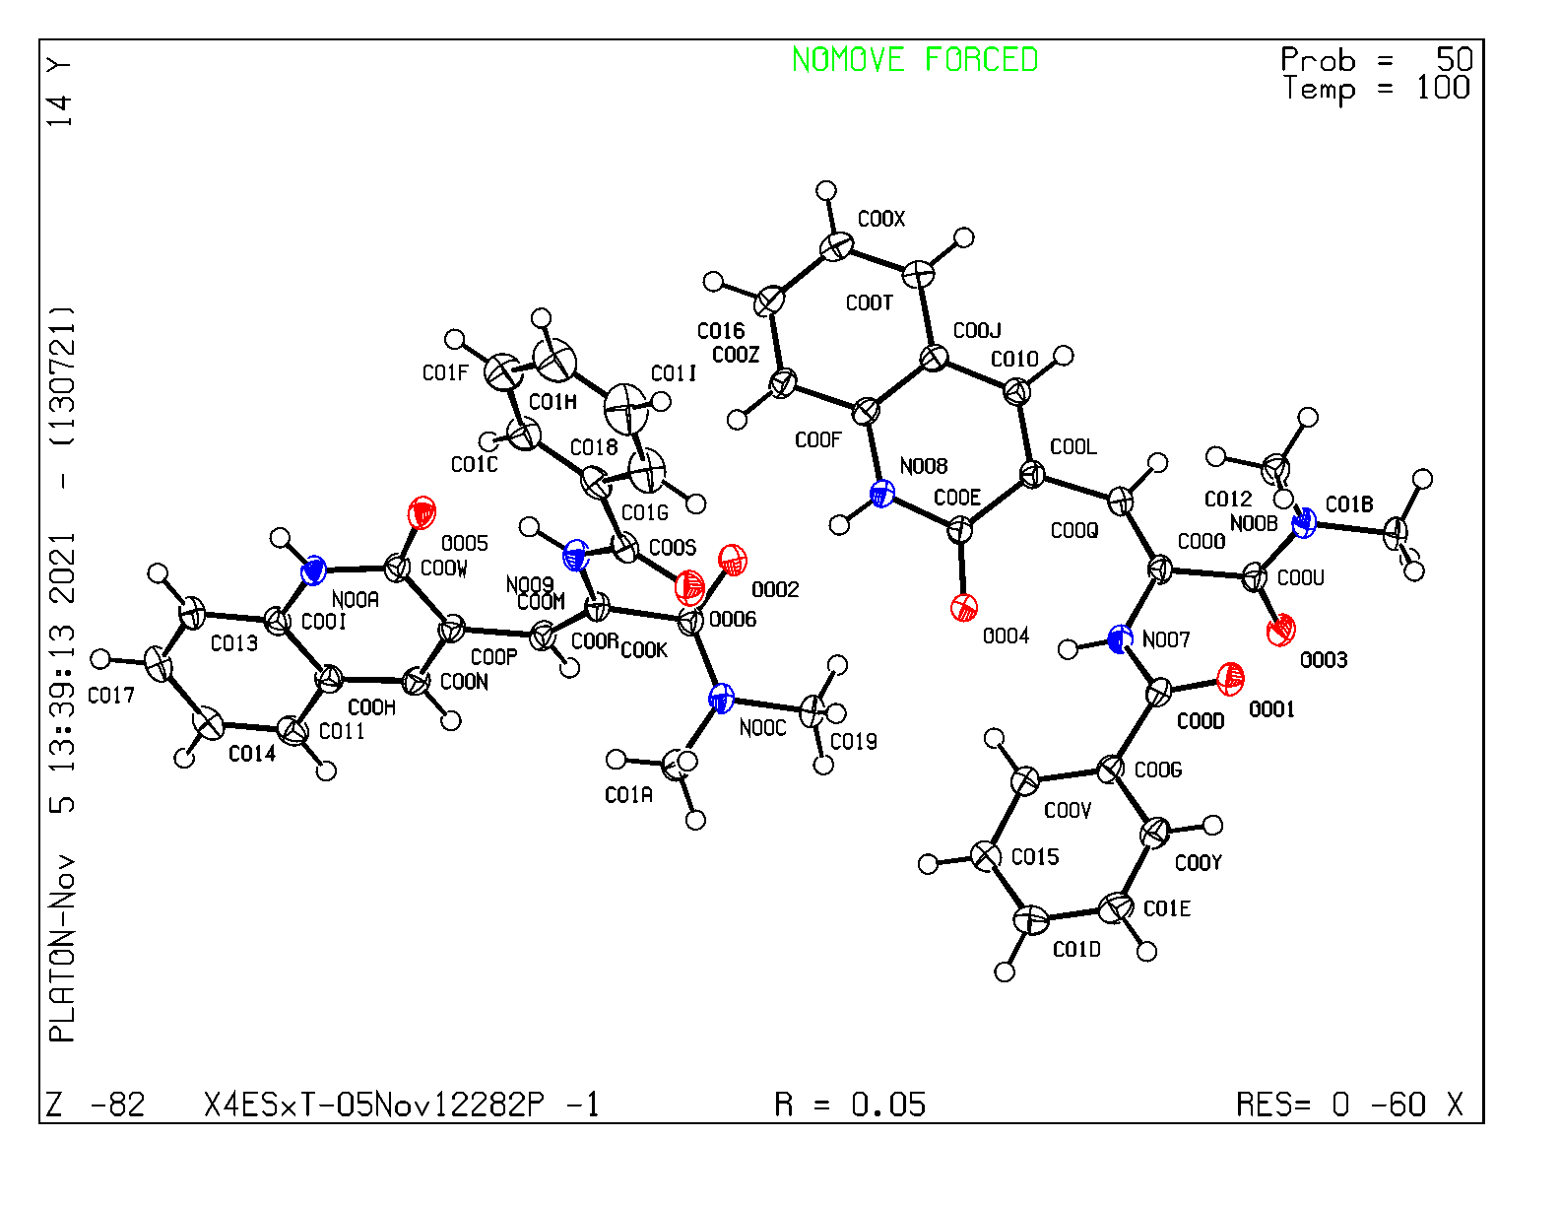

**Fig 3.** ORTEP diagram of compound **8**