**Graphical abstract :**

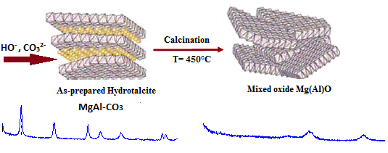



* The thermal treatment under air at 450°C of the synthesized materials resulted in decomposition of hydrotalcite structure and formation of Mg-Al mixed oxides.
* The evaluation of the basicity by chemisorption of phenol, showed that the number of basic sites varies in parallel with the molar ratio and the specific surface of these materials.