**Graphical Abstract**

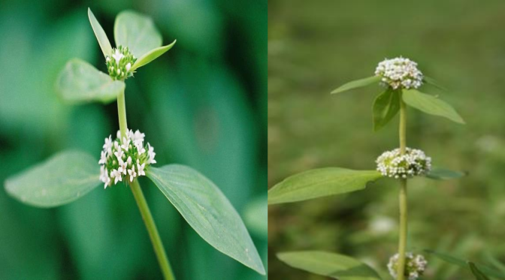

**n-butanol fraction of the seeds (IC50 of 0.293 mg/mL)** **(Antioxidant activity)**

*Mitracarpus scaber*

* Extracts of the leaves, stem, roots and seeds of *Mitracarpus scaber* plant have been fully investigated in an attempt to determine their phytochemical and antioxidant activities. For the first time
* The total flavonoid assay revealed a high content in the leaves (1.6236 %)
* Calculated IC50 showed that the n-butanol fraction of the seeds exhibited the highest activity with an IC50 of 0.293 mg/mL, less than ascorbic acid with an IC50 of 0.387 mg/mL.