A regio- and stereoselectivity and molecular mechanism study on the addition reactions of morpholine and m-CPBA to 9α-hydroxyparthenolide using DFT calculations

Sana EL HAMIDI¹, Wafaa BOUMYA¹, Redouan HAMMAL², Mohamed MOUMOU², Asmaa BEN NAJI¹, M’hamed SADIQ¹, Ahmed CHEKROUN², Ahmed BENHARREF², Noureddine BARKA^{1,*} and Mohamed ABDENNOURI¹

¹ Sultan Moulay Slimane University of Beni-Mellal, Research Group in Environmental Sciences and Applied Materials (SEMA), FP Khouribga, B.P. 145, 25000 Khouribga, Morocco.
² Cadi Ayyad University, Faculty of Sciences Semlalia, Laboratory of Biomolecular Chemistry Natural Substances and Reactivity (URAC 16), BP 2390, Marrakech, Morocco.

*Corresponding author: Tel.: +212661666622; fax: +212523490359; E-mail:barkanoureddine@yahoo.fr

Abstract: The chemoselectivity and stereospecificity of the addition of the morpholine and the meta-chloroperoxybenzoic acid (m-CPBA) onto 9α-hydroxyparthenolide was studied using Density Functional Theory (DFT) calculations at the B3LYP/6-311+G(d,p) computational level within the Molecular Electron Density Theory (MEDT), in order to demonstrate the key role of the Global Electron Density Transfer (GEDT) and to examine the polar character of these reactions. This work is divided into two parts; the first part concerns the reaction between the morpholine and the 9α-hydroxyparthenolide. The second part deals with the epoxidation of the 9α-hydroxyparthenolide by the m-CPBA followed by the addition of the morpholine to the major product resulting from the epoxidation step. The obtained results show that the reaction between the morpholine and the 9α-hydroxyparthenolide takes place on the double bond C₃=C₄. On the other hand, when 9α-hydroxyparthenolide is attacked by m-CPBA, the epoxidation reaction is carried out on the double bond C₁=C₂.

Keywords: 9α-Hydroxyparthenolide; Epoxidation; DFT; GEDT; Polar reactions.

1. Introduction
The regio and stereoselectivity in organic synthesis are crucial parameters, especially when the reaction product must be a particular regio- or stereoisomer, such as in the case of the pharmaceutical industry. Therefore, it is interesting to understand the parameters that induce the different types of selectivity and thus be able to control them, and in order to fully understand the chemical process of these reactions and provide valuable predictions to the experimenters, a theory study seems necessary.
It is important to point out that the study of the chemical reactivity of the compounds used in the manufacture of drugs has been the subject of enormous experiments carried out by researchers in order to find and invent efficient drugs for cancer, which remains one of the most serious health problems all over the world and one of the leading causes of death. Many chemotherapeutic agents have been developed to treat different types of cancer, but the use of these agents causes many undesirable effects. This clearly underlines the urgent need to develop novel chemotherapeutic agents with higher bioactivity and fewer side effects. One of the most promising approaches for obtaining novel therapeutic agents in medicinal chemistry is the functionalization of natural products.
In this context, studies have shown that the parthenolide (PTL), which is originally purified from the shoots of feverfew (Tanacetum parthenium), has shown potent anticancer and anti-inflammatory activities¹. However, this compound is faintly soluble in water, which limited its potential therapeutic use in human body. For this reason, the fixation amine groups to the parthenolide are necessary to make it more soluble and more biologically active. In view of the high biological activity of aminoparthenolides, a series of their hydroxy and epoxy-analogs types II and III (Scheme 1) were synthesized.
Generally, understanding the changes in these and other molecules during a chemical reaction is not easy in many cases because these changes take place in a very short time. For this reason, certain theories are important to examine and understand molecular reactivity and to study the reaction mechanisms.
Recently, the increase in computing power of computers, the improvement of algorithms and the development of original approaches in the methods of numerical resolution of the equations of quantum mechanics have made it possible to obtain numerical results very comparable to those measured during experiments. It is possible to access with very high precision all the electronic properties of chemical systems and to calculate their variations along the reaction paths. In particular, quantum theories of reactivity currently make it possible not only to develop reaction mechanisms and energy profiles, but also to justify and predict experimental chemo-, stereo- and regioselectivity.
In this study, we present theoretical justifications for the regio- and stereoselectivity experimentally observed during the addition of few molecules to the 9α-hydroxyparthenolide using the morpholine in the first step, then the epoxidation of the 9α-hydroxyparthenolide by the m-CPBA followed by the addition of the morpholine according to the reaction sequences proposed in the (Scheme 2). By the use of different theoretical approaches namely, the frontier molecular orbital theory (FMO), the calculation of activation energies and reactivity indices derived from DFT.

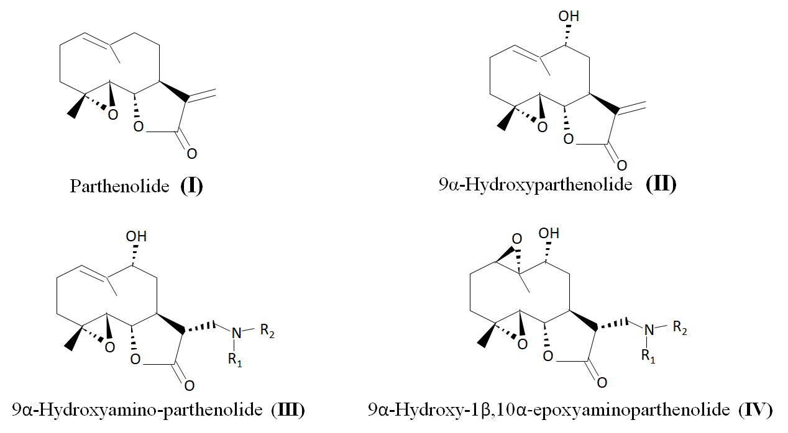
Scheme 1. Structure of the parthenolide and its derivatives.

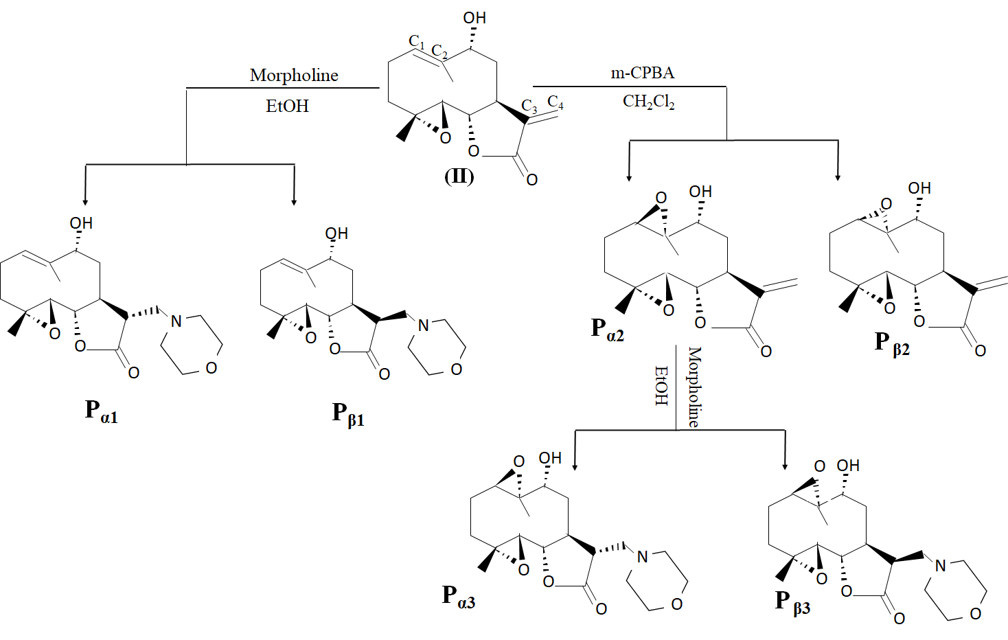
Scheme 2. Addition of the morpholine and the m-CPBA onto the 9α-hydroxyparthenolide.
2. Theoretical and computational methods
2.1. Global and local reactivity indices
Organic reactions can be classified as non-polar or polar depending on the overall electronic character of the bond formation and/or bond breaking along the reaction. The electrophilic or nucleophilic power of a molecule is related to its ability to exchange electron density along a reaction and the description of this power require to take into consideration clearly the electronic structure of the system and this could only be possible only with a quantum description.
Furthermore, and to solve the problem of studying the chemical reactivity of organic and pharmaceutical molecules and to explain why some sites of the molecules are more reactive than others, several theories have been established for the study of the chemical reactivity. Such as, the transition state theory (developed by Eyring in 1931) ³, frontier molecular orbital theory (initiated by K. Fukui in 1952) ⁴ and the density functional theory (proposed by G. Klopman in 1968) ⁵.
With the application of the quantum or molecular mechanics, it is possible to obtain several parameters such as structural parameters (bond lengths, valence angles, hydrogen bonds), the energy parameters (binding energy, enthalpy of formation), the electronic parameters (charges, orbital energies (Highest Occupied Molecular Orbital (HOMO), Lowest Unoccupied Molecular Orbital (LUMO)), E_{gap} (energy difference between E_{HOMO} and E_{LUMO})….).
The calculated levels of energy of HOMO and LUMO can be used for the calculation of other parameters, which informs us about the stability of the molecule, such as ionization energy (I), electron affinity (A), electronegativity (χ), electronic chemical potential (µ), chemical hardness (η), chemical softness (S), and electrophilicity index (⍵). The parameters were calculated using the following equations: Ionization Energy (I) = -E_{HOMO}, Electron Affinity (A) =-E_{LUMO}, Electronegativity (χ) = - (E_{HOMO}+E_{LUMO})/2 ⁶, Electronic Chemical Potential (µ) = - (χ) = (E_{HOMO}+E_{LUMO})/2 ⁷, Chemical Hardness (η)= (E_{LUMO} - E_{HOMO}) ⁸, Electrophilicity Index (⍵)=µ²/2η ⁹ and molecular softness (S) =1/2η ¹⁰. The nucleophilicity index N is expressed as a function of the HOMO energy of tetracyanoethylene (TCE) as N= E_{HOMO} (Nu) - E_{HOMO} (TCE) ¹¹.
In a polar reaction, the breaking and formation of bonds take place at a specific site of a reactive molecule, and if a molecule has several points with similar reactivity, we can talk of regio or chemoselectivity as in the case of cycloaddition reactions, in which the different approach modes of a reagent towards the other can yield two competitive regioisomers. The most favorable regioisomeric channel is that involving the bond formation between the most electrophilic and the most nucleophilic center of the reagents. Consequently, it is desirable to have local reactivity indices able to characterize these relevant centers and positions in organic molecules. The local electrophilicity index ω_{k}, the local nucleophilicity index N_{k}, the Parr functions () ¹² and the Fukui function ( ) ¹³ have been confirmed to be useful tools in the study of the regioselectivity in cycloaddition reactions and calculate as follows, the local electrophilicity and nucleophilicity indices were calculated as , respectively ¹², where electrophilic P_{k}⁺ and nucleophilic P_{k}⁻ Parr functions are obtained by analysis of the Mullikan atomic spin density (ASD) of the radical anion and radical cation of the reactants. The Fukui functions (FF) are calculated using the procedure proposed by Yang and Mortier, based on a finite difference method: (for nucleophilic attack), (for elecrtophilic attack) and (for radical attack), where ρ_{k}(N); ρ_{k}(N-1) and ρ_{k}(N+1) are the gross electronic populations of the site k in neutral, cationic, and anionic systems, respectively ¹⁴.

2.2. Computational details
DFT calculations were carried out using the Becke three-parameter hybrid exchange functional and the Lee-Yang-Parr correlation functional (B3LYP) ¹⁵ together with the standard 6-311+G(d,p) basis set ¹⁶. Optimizations were carried out using the Berny analytical gradient optimization method. The stationary points were characterized by frequency calculations in order to verify that the transition state (TS) have one and only one imaginary frequency. The IRC was performed and plotted to verify that the TS is well connected to both minima (reagents and products) ¹⁷⁻¹⁹.
The electronic structures of the stationary points and the bond orders (Wiberg indices) were analyzed using the natural bond orbital method (NBO) ^{18,19}. The values of enthalpies, entropies and free energies were calculated using standard statistical thermodynamics. The Gaussian 09W suite of programs was used in all calculations ²⁰.

3. Results and Discussion
3.1. Addition of morpholine and m-CPBA onto 9α-hydroxyparthenolide
3.1.1. Analysis of the CDFT indices of the reagents
Several studies devoted to organic reactions have shown that the analysis of the reactivity indices defined within the conceptual density functional theory (CDFT) is a powerful tool to understand the reactivity in polar reactions. Global DFT reactivity indices, namely, the electronic chemical potential µ, chemical hardness η, softness S, electrophilicity ⍵, nucleophilicity N indices and the maximum number of electrons transferred ∆N_{max} of reagents are given in Table 1. The table indicates that, the electrophilic and nucleophilic character of 9α-hydroxyparthenolide changes from one reaction to the other, depending on the attack reagent. In the first reaction, the electronic chemical potential of morpholine, μ = -3.103 eV, is higher than that of the 9α-hydroxyparthenolide, μ= -4.239 eV. Thus, signifying that the global electron density transfer (GEDT) will go from the morpholine towards the 9α-hydroxyparthenolide. The morpholine presents an electrophilicy ω index of 0.755 eV and a nucleophilicity N index of 2.851 eV, being classified as strong nucleophile than the 9α-hydroxyparthenolide, which has an electrophilicy ω index of 1.890 eV and a nucleophilicity N index of 2.524 eV. Consequently, the 9α-hydroxyparthenolide behaves as an electrophile, while the morpholine behaves as a nucleophile.
In the second reaction, the electrophilicity ⍵ and the nucleophilicity N indices and the electronic chemical potential µ of the 9α-hydroxyparthenolide were 1.878, 2.495 and -4.246 eV, respectively. While those corresponding to m-CPBA were 2.147, 1.779 and -4.748 eV, respectively. These results indicate that the 9α-hydroxyparthenolide is a nucleophile, while, m-CPBA is an electrophile. The electrophilicity ⍵ and nucleophilicity N values indicate that the epoxidation reaction will have a high polar character, in agreement with high difference between their electronic chemical potentials µ.
On the other hand, the prediction of the character electrophilic/nucleophilic is well confirmed also by the frontier molecular orbital theory, so that the formation of the complex results by an exchange of electrons between the two-molecular orbital HOMO of the donor (nucleophile) and LUMO of the acceptor (electrophile). The reaction corresponding to the lowest difference of energy between the two orbital HOMO and LUMO is always favored. The energy gap in reaction (1) between HOMO of the morpholine and LUMO of the 9α-hydroxyparthenolide, ∆E_{gap1} = 4.427 eV smaller than the energy gap between HOMO of the 9α-hydroxyparthenolide and LUMO of the morpholine, ∆E_{gap1’} = 6.699e, confirming that the global electron density transfer will go from the morpholine towards the reagent (II). But in the reaction (2), ∆E_{gap} between HOMO of the compound (II) and LUMO of the m-CPBA, ∆E_{gap2}= 4.522 eV is smaller than the energy gap between HOMO of the m-CPBA and LUMO of (II), ∆E_{gap2}’= 5.516 eV, confirming that the GEDT will go from the compound (II) towards the m-CPBA (Figure 1).

Table 1. Electronic chemical potential μ, chemical hardness η, electrophilicity ω, nucleophilicity N and softness S calculated using B3LYP/ 6-311+G (d,p) (eV).

 | Reaction 1 (In DCM) |  | Reaction 2 (In Ethanol)
 | 9α-hydroxyparthenolide | Morpholine | 9α-hydroxyparthenolide | m-CPBA
µ | -4.239 | -3.103 | -4.246 | -4.748
ɳ | 4 .754 | 6.372 | 4.799 | 5.238
⍵ | 1.890 | 0.755 | 1.878 | 2.147
N | 2 .524 | 2.851 | 2.495 | 1.779
S | 0.105 | 0.078 | 0.104 | 0.095
∆N_{max} | 0.891 | 0.486 | 0.884 | 0.905

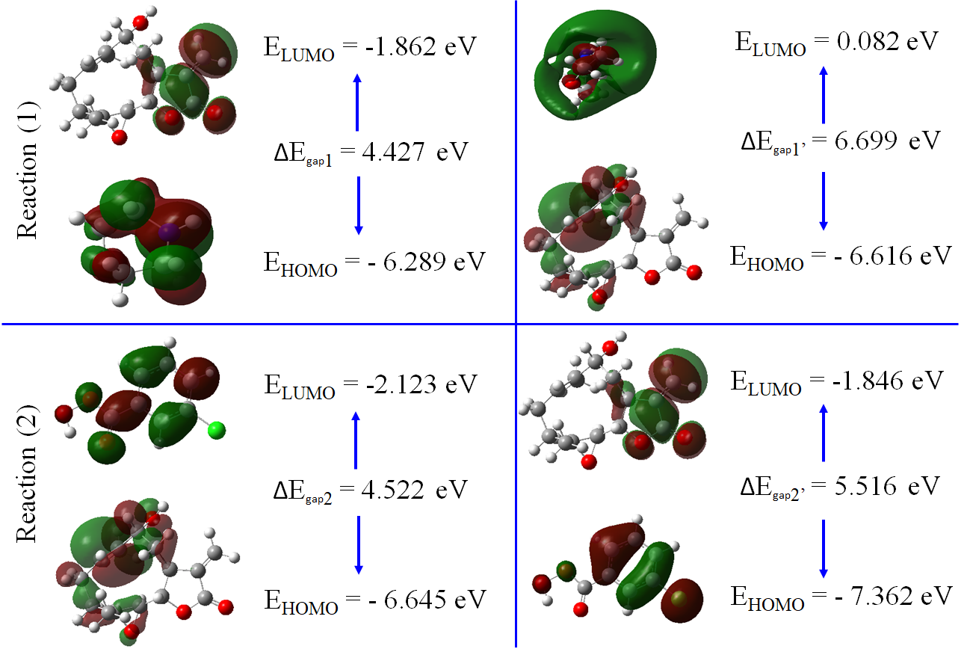

Figure 1. Energy gap between HOMO and LUMO of reagents in path reactions.
3.1.2. Using electrophilicity and nucleophilicity indices to predict the regio and stereoselectivity of the reactions
In reactions involving the participation of non-symmetric reagents, the most favorable reactive channel was that associated by the initial two-center interaction between the greatest electrophilic center of the electrophile unit and the greatest nucleophilic one of the nucleophile entities. Recently, Domingo et al.¹¹ proposed the electrophilic P_{k}⁺ and nucleophilic P_{k}⁻ Parr functions derived from the changes of spin electron-density reached via the GEDT process from the nucleophile to the electrophile as a powerful tool for the study of the local reactivity in polar processes. Accordingly, the nucleophilic P_{k}⁻ Parr functions of morpholine and the electrophilic P_{k}⁺ Parr functions of the compound (II) were analyzed in order to characterize the most electrophilic and nucleophilic centers of the species involved in this reaction and, thus, to explain the regioselectivity experimentally observed. Figure 2 shows that the Mulliken atomic spin densities of the radical cation and radical anion, together with the nucleophilic P_{k}⁻ Parr functions of morpholine and the electrophilic P_{k}⁺ Parr functions of (II).

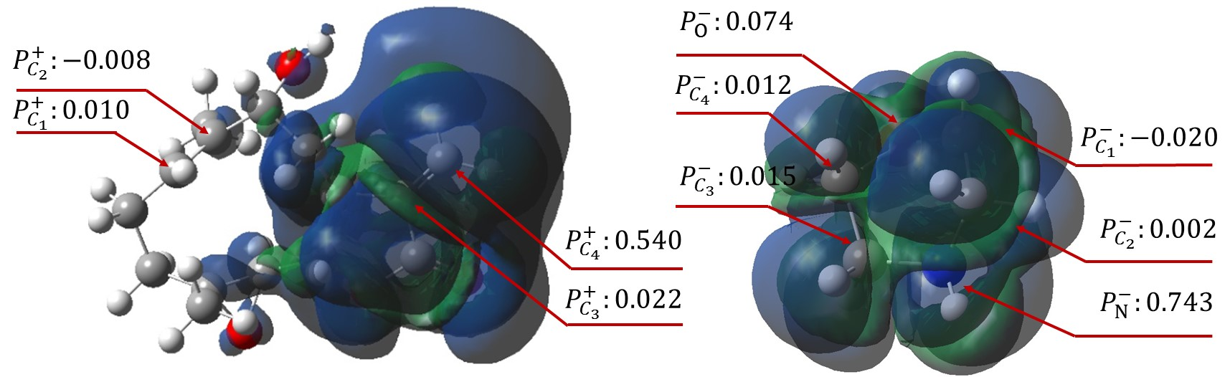
Figure 2. Three-dimensional representations of the Mulliken atomic spin densities (ASD) of radical anion (II) and radical cation (Morpholine), together with the nucleophilic P_{k}⁻of morpholine and electrophilic P_{k}⁺ Parr functions of (II).

Analysis of the nucleophilic P_{k}⁻ Parr functions at the reactive sites of morpholine indicates that the azote atom, with a P_{k}⁻ value of 0.743 is nucleophilically activated, the latter more than the others atoms. On the other hand, the electrophilic P_{k}⁺ Parr functions at the reactive sites of 9α-hydroxyparthenolide indicate that the more electrophilic center is the C₄ carbon atom, possessing the maximum value of 0.540 fellowed by the C₃ carbon atom, with a P_{k}⁺ value of 0.022. These results indicate that the most reactive fragment of 9α-hydroxyparthenolide is the C₃-C₄ double bond than the other double bond C₁-C₂. While in the other steep, analysis of the nucleophilic P_{k}⁻ Parr functions for 9α-hydroxyparthenolide indicates that the two carbons of the C₁–C₂ double bond are more nucleophilically activated, P_{k}⁻ = 0.318 and 0.466, than those of the C₃–C₄ double bond, P_{k}⁻ = -0.021 and 0.005. Consequently, as expected, the attack will take place on C₁–C₂ double bond rather than C₃–C₄ double bond of the compound (II). The asymmetric nucleophilic activation of the exocyclic double bond accounts for the asynchronicity found in the formation of the two C–O single bonds in these epoxidation reactions. Therefore, it is expected that the attack of m-CPBA takes place on the C₁–C₂ double bond of (II), in excellent agreement with experimental outcomes ¹. Analysis of the electrophilic P_{k}⁺ Parr functions for m-CPBA indicates that the oxygen atom O* is the most electrophilic center of this molecule, P_{k}⁺ = 0.018 (Figure 3).
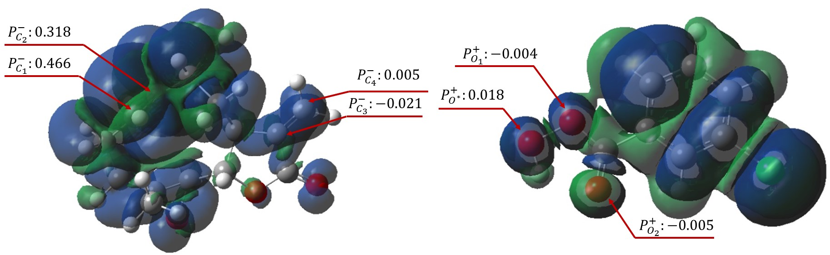
Figure 3. Three-dimensional representations of the (ASD) of the reagents (II) and m-CPBA, together with the nucleophilic P_{k}⁻of (II) and electrophilic P_{k}⁺ Parr functions of m-CPBA.
3.1.3. Analysis of the potential energy surface and prediction of the reaction mechanism
Due to the asymmetry of both reagents in each reaction, two competitive channels are feasible for the reaction between 9α-hydroxyparthenolide and morpholine. As shown in Scheme 3, they are related to the two stereoisomeric approach modes of C₃-C₄ double bond, named endo P_{α1} and exo P_{β1}. Same thing for the epoxy reaction of the compound (II) with the m-CPBA leads to a regio-stereoselective reaction with two products P_{α2} and P_{β2} in C₁-C₂ double bond (Scheme 3).
In ethanol, the activation energies associated with the reaction between the reactant (II) and the morpholine was occurred on the two faces of C₃-C₄ double bond. This reaction possesses an activation energy of 33.25 kcal/mol via TS_{α1}, leading to formation of the most favorable, P_{α1}, and 37.02 kcal/mol passing by TS_{β1}, with formation the least favorable, P_{β1}. In dichloromethane, the epoxidation of (II) by the m-CPBA presents an activation energy, 10.63 kcal/mol via TS_{α2}, with formation the most favorable, P_{α2}, and 15.02 kcal/mol by way of TS_{β2}, with formation the least favorable, P_{β2}.
Therefore, these energy results calculated by CDFT of transition states for the (1) and (2) reactions showed to proceed through a concerted pathway, and were in agreement with the experimentally observed regio and stereoselectivity ²⁰.
An analysis of the stationary points involved in the two stereoisomeric paths indicates that this reaction takes place through a one-step mechanism. Consequently, four TSs, TS_{α1}, TS_{β1}, TS_{α2} and TS_{β2} were located and characterized on the potential energy surface (PES) of these reactions. Relative enthalpies, ∆H and Gibbs free energies, ∆G, for the species involved in the reaction between the compound (II) and the morpholine in the presence of ethanol and in the reaction between the compound (II) and the m-CPBA in the presence of dichloromethane are displayed in Table 2.

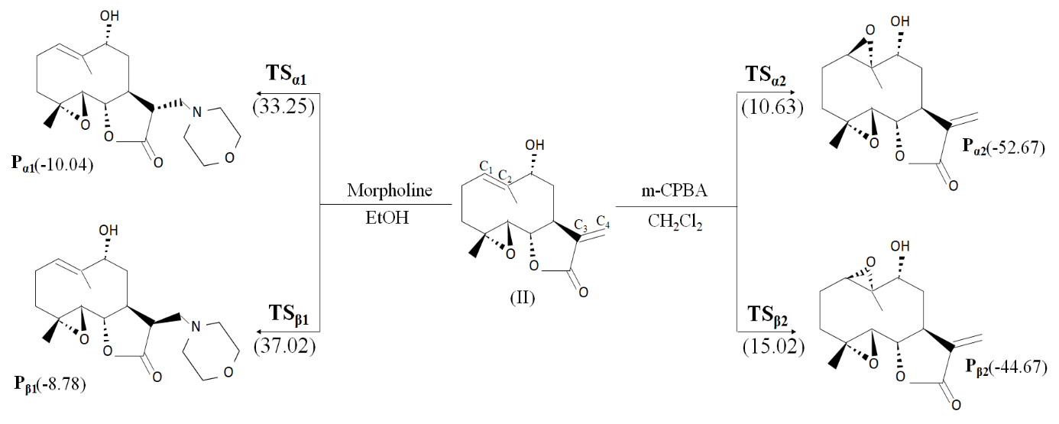
Scheme 3. Reaction between (II) and morpholine (1), (II) and m-CPBA (2), B3LYP/6-311+G (d,p) relative energies, in kcal/mol, are given in parentheses.

Table 2. B3LYP/6-311+G(d.p) relative enthalpies and Gibbs free energies, computed at room temperature and 1 atm for the stationary points involved in reaction between morpholine, m-CPBA and (II)
 | System | G (a.u) | H (a.u) | ∆G(Kcal/mol) | ∆H(Kcal/mol) | υ (cm⁻¹)
Reaction 1 | II | -884.441 | -884.376 | - | -
Reaction 1 | Morpholine | -287.771 | -287.735 | - | -
Reaction 1 | TS_{α1} | -1172.140 | -1172.061 | 45.18 | 31.37 | -1768.97
Reaction 1 | TS_{β1} | -1172.134 | -1172.054 | 48.94 | 35.76 | -1740.68
Reaction 1 | P_{α1} | -1172.225 | -1172.131 | -8.15 | -12.55
Reaction 1 | P_{β1} | -1172.222 | -1172.122 | -6.27 | -6.90
Reaction 2 | II | -884.439 | -884.440 | - | -
Reaction 2 | m-CPBA | -955.649 | -955.602 | - | -
Reaction 2 | TS_{α2} | -1840.060 | -1840.030 | 17.57 | 7.53 | -371.67
Reaction 2 | TS_{β2} | -1840.020 | -1840.011 | 42.67 | 19.45 | -359.20
Reaction 2 | P_{α2} | -959.662 | -959.597 | -49.57 | -10.04
Reaction 2 | P_{β2} | -959.649 | -959.584 | -41.41 | -1.88

Some appealing conclusions can be drawn from these energy results relative enthalpies and Gibbs free energies of the stationary points and the TS of the two reactions (1) and (2) are given in Table 2:
- The activation enthalpy energy associated with the most favorable product performed by the reaction of the compound (II) and the morpholine show that TS_{α1} is located 4.39 kcal/mol below TS_{β1}.
- The activation Gibbs free energy associated with the most adequate (Pα₁) reaction channel being by -8.15 kcal/mol. These values show that this reaction between (II) and morpholine is energetically exergonic.
About the epoxy reaction, the calculation of the energies of the reactants, the products obtained, TS_{α2} and TS_{β2} transition states energies at the C₁=C₂ double bond of (II) and the difference in transition energy show that the attack is kinetically preferred at α side (Table 2). This result shows that:
- The activation energies corresponding to the attack at the two sides of the C₁=C₂ double bond of (II) are 17.57 kcal mol⁻¹ at α side and 42.67 kcal mol⁻¹ at β side, showing that the formation of α isomers is kinetically preferred to the formation of β isomers;
- The formation of P_{α2} and P_{β2} is an exergonic reaction, by - 49.57 and - 41.41 kcal.mol⁻¹, respectively.
We also notice that the energy barrier corresponding to the approach to the α-side in two reactions is less than the corresponding one to the β-side (Figure 4). This result allows us to conclude that α-attack is kinetically and thermodynamically favored. It also explains the great stereoselectivity observed experimentally ²⁰.
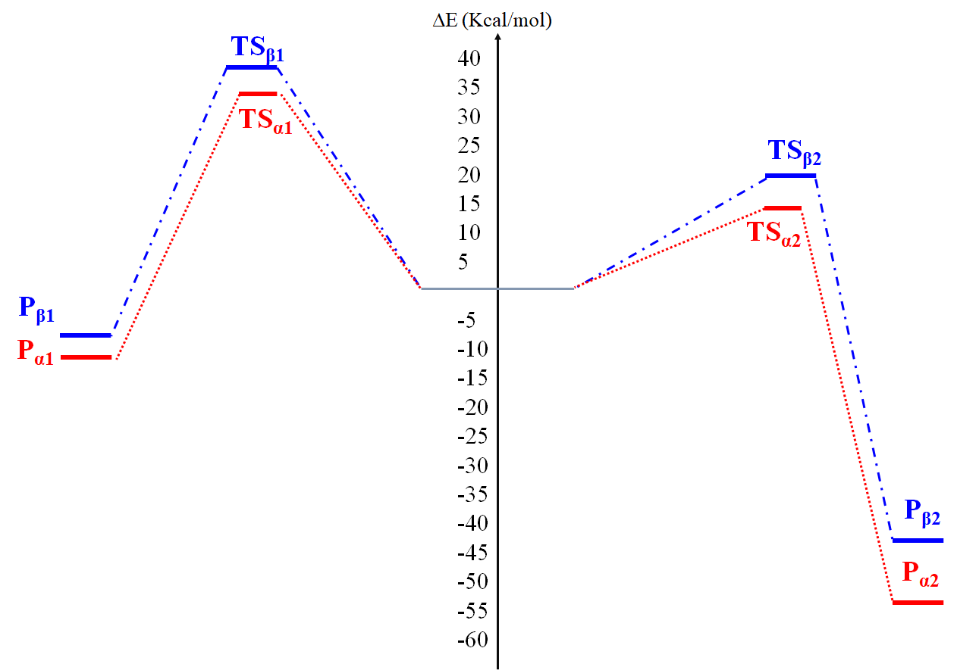
Figure 4. Energy profile of reactions between morpholine, m-CPBA and 9α-hydroxyparthenolide.

3.2 Addition of morpholine onto major product P_{α2}
The epoxidation reaction of the compound (II) by the m-CPBA is followed by the addition of morpholine to the major product P_{α2}, which the attack is carried out on the remaining C₃-C₄ double bond with two possible products P_{α3} and P_{β3} (Scheme 4).
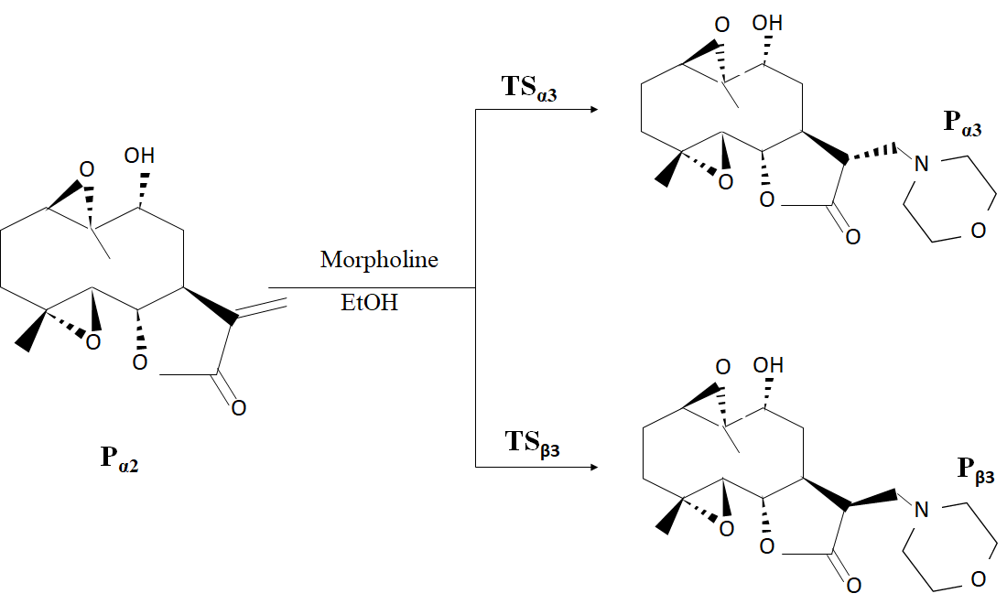
Scheme 4. Addition reaction of morpholine onto P_{α2} product.
3.2.1. Analysis of intramolecular chemical descriptors of the reaction between P_{α2} and morpholine
In order to predict the reactivity of reagents in reaction between morpholine and the major product, P_{α2}, founded as from the epoxy reaction of (II), we used B3LYP/6-311+G(d,p) level to calculate the global reactivity indices, Table 3 summarizes the obtained values of energy of HOMO and LUMO, difference between ε(HOMO) and ε(LUMO) ∆E_{gap}, electronic chemical potential μ, chemical hardness η, global electrophilicity ω, nucleophilicity N and softness S of P_{α2} and morpholine.
The high difference between P_{α2} and morpholine electronic chemical potential, 1.65 eV, indicate that this reaction has an important polar character. The morpholine behaves as nucleophile with an electrophilicy ω index of 0.755 eV and a nucleophilicity N index of 2.851 eV. While P_{α2} is classified as strong electrophile by ω index of 1.975 eV and a nucleophilicity N index of 1.527 eV.
To confirm the character electrophilic/nucleophilic of reagents, we have calculated the energy gap between HOMO and LUMO of reactive molecules in this reaction. ∆E_{gap} between HOMO of P_{α2} and LUMO of morpholine, ∆E_{gap} = 6.531 eV is higher than the energy gap between HOMO of morpholine and LUMO of P_{α2}, ∆E_{gap’} = 4.396e confirming that the GEDT will go from the morpholine towards P_{α2}.

Table 3. Intramolecular chemical descriptors (eV) for P_{α2} and morpholine, taking the HOMO energy of tetracyanoethylene (TCE) as a reference [ε_{HOMO} (TCE) = - 0.3359 (a.u) = -9.1413 (eV)].
 | P_{α2} |  | Morpholine
ε(HOMO) | -7.613 | ∆E_{gap}= 6.531 | -6.289 | ∆E_{gap}’= 4.396
ε(LUMO) | -1.893 | ∆E_{gap}= 6.531 | -0.082 | ∆E_{gap}’= 4.396
µ | -4.753 |  | -3.103
ɳ | 5.719 |  | 6.372
⍵ | 1.975 |  | 0.755
N | 1.527 |  | 2.851
S | 0.087 |  | 0.078
∆N_{max} | 0.831 |  | 0.486

3.2.2 Kinetic and thermodynamic study
We studied the stereoselectivity of the addition of morpholine to P_{α2}, the major product obtained from the epoxidation reaction of 9α-hydroxyparthenolide. This addition has been examined for both α and β sides. Calculated energies using DFT method of the reagents, the obtained products, TS_{α3}, TS_{β3} at the C₃=C₄ double bond of P_{α2} and the difference in transition energy are listed in Table 4.
From energies given in Table 4, we can deduce that:
- The transition state energy of the β side of double bond C₃=C₄ is located in front of 32.80 and 30.34 kcal/mol above the transition state energy of the α side respectively;
- The formation of products P_{α3} and P_{β3} are exothermic reaction by -16.16 and -10.13 kcal/mol respectively.

These values show that the reaction between P_{α2} and morpholine is energetically exothermic. We also notice that the energy barrier corresponding to the approach of the α-side is less than the corresponding one of the β-side. These results allow us to conclude that α-attack is kinetically and thermodynamically favored.
Therefore, these energy results calculated by CDFT of transition states for this reaction showed to proceed through a concerted pathway, and were in agreement with the experimentally observed regio and stereoselectivity in previous studies by our co-authors ²⁰.

Table 4. Thermodynamic energies of the reaction between P_{α2} and morpholine calculated using B3LYP/6-311+G (d,p) basis set.
 | E (a.u) | G (a.u) | H (a.u) | ∆E(Kcal/mol) | ∆G(Kcal/mol) | ∆H(Kcal/mol)
P_{α2} | -959.953 | -959.665 | -959.600
Morpholine | -287.876 | -287.771 | -287.735
TS_{α3} | -1247.780 | -124.365 | -1247.285 | 30.34 | 44.55 | 31.37
TS_{β3} | -1247.777 | -1247.369 | -1247.289 | 32.80 | 42.04 | 28.86
P_{α3} | -1247.855 | -1247.438 | -1247.358 | -16.16 | -1.25 | -14.43
P_{β3} | -1247.845 | -1247.429 | -1247.348 | -10.13 | 4.39 | -8.15

3.2.3. Analysis of the IRC of the reaction between P_{α2} and morpholine
The cycloaddition reaction may have one of two main mechanisms, concerted or stepwise. The concerted mechanism involves a single step with asynchronous formation of two bonds, or a single step with two phases, characterized by the formation of the first bond followed by closure of the cycle without the formation of a stable intermediary reactant, while the two-step mechanism involves an intermediary reactant. Moreover, we studied the molecular system as it develops during the reaction between P_{α2} and morpholine by calculating the intrinsic reaction coordinate (IRC) in order to show that the transition state is indeed linked to the two minima (reactants and product).
The plots E=f(IRC) corresponding to all possible pathways are shown in Figure 5. IRC calculation shows that this reaction follows a concerted mechanism in a single step but in two phases. Analysis of the IRC calculated using B3LYP/6-311+G(d,p) basis set shows that whatever quantity of morpholine is used in the interaction with P_{α2}, the transition states are reached without going through a stable intermediary stage.

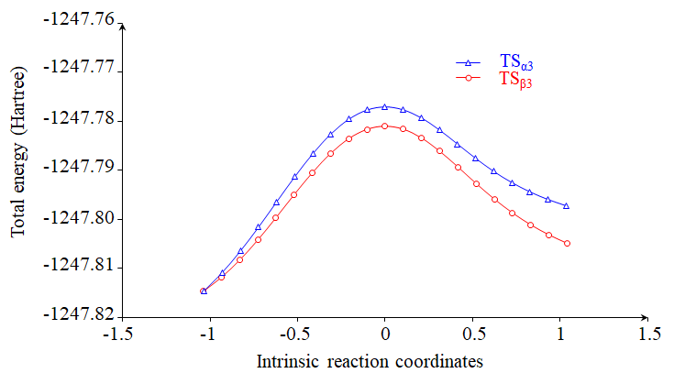
Figure 5. IRC profiles of the reaction between P_{α2} and morpholine calculated using B3LYP/6-311+G (d,p) level.

3.3. Structural analysis of the transition states of all reactions
The geometries of the TS associated with the studied reactions are shown in Figure 6. The lengths of the two forming bonds at the TS associated with the reaction between the reagents in each reaction are different, indicate that they are associated with slightly asynchronous.
In order to evaluate the polar nature of the all studied reaction. The GEDT values computed at the TS of the reaction between the compound (II) and morpholine are: 0.378e at TS_{α1} and 0.396e at TS_{β1}, and TS of the reaction of (II) with m-CPBA are: 0.580e and 0.593e at TS_{α2} and TS_{β1}, respectively. While, for the TS of the reaction between P_{α2} and morpholine are: 0.342e and 0.368e at TS_{α3} and TS_{β3}, respectively. These very high values indicate the polar character of these reactions, in a perfect much agreement with the analysis of the CDFT reactivity indices of the reagents.

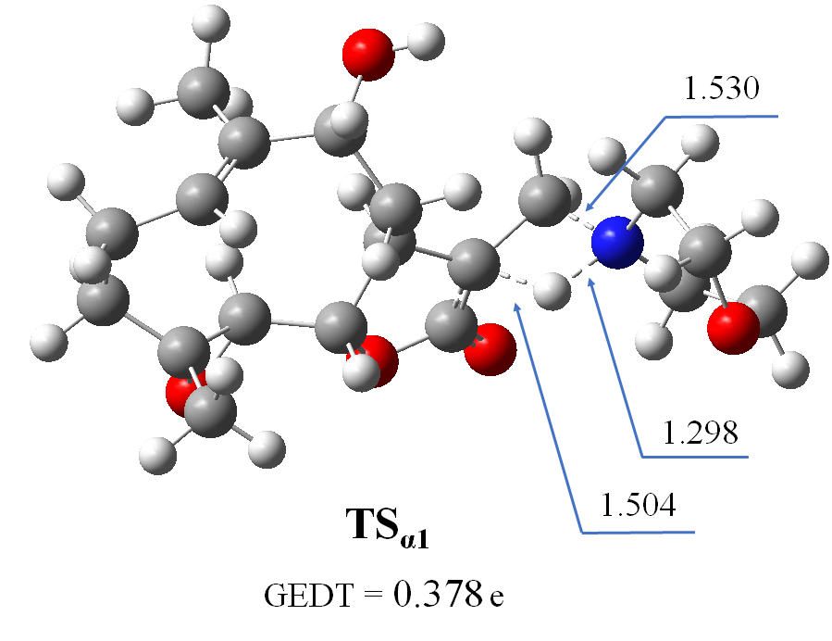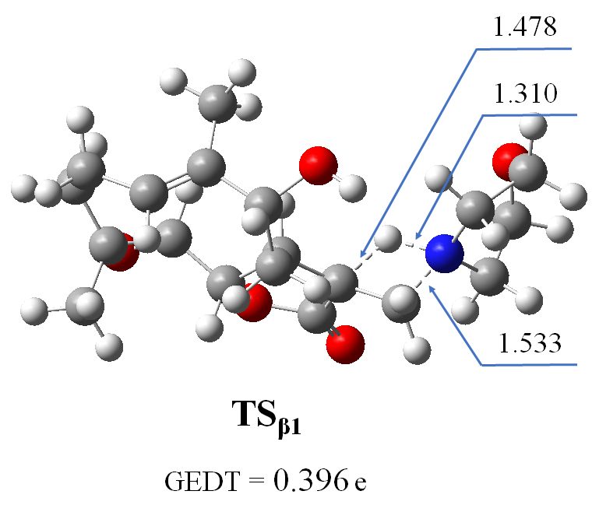
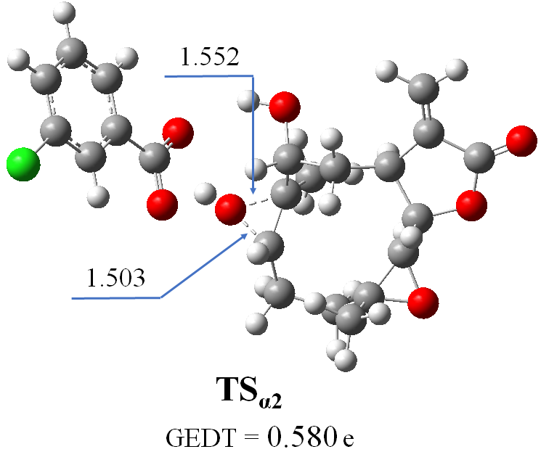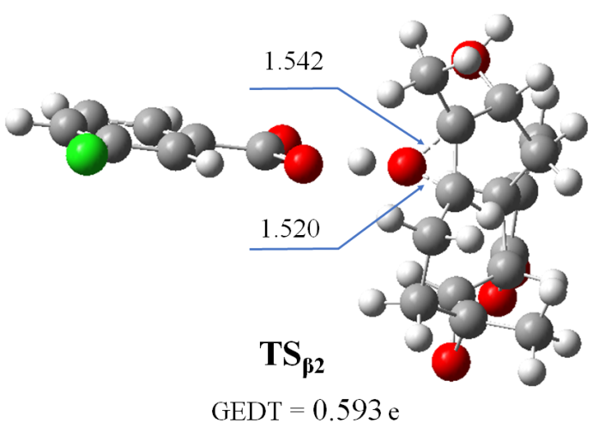
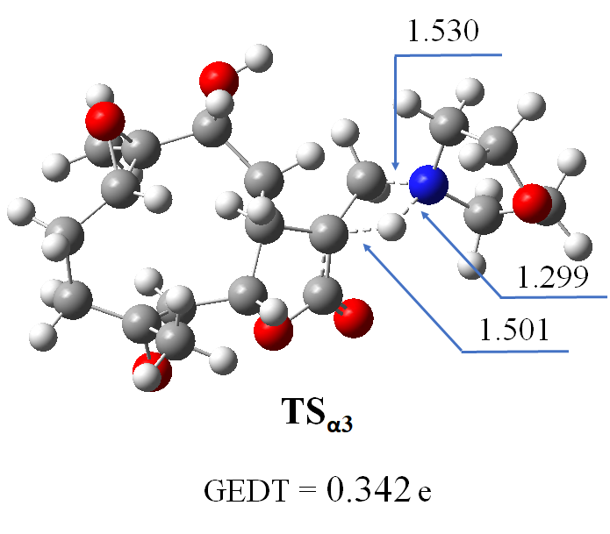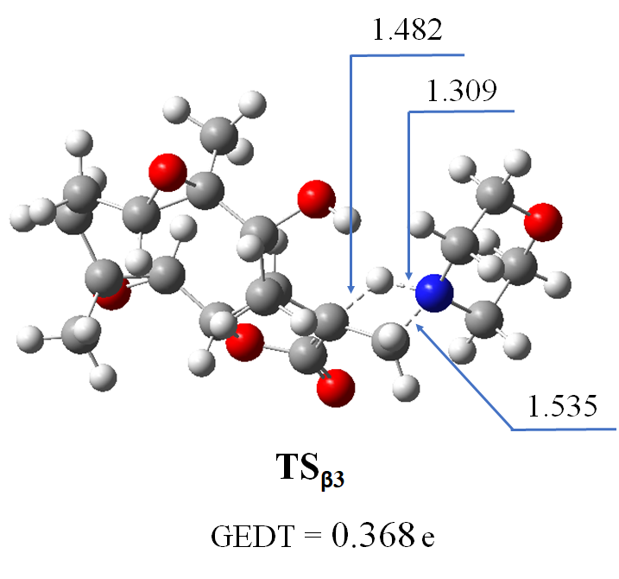

Figure 6. Geometries and lengths of the forming bonds, in Angstroms, and GEDT values, in e, of the TS involved in all reactions.

4. Conclusion

The mechanism of the chemo- and the stereoselectivity for the addition of morpholine and m-CPBA onto 9α-hydroxyparthenolide was studied using B3LYP/6-311+G (d, p). The theoretical results obtained enabled us to conclude that the activation energies and reactivity indices calculated correctly predicted the chemoselectivity experimentally observed for the studied reactions. In the first step, the reaction between the morpholine and the 9α-hydroxyparthenolide takes place on the double bond C₃=C₄ giving two products P_{α1} and P_{β1}, with P_{α1} as the major product according to kinetic and thermodynamic calculations. On the other hand, when 9α-hydroxyparthenolide is attacked by m-CPBA, the epoxidation reaction is carried out on the double bond C₁=C₂ of the compound (II), producing a minority of the β-stereoisomer, referred as P_{β2} and a majority of the α-stereoisomer, referred to here as P_{α2}. This latter was thereafter treated with morpholine via an exothermic reaction leading to the formation of the two products P_{α3} and P_{β3} who are formed at the α and β sides, respectively, of the C₃=C₄ double bond of P_{α2}. The product P_{α3} is kinetically and thermodynamically favored with a high stereoselectivity.
The results we found do affirm that the density functional theory has given a conceptual framework to the study of the reactivity and selectivity of a chemical reaction through local and global descriptors and the polar character of these reactions is correlated with the course of the corresponding GEDT to TS in such a way that the higher the GEDT implies that the activation energy is low and the reaction is polar.

References

1- A. Ghantous, A. Sinjab, Z. Herceg, N. Darwiche, Parthenolide: from plant shoots to cancer roots, Drug discovery today, 2013,18, 894–905.
2- M. Moumou, A.R. El Bouakher, H. Allouchi, A. El Hakmaoui, A. Benharref, V. Mathieu, G. Guillaumet, M. Akssira, Synthesis and biological evaluation of 9α- and 9β-hydroxyaminoparthenolides as novel anticancer agents, Bioorg. Med. Chem. Lett., 2014, 24, 4014-4018.
3- H. Eyring, the energy of activation for bimolecular reactions involving hydrogen and the halogens, according to the quantum mechanics, J. Am. Chem. Soc., 1931, 53, 2537-2549.
4- K. Fukui, T. Yonezawa, H. Shingu, A molecular orbital theory of reactivity in aromatic hydrocarbons, J. Chem. Phys., 1952, 20, 722-725.
5- G. Klopman, Chemical reactivity and the concept of charge-and frontier-controlled reactions, J. Am. Chem. Soc., 1968, 90, 223-234.
6- R.G. Parr, R.G. Pearson, Absolute Hardness: Companion Parameter to Absolute Electronegativity, J. Am. Chem. Soc., 1983, 105, 7512-7516.
7- S. El Hamidi, M. Khnifira, A. Elhalil, R. Hammal, N. Barka, M. Sadiq, A. Benharref, H. Lafridi, H. Zgou, M. Abdennouri, A theoretical study of regio and stereoselectivity nitration of thymol and carvacrol using DFT approach, Mor. J. Chem., 2019, 7, 363-372.
8- L.R. Domingo, M.R. Gutiérrez, P. Pérez, A new model for C-C bond formation processes derived from the Molecular Electron-Density Theory in the study of the mechanism of [3+2] cycloaddition reactions of carbenoid nitrile ylides with electron- deficient ethylenes. Tetrahedron, 2016, 72, 1524- 1532.
9- R.G. Parr, L.V. Szentpaly, S. Liu, Electrophilicity index, J. Am. Chem. Soc., 1999, 121, 1922-1924.
10- R. Hammal, M. Zoubir, A. Benharref, A. El Hajbi, Natural Bond Orbital Population Analysis of α-trans-himachalene, J. RJPBCS, 2017, 8(6), 423-432.
11- L.R. Domingo, P. Pérez, The nucleophilicity N index in organic chemistry, J. Org. Biomol. Chem. 2011, 9, 7168-7175.
12- L.R. Domingo, P. Pérez, J.A. Sáez, Understanding the local reactivity in polar organic reactions through electrophilic and nucleophilic Parr functions. RSC Advances 2013, 3, 1486-1494.
13- A. Zeroual, R. Hammal, A. Benharref, A. El Hajbi, The regio- and stereoselective addition of dibromocarbene and dichlorocarbene onto β-himachalene, Mor. J. Chem., 2015, 3, 698-704.
14- W. Yang, W.J. Mortier, The Use of Global and Local Molecular Parameters for the Analysis of the Gas-Phase Basicity of Amines, J. Am. Chem. Soc., 1986, 108, 5708-5711.
15- R.K. Otmane, T.S. Ouk, R. Bahadi, A. Bouzina, S.D. Djouad, K. Bechlem, R. Zerrouki, T. Ben Hadda, F. Almalki, M. Berredjem, Synthesis, DFT and POM analyses of cytotoxicity activity of α- amidophosphonates derivatives: Identification of potential antiviral O,O-pharmacophore site, J. Mol. Struc., 2019, 1197, 196-203.
16- P. Pérez., L.R. Domingo, M. Duque-Noreña., E.A. Chamorro, A condensed-to-atom nucleophilicity index. An application to the director effects on the electrophilic aromatic substitutions, J. Mol. Struc. Theochem. 2009, 895, 86-91.
17- R. Hammal, A. Benharref, A. El Hajbi, Exploitation of the mechanism and selectivity of [1+2] cycloaddition reaction between α– cis- himachalène and dibromocarbène using DFT- based reactivity indices, J. CMMDA, 2015, 5, 16-24.
18- W.J. Hehre, L. Radom, P.R. Schleyer, Ab Initio Molecular Orbital Theory, Wiley, New York, 1986.
19- H.B. Schlegel, Geometry optimization on potential energy surfaces, In Yarkony DR (ed) Modern Electronic Structure Theory, World Scientific Publishing, Singapore, 1995, pp. 459-500.
20- M.J. Frischet al., Gaussian 09, Gaussian Inc., Wallingford CT, 2009.

