MEDITERRANEAN JOURNAL OF CHEMISTRY

Graphical Abstract

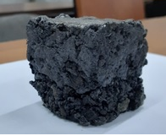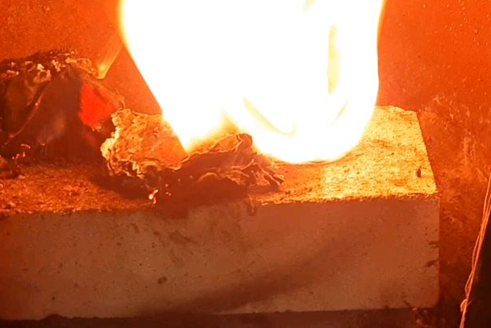
Resulting coal briquette Burning briquette with foam

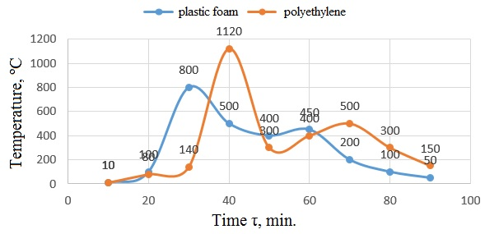
The temperature profile of the combustion of briquettes with polyethylene and foam

