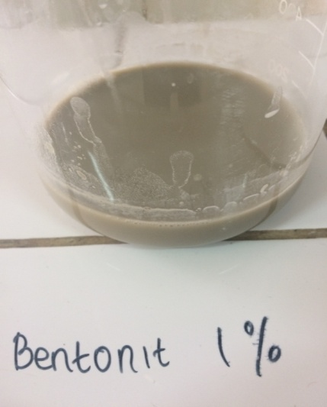 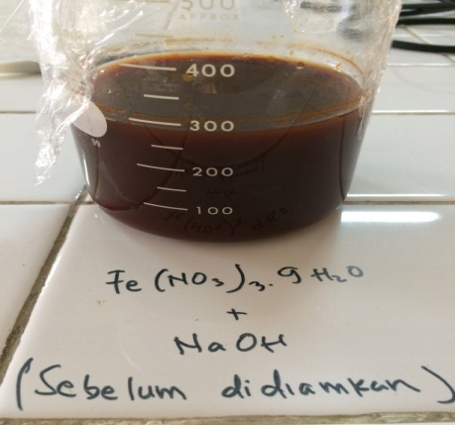

Fe doped onto bentonite

Activated Bentonite Fe Doping Solution

Fe(NO3)3.9H2O + NaOH