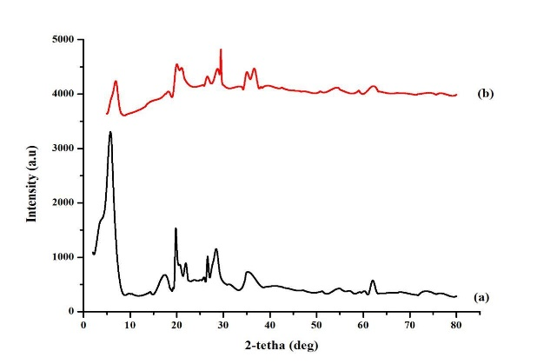

**Figure 1.** XRD spectrum: (a) Controlled Bentonite (activated), (b) Fe(III) doped Bentonite

**Figure 2.** Metal composition for controlled bentonite and Fe(III) doped onto bentonite

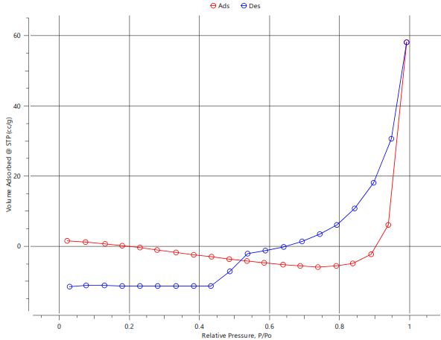

(A)

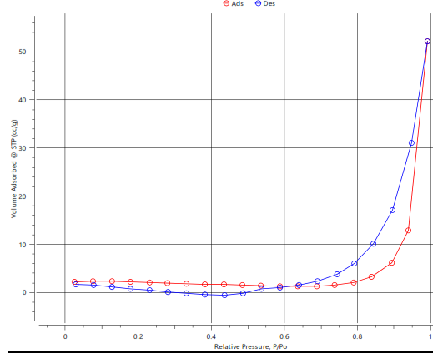

(B)

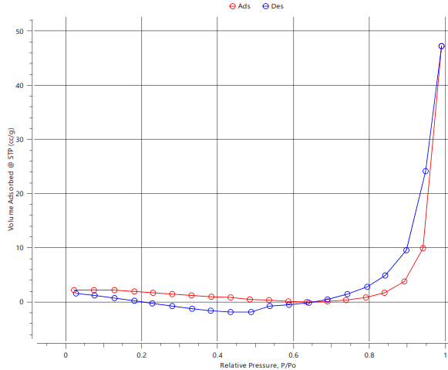

(C)

**Figure 3.** Nitrogen adsorption and desorption profile: (a) natural bentonite, (b) activated bentonite (controlled) and (c) Fe(III) doped onto bentonite

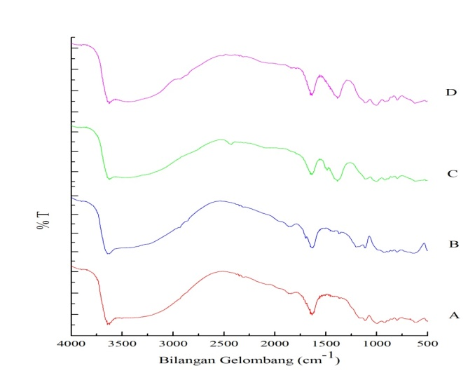

a

b

c

d

**Figure 4.** FT-IR spectrum: (a) activated bentonite (controlled) (b) activated bentonite after adsorbing phenol, (c) bentonite doped with Fe(III), (d) Fe(III) doped bentonite after adsorbing phenol

**Figure 5**. pHpzc analysis

**Figure 6.** Effect of contact time of adsorption of activated bentonite (controlled) and Fe(III) doped bentonite on phenol

**Figure 7.** Effect of phenol concentration and temperature on activated bentonite (controlled)

**Figure 8.** Effect of phenol concentration and temperature on Fe (III) doped onto bentonite

**Table 1.** The composition of Fe metal before and after the doping process

|  |  |
| --- | --- |
| **Sample** | **Fe (%)** |
| **Controlled bentonite** | 21.3 |
| **Doped bentonite** | 59.11 |

**Table 2.** BET Results Data

|  |  |  |  |
| --- | --- | --- | --- |
| Type of BentoniteAdxType of adsorbent | **Surface Area (m2/g)** | **Pore Diameter BJH (nm)** | **Pore Volume**  **BJH (cm3/g)** |
| **Natural** | 6.464 | 13.211 | 0.105 |
| **Controlled** | 6.060 | 13.263 | 0.083 |
| **Doped** | 5.166 | 13.559 | 0.077 |

**Table 3.** The kinetic model constants of phenol adsorption on the effect of time

|  |  |  |  |  |  |  |  |
| --- | --- | --- | --- | --- | --- | --- | --- |
| **Adsorbent** | **Qexp (mg/g)** | ***Pseudo-first-order*** | | | ***Pseudo-second-order*** | | |
| **Qe (mg/g)** | **k1** | **R2** | **Qe (mg/g)** | **k2** | **R2** |
| **Controlled** | 7,18 | 10,51 | 0,03 | 0,94 | 12,3 | 0,001 | 0,94 |
| **Doped** | 16,46 | 14,44 | 0,03 | 0,4 | 18,72 | 0,0004 | 0,16 |

**Table 4.** Data on adsorption isotherm using the Langmuir model and Freundlich

|  |  |  |  |  |  |  |
| --- | --- | --- | --- | --- | --- | --- |
| **Temp.**  **(oC)** | **Model isotherm Langmuir** | | | **Model isotherm Freundlich** | | |
| **Para**  **meter** | **Controlled Bentonite** | **Fe (III) doped onto bentonite** | **Para**  **meter** | **Controlled Bentonite** | **Fe (III) doped onto bentonite** |
| **30** | KL (L/mg) | 0.0076 | 4.5785 | KF | 0.0001 | 0.0204 |
| Qm (mg/g) | 1.7082 | 16.0513 | n | 0.4281 | 0.7059 |
| R2 | 0.8870 | 0.7559 | R2 | 0.9742 | 0.9626 |
| **50** | KL (L/mg) | 0.0031 | 0.0063 | KF | 0.0681 | 0.0148 |
| Qm (mg/g) | 46.5116 | 15.8478 | n | 0.8001 | 0.6152 |
| R2 | 0.5585 | 0.6384 | R2 | **0.9889** | **0.9616** |
| **70** | KL (L/mg) | 0.0049 | 0.0068 | KF | 0.0819 | 0.0158 |
| Qm (mg/g) | 45.4545 | 17.1526 | n | 0.7395 | 0.6013 |
| R2 | 0.7712 | 0.6219 | R2 | 0.9623 | 0.9627 |

**Table 5.** Data of Entropy (ΔS), Enthalpy (ΔH), free energy Gibbs (∆G), and Adsorption capacity (Qe)

|  |  |  |  |  |  |  |  |  |  |
| --- | --- | --- | --- | --- | --- | --- | --- | --- | --- |
| **Conc.**  **(mg/L)** | **Temp.**  **(K)** | **Controlled bentonite** | | | | **Doped bentonite** | | | |
| **Qe**  **(mg/g)** | **ΔS**  **(kJ/mole)** | **ΔH**  **(kJ/mole)** | **ΔG**  **(kJ/mole)** | **Qe**  **(mg/g)** | **ΔS**  **(kJ/mole)** | **ΔH**  **(kJ/mole)** | **ΔG**  **(kJ/mole)** |
| **50** | 303 | 0.349 | 0.2847 | -97.616 | -11.350 | 3.695 | 0.074 | -39.040 | -6.467 |
| 313 | 2.791 | -8.503 | 4.364 | -5.722 |
| 323 | 8.326 | -5.656 | 8.060 | -4.977 |
| 333 | 9.047 | -2.809 | 8.337 | -4.232 |
| **100** | 303 | 5.419 | 0.1442 | -50.601 | -6.908 | 10.230 | 0.039 | -29.263 | -5.452 |
| 313 | 13.349 | -5.466 | 12.817 | -5.060 |
| 323 | 17.047 | -4.024 | 15.127 | -4.668 |
| 333 | 27.860 | -2.582 | 17.528 | -4.276 |
| **150** | 303 | 18.767 | 0.060 | -23.196 | -5.016 | 22.702 | 0.050 | -19.384 | -4.234 |
| 313 | 23.407 | -4.416 | 29.676 | -3.734 |
| 323 | 26.651 | -3.816 | 36.605 | -3.234 |
| 333 | 38.302 | -3.216 | 38.937 | -2.734 |