**Electrical conductivity study of poly**

**(*p*-anisidine) doped and undoped ZnO nanocomposite**

**K.Rathidevi1*, N.Velmani2 and D.Tamilselvi3**

1. Fig. 1: FTIR spectrum of PPA polymer; ZnO nanoparticles; ZPPA and MZPPA Polymeric composite blends
2. Fig. 2A: SEM images of PPA polymer; 2B: SEM image of ZPPA polymeric composite and 2C: SEM image of MZPPA polymeric composite blend and 2D: SEM image of ZnO nanoparticle.
3. Fig. 3: XRD image of ZnO semiconductor material, PPA conducting polymer, ZPPA and MZPPA polymeric composite blends
4. Fig. 4: UV-Vis spectra of PPA conducting polymer, ZPPA and MZPPA polymeric composite blends.
5. Fig. 5: TGA thermograph of PPA polymer, ZPPA and MZPPA polymeric composite blends.
6. Fig. 6: Variation in electrical conductivity with synthesized conducting materials against temperature difference.
7. Fig. 7: Arrhenius plot of dc conductivity against difference in temperature.

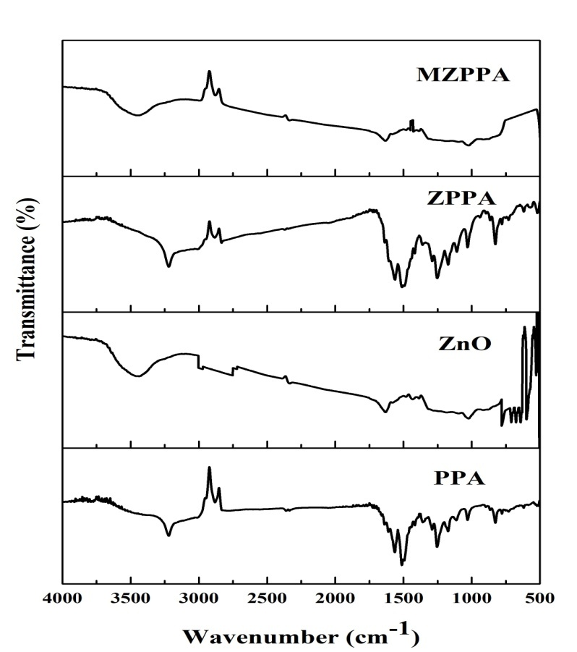

Fig. 1: FTIR spectrum of PPA polymer; ZnO nanoparticles; ZPPA and MZPPA Polymeric composite blends

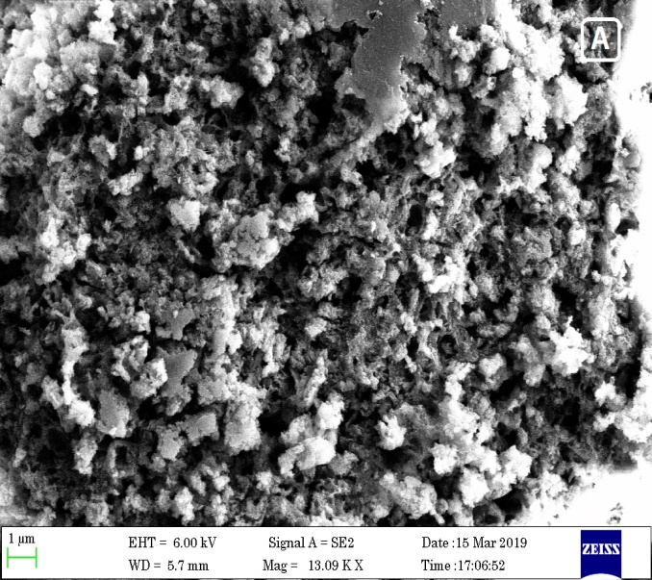 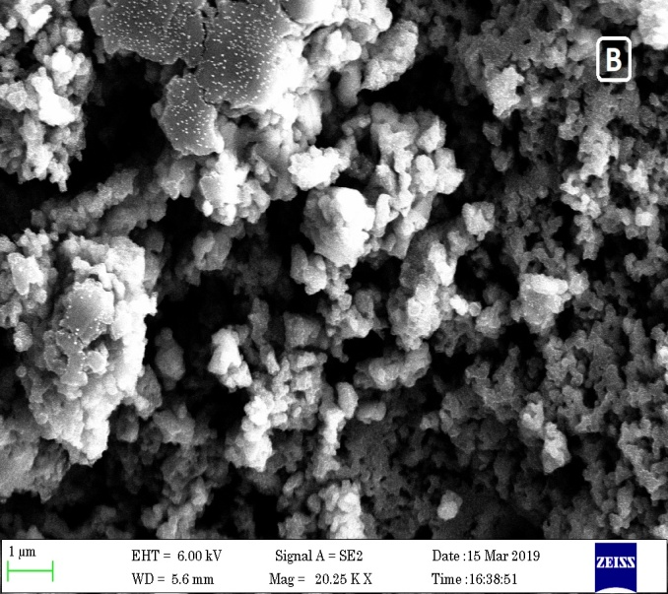

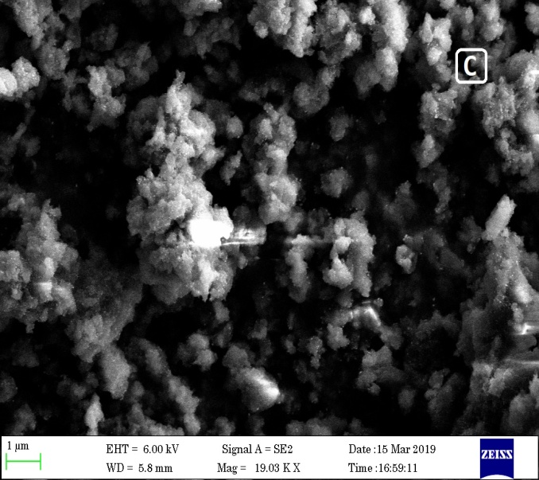 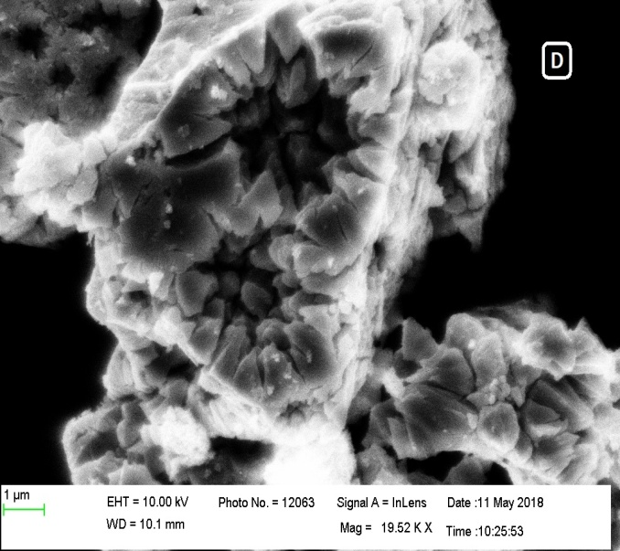

Fig. 2A: SEM images of PPA polymer; 2B: SEM image of ZPPA polymeric composite and 2C: SEM image of MZPPA polymeric composite blend and 2D: SEM image of ZnO nanoparticle.

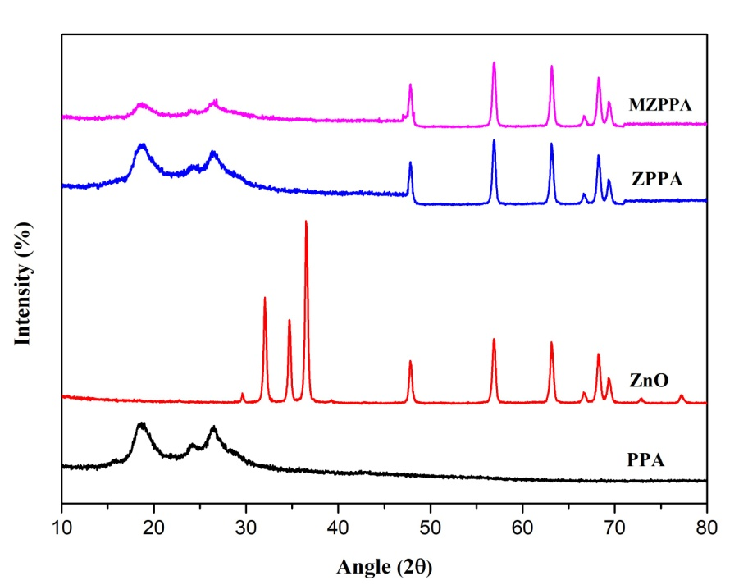

Fig. 3: XRD image of ZnO semiconductor material, PPA conducting polymer, ZPPA and MZPPA polymeric composite blends

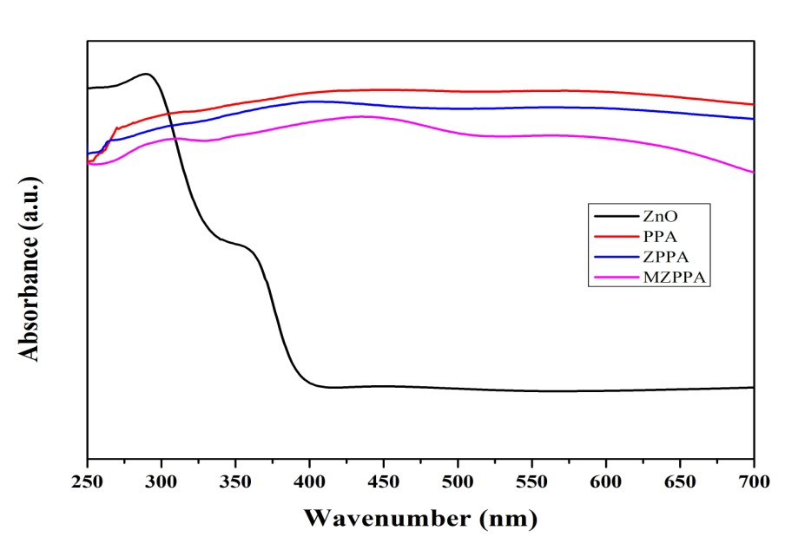

Fig. 4: UV-Vis spectra of PPA conducting polymer, ZPPA and MZPPA polymeric composite blends.

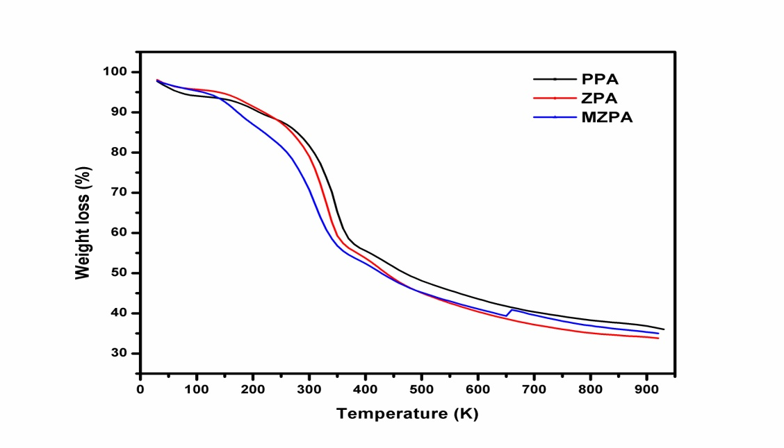

Fig. 5: TGA thermograph of PPA polymer, ZPPA and MZPPA polymeric composite blends.

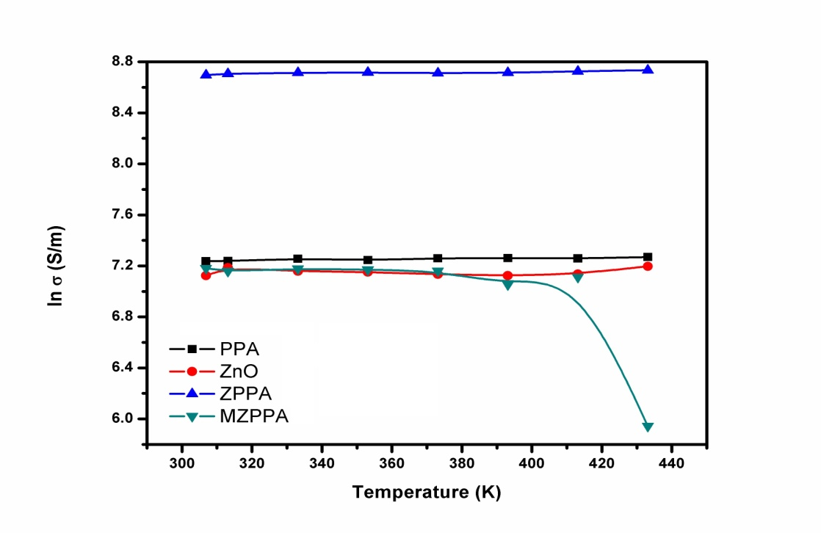

Fig. 6: Variation in electrical conductivity with synthesized conducting materials against temperature difference.

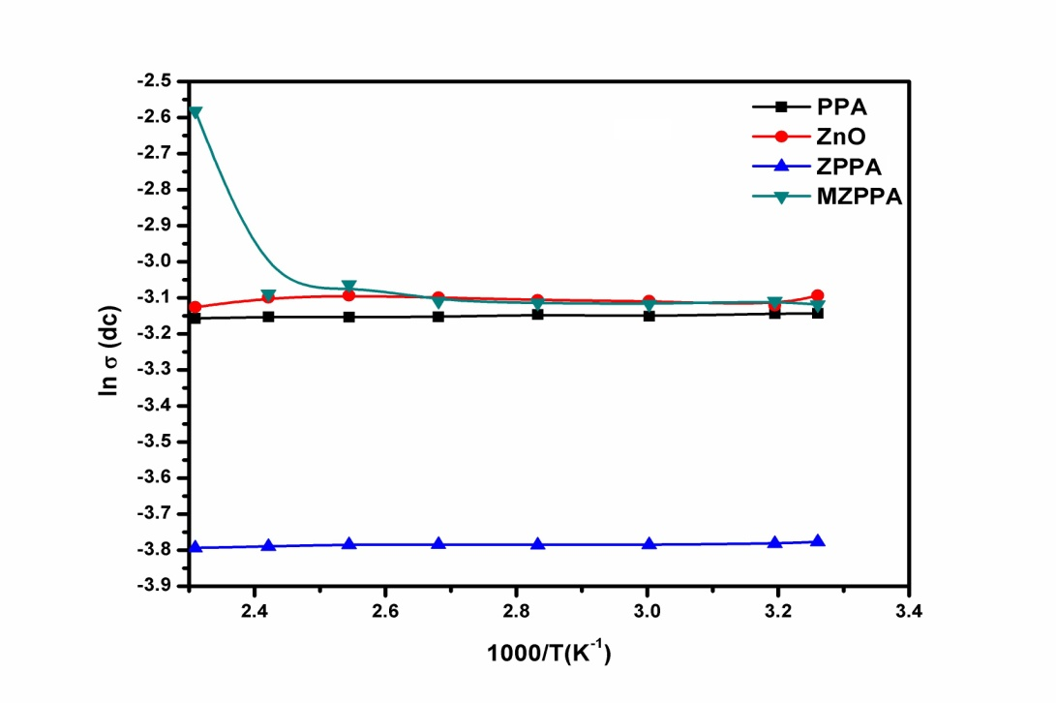

Fig. 7: Arrhenius plot of dc conductivity against difference in temperature.